Supporting Materials
for

DOI: 10.6060/mhc224315m
Effect of Halogenation of ortho-Positions of Tetraphenylporphyrin and Its Cd(II) Complex on Their Complexing Ability towards d-Metal Salts in Dimethylformamide

Svetlana V. Zvezdina, Natalya V. Chizhova, Nugzar Z. Mamardashvili,@ and Oskar I. Koifman

G.A. Krestov Institute of Solution Chemistry, Russian Academy of Sciences, Akademicheskaya St. 1, Ivanovo 153045, Russian Federation
@Corresponding author E-mail: ngm@isc-ras.ru

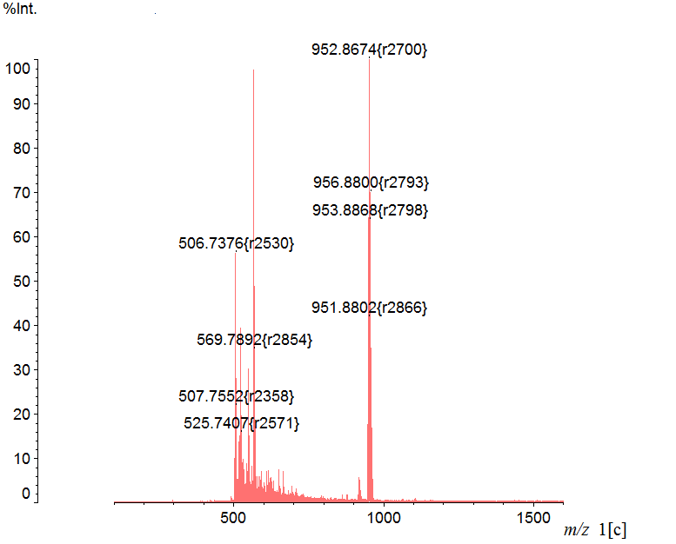
Fig. 1Sa. Zn(II)-5,10,15,20-tetra(2,6-dichlorophenyl)porphyrin mass spectrum.

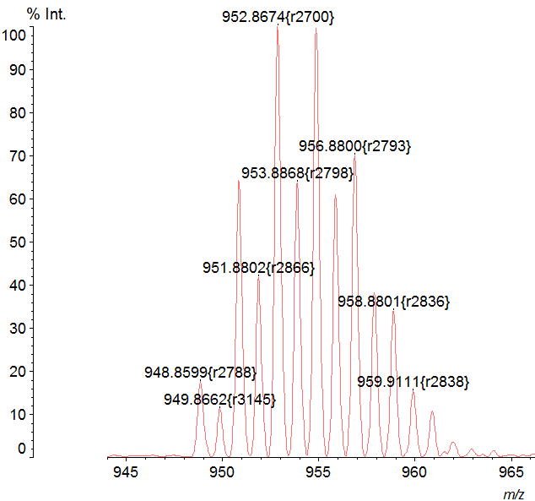  A | 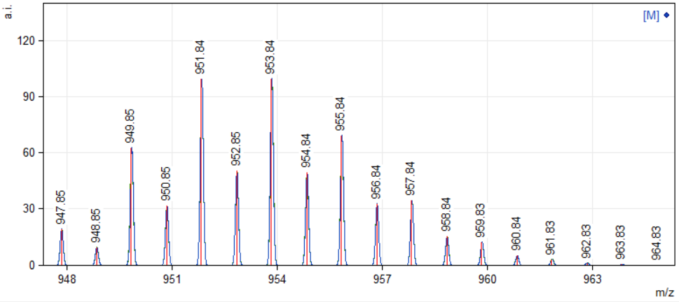  B
Fig. 1Sb. Zn(II)-5,10,15,20-tetra(2,6-dichlorophenyl)porphyrin mass spectrum: A -experimental data, B -theoretical isotopic distribution.

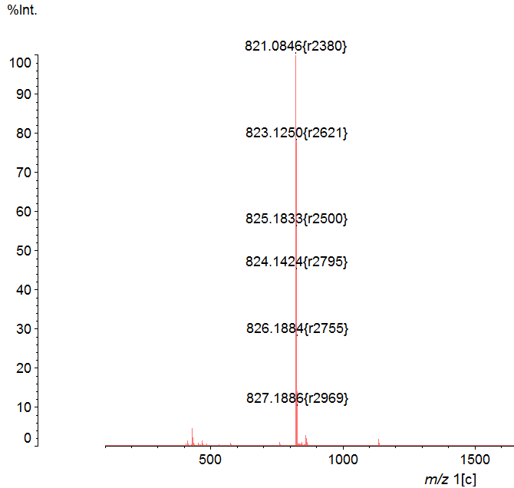
Fig. 2Sa. Zn(II)-5,10,15,20-tetra(2,6-difluorophenyl)porphyrin mass spectrum.

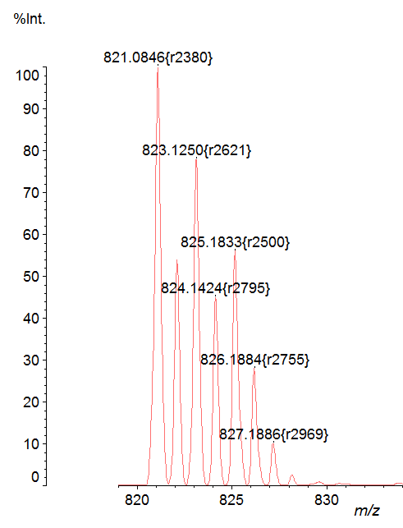  A | 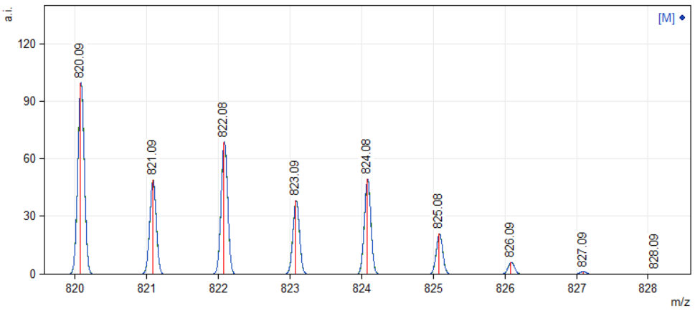  B
Fig. 2Sb. Zn(II)-5,10,15,20-tetra(2,6-difluorophenyl)porphyrin mass spectrum: A -experimental data, B -theoretical isotopic distribution.

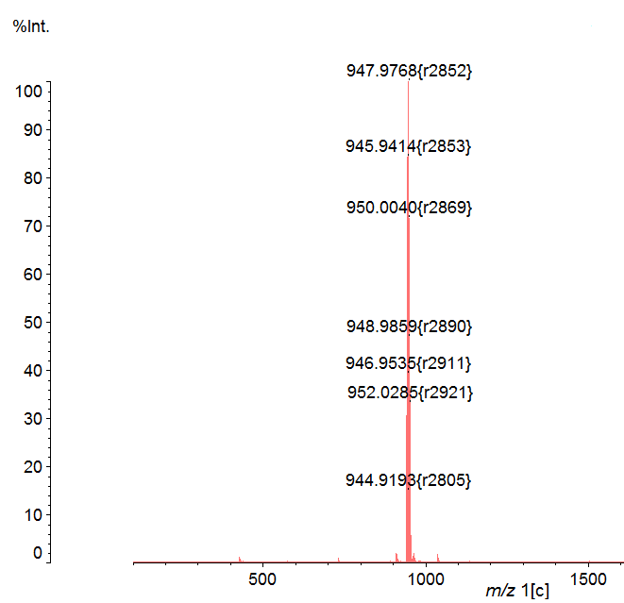
Fig. 3Sa. Со(II)-5,10,15,20-tetra(2,6-dichlorophenyl)porphyrin mass spectrum.

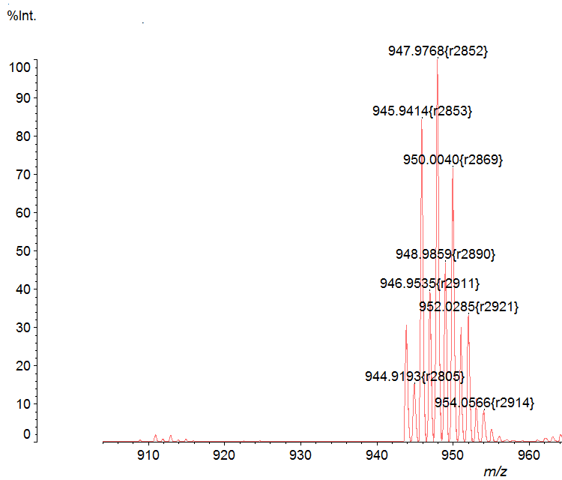  A | 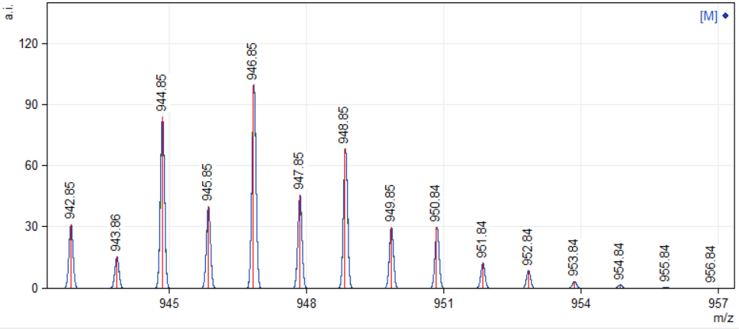  B
Fig. 3Sb. Со(II)-5,10,15,20-tetra(2,6-dichlorophenyl)porphyrin mass spectrum: A -experimental data, B -theoretical isotopic distribution.

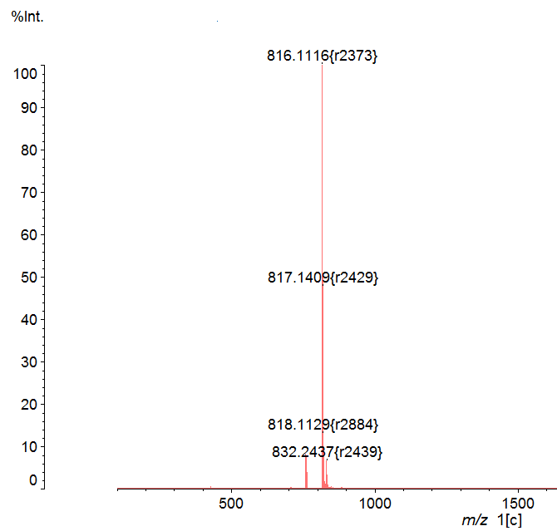
Fig. 4Sa. Со(II)-5,10,15,20-tetra(2,6-difluorophenyl)porphyrin mass spectrum.

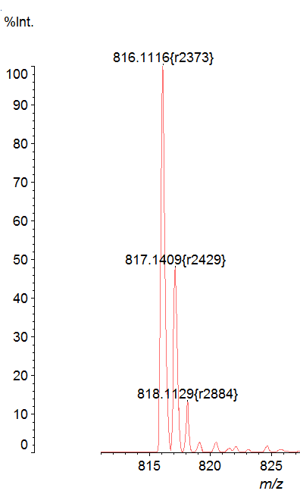  A | 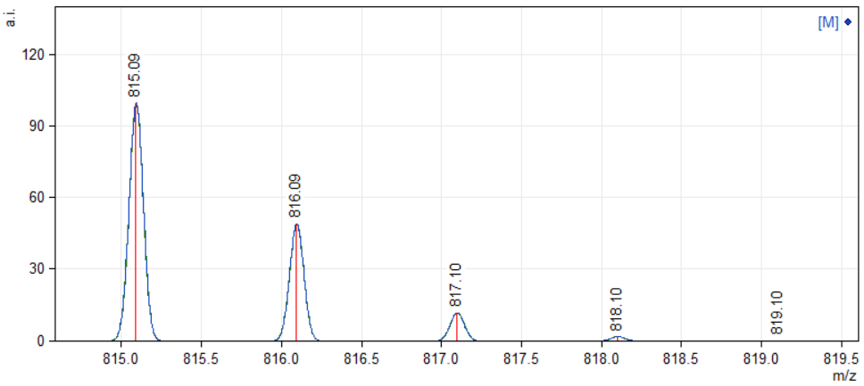  B
Fig. 4Sb. Со(II)-5,10,15,20-tetra(2,6-difluorophenyl)porphyrin mass spectrum: A -experimental data, B -theoretical isotopic distribution.

