Supporting Information
for
DOI: 10.6060/mhc224374v
Preparation of a Hybrid Сeramic-Based Material with Immobilized Dicarboxyl-Terminated Ruthenium(II) Clathrochelate and Its Catalytic Activity in Methane Oxidative Conversion
A. S. Chuprin,ª A. V. Vologzhanina,ª A. S. Loktev,^{b,c,d} M. G. Bugaenko,ª Y. Z. Voloshin,^{a-c@} V. M. Buznik,^{b} and A. G. Dedov^{b,c,d}
ª Nesmeyanov Institute of Organoelement Compounds, Russian Academy of Sciences, 119991 Moscow, Russia
^{b} Gubkin Russian State University of Oil and Gas (National Research University), 119991 Moscow, Russia
^{c} Kurnakov Institute of General and Inorganic Chemistry of the Russian Academy of Sciences, 119991, Moscow, Russia
^{d}Topchiev Institute of Petrochemical Synthesis, Russian Academy of Sciences, Moscow, 119991 Russia
@Corresponding author E-mail: voloshin@igic.ras.ru, voloshin@ineos.ac.ru

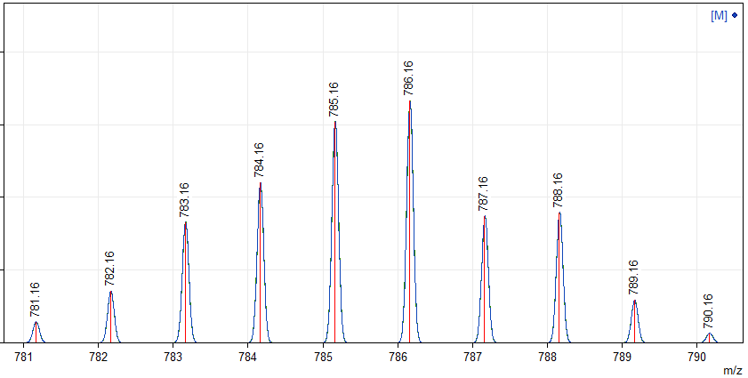
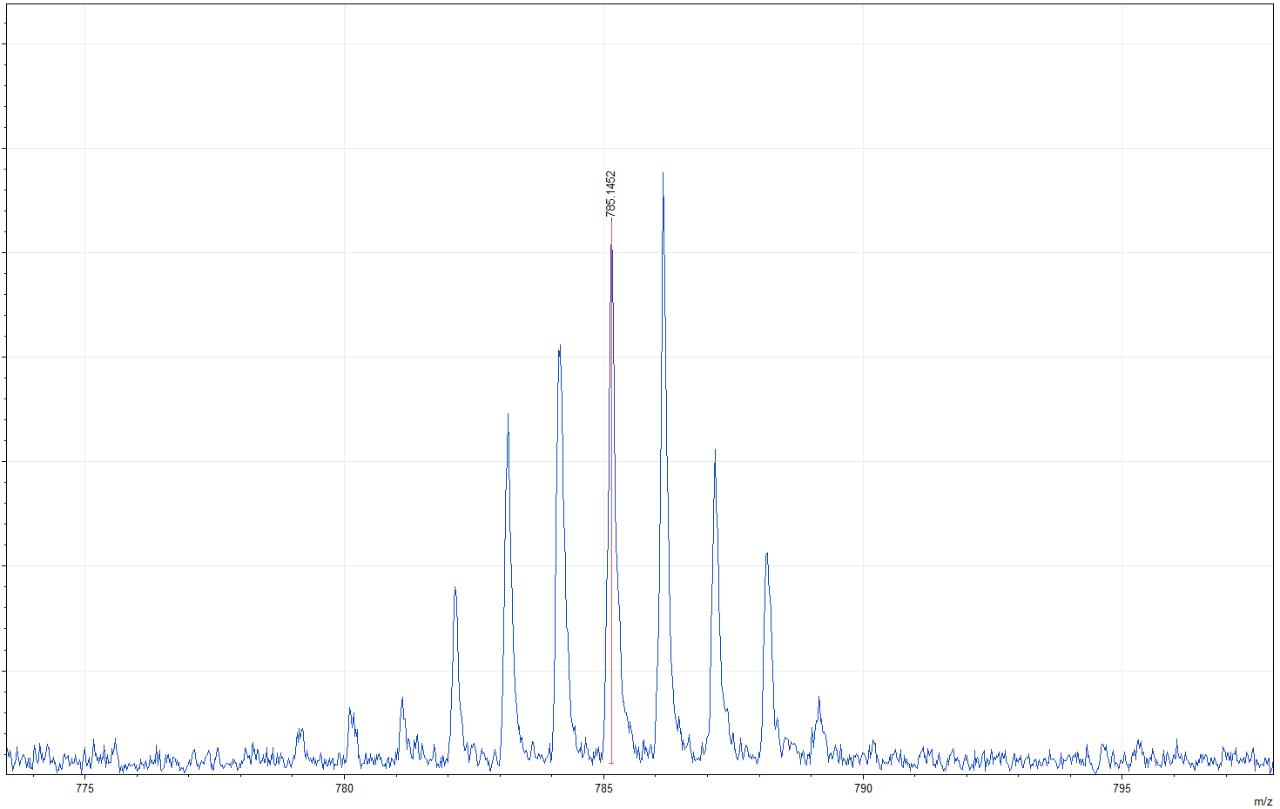
Figure S1. Fragment of the MALDI-TOF mass spectrum of the clathrochelate RuNx₃(B4-C₆H₄COOH) in its positive range. Insert: the theoretically calculated isotopic distribution of its molecular ion.

δ¹_{H} (ppm)
Figure S2. Solution ¹H NMR spectrum of the clathrochelate
RuNx₃(B4-C₆H₄COOH) in pyridine-d₅.

δ¹³_{C} (ppm)
Figure S3. Solution ¹³C{¹H} NMR spectrum of the clathrochelate
RuNx₃(B4-C₆H₄COOH) in pyridine-d₅.

Figure S4. Solution UV-vis spectrum of the clathrochelate
RuNx₃(B4-C₆H₄COOH)₂ in DMSO (shown in black line) and its deconvolution on the Gaussian components (shown in color lines).

