Supplementary materials
Stability of manganese(II) phthalocyanine films in ambient air
P.A. Yunin, Y.I. Sachkov, V.V. Travkin, G.L. Pakhomov
DOI: 10.6060/mhc224426y

Supplement 1
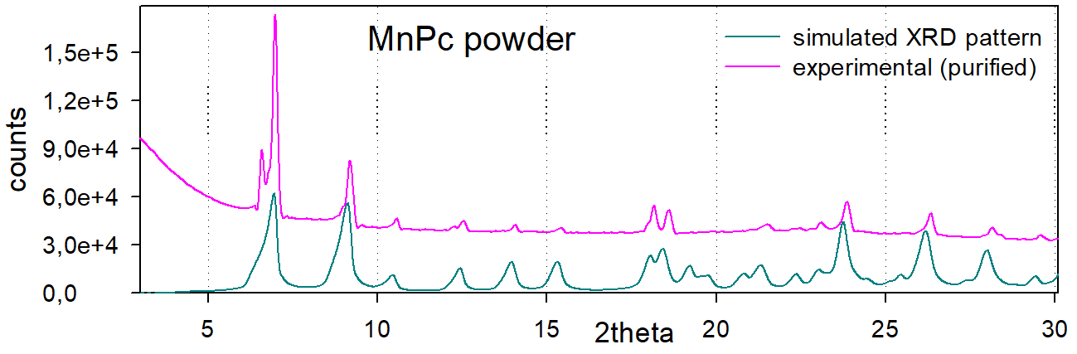
Comparison of the experimental XRD spectrum (purified PcMn powder in Fig. 2) and the spectrum calculated using the CIF file CCDC#1212698 [18].

Supplement 2
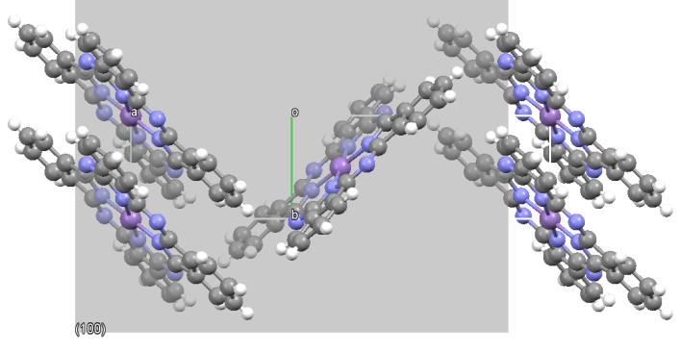 | 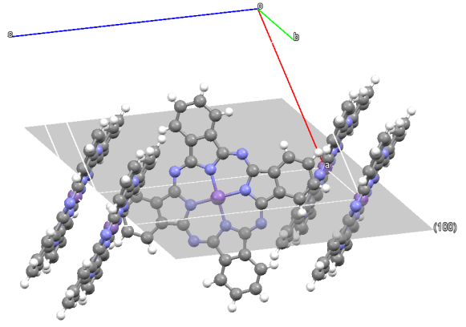
Top view | Isometric view
Views of the packing of molecules in a β-PcMn film textured by the (100) plane oriented parallel to the silicon substrate (marked in gray)

Supplement 3
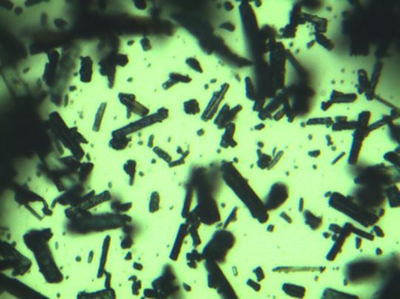 | 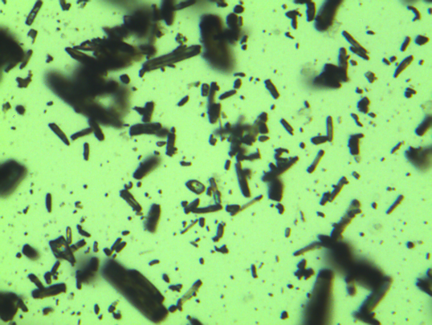
As-received (raw, unpurified) | Recrystallized (purified)
Photographs of MnPc powder in an optical microscope (200× magnification)

Supplement 4
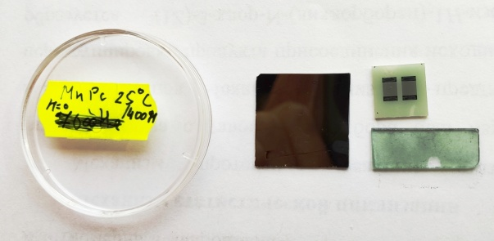 | 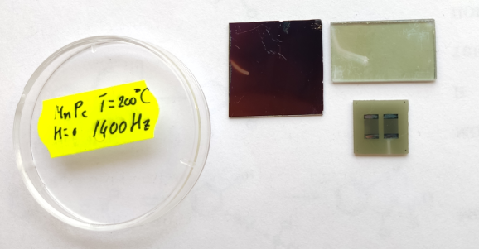
T_{g}=25ºC | T_{g}=200ºC
Photographs of thin-film PcMn samples on various substrates used in this work after one month storage in air.

Supplement 5
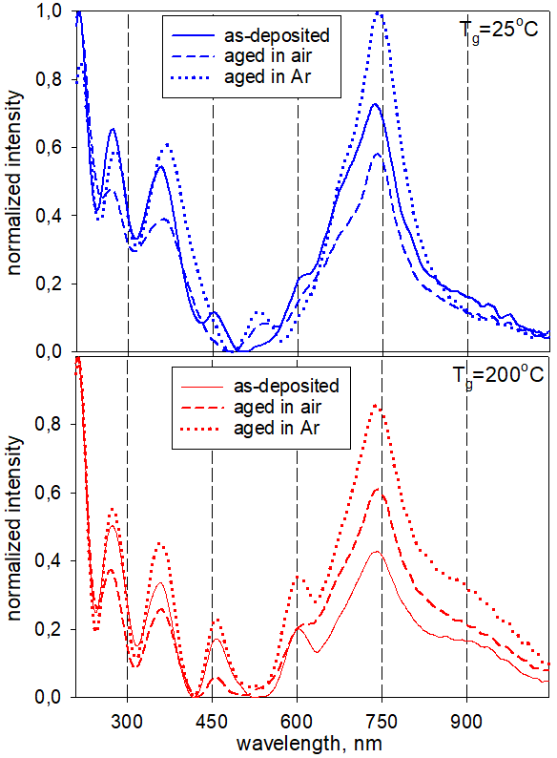 | ← Redrawn from Fig. 4: Comparison of spectra of PcMn films on cold and hot substrates.
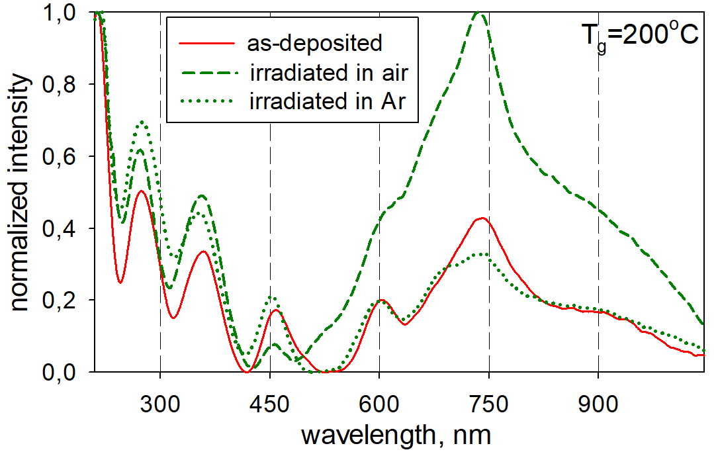 | 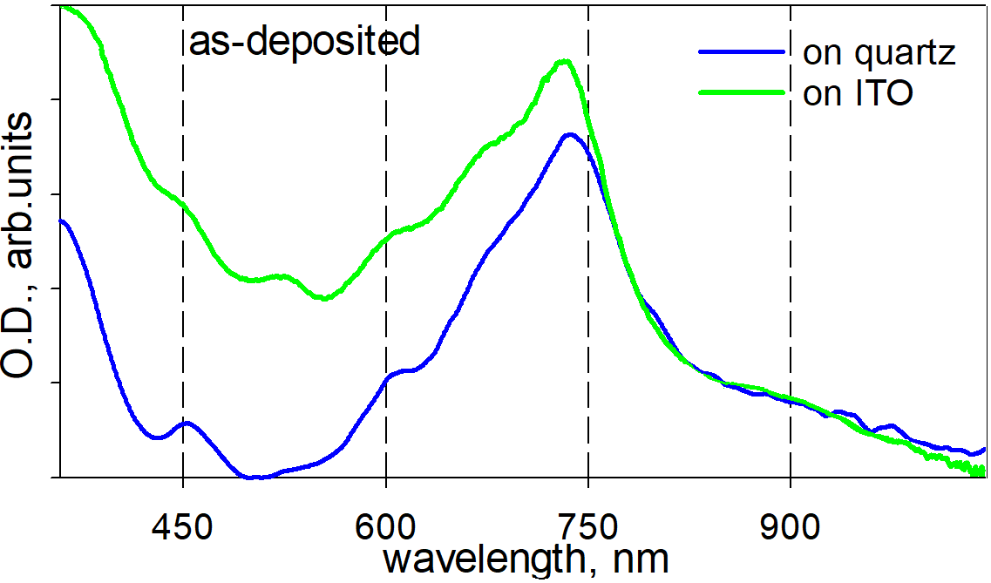
Spectra of the β-PcMn film in air and Ar before and after one-sun illumination for 13 h (a Zolix SS150 solar simulator with AM1.5G filter) | Spectra of PcMn films with T_{g}=25ºC on quartz (green curve) and indium-tin oxide (ITO, blue curve)

Supplement 6
 |  | As-deposited on Si | As-deposited on SiO₂ |  |  |  |  | T_{g}=200ºC on SiO₂
T_{g}=25ºC |  | 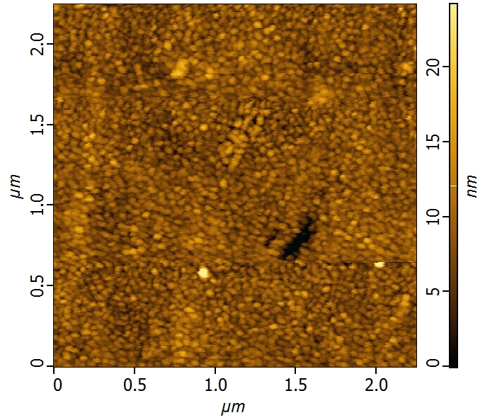 | 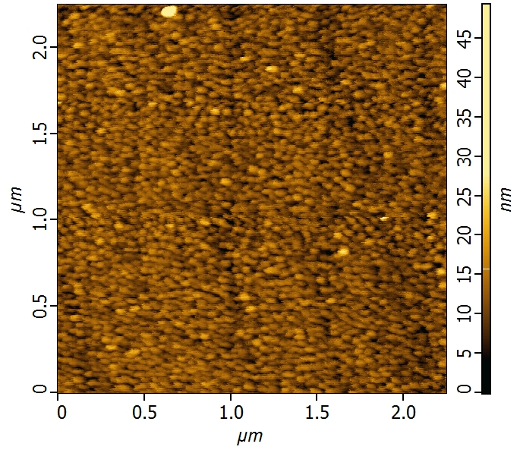 |  |  | Initial |  | 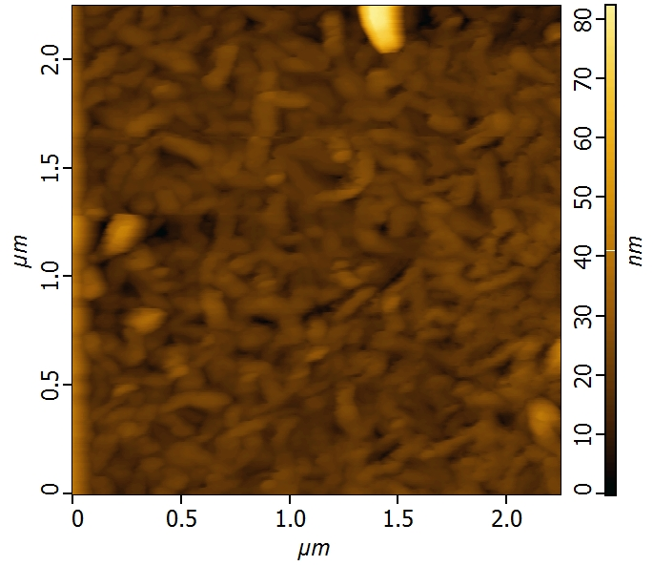
T_{g}=200ºC | 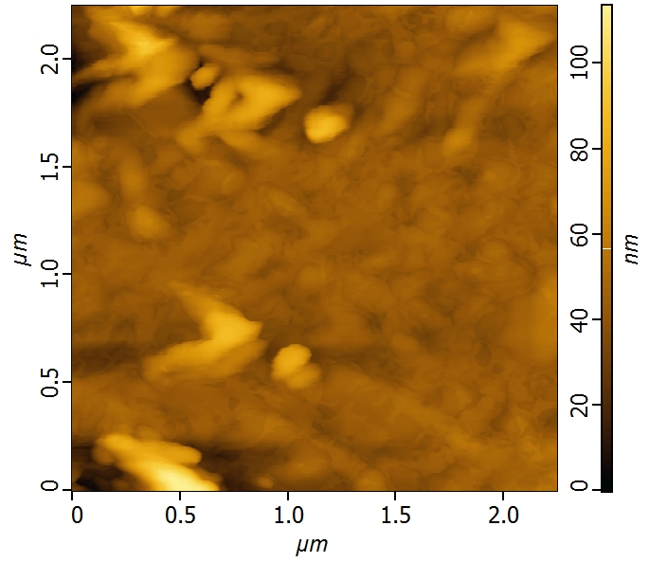 |  |  |  | Stored in air for 1 month |  | 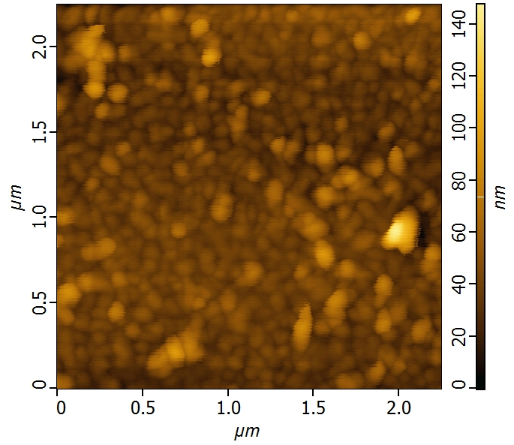
AFM images of the surface of PcMn films deposited on silicon (left column) and quartz substrates at 25º and 200ºC,
before and after 1 month storage in air, cf. Fig. 6.

Supplement 7
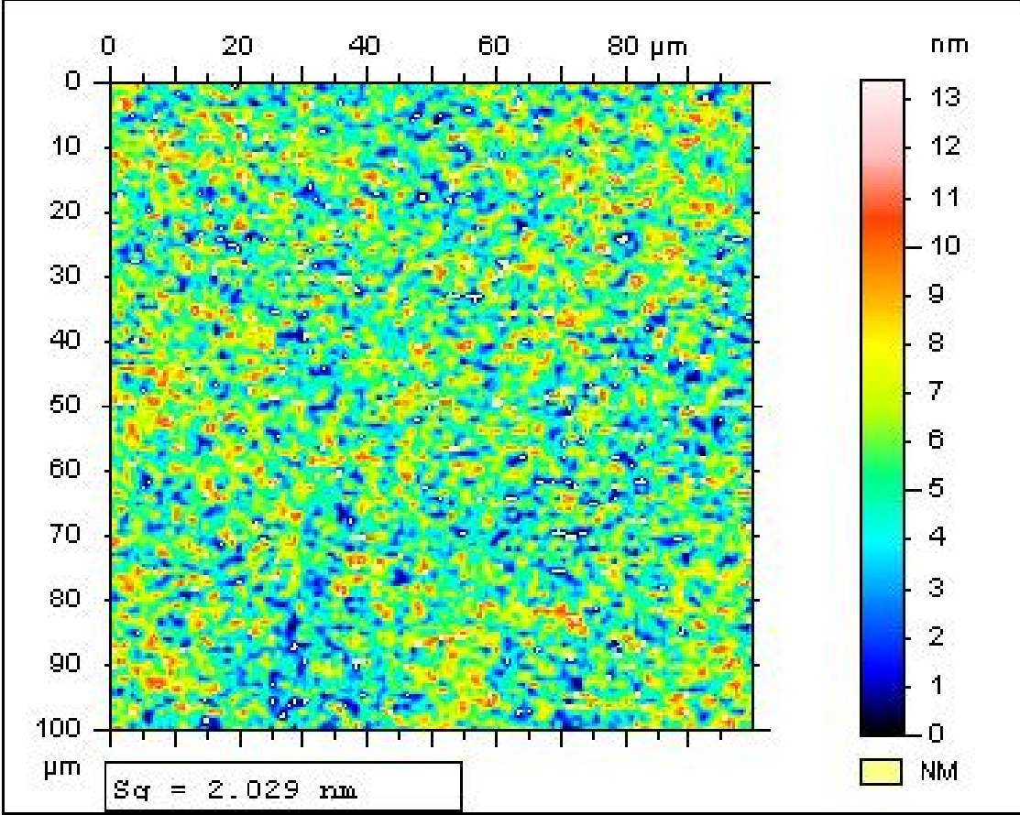 | 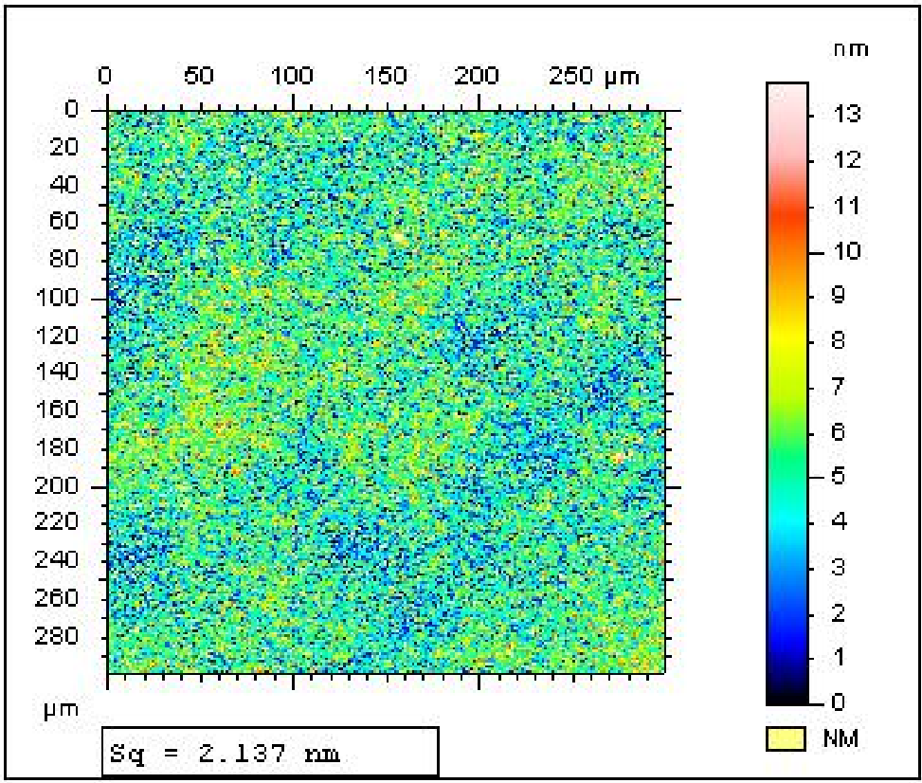
WLI images of the surface of the low-temperature PcMn film after 1 month storage in air, with different magnification. Sq = root mean square roughness

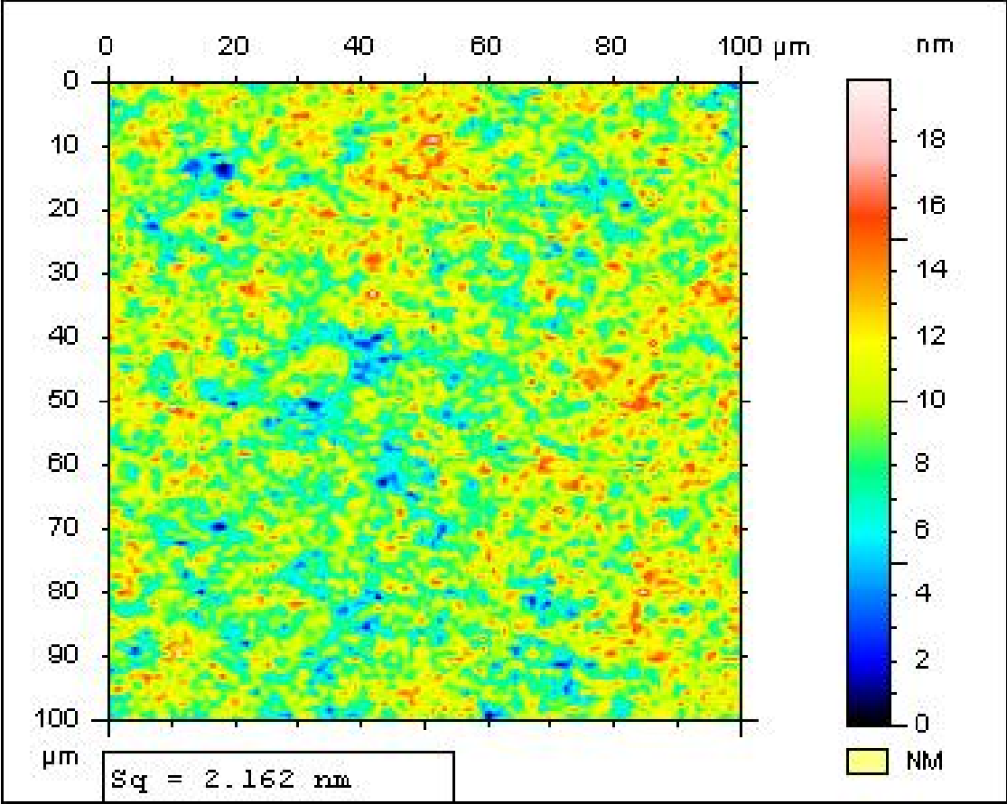 | 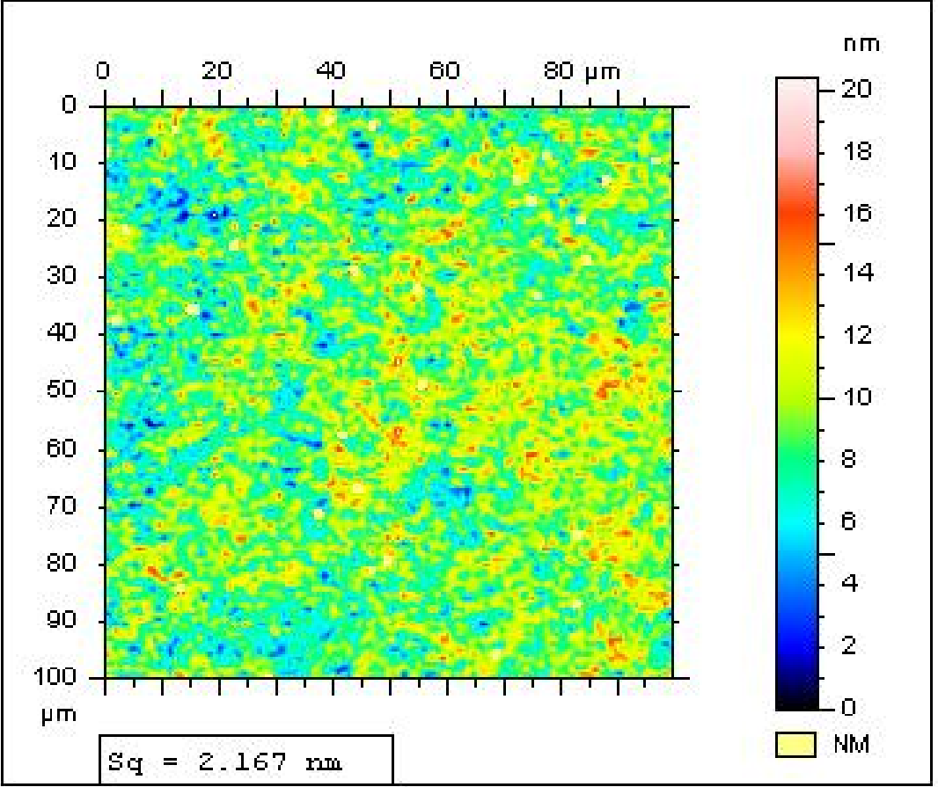
Tg=200ºC, stored in air | Tg=200ºC, stored in Ar
WLI images of the surface of the high-temperature PcMn film after 1 month storage

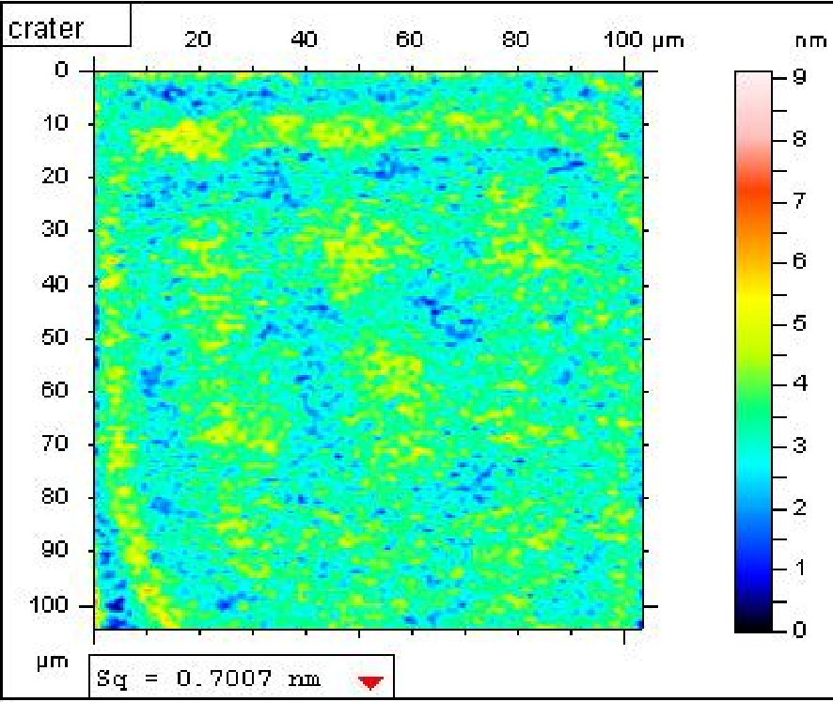 | 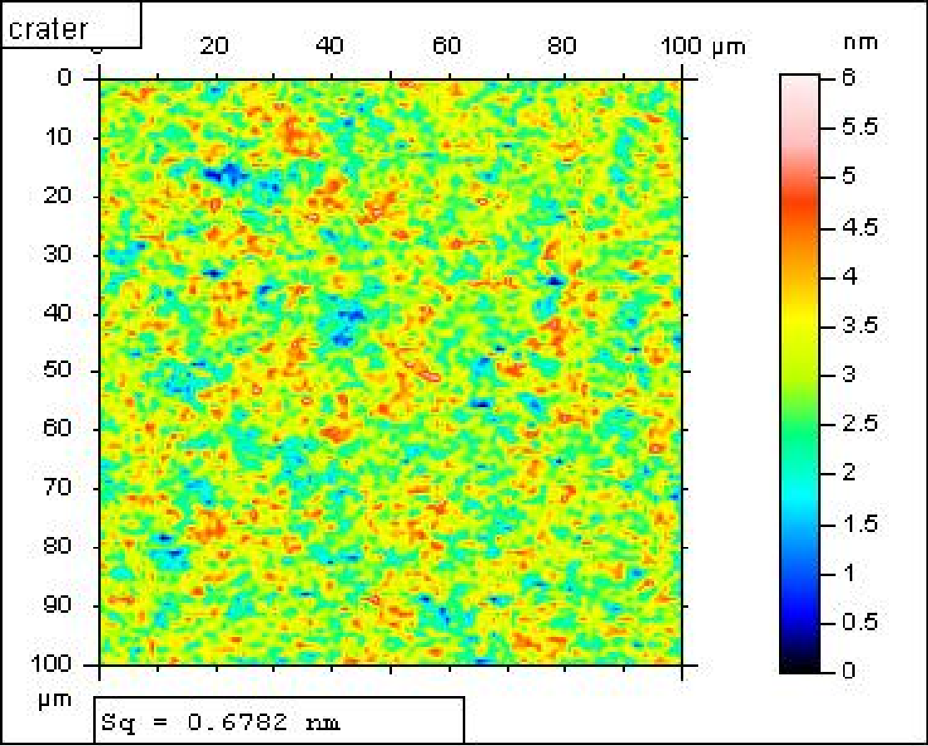
T_{g}=25ºC, stored in air | T_{g}=200ºC, stored in air
WLI images of the bottom of crater remaining after SIMS depth profiling down to silicon substrate

Supplement 8
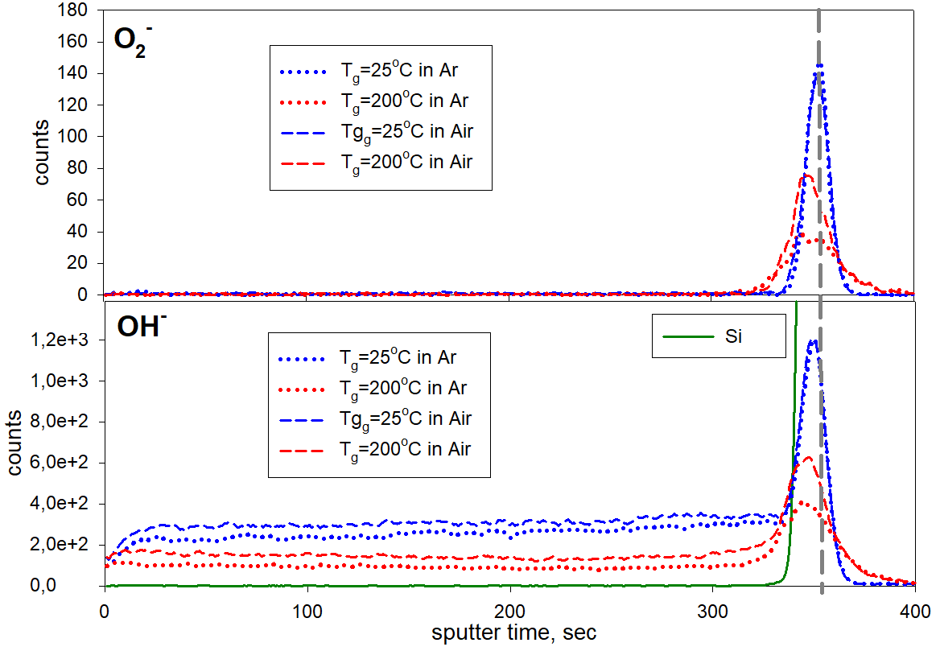
SIMS profiles for negative secondary ions O₂⁻ and OH⁻, cf. Fig. 5.

