Octa-tert-butylsulfanyl zinc tetrapyrazineporphyrazinate: self-assembled nanostructures at the air-water interface and `solid solution` in thin films

Bukharin D.B.^{а}, Maiorova L.A. ^{а,b *}, Gromov A.N.^{b}, Koifman O.I. ^{а,c}

ª Ivanovo State University of Chemistry and Technology, Ivanovo, Russia
^{b} Institute of Pharmacoinformatics, Federal Research Center “Computer Science and Control” of Russian Academy of Sciences, Moscow, Russia
^{c} G.A. Krestov Institute of Solution Chemistry of the Russian Academy of Sciences, Ivanovo, Russia
Abstract
Nanostructured monolayers of zinc octa-tert-butylsulfanyltetrapyrazineporphyrazinate (ZnSPPz) were obtained at the water-air interface. It was found that this compound is characterized by the formation of two types of very stable monolayers: face-on and edge-on. The boundaries of the existence of M-monolayers of various types and the quantitative characteristics of their structure and properties (the size of nanostructures formed in the layer, the number of molecules in them, the distances between them, and others) are determined. The model, a phase diagram, and schemes of monolayers are constructed. It is shown that ZnSPPz behaves like a solid solution in the Langmuir-Schafer films obtained from the formed monolayers. The results are of interest for the development and creation of chemical sensors and photoactive thin-film nanomaterials based on ZnSPPz.

Keywords: air-water interface, self-assembly, nanostructures, thin films, solid solution, zinc tetrapyrazineporphyrazine.
*Maiorova L.A. E-mail: Maiorova.larissa@gmail.com

Introduction
Nanotechnology makes it possible to create materials with fundamentally new properties and applications [1-6]. At the stage of transition from the molecular scale to the nanoscale, the main goal is to control the placement of molecules. This problem can be solved, in particular, using the Langmuir-Blodgett technique. A significant number of works have been devoted to floating layers and thin films of macroheterocyclic compounds, but the data on the resulting nanostructures are inconsistent. Studies of self-organization in floating layers and quantitative data on the structure of the floating layer are practically absent (most works estimate the structure only qualitatively).
In recent years, there has been an interest in porphyrazines with a variety of both carbon and heteroatomic substituents (S, O, N) associated directly with the periphery of the macroheterocycle [7-10]. This is due to the strong dependence of the electronic and optical properties of the macroheterocyclic ring system on the nature of the substituent, as well as to the relatively simple synthesis. Unlike phtalocyanine analogs, porphyrazines have an increased solubility in organic solvents. These special properties of porphyrazines distinguish them in the family of tetrapyrrole macroheterocycles and expand the scope of potential applications.
To date, low-dimensional porphyrin-based nanostructures with promising properties have been obtained in three-dimensional (3D) environments, on solid surfaces using two-dimensional (2D) templates, exploiting covalent bonding [11, 12] or various non-covalent intermolecular interactions [13–17]. Self-assembly is a key player in materials nanoarchitectonics [18–23]. The nanostructures formed in this way arise from molecules carrying side groups that promote the process. Supramolecular polymers were created using diverse self-assembly strategies [24-28]. wherein biomolecules are employed. Formation of different kinds of supramolecular assemblies from some compounds at the water surface [29, 30], during electrochemical deposition on electrodes [31-38] and in metal-organic frameworks [39,40] was reported.
Previously, we demonstrated the possibility of supramolecular design at the air-water interface by controlled self-assembly of porphyrins into 2D and 3D nanostructures [41-46]. The concept of nanostructuring of organic compounds at the air-water interface and a model of a floating layer, the structural units of which can be both individual molecules (Langmuir's approach, special case) and their major nanostructures (so-called M-nanostructures, general case), were presented [5, 3, 47-50]. The formation of the porphyrin nanoparticles from magnesium porphine, a functional element of chlorophyll, was reported [3]. The possibility of nanoparticle formation by vitamin B₁₂ and its hydrophobic derivatives was shown. This is valuable for pharmacology, since these compounds have a neuroprotective effect [4, 51]. Self-organization of tetrapyrazinporphyrazine and the formation of nanostructures of these compounds at the water-air interface have not yet been studied.

Derivatives of pyrazine-annelated porphyrazines are now being actively studied as promising photosensitizers, fluorescent sensors, and materials for photovoltaics [52, 53]. The incorpration of bulk tert-butyl sulfonyl groups (t-BuS-) into the peripheral positions of pyrazine fragments not only gives macrocyclic compounds good solubility in organic solvents [54], but can also determine the features of supramolecular organization in thin films.
In this work, we investigated the possibilities of the formation of zinc octatetrabutyl-sulfonyl tetrapyrazinporphyrazine nanostructures (ZnSP, Fig. 1). Peculiarities of the formation of ZnSPPz monolayers were studied. Langmuir-Schaefer films were prepared and examined by UV-Vis spectroscopy.
Experimental
Octa-tert-butylsulfanyl zinc tetrapyrazineporphyrazinate was synthesized according to the known method [54].
NT-MDT Langmuir-Blodgett setup (Zelenograd, Russia) was used for the experiments. A solution in toluene (С=1.7⋅10⁻⁴ mol/L) was used to obtain floating layers. The layer compression rate was v=3.2 cm²/min. Wilhelmy sensor was used to measure the surface pressure (with 0.02 mN/m accuracy). The measurement error of the area per molecule in the layer (A) was 2%.
The structure of the layers was analyzed within the framework of the author's model and quantitative method for analyzing the compression isotherms of the nanostructured M-monolayer [3,5,45]. The method is designed to determine the characteristics of the structure and properties of the nanostructured Langmuir layer (parameters of the model).
The layer in the stable state is described by the equation π(A-A_{mol})=kT/n, where π is the surface pressure, A is the area per molecule in the layer, A_{mol} is the area per molecule in the aggregate, n is the number of molecules in the aggregate, k is the Boltzmann constant and T is the absolute temperature. The surface area per molecule in a nanostructures and the aggregation number were determined by approximating the πA-π curve section by a linear function using the least squares method (πA uncertainty ≤3%). The main characteristics of the floating layer were determined in the following manner: β = kT/n, where β is the ordinate of the intersection point between the line, describing the isotherm’s πA-π region corresponding to the stable state of the layer, and the πA axis; А_{mol} is the slope of the line. According to the model, the two-dimensional M-nanostructure (nanoaggregate) has the shape of a circle with the surface area of S_{aggr} = nA_{mol} and the diameter of D_{aggr} = 2(S_{aggr}/π)^{1/2}.
The distance between the boundaries of the nanostructures is the same on average, d_{i} = 2(n/π)^{1/2}(A_{i}^{1/2}–A_{mol}^{1/2}). The degrees of coverage of the water surface at the initial and end points of the stable state can be defined as c_{i-edge} = A_{proj-edge}/A_{i} ×100 % and c_{f-edge} = A_{proj-edge}/A_{f} ×100 %, respectively. Here A_{proj-edge} is the surface area of the edge-on projection of a molecule model, π_{i} and π_{f} are the respective pressures at the onset and at the end of the stable state, with A_{i} and A_{f} are the abscissas of the start and the end of the linear portion of the π-A isotherm. The degree of coverage of the water surface by nanostructures at the onset point of the stable state can be calculated with c_{i-aggr} = A_{mol}/A_{i}. The content of water in M- nanostructures (calculated per molecule) and between them at the onset point of the stable state can be calculated, respectively, with w_{in-М} = A_{mol} - A_{pack} and w_{inter-M-i} = A_{i} - A_{mol}, where A_{pack} is the area per molecule in the packed state. The error of determining the parameters of the layer does not exceed 3% for А_{mol}; 7% for D_{NS} and w_{inter-M-i}; 10% for n, c_{i-NS}, w_{in-M,} and d_{i}.
The layers were transferred onto quartz substrates by the Langmuir-Schafer method. Electronic absorption spectra of the transferred layers were recorded on a HITACHI U-2000 and SHIMADZU UV-1800 scanning spectrophotometers with a wavelength accuracy of ±1 nm. The geometric characteristics of the molecules were determined from molecular models in HyperChem 7.01, MM+ calculation method (Fig. 1).
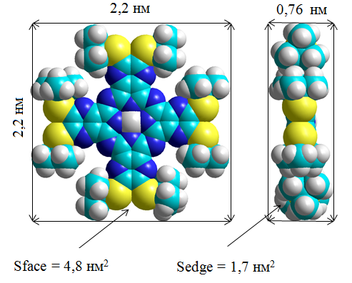
Figure 1. Model of the octatetrabutyl-sulfonyl tetrapyrazinporphyrazine zinc molecule (ZnSPz).
Geometric characteristics of the molecule: projection areas A_{proj}(face)=3.2 nm² and A_{proj}(edge)=1.1 nm², areas of circumscribed rectangles 4.8 nm² and 1.7 nm² (Fig. 1, S_{face} and S_{edge}, respectively) and areas in the densely packed monolayer, S_{pack} face=4.5 nm² (a=2.3 nm; b=2.1 nm; α=68°) and S_{pack} edge=1.6 nm² (a=2.2 nm; b=0.72 nm; α=90°).
Results
The quantitative analysis of the compression isotherms plotted in the π-A and πA-π axes (Fig. 2) shows that in the studied range of ISDCs (the initial degree of water surface coverage, defined as c_{face}/c_{edge}) from 10/3.4 to 139/49% three types of stable monolayers are formed: face-on, edge-on1 and edge-on2. The main characteristics of floating ZnSPPz layers are presented in Table 1.
At small ISDC values (c_{face} up to 15%), face-on type monolayers (molecules in them are oriented along the water surface) with condensed nanostructures (NS) are formed. These monolayers are characterized by a large aggregation number (n=27) and low water content both in and between the NSs: 38% of A_{mol} and 0.7 nm² per ZnSPPz molecule, respectively (c_{face}=15%). At higher ISCD values, edge-on monolayers of two different types are formed: the edge-on1 type for c_{face} from 20 to 44%, and the edge-on2 type for c_{face} from 33 to 139%. The latter type is characterized by a constant area per molecule (A_{mol} = 2.2 nm²).
In stable edge-on1 monolayers the plane of the molecule is at an angle to the water surface. The minimum tilt angle (ψ_{min}) of ZnSPPz molecules in the stacks varies from 14° to 29°, the number of molecules in the M_{edge} nanostructures from 32 to 123, the water content between them from 0.55 to 0.12 nm², and the layer compressibility from 31 to 100 m/N.
a) | b)
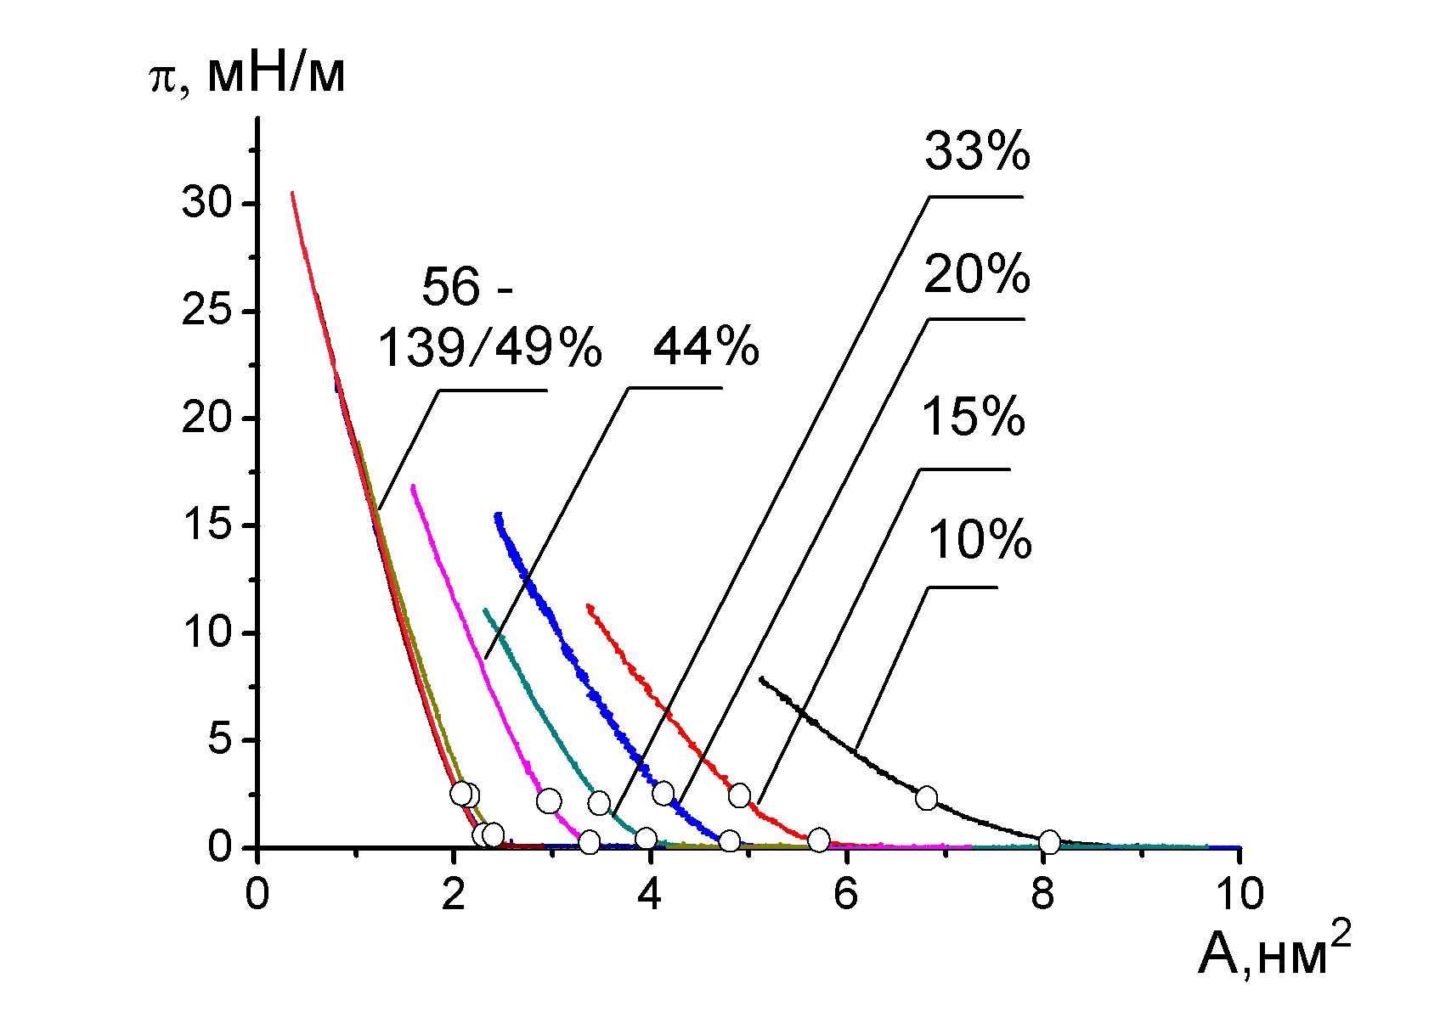 | 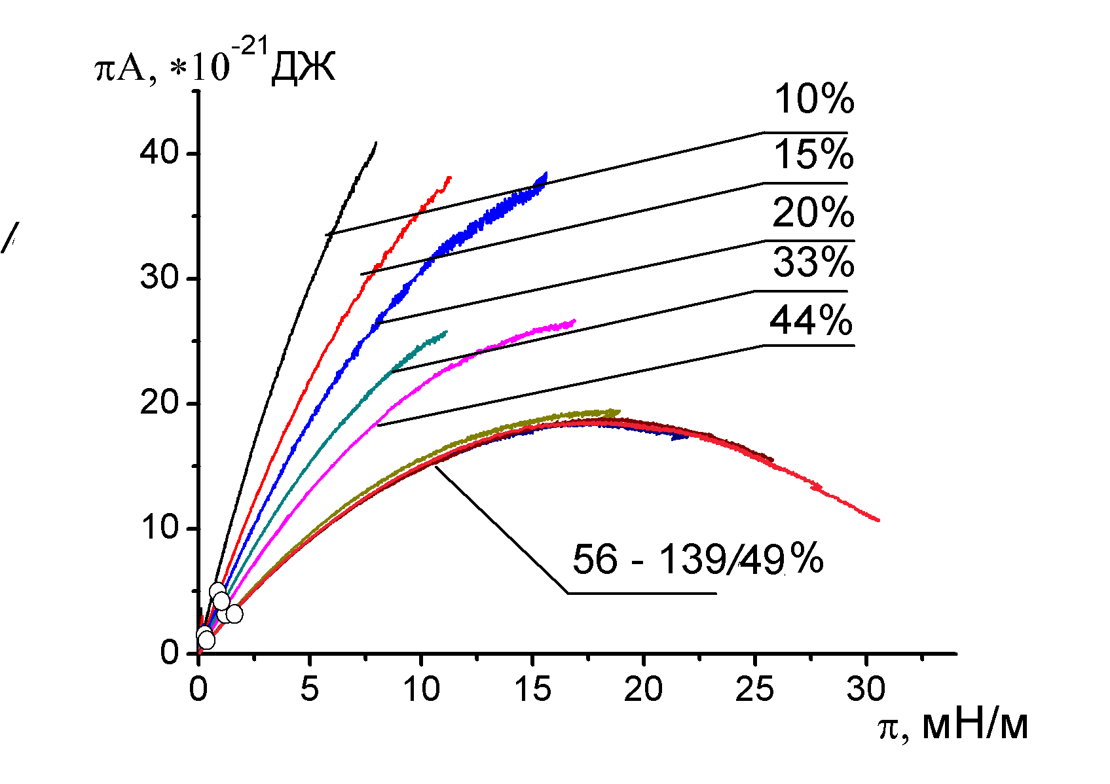

Figure 2. Surface pressure - area isotherms of ZnSPPz in π-A (a) and πA-π (b) axes for different values of the initial degree of water surface coverage: 10/3.4; 15/5; 20/7; 33/11; 44/15; 56/19; 77/26; 110/38; and 139/49% (С=1.7⋅10⁻⁴ mol/L). The dots show the boundaries of the stable states of the layer.
Table 1. Characteristics of ZnSPPz floating layers obtained at different initial degrees of surface coverage.
ISCD (c_{face/Cedge}), % | Type of the nanostructures | (c_{i-face}-c_{f-face}),  %  [c_{i-NS}] | π_{i}-π_{f,},  mN m⁻¹ | A_{mol.} nm² | n | D_{NS}  (S_{NS}),nm(nm²) | ψ_{min,}° | w_{in-M} /  A_{mol},% | w_{inter-M},  nm² | r, nm | d_{i}, nm | B,  m N⁻¹
10/3,4 | Mono face | 38-45  [86] | 0.17-  1.52 | 7.3 | 16 | 12 (114) | 0 | 56 | 1.2 | 1.0 | 0.9 | 99
15/5 | Mono face | 54-62  [88] | 0.19-  1.52 | 5.2 | 27 | 13 (140) | 0 | 38 | 0.7 | 0.55 | 0.9 | 87
20/7 | Mono сухие face | 65-74  [89] | 0.19-  1.84 | 4.3 | 32 | 13 (139) | 0 | 0 | 0.55 | - | 0.8 | 72
33/11 | Mono edge1 | 76-88  [87] | 0.19-  1.56 | 3.6 | 37 | 13  (137) | 17 | 70* | 0.5 | - | 0.93 | 100
44/15 | Mono edge1 | 93-107  [89] | 0.18-  1.84 | 3.0 | 42 | 13  (128) | 21 | 64* | 0.4 | - | 0.77 | 75
56/19 | Mono edge2 | 128-147  [89] | 0.17-  2.2 | 2.2 | 49 | 14  (85) | 29 | 50* | 0.27 | - | 0.6 | 63
77/26 | Mono edge2 | 130-146  [90] | 0.17-  1.4 | 2.2 | 76 | 15  (168) | 29 | 50* | 0.25 | - | 0.8 | 87
110/38 | Mono edge2 | 136-146  [93] | 0.19-  1.35 | 2.2 | 106 | 17  (232) | 29 | 50* | 0.17 | - | 0.65 | 62
139/49 | Mono edge2 | 139-146  [95] | 0.19-  1,73 | 2.2 | 123 | 18 (267) | 29 | 50* | 0.12 | - | 0.5 | 31

ISCD: initial surface coverage degree presented as c_{face} (c_{edge});
π: surface pressure;
π_{i} - π_{f}: the pressure region where the stable state exists, and the span of the region;
A_{mol}: surface area per molecule in a NS;
n: aggregation number (the number of molecules in an NS);
c_{i(face)}и c_{f(face)} surface coverage degree at the initial and final points of the stable state respectively;
c_{i-NS}: SCD by M-nanostructures at the initial point of the stable state;
D_{NS} and S_{NS}: diameter and surface area of a NS;
ψ_{min}: the lowest tilt angle of molecules in stacks (“dry” NS);
w_{in-M}/A_{mol}: water content per molecule in M-nanostructure at the initial point of the stable state;
w_{inter-M-i}: water content per molecule between M-nanostructures at the initial point of the stable state;
r: the average distance between molecules in the NS;
d_{i}: the distance between NSs at initial points of the stable state;
B: compressibility of the layer.
*The amount of water in the aggregates was calculated for vertical arrangement of the molecules in the stacks.

The obtained results allow us to plot the dependences of the main characteristics of the layer on the ISCD and to present a model of the ZnSPPz monolayer formed from a solution in toluene with face-on and edge-on NS.
a) | b)
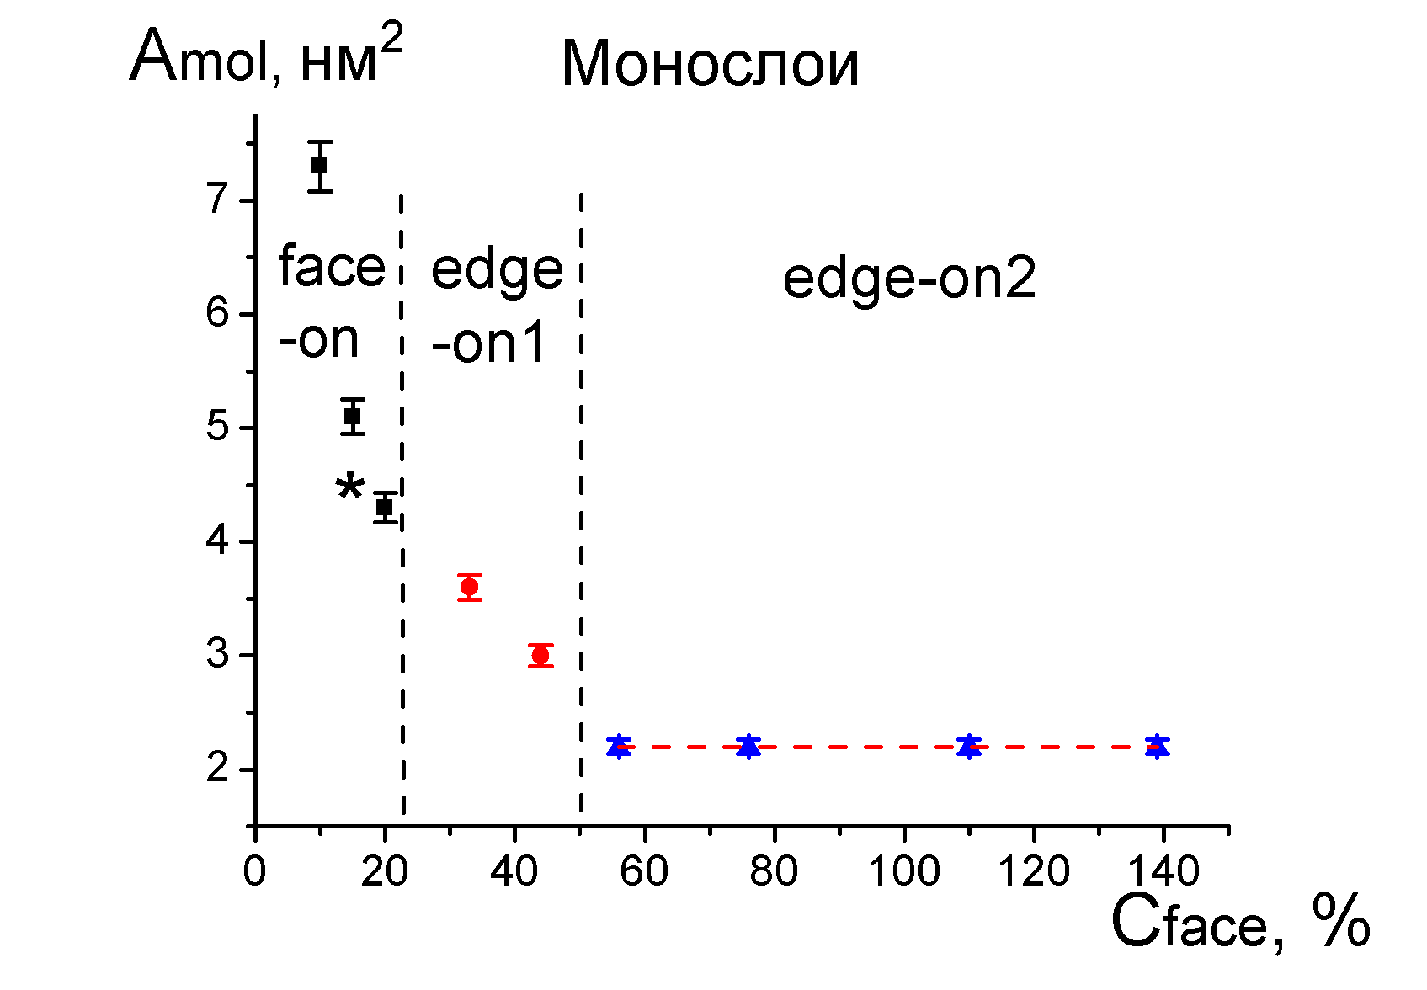 | 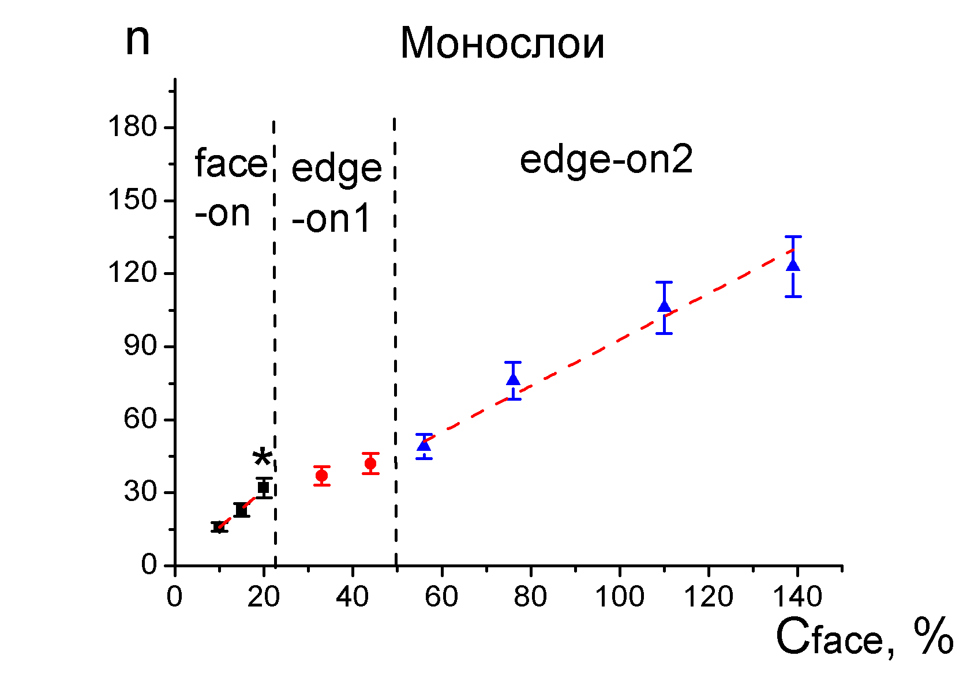
c) | d)
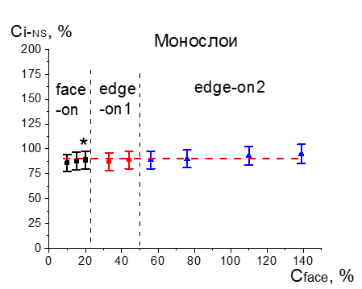 | 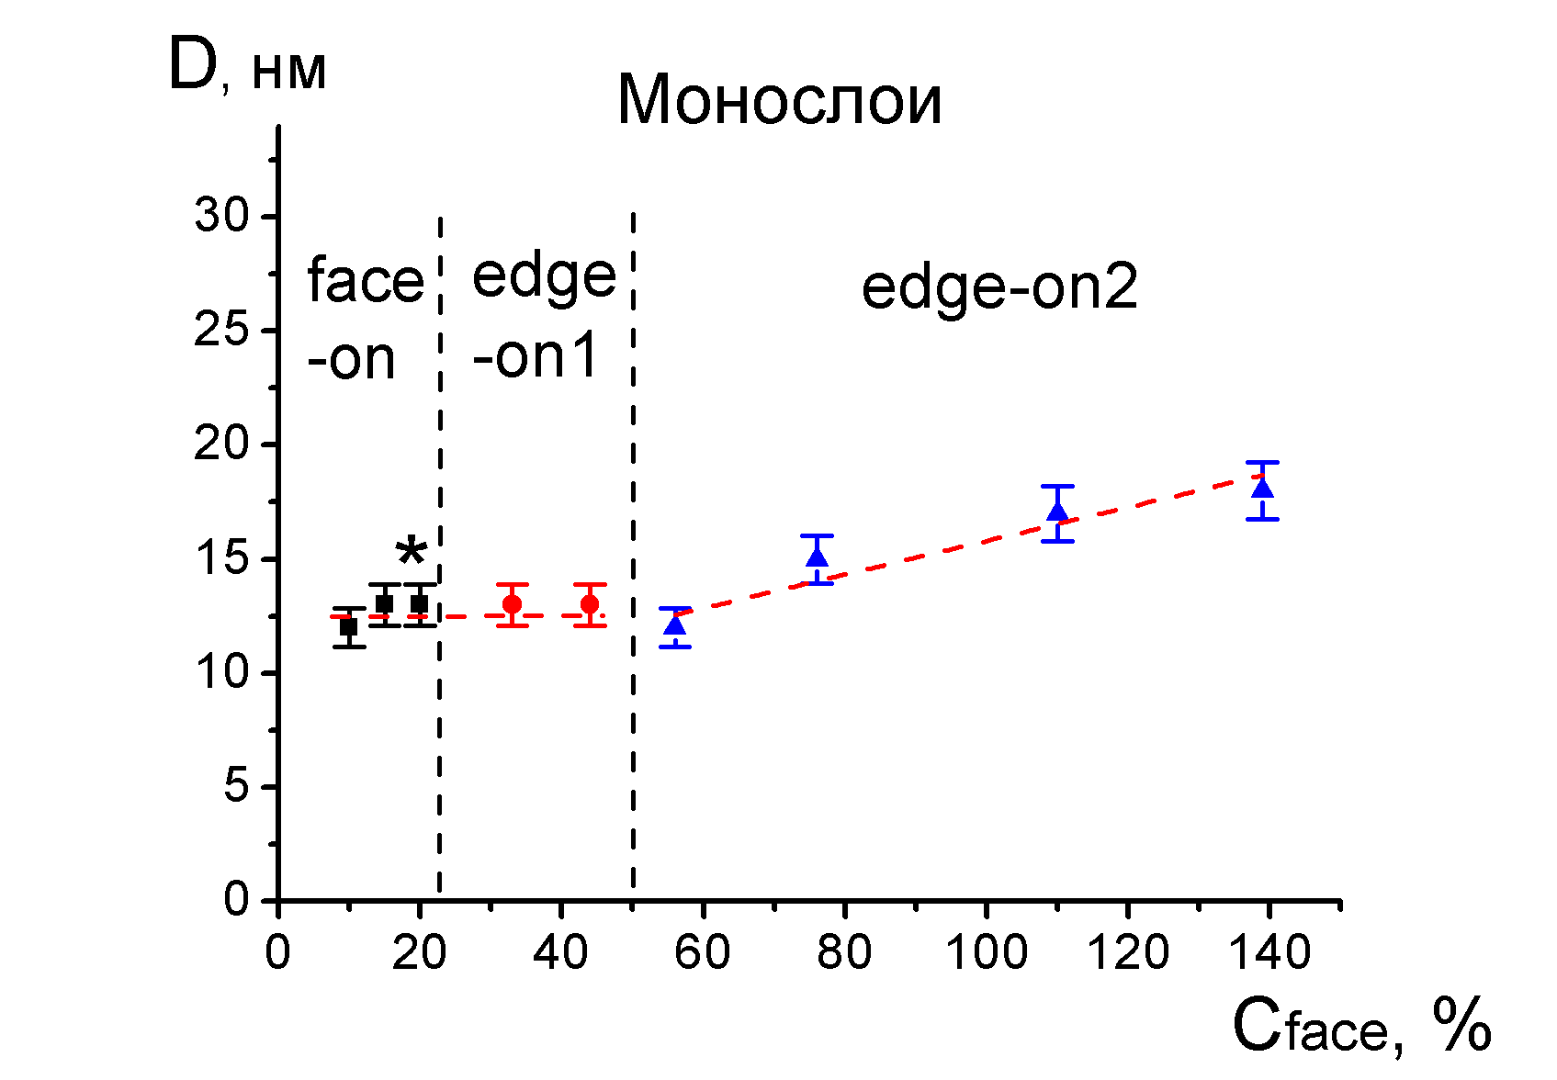

Figure 3. Dependences on the ISCD for: (a) area per molecule in ZnSPPz M-nanostructures; (b) number of molecules in NS, n; (c) degree of nanostructure coverage at the initial point of the stable monolayer, C_{i-NS} and (d) diameter of nanostructures, D_{NS}.
Analysis of the dependences of the area per molecule in the nanostructures, the aggregation number, the initial degree of surface coverage of NSs and others (Fig. 3) give the following relationships for face-on monolayers: n = 0.45+1.5×c_{face} (1), D_{NS} const=12.5 (nm) (2), с_{i-NS} const =89% (3), W_{in-M}/A_{mol}=(73.7–2.1×c_{face} ), % (4). For edge-on monolayers of 2nd type the relationships are as follows: A_{mol} const= 2.2 (nm²) (5), n = 0.95×c_{face} – 2 (6), D_{aggr} = 8.4 – 0.07×c_{face} (nm) (7), W_{in-M}/A_{mol} = const = 50 (%) (8), с_{i-NS} = const = 89% (9). These equations together with the basic equation of state of the layer π(A-A_{mol})=kT/n constitute the model of ZnSPPz monolayer.
In face-on monolayers, the size of the formed nanostructures does not change with increasing ISCD. Their density increases, but so does the number of molecules in them (Fig. 3 b, d). At c_{face}=20%, "dry" face-on nanostructures are formed, indicating that this ISCD value is near the border of the areas between face-on and edge-on NSs. The value of the boundary between these areas, taking into account the error in с_{face} (3%), is 19.4%. This makes it possible to calculate constants that characterize such monolayers and do not depend on the conditions of their formation: the maximum values of the aggregation number and the percentage of water in NS are n_{max}=32 and (w_{in-M}/A_{mol})_{max}=32%.
A characteristic feature of type 2 edge-on nanostructures is a constant value of A_{mol}=2.2 nm². In other words, the density of the formed NS does not change when the initial degree of surface coverage increases throughout the ISCD range. At the same time, the number of molecules in them grows (Fig. 3 a, b). Note that for this compound, the diameter of the face-on and edge-on1 nanostructures formed on the water surface does not depend on ISCD (D_{NS} = const = 12.5 nm). The degree of surface coverage by nanostructures at the beginning of the stable monolayer zone (monolayer density) is the same for all types of monolayers (с_{i-NS}=89%).
Figure 4 shows the regions of stable face-on and edge-on M-monolayers formation.Schematics illustrating fragments and main characteristics of the monolayer of "dry" face-on (c_{face}=20%) and edge-on2 (c_{face}=77%) nanostructures are shown in figure 5.

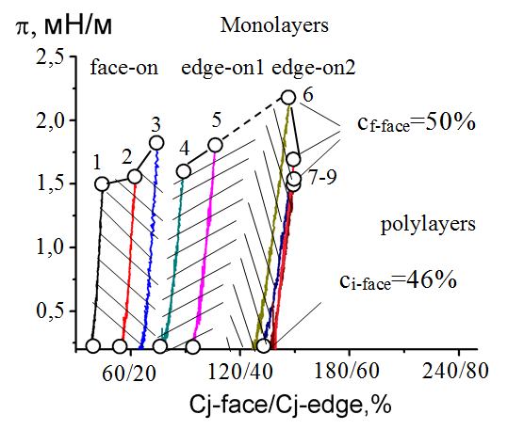
Figure 4: State diagram of stable floating M-monolayers of ZnSPPz. The areas where monolayers of different types are formed are shown by different hatching. The values of ISCD for isotherms 1-9: 10/3.4; 15/5; 20/7; 33/11; 44/15; 56/19; 77/26; 110/38; 139/49%, С=1.7⋅10⁻⁴ mol/L.
a) | b)
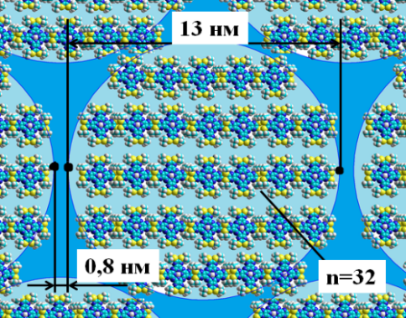 | 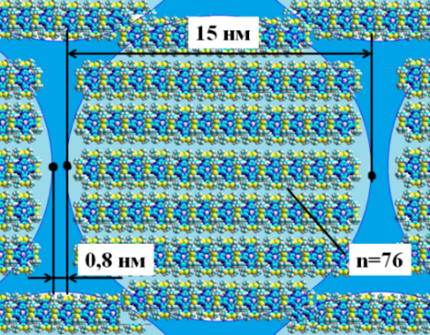
Figure 5. Schematics of the structure model and the main structural characteristics of (a) "dry" face-on (c_{face}=20%) and (b) edge-on2 (c_{face}=77%) ZnSPPz monolayers.
What determines such stability of ZnSPPz nanostructures formed in monolayers and why is the monolayer itself stable up to a very high initial degree of surface coverage and does not form 3D nanostructures (multilayers) even at c_{face}=139%? To answer this question, ZnSPPz thin films on solid substrates were prepared from nanostructures formed at the water-air interface. At a surface pressure close to the end of the monolayer existence boundary defined as above, the barriers were stopped and the Langmuir-Schaefer method was used to sequentially transfer the layers to the substrate(fused silica). Slowly lowering the substrate, it was brought into contact with the surface of the layer, and then slowly raised. This operation was repeated as many times as the number of layers needed to be transferred. The conditions under which the films were formed are shown in Table 2 and Fig. 6.
Table 2.* Characteristics of floating ZnSPPz layers obtained at different values of initial degree of surface coverage.
c_{face/Cedge,} % | State of the layer | c_{i-face}-c_{f-face}  (c_{i-edge}-  c_{f-edge}),%  ((Δc_{j-face}))  [c_{i-NS}] | π_{i}-π_{f,},  (Δπ),  mN m⁻¹ | A_{mol.} nm² | n | D_{NS}  (S_{NS}),nm(nm²) | ψ_{min,}° | w_{in-M} /  A_{mol},% | w_{inter-M},  nm² | r, nm | d_{i}, nm | B,  m N⁻¹
10/3,4 | Mono face | 38-45  (13-15)  ((7))  [86] | 0,17-  1.52  (1.35) | 7,3 | 16 | 12 (114) | 0 | 56 | 1,2 | 1,0 | 0,9 | 99
56/19,2 | Mono edge2 | 128-147  (44-51)  ((19))  [89] | 0,17-  2.2  (2.03) | 2.2 | 49 | 14  (85) | 29 | 50* | 0,27 | - | 0,6 | 63
*see the comment to Table 1.
a) | b)
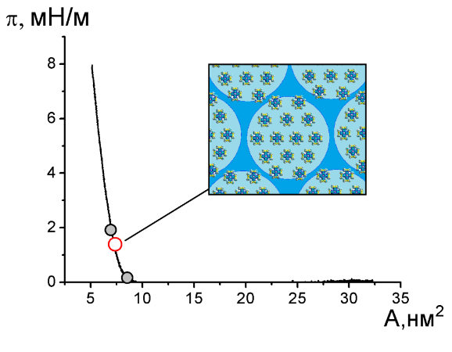 | 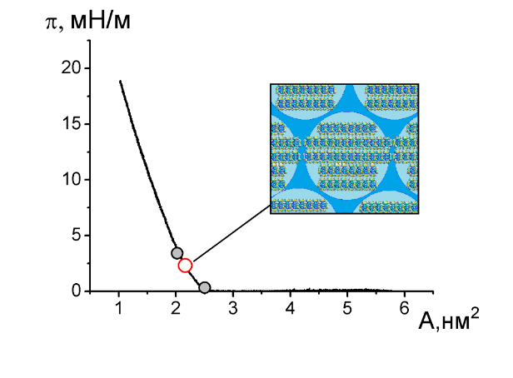
Figure 6. π-A isotherms of ZnSPPz, c_{face}=10% (a) and 56% (b). The white dots show the surface pressure at which the transfer was performed. The gray dots mark the zone of stable state of the layer. The insets show a schematic of the fragments of the monolayer being transferred.
The absorption spectra of LS films of ZnSPPz obtained from floating monolayers of face-on (c_{face}=10%) and edge-on (c_{face}=56%) types are shown in figure 7.
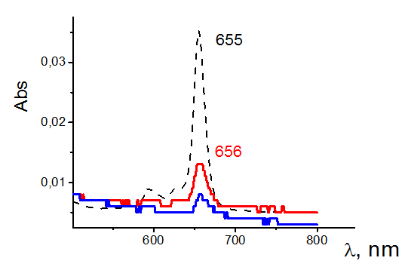
Figure 7. Absorption spectra of the solution of ZnSPPz (black line); of 33-layer LS films prepared from face-on monolayers (blue line); of 22-layer LS films prepared from edge-on monolayers (red line).
As can be seen from Figure 7, the position of the Q band in the spectra obtained by transferring face-on and edge-on ZnSPPz monolayers onto quartz substrates is similar to its position in the solution spectrum (λ=655 nm and 656 nm, respectively). The reason is very weak intermolecular interactions. Note that this is the first porphyrin-type compound, out of the huge number of different compounds we have previously studied, that behaves in this way. Even standard van der Waals intermolecular interactions batochromatically shift the main spectral bands of films of such compounds by 3-4 nm. ZnSPPz studied in this work in a film on a solid support actually forms a `solid solution`. It can be assumed that other properties of such films will be similar to those of the compound in solution, which may be an advantage over films in which uncontrolled aggregation is observed, leading, as a consequence, to the loss of the functional properties of the compound. This behavior of the porphyrazine under study is also of interest from the point of view of forming composite materials with it, where the contact of the components at the molecular level should be ensured.
Conclusion
Nanostructured floating monolayers of zinc octatretbutyl-sulfonyl tetrapyrazinporphyrazine (ZnSPPz) were obtained. It was found that this compound is characterized by the formation of two types of monolayers: face-on and edge-on. Quantitative characteristics of their structure and properties were determined: size of nanostructures formed in the layer, number of molecules in the nanostructures, distances between the molecules, water content in the nanostructures and between them, compressibility, interval of existence by pressure and by the current degree of surface coverage. The boundaries of the existence of M monolayers of different types were determined. Quantitative dependences of the main parameters of face-on and edge-on monolayers on the initial degree of surface coverage were established. The model, state diagram, and monolayer diagrams were plotted.
The formed monolayers are very stable. The diameter of the face-on and edge-on1 nanostructures formed on the water surface does not depend on the formation conditions (D_{NS} = const = 12 nm). The monolayer density at the beginning of the stable state is the same for all types of monolayers (с_{i-NS} = 89%).
ZnSPPz films were obtained and studied by UV-Vis spectroscopy. It was shown that the films of zinc octatetrabutyl-sulfonyl tetrapyrazinporphyrazine are a `solid solution`.
The results are of interest for the design and development of chemical sensors and photoactive thin-film nanomaterials.

Acknowledgements
The work was supported by the Russian Science Foundation Grant No. 20-12-00175, IGCTU (research) and the Ministry of Science and Higher Education of the Russian Federation No. FZZW-2020-0008 (synthesis of the compound).

References: see at http://mhc-isuct.ru/article/view/4808/2800

