Supporting Information for

First Macrocyclic 1,2,3-Triazolyl Uridine Analogues

DOI: 10.6060/mhc224868a

Olga V. Andreeva,@ Mayya G. Belenok, Bulat F. Garifullin, Irina Yu. Strobykina, Liliya F. Saifina, Vyacheslav E. Semenov, Vladimir E. Kataev

*Arbuzov Institute of Organic and Physical Chemistry, FRC Kazan Scientific Center, Russian Academy of Science, Kazan, 420088, Russian Federation*

*@Corresponding author E-mail:* [*ovandreeva76@mail.ru*](mailto:ovandreeva76@mail.ru)

**NMR spectra of compounds 10, 11, 12, 13, 14.**

Azido 5-mesyloxy-2,3-O-isopropylidene-β- D-ribofuranoside (10)………………………….. 2

1,3-Bis{1-(5-mesyloxy-2,3-O-isopropylidene-β- D-ribofuranosyl)-1H-1,2,3-triazol-4-yl]methyl}pyrimidine-2,4-dion (11)……………………………………………………….….. 4

1,3-Bis{1-(5-azido-5-deoxy-2,3-O-isopropylidene-β-D-ribofuranosyl)-1H-1,2,3-triazol-4-yl]methyl}pyrimidine-2,4-dion (12)…………………………………………………………... 6

42,43,112,113-di-O-isopropylideno-1(3,1)-uracila-3(4,1),5(1,4),10(4,1),12(1,4)-tetratriazola-4(1,5),11(5,1)-di-β-D-ribofuranosacyclotriskaidecaphan (13)………………………………... 8

42,43,112,113,172,173,242,243-tetra-O-isopropylideno-1(3,1),14(3,1)-diuracila-3(4,1),5(1,4), 10(1,4),12(1,4),16(4,1),18(1,4),23(4,1)-octatriazola-4(1,5),11(5,1),17(1,5),24(5,1)-tetra-β-D-ribofuranosacyclotetracosahexaphan (14)………………………………………………………11

**Azido 5-mesyloxy-2,3-O-isopropylidene-β- D-ribofuranoside** (**10**)

**1H NMR (CDCl3, 500 MHz) *δ* ppm**



**13C NMR (100 MHz, CDCl3) *δ* (ppm)**



**1,3-Bis{1-(5-mesyloxy-2,3-O-isopropylidene-β- D-ribofuranosyl)-1H-1,2,3-triazol-4-yl]methyl}pyrimidine-2,4-dion** (**11**)

**1H NMR (CDCl3, 500 MHz) *δ* ppm**



**13C NMR (100 MHz, CDCl3) *δ* (ppm)**



**1,3-Bis{1-(5-azido-5-deoxy-2,3-O-isopropylidene-β-D-ribofuranosyl)-1H-1,2,3-triazol-4-yl]methyl}pyrimidine-2,4-dion** (**12**)

**1H NMR (CDCl3, 600 MHz) *δ* ppm**



**13C NMR (100 MHz, CDCl3) *δ* (ppm)**



**42,43,112,113-di-O-isopropylideno-1(3,1)-uracila-3(4,1),5(1,4),10(4,1),12(1,4)-tetratriazola-4(1,5),11(5,1)-di-β-D-ribofuranosacyclotriskaidecaphan** (**13**).

**1H NMR (CDCl3, 600 MHz) *δ* ppm**



**13C NMR (100 MHz, CDCl3) *δ* (ppm)**



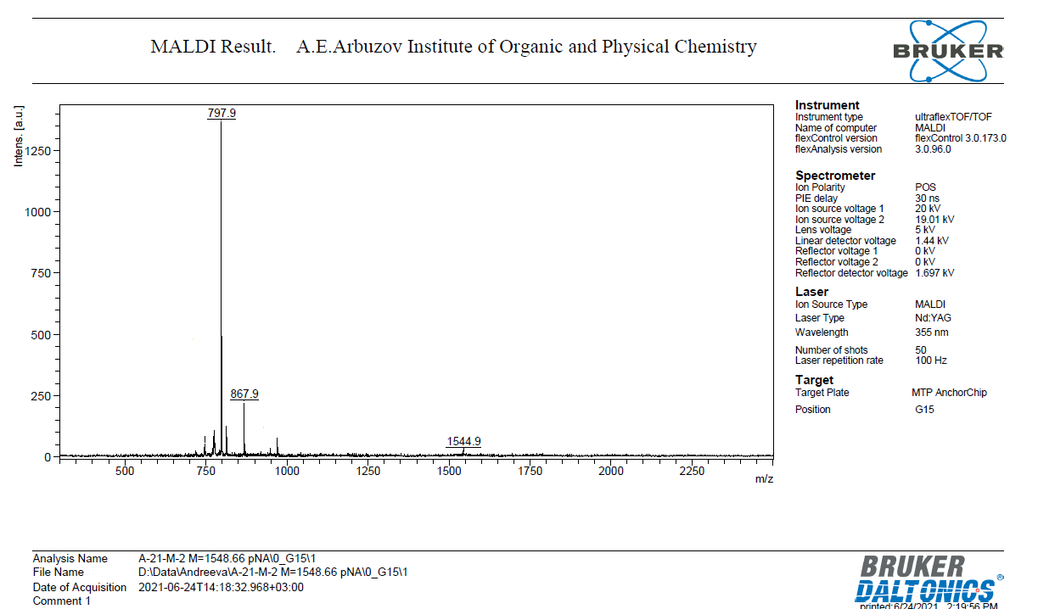

**42,43,112,113,172,173,242,243-tetra-O-isopropylideno-1(3,1),14(3,1)-diuracila-3(4,1),5(1,4),10(1,4),12(1,4),16(4,1),18(1,4),23(4,1)-octatriazola-4(1,5),11(5,1),17(1,5),24(5,1)-tetra-β-D-ribofuranosacyclotetracosahexaphan** (**14**)

**1H NMR (CDCl3, 500 MHz) *δ* ppm**



**13C NMR (100 MHz, CDCl3) *δ* (ppm)**



**13C NMR (100 MHz, CDCl3) *δ* (ppm)**



