**Supplementary Materials**

**Gas-Phase Structure of 4-(4-hydroxyphenylazo)phthalonitrile - Precursor for Synthesis of Phthalocyanines with Macrocyclic and Azo Chromophores (DOI: 10.6060/mhc245112p)**

Alexander E. Pogonin@, Ivan Yu. Kurochkin, Alexander V. Krasnov, Alyona S. Malyasova, Kuzmin Ilya A., Tatyana V. Tikhomirova and Georgiy V. Girichev

*Ivanovo State University of Chemistry and Technology, Ivanovo, 153000, Russian Federation*

@*Corresponding author E-mail: pogonin@isuct.ru*

[Table S1. Conditions of GED experiments for ***p-HPhAPN***. 2](#_Toc165197500)

[Table S2. The most intensive ions in the mass spectrum of ***p-HPhAPN*** were recorded by APDM-1 during the combined GED/MS experiment. 2](#_Toc165197501)

[Figure S1. Comparison of theoretical radial distribution functions f(r) of different structures of ***p-HPhAPN***. 3](#_Toc165197502)

[Table S3. Z-matrix used for model ***c*** in the GED refinement. 4](#_Toc165197503)

[Table S4. Z-matrix used for model ***a*** in the GED refinement. 5](#_Toc165197504)

[Table S5. Z-matrix used for model ***e*** in the GED refinement. 6](#_Toc165197505)

[Table S6. Z-matrix was used for model ***f*** in the GED refinement. 7](#_Toc165197506)

[Table S7. Nucleus-independent chemical shifts (NICS)a indexes for ***E-AB*** and ***p-HPhAPN*** 8](#_Toc165197507)

[Table S8. Electron delocalization indexes (DI) calculated by QTAIM for several structures of ***p-HPhAPN***. 8](#_Toc165197508)

[Figure S2. Calculated (GFN2-xTB) EI-MS (below, inverted intensities) of E-AB in comparison with the experimental EI-MS [75] (above). 9](#_Toc165197509)

[Figure S3. Comparison of calculated (GFN2-xTB) EI-MS of E-AB (above) and Z-AB (below, inverted intensities). 9](#_Toc165197510)

[Figure S4. Comparison of calculated (GFN2-xTB) EI-MS of p-HPhAPN isomers ***a*** (above) and ***za***(below, inverted intensities). 10](#_Toc165197511)

[Figure S5. Comparison of calculated (GFN2-xTB) EI-MS of ***p-HPhAPN*** isomers ***a*** (above) and ***e***(below, inverted intensities). 10](#_Toc165197512)

[Figure S6. Temperature dependence of conformational/isomeric composition of p-HPhAPN. 11](#_Toc165197513)

[Figure S7. Experimental (cycles) and theoretical (red solid lines) radial distribution curve for models ***c*** and ***a*** of p-HPhAPN and the difference curve Δf(r) (blue solid line). 12](#_Toc165197514)

[Figure S8. Experimental (cycles) and theoretical (red solid lines) radial distribution curve for models ***f*** and ***e*** of p-HPhAPN and the difference curve Δf(r) (blue solid line). 13](#_Toc165197515)

[Table S9. Semi-experimental parameters of ***p-HPhAPN*** (azo forms ***a*** and ***c***). 14](#_Toc165197516)

[Table S10. Relative energiesa of different isomers of ***Zn-tHPhDaPc*** obtained using different forms (***a***, ***c***, ***e***, ***f***) of ***p-HPhAPN***. 17](#_Toc165197517)

[Table S11. Internuclear distances (Å)a of zinc complex ***Zn-tHPhDaPc*** obtained using ***a*** and ***c*** forms of ***p-HPhAPN*** and corresponding Internuclear distances of ***p-HPhAPN*** (models ***a*** and ***c***). 17](#_Toc165197518)

[Table S12. Nucleus-independent chemical shifts (NICS)a indexes for Zinc phtalocyanine (ZnPc) and ***Zn-tHPhDaPc*** . 18](#_Toc165197519)

Table S1. Conditions of GED experiments for ***p-HPhAPN***.

|  |  |  |
| --- | --- | --- |
| L, mm | 338 | 598 |
| N | 4 | 4 |
| I, μA | 1.73 | 1.00 |
| λ, Å | 0.04272(4) | 0.04158(4) |
| T, K | 464(5) | 463(5) |
| t, s | 68 | 60 |
| pcol , Torr | 2·10–6 | 2.1·10-6 |
| pMS, Torr | 6.0·10–7 | 6.0·10–7 |
| smin-smax(∆*s*), Å-1 | 2.3-27.6 (0.1) | 1.3-16.2 (0.1) |
| Uion, V | 50 | 50 |

L - distance from nozzle to plate; N - number of recorded films; I - primary electron beam current; λ - electron wavelength; T - effusion cell temperature; t - exposure time; pcol - residual gas pressure in diffraction chamber, pMS - residual gas pressure in mass spectrometry unit; smin-smax (∆s), range and step (in brackets) of scattering angles; Uion - ionization voltage.

Table S2. The most intensive ions in the mass spectrum of ***p-HPhAPN*** were recorded by APDM-1 during the combined GED/MS experiment.

|  |  |  |
| --- | --- | --- |
| m/z | Relative intensity, % | |
|  | Experiment with L=338 mm | Experiment with L=598 mm |
| 248 | 25 | 24 |
| 127 | 12 | 11 |
| 121 | 38 | 37 |
| 100 | 8 | 6 |
| 93 | 100 | 100 |
| 65 | 53 | 52 |
| 52 | 9 | 9 |

X:\Pogonin\OBJECTS\Alena\Graph1-pcseg-2-Article.tif

Figure S1. Comparison of theoretical radial distribution functions f(r) of different structures of ***p-HPhAPN***.

Differences functions ∆f(r) were calculated concerning model ***a***. Differences between the models (a possible path of transition from structure to structure) are presented to the right of the picture: “H” - different arrangement of hydrogen atoms of the hydroxyl group (rotation of the hydroxyl group around the CO bond or rotation of the –Ph-OH group around the N’1-C’2 bond); “- CN” – cisoid/transoid arrangement of nitrile groups concerning the azo/hydrazone group (rotation of the–Ph-2CN moiety around the N1-C2 bond); “tautomerism” – enol and keto forms; “-NH” – the presence of a bond between a H and N1/N’1 atoms; “E-→Z- isomerism” – trans- and cis- isomers.

Vibrational amplitudes and vibrational corrections (rh1-ra) to nuclear distances were calculated on the base of force field obtained from QC calculations using VibModule program for the temperature T = 450 K. Calculations of the model radial distributions curves f(r) were performed in the UNEX programming environment. The difference curves Δf(r) were calculated relative to the curve corresponding to structure ***a*** (Figure 3): Δf(r) = fj(r)–fa(r)). The deviation of the j-th curve from the reference curve was characterized by disagreement factor (Rf,j) between the theoretical molecular scattering intensities corresponding to different models:

$R_{f,j}=\sqrt{\frac{\sum_{i=1}^{N}{{{(sM(s_{i})}_{a}-k_{M}{sM\left(s_{i}\right)}_{model j})}^{2}}}{\sum_{i=1}^{N}{{{(sM\left(s_{i}\right)}_{model j})}^{2}}}}∙100\%$

where sM(si)a is theoretical molecular scattering intensities for structure ***a***; sM(si)model j – theoretical molecular scattering intensities for the corresponding model (Figure 3); *kM* – is the scale.

Table S3. Z-matrix used for model ***c*** in the GED refinement.

|  |  |  |
| --- | --- | --- |
| Body of Z-matrix | | |
| 1 N  2 N 1 NN  3 C 1 RN1 2 AN1  4 C 2 RN1\_ 1 AN1\_ 3 T  5 C 3 RCC1 1 AC1 2 T1  6 C 4 RCC1\_ 2 AC1\_ 1 T1\_  7 C 5 RCC2 3 AC2 1 T2  8 C 6 RCC2\_ 4 AC2\_ 2 T2\_  9 C 7 RCC3 5 AC3 3 TPh1  10 C 8 RCC3\_ 6 AC3\_ 4 TPh1\_  11 C 9 RCC4 7 AC4 5 TPh2  12 C 10 RCC4\_ 8 AC4\_ 6 TPh2\_  13 C 3 RCC5 11 RCC6 5 TPh3 4  14 C 4 RCC5\_ 12 RCC6\_ 6 TPh3\_ 4  15 C 7 R\_CCN1 9 A\_CCN1 5 T\_CCN1  16 C 9 R\_CCN2 7 A\_CCN2 11 T\_CCN2  17 N 15 RNC1 7 A\_NC1 9 T\_NC1  18 N 16 RNC2 9 A\_NC2 11 T\_NC2  19 O 10 RCO 8 ACO 12 TCO  20 H 5 RCH1 3 ACH1 7 TH1  21 H 6 RCH1\_ 4 ACH1\_ 8 TH1\_  22 H 8 RCH2\_ 6 ACH2\_ 10 TH2  23 H 11 RCH3 9 ACH3 13 TH3  24 H 12 RCH3\_ 10 ACH3\_ 14 TH3\_  25 H 13 RCH4 3 ACH4 11 TH4  26 H 14 RCH4\_ 4 ACH4\_ 12 TH4\_  27 H 19 ROH 10 AOH 12 TOH | | |
| Variables Values | | Atom numbering |
| NN 1.252 1  RN1 1.414 2  RN1\_ 1.400 3  RCC1 1.393 4  RCC1\_ 1.406 5  RCC2 1.393 6  RCC2\_ 1.377 7  RCC3 1.409 8  RCC3\_ 1.401 9  RCC4 1.400 10  RCC4\_ 1.395 11  RCC5 1.401 12  RCC6 1.380 14  RCC5\_ 1.397 13  RCC6\_ 1.384 15  R\_CCN1 1.429 16  R\_CCN2 1.426 17  RNC1 1.151 18  RNC2 1.152 19  RCO 1.356 20  RCH1 1.080 22  RCH1\_ 1.079 23  RCH2\_ 1.081 25  RCH3 1.080 26  RCH3\_ 1.083 27  RCH4 1.079 28  RCH4\_ 1.081 29  ROH 0.962 21  AN1 114.8 30  AN1\_ 116.3 31  AC1 115.4 32  AC1\_ 124.9 33  AC2 120.6 34  AC2\_ 120.2 34  AC3 119.6 34  AC3\_ 120.0 34  AC4 119.3 34  AC4\_ 120.3 34 | A\_CCN1 121.0 40  A\_CCN2 121.2 41  A\_NC1 178.8 42  A\_NC2 178.6 43  ACO 116.9 35  ACH1 119.0 46  ACH1\_ 119.2 47  ACH2\_ 121.4 49  ACH3 118.9 50  ACH3\_ 120.1 51  ACH4 119.2 52  ACH4\_ 118.5 53  AOH 110.6 45  T 180.0 54  T1 180.0 55  T1\_ 0.0 56  T2 180.0 57  T2\_ 180.0 58  TPh1 0.0 59  TPh1\_ 0.0 60  TPh2 0.0 61  TPh2\_ 0.0 62  TPh3 180.0 63  TPh3\_ 180.0 64  T\_CCN1 180.0 65  T\_CCN2 180.0 66  T\_NC1 180.0 67  T\_NC2 0.0 68  TCO 180.0 69  TH1 180.0 71  TH1\_ 180.0 72  TH2 180.0 73  TH3 180.0 75  TH3\_ 180.0 76  TH4 180.0 77  TH4\_ 180.0 78  TOH 0.0 70 |  |

Table S4. Z-matrix used for model ***a*** in the GED refinement.

|  |  |  |
| --- | --- | --- |
| Body of Z-matrix | | |
| 1 N  2 N 1 NN  3 C 1 RN1 2 AN1  4 C 2 RN1\_ 1 AN1\_ 3 T  5 C 3 RCC1 1 AC1 2 T1  6 C 4 RCC1\_ 2 AC1\_ 1 T1\_  7 C 5 RCC2 3 AC2 1 T2  8 C 6 RCC2\_ 4 AC2\_ 2 T2\_  9 C 7 RCC3 5 AC3 3 TPh1  10 C 8 RCC3\_ 6 AC3\_ 4 TPh1\_  11 C 9 RCC4 7 AC4 5 TPh2  12 C 10 RCC4\_ 8 AC4\_ 6 TPh2\_  13 C 3 RCC5 11 RCC6 5 TPh3 4  14 C 4 RCC5\_ 12 RCC6\_ 6 TPh3\_ 4  15 C 7 R\_CCN1 9 A\_CCN1 5 T\_CCN1  16 C 9 R\_CCN2 7 A\_CCN2 11 T\_CCN2  17 N 15 RNC1 7 A\_NC1 9 T\_NC1  18 N 16 RNC2 9 A\_NC2 11 T\_NC2  19 O 10 RCO 8 ACO 12 TCO  20 H 5 RCH1 3 ACH1 7 TH1  21 H 6 RCH1\_ 4 ACH1\_ 8 TH1\_  22 H 8 RCH2\_ 6 ACH2\_ 10 TH2  23 H 11 RCH3 9 ACH3 13 TH3  24 H 12 RCH3\_ 10 ACH3\_ 14 TH3\_  25 H 13 RCH4 3 ACH4 11 TH4  26 H 14 RCH4\_ 4 ACH4\_ 12 TH4\_  27 H 19 ROH 10 AOH 12 TOH | | |
| Variables Values | | Atom numbering |
| NN 1.252 1  RN1 1.414 2  RN1\_ 1.400 3  RCC1 1.398 4  RCC1\_ 1.406 5  RCC2 1.389 6  RCC2\_ 1.377 7  RCC3 1.413 8  RCC3\_ 1.401 9  RCC4 1.396 10  RCC4\_ 1.395 11  RCC5 1.396 12  RCC6 1.384 14  RCC5\_ 1.397 13  RCC6\_ 1.384 15  R\_CCN1 1.430 16  R\_CCN2 1.427 17  RNC1 1.151 18  RNC2 1.152 19  RCO 1.356 20  RCH1 1.079 22  RCH1\_ 1.079 23  RCH2\_ 1.081 25  RCH3 1.080 26  RCH3\_ 1.083 27  RCH4 1.081 28  RCH4\_ 1.081 29  ROH 0.962 21  AN1 114.8 30  AN1\_ 116.4 31  AC1 124.4 232  AC1\_ 125.0 33  AC2 120.1 34  AC2\_ 120.2 34  AC3 120.1 34  AC3\_ 120.0 34  AC4 119.2 34  AC4\_ 120.3 34 | A\_CCN1 120.7 40  A\_CCN2 121.1 41  A\_NC1 178.8 42  A\_NC2 178.7 43  ACO 116.9 35  ACH1 119.6 46  ACH1\_ 119.2 47  ACH2\_ 121.4 49  ACH3 119.2 50  ACH3\_ 120.1 51  ACH4 118.6 52  ACH4\_ 118.5 53  AOH 110.6 45  T 180.0 54  T1 0.0 255  T1\_ 0.0 56  T2 180.0 57  T2\_ 180.0 58  TPh1 0.0 59  TPh1\_ 0.0 60  TPh2 0.0 61  TPh2\_ 0.0 62  TPh3 180.0 63  TPh3\_ 180.0 64  T\_CCN1 180.0 65  T\_CCN2 180.0 66  T\_NC1 180.0 67  T\_NC2 0.0 68  TCO 180.0 69  TH1 180.0 71  TH1\_ 180.0 72  TH2 180.0 73  TH3 180.0 75  TH3\_ 180.0 76  TH4 180.0 77  TH4\_ 180.0 78  TOH 0.0 70 |  |

Table S5. Z-matrix used for model ***e*** in the GED refinement.

|  |  |  |
| --- | --- | --- |
| Body of Z-matrix | | |
| 1 N  2 N 1 NN  3 C 1 RN1 2 AN1  4 C 2 RN1\_ 1 AN1\_ 3 T  5 C 3 RCC1 1 AC1 2 T1  6 C 4 RCC1\_ 2 AC1\_ 1 T1\_  7 C 5 RCC2 3 AC2 1 T2  8 C 6 RCC2\_ 4 AC2\_ 2 T2\_  9 C 7 RCC3 5 AC3 3 TPh1  10 C 8 RCC3\_ 6 AC3\_ 4 TPh1\_  11 C 9 RCC4 7 AC4 5 TPh2  12 C 10 RCC4\_ 8 AC4\_ 6 TPh2\_  13 C 3 RCC5 11 RCC6 5 TPh3 4  14 C 4 RCC5\_ 12 RCC6\_ 6 TPh3\_ 4  15 C 7 R\_CCN1 9 A\_CCN1 5 T\_CCN1  16 C 9 R\_CCN2 7 A\_CCN2 11 T\_CCN2  17 N 15 RNC1 7 A\_NC1 9 T\_NC1  18 N 16 RNC2 9 A\_NC2 11 T\_NC2  19 O 10 RCO 8 ACO 12 TCO  20 H 5 RCH1 3 ACH1 7 TH1  21 H 6 RCH1\_ 4 ACH1\_ 8 TH1\_  22 H 8 RCH2\_ 6 ACH2\_ 10 TH2  23 H 11 RCH3 9 ACH3 13 TH3  24 H 12 RCH3\_ 10 ACH3\_ 14 TH3\_  25 H 13 RCH4 3 ACH4 11 TH4  26 H 14 RCH4\_ 4 ACH4\_ 12 TH4\_  27 H 1 RNH 2 ANH 4 TNH | | |
| Variables Values | | Atom numbering |
| NN 1.323 301  RN1 1.387 302  RN1\_ 1.307 303  RCC1 1.396 4  RCC1\_ 1.453 305  RCC2 1.390 6  RCC2\_ 1.343 307  RCC3 1.410 8  RCC3\_ 1.478 309  RCC4 1.398 10  RCC4\_ 1.468 311  RCC5 1.400 12  RCC6 1.380 14  RCC5\_ 1.450 313  RCC6\_ 1.344 315  R\_CCN1 1.430 16  R\_CCN2 1.425 17  RNC1 1.151 18  RNC2 1.152 19  RCO 1.224 320  RCH1 1.078 22  RCH1\_ 1.083 23  RCH2\_ 1.081 25  RCH3 1.080 26  RCH3\_ 1.081 27  RCH4 1.082 28  RCH4\_ 1.082 29  RNH 1.012 321  AN1 121.3 330  AN1\_ 121.3 331  AC1 121.5 332  AC1\_ 126.6 333  AC2 119.8 34  AC2\_ 120.7 34  AC3 120.7 34  AC3\_ 122.1 34  AC4 118.6 34  AC4\_ 116.1 34 | A\_CCN1 120.6 40  A\_CCN2 121.5 41  A\_NC1 178.9 42  A\_NC2 178.6 43  ACO 121.1 335  ACH1 119.9 46  ACH1\_ 120.5 347  ACH2\_ 121.9 49  ACH3 119.2 50  ACH3\_ 116.7 351  ACH4 120.1 352  ACH4\_ 116.4 353  ANH 121.3 345  T 180.0 54  T1 0.0 55  T1\_ 0.0 56  T2 180.0 57  T2\_ 180.0 58  TPh1 0.0 59  TPh1\_ 0.0 60  TPh2 0.0 61  TPh2\_ 0.0 62  TPh3 180.0 63  TPh3\_ 180.0 64  T\_CCN1 180.0 65  T\_CCN2 180.0 66  T\_NC1 180.0 67  T\_NC2 0.0 68  TCO 180.0 69  TH1 180.0 71  TH1\_ 180.0 72  TH2 180.0 73  TH3 180.0 75  TH3\_ 180.0 76  TH4 180.0 77  TH4\_ 180.0 78  TNH 0.0 70 |  |

Table S6. Z-matrix was used for model ***f*** in the GED refinement.

|  |  |  |
| --- | --- | --- |
| Body of Z-matrix | | |
| 1 N  2 N 1 NN  3 C 1 RN1 2 AN1  4 C 2 RN1\_ 1 AN1\_ 3 T  5 C 3 RCC1 1 AC1 2 T1  6 C 4 RCC1\_ 2 AC1\_ 1 T1\_  7 C 5 RCC2 3 AC2 1 T2  8 C 6 RCC2\_ 4 AC2\_ 2 T2\_  9 C 7 RCC3 5 AC3 3 TPh1  10 C 8 RCC3\_ 6 AC3\_ 4 TPh1\_  11 C 9 RCC4 7 AC4 5 TPh2  12 C 10 RCC4\_ 8 AC4\_ 6 TPh2\_  13 C 3 RCC5 11 RCC6 5 TPh3 4  14 C 4 RCC5\_ 12 RCC6\_ 6 TPh3\_ 4  15 C 7 R\_CCN1 9 A\_CCN1 5 T\_CCN1  16 C 9 R\_CCN2 7 A\_CCN2 11 T\_CCN2  17 N 15 RNC1 7 A\_NC1 9 T\_NC1  18 N 16 RNC2 9 A\_NC2 11 T\_NC2  19 O 10 RCO 8 ACO 12 TCO  20 H 5 RCH1 3 ACH1 7 TH1  21 H 6 RCH1\_ 4 ACH1\_ 8 TH1\_  22 H 8 RCH2\_ 6 ACH2\_ 10 TH2  23 H 11 RCH3 9 ACH3 13 TH3  24 H 12 RCH3\_ 10 ACH3\_ 14 TH3\_  25 H 13 RCH4 3 ACH4 11 TH4  26 H 14 RCH4\_ 4 ACH4\_ 12 TH4\_  27 H 1 RNH 2 ANH 4 TNH | | |
| Variables Values | | Atom numbering |
| NN 1.323 301  RN1 1.388 302  RN1\_ 1.307 303  RCC1 1.396 4  RCC1\_ 1.453 305  RCC2 1.390 6  RCC2\_ 1.344 307  RCC3 1.409 8  RCC3\_ 1.478 309  RCC4 1.399 10  RCC4\_ 1.468 311  RCC5 1.400 12  RCC6 1.381 14  RCC5\_ 1.450 313  RCC6\_ 1.344 315  R\_CCN1 1.429 16  R\_CCN2 1.425 17  RNC1 1.151 18  RNC2 1.152 19  RCO 1.224 320  RCH1 1.082 22  RCH1\_ 1.083 23  RCH2\_ 1.081 25  RCH3 1.080 26  RCH3\_ 1.081 27  RCH4 1.078 28  RCH4\_ 1.082 29  RNH 1.012 321  AN1 121.3 330  AN1\_ 121.3 331  AC1 118.4 432  AC1\_ 126.6 333  AC2 120.4 34  AC2\_ 120.8 34  AC3 120.1 34  AC3\_ 122.1 34  AC4 118.6 34  AC4\_ 116.1 34 | A\_CCN1 121.1 40  A\_CCN2 121.4 41  A\_NC1 178.5 42  A\_NC2 178.7 43  ACO 121.2 335  ACH1 120.6 446  ACH1\_ 120.5 347  ACH2\_ 121.9 49  ACH3 118.9 50  ACH3\_ 116.6 351  ACH4 119.5 352  ACH4\_ 116.4 353  ANH 121.3 345  T 180.0 54  T1 180.0 55  T1\_ 0.0 56  T2 180.0 57  T2\_ 180.0 58  TPh1 0.0 59  TPh1\_ 0.0 60  TPh2 0.0 61  TPh2\_ 0.0 62  TPh3 180.0 63  TPh3\_ 180.0 64  T\_CCN1 180.0 65  T\_CCN2 180.0 66  T\_NC1 180.0 67  T\_NC2 0.0 68  TCO 180.0 69  TH1 180.0 71  TH1\_ 180.0 72  TH2 180.0 73  TH3 180.0 75  TH3\_ 180.0 76  TH4 180.0 77  TH4\_ 180.0 78  TNH 0.0 70 |  |

Table S7. Nucleus-independent chemical shifts (NICS)a indexes for ***E-AB*** and ***p-HPhAPN***

|  |  |  |  |  |  |  |  |
| --- | --- | --- | --- | --- | --- | --- | --- |
| Structure  (see Figures 1-2) |  | ***p-HPhAPN*** | | | | | |
| ***E-AB*** | ***a*** | ***e*** | ***g*** | ***za*** | ***ze*** | ***zg*** |
| for phenyl moiety substituted by two –CN groups | | | | | | | |
| NICS(0) | -7.0 | -7.8 | -8.2 | -7.2 | -8.6 | -8.4 | -7.3 |
| NICS(1) | -8.8 | -8.7 | -8.5 | -8.0 | -8.8 | -8.5 | -7.8 |
| for phenyl moiety substituted by –OH/O group | | | | | | | |
| NICS(0) ' | -7.0 | -6.9 | 3.9 | 2.5 | -8.6 | 4.9 | 1.9 |
| NICS(1) ' | -8.8 | -7.9 | -1.0 | -1.7 | -8.7 | -0.4 | -1.8 |

a For comparison, the corresponding values of the initial compounds were found: Benzene: NICS(0)=-8.1, NICS(1)=-9.9; Phenol: NICS(0)=-9.0, NICS(1)=-9.4; Phthalonitrile: NICS(0)=-8.7, NICS(0)=-9.8.

Table S8. Electron delocalization indexes (DI) calculated by QTAIM for several structures of ***p-HPhAPN***.

|  |  |  |  |  |  |
| --- | --- | --- | --- | --- | --- |
| Structure  (see Figures 1-2) | ***a*** | ***e*** | ***g*** | ***za*** | ***ze*** |
| DI(N1-N'1) | 1.86 | 1.38 | 1.48 | 1.93 | 1.31 |
| DI(N1-C2) | 1.06 | 1.01 | 1.12 | 1.03 | 1.02 |
| DI(N'1-C'2) | 1.08 | 1.35 | 1.15 | 1.04 | 1.40 |
| DI(O-C) | 0.94 | 1.34 | 1.33 | 0.94 | 1.35 |
| DI(O-C) | 1.28 | 1.08 | 1.13 | 1.28 | 1.07 |
| DI(C2'-C3') | 1.26 | 1.09 | 1.13 | 1.29 | 1.06 |
| DI(C6'-C7') | 1.41 | 1.65 | 1.61 | 1.42 | 1.67 |
| DI(C3'-C4') | 1.45 | 1.66 | 1.62 | 1.41 | 1.67 |
| DI(C5'-C6') | 1.30 | 1.03 | 1.03 | 1.27 | 1.00 |
| DI(C4'-C5') | 1.26 | 1.01 | 1.03 | 1.30 | 1.02 |

X:\Pogonin\OBJECTS\Alena\E-Ab-Exp-MSQC.tif

Figure S2. Calculated (GFN2-xTB) EI-MS (below, inverted intensities) of E-AB in comparison with the experimental EI-MS [75] (above).

X:\Pogonin\OBJECTS\Alena\Ab-MSQC.tif

Figure S3. Comparison of calculated (GFN2-xTB) EI-MS of E-AB (above) and Z-AB (below, inverted intensities).

X:\Pogonin\OBJECTS\Alena\1-MSQC-average.tif

Figure S4. Comparison of calculated (GFN2-xTB) EI-MS of p-HPhAPN isomers ***a*** (above) and ***za***(below, inverted intensities).

X:\Pogonin\OBJECTS\Alena\1-MSQC-ave_A-E.tif

Figure S5. Comparison of calculated (GFN2-xTB) EI-MS of ***p-HPhAPN*** isomers ***a*** (above) and ***e***(below, inverted intensities).

For assignment black (pink dashed) arrows were used if the contribution of the presented structure to the total intensity is at least (less than) 70%.

X:\Pogonin\OBJECTS\Alena\Gr_1_pcseg-2.tif

Figure S6. Temperature dependence of conformational/isomeric composition of p-HPhAPN.

Green dashed and dotted line – conformer ***a***, red dotted line – conformer ***b***, pink solid line – conformer **c**, blue dashed line– conformer ***d***. The dashed vertical line corresponds to the temperature of the GED experiment (464 K). This dependence was calculated using a “rigid rotor - harmonic oscillator” approximation realized in the VibModule program.

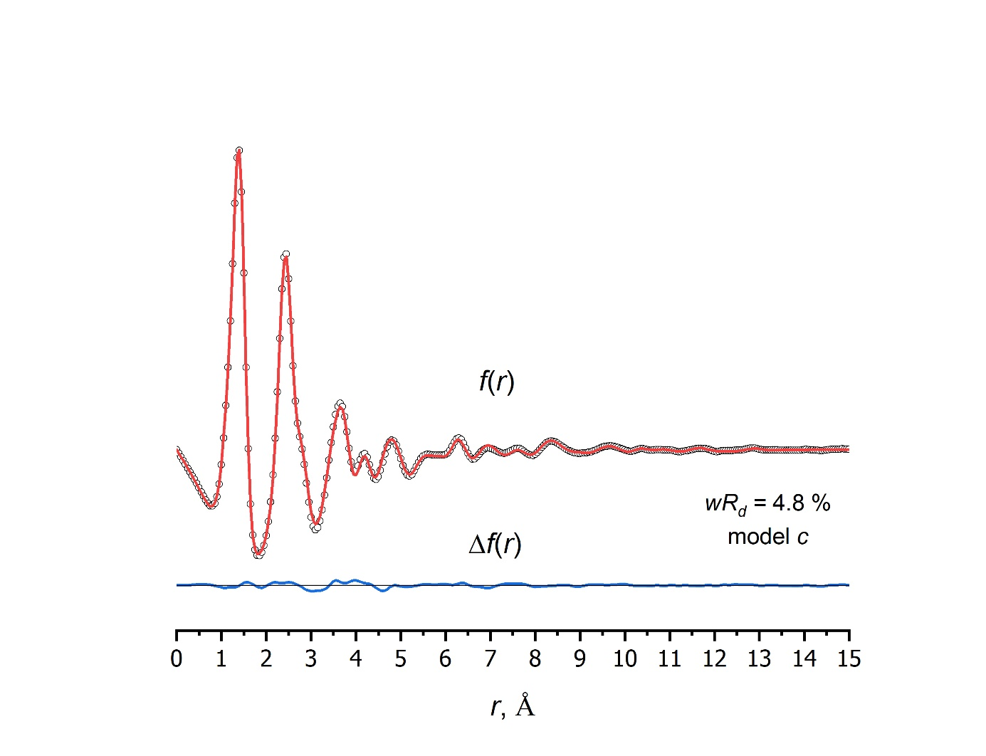

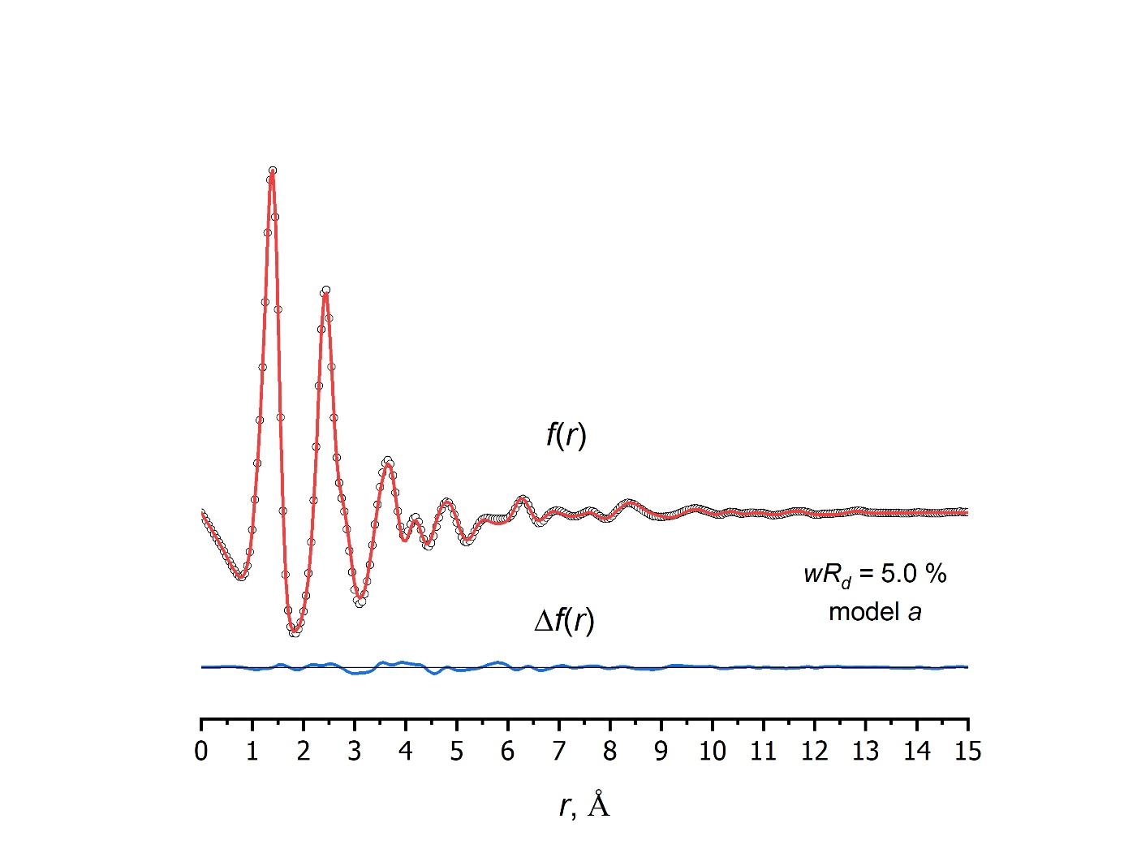

Figure S7. Experimental (cycles) and theoretical (red solid lines) radial distribution curve for models ***c*** and ***a*** of p-HPhAPN and the difference curve Δf(r) (blue solid line).

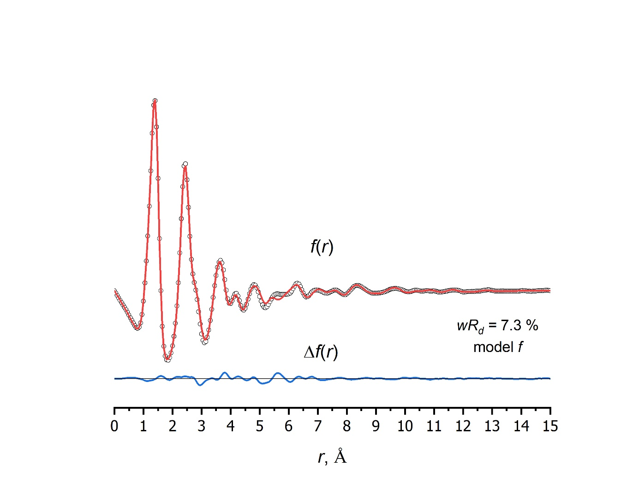

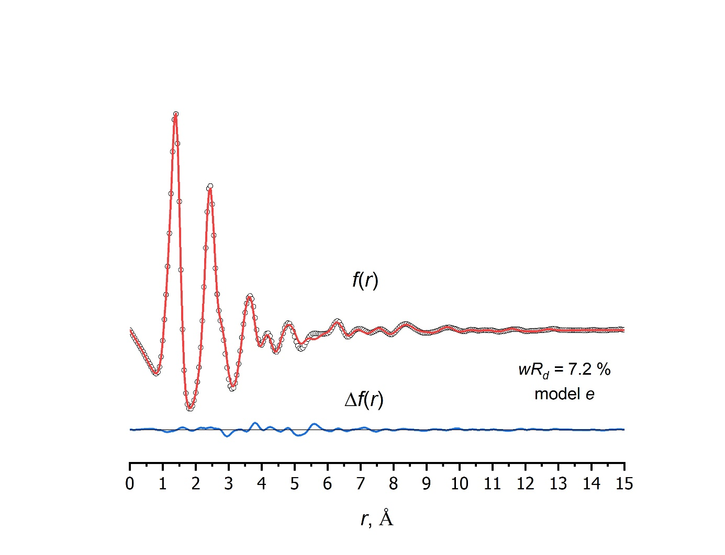

Figure S8. Experimental (cycles) and theoretical (red solid lines) radial distribution curve for models ***f*** and ***e*** of p-HPhAPN and the difference curve Δf(r) (blue solid line).

Table S9. Semi-experimental parameters of ***p-HPhAPN*** (azo forms ***a*** and ***c***).

|  |  |  |  |  |  |
| --- | --- | --- | --- | --- | --- |
| Atom 1 a | Atom 2 a | Atom 3 a | Atom 4 a | ***a*** | ***c*** |
| internuclear distances, Å | | | | | |
| 1 | 2 |  |  | 1.250(8) | 1.250(8) |
| 1 | 3 |  |  | 1.415(11) | 1.415(11) |
| 2 | 4 |  |  | 1.396(11) | 1.397(11) |
| 3 | 5 |  |  | 1.393(11) | 1.388(11) |
| 3 | 13 |  |  | 1.401(11) | 1.406(11) |
| 4 | 6 |  |  | 1.402(11) | 1.403(11) |
| 4 | 14 |  |  | 1.398(11) | 1.398(11) |
| 5 | 7 |  |  | 1.385(11) | 1.389(11) |
| 5 | 20 |  |  | 1.081(12) | 1.082(12) |
| 6 | 8 |  |  | 1.365(11) | 1.365(11) |
| 6 | 21 |  |  | 1.082(12) | 1.082(12) |
| 7 | 9 |  |  | 1.427(11) | 1.422(11) |
| 7 | 15 |  |  | 1.434(11) | 1.433(11) |
| 8 | 10 |  |  | 1.393(11) | 1.393(11) |
| 8 | 22 |  |  | 1.083(12) | 1.083(12) |
| 9 | 11 |  |  | 1.399(11) | 1.403(11) |
| 9 | 16 |  |  | 1.432(11) | 1.432(11) |
| 10 | 12 |  |  | 1.392(11) | 1.392(11) |
| 10 | 19 |  |  | 1.331(10) | 1.331(10) |
| 11 | 13 |  |  | 1.384(11) | 1.381(11) |
| 11 | 23 |  |  | 1.083(12) | 1.083(12) |
| 12 | 14 |  |  | 1.377(11) | 1.377(11) |
| 12 | 24 |  |  | 1.085(12) | 1.085(12) |
| 13 | 25 |  |  | 1.083(12) | 1.082(12) |
| 14 | 26 |  |  | 1.083(12) | 1.083(12) |
| 15 | 17 |  |  | 1.155(10) | 1.155(10) |
| 16 | 18 |  |  | 1.156(10) | 1.156(10) |
| 19 | 27 |  |  | 0.961(12) | 0.961(12) |
| bond angles, ° | | | | | |
| 2 | 1 | 3 |  | 114.9(12) | 114.9(12) |
| 1 | 2 | 4 |  | 116.3(11) | 116.1(11) |
| 1 | 3 | 5 |  | 124.1(13) | 115.2(13) |
| 1 | 3 | 13 |  | 117.3(18) | 126.2(18) |
| 2 | 4 | 6 |  | 125.4(10) | 125.3(10) |
| 2 | 4 | 14 |  | 116.1(17) | 116.2(17) |
| 5 | 3 | 13 |  | 118.5(13) | 118.6(13) |
| 3 | 5 | 7 |  | 120.3(3) | 120.9(3) |
| 3 | 5 | 20 |  | 119.5(14) | 118.9(14) |
| 3 | 13 | 11 |  | 122.8(20) | 122.2(20) |
| 3 | 13 | 25 |  | 118.5(14) | 119.1(14) |
| 6 | 4 | 14 |  | 118.5(13) | 118.5(13) |
| 4 | 6 | 8 |  | 120.4(3) | 120.4(3) |
| 4 | 6 | 21 |  | 119.1(14) | 119.1(14) |
| 4 | 14 | 12 |  | 121.5(22) | 121.5(22) |
| 4 | 14 | 26 |  | 118.5(14) | 118.5(14) |
| 7 | 5 | 20 |  | 120.2(14) | 120.2(14) |
| 5 | 7 | 9 |  | 120.4(3) | 119.9(3) |
| 5 | 7 | 15 |  | 117.1(12) | 117.3(12) |
| 8 | 6 | 21 |  | 120.4(14) | 120.4(14) |
| 6 | 8 | 10 |  | 120.2(3) | 120.3(3) |
| 6 | 8 | 22 |  | 121.4(14) | 121.4(14) |
| 9 | 7 | 15 |  | 122.6(12) | 122.9(12) |
| 7 | 9 | 11 |  | 119.5(3) | 119.5(3) |
| 7 | 9 | 16 |  | 122.9(12) | 123.0(12) |
| 7 | 15 | 17 |  | 178.3(13) | 178.3(13) |
| 10 | 8 | 22 |  | 118.3(14) | 118.3(14) |
| 8 | 10 | 12 |  | 120.6(3) | 120.5(3) |
| 8 | 10 | 19 |  | 116.7(13) | 116.7(13) |
| 11 | 9 | 16 |  | 117.6(13) | 117.5(13) |
| 9 | 11 | 13 |  | 118.5(14) | 119.0(14) |
| 9 | 11 | 23 |  | 119.2(14) | 118.9(14) |
| 9 | 16 | 18 |  | 178.3(14) | 178.2(14) |
| 12 | 10 | 19 |  | 122.8(14) | 122.8(14) |
| 10 | 12 | 14 |  | 118.7(16) | 118.7(16) |
| 10 | 12 | 24 |  | 120.1(14) | 120.1(14) |
| 10 | 19 | 27 |  | 110.5(14) | 110.5(14) |
| 13 | 11 | 23 |  | 122.3(20) | 122.1(20) |
| 11 | 13 | 25 |  | 118.7(24) | 118.7(24) |
| 14 | 12 | 24 |  | 121.2(21) | 121.2(21) |
| 12 | 14 | 26 |  | 120.0(26) | 119.9(26) |
| dihedral angles, ° | | | | | |
| 4 | 2 | 1 | 3 | -180.0(14) | -180.0(14) |
| 2 | 1 | 3 | 5 | 0.0(14) | 180.0(14) |
| 2 | 1 | 3 | 13 | 180.0(25) | 0.0(27) |
| 1 | 2 | 4 | 6 | 0.0(14) | 0.0(14) |
| 1 | 2 | 4 | 14 | -180.0(25) | -180.0(25) |
| 1 | 3 | 5 | 7 | 180.0(14) | 180.0(14) |
| 1 | 3 | 5 | 20 | 0.0(19) | 0.0(19) |
| 1 | 3 | 13 | 11 | -180.0(21) | -180.0(24) |
| 1 | 3 | 13 | 25 | 0.0(25) | 0.0(27) |
| 2 | 4 | 6 | 8 | 180.0(14) | 180.0(14) |
| 2 | 4 | 6 | 21 | 0.0(19) | 0.0(19) |
| 2 | 4 | 14 | 12 | -180.0(20) | 180.0(20) |
| 2 | 4 | 14 | 26 | 0.0(24) | 0.0(24) |
| 7 | 5 | 3 | 13 | 0.0(17) | 0.0(17) |
| 20 | 5 | 3 | 13 | -180.0(22) | -180.0(22) |
| 5 | 3 | 13 | 11 | 0.0(15) | 0.0(15) |
| 5 | 3 | 13 | 25 | -180.0(21) | -180.0(21) |
| 3 | 5 | 7 | 9 | 0.0(14) | 0.0(14) |
| 3 | 5 | 7 | 15 | 180.0(19) | 180.0(19) |
| 3 | 13 | 11 | 9 | 0.0(24) | 0.0(24) |
| 3 | 13 | 11 | 23 | 180.0(28) | 180.0(28) |
| 8 | 6 | 4 | 14 | 0.0(17) | 0.0(17) |
| 21 | 6 | 4 | 14 | 180.0(22) | 180.0(22) |
| 6 | 4 | 14 | 12 | 0.0(15) | 0.0(15) |
| 6 | 4 | 14 | 26 | -180.0(21) | 180.0(21) |
| 4 | 6 | 8 | 10 | 0.0(14) | 0.0(14) |
| 4 | 6 | 8 | 22 | -180.0(19) | -180.0(19) |
| 4 | 14 | 12 | 10 | 0.0(24) | 0.0(24) |
| 4 | 14 | 12 | 24 | 180.0(28) | -180.0(28) |
| 9 | 7 | 5 | 20 | 180.0(19) | 180.0(19) |
| 15 | 7 | 5 | 20 | 0.0(23) | 0.0(23) |
| 5 | 7 | 9 | 11 | 0.0(14) | 0.0(14) |
| 5 | 7 | 9 | 16 | -180.0(19) | -180.0(19) |
| 5 | 7 | 15 | 17 | 0.0(19) | 0.0(19) |
| 10 | 8 | 6 | 21 | -180.0(19) | -180.0(19) |
| 22 | 8 | 6 | 21 | 0.0(24) | 0.0(24) |
| 6 | 8 | 10 | 12 | 0.0(14) | 0.0(14) |
| 6 | 8 | 10 | 19 | -180.0(19) | -180.0(19) |
| 11 | 9 | 7 | 15 | 180.0(19) | 180.0(19) |
| 16 | 9 | 7 | 15 | 0.0(24) | 0.0(24) |
| 9 | 7 | 15 | 17 | 180.0(14) | 180.0(14) |
| 7 | 9 | 11 | 13 | 0.0(25) | 0.0(25) |
| 7 | 9 | 11 | 23 | -180.0(28) | -180.0(29) |
| 7 | 9 | 16 | 18 | 180.0(19) | 180.0(19) |
| 12 | 10 | 8 | 22 | -180.0(19) | -180.0(19) |
| 19 | 10 | 8 | 22 | 0.0(23) | 0.0(23) |
| 8 | 10 | 12 | 14 | 0.0(25) | 0.0(25) |
| 8 | 10 | 12 | 24 | -180.0(29) | 180.0(29) |
| 8 | 10 | 19 | 27 | -180.0(19) | 180.0(19) |
| 13 | 11 | 9 | 16 | -180.0(28) | -180.0(28) |
| 23 | 11 | 9 | 16 | 0.0(31) | 0.0(31) |
| 11 | 9 | 16 | 18 | 0.0(14) | 0.0(14) |
| 9 | 11 | 13 | 25 | 180.0(28) | 180.0(28) |
| 14 | 12 | 10 | 19 | -180.0(29) | 180.0(29) |
| 24 | 12 | 10 | 19 | 0.0(32) | 0.0(32) |
| 12 | 10 | 19 | 27 | 0.0(14) | 0.0(14) |
| 10 | 12 | 14 | 26 | 180.0(28) | -180.0(28) |
| 25 | 13 | 11 | 23 | 0.0(31) | 0.0(31) |
| 26 | 14 | 12 | 24 | 0.0(31) | 0.0(31) |
| 20 | 5 | 3 | 7 | 0.0(12) | 0.0(12) |
| 25 | 13 | 3 | 11 | 0.0(12) | 0.0(12) |
| 21 | 6 | 4 | 8 | 0.0(12) | 0.0(12) |
| 26 | 14 | 4 | 12 | 0.0(12) | 0.0(12) |
| 22 | 8 | 6 | 10 | 0.0(12) | 0.0(12) |
| 23 | 11 | 9 | 13 | 0.0(12) | 0.0(12) |
| 24 | 12 | 10 | 14 | 0.0(12) | 0.0(12) |

a Numbering from Tables S3-S4;

b uncertainties for the bond lengths were estimated as [(2.5σLS)2 + (0.002r)2]1/2; uncertainty for the angle was estimated as 3σLS.

Table S10. Relative energiesa of different isomers of ***Zn-tHPhDaPc*** obtained using different forms (***a***, ***c***, ***e***, ***f***) of ***p-HPhAPN***.

|  |  |  |
| --- | --- | --- |
| Isomer | Form of of ***p-HPhAPN*** | Relative energy, kJ∙mol-1 |
| I | a | 4.1 |
| II | a | 5.3 |
| III | a | 4.9 |
| IV | a | 4.7 |
| I | c | 0.0 |
| II | c | 0.0 |
| III | c | 0.2 |
| IV | c | 0.0 |
| I | e | 104.6 |
| II | e | 105.7 |
| III | e | 105.2 |
| IV | e | 105.2 |
| I | f | 102.4 |
| II | f | 104.5 |
| III | f | 103.5 |
| IV | f | 103.3 |

a according to B3LYP-D3/pcseg-2 calculations

Table S11. Internuclear distances (Å)a of zinc complex ***Zn-tHPhDaPc*** obtained using ***a*** and ***c*** forms of ***p-HPhAPN*** and corresponding Internuclear distances of ***p-HPhAPN*** (models ***a*** and ***c***).

|  |  |  |  |  |  |
| --- | --- | --- | --- | --- | --- |
|  | ***Zn-tHPhDaPc*** (I)  C4v | |  | ***p-HPhAPN***  Cs | |
| ***a*** | ***c*** |  | a | c |
| N-N | 1.251 | 1.251 |  | 1.252 | 1.252 |
| N-C | 1.406 | 1.406 |  | 1.400 | 1.400 |
| N-C | 1.413 | 1.412 |  | 1.414 | 1.414 |
| Cδ-Cδ | 1.408 | 1.413 |  | 1.396 | 1.401 |
| Сγ-Cδ | 1.386 | 1.382 |  | 1.384 | 1.380 |
| Сγ-Cδ | 1.400 | 1.395 |  | 1.398 | 1.393 |
| Сγ-Cβ | 1.390 | 1.394 |  | 1.396 | 1.400 |
| Сγ-Cβ | 1.382 | 1.386 |  | 1.389 | 1.393 |
| Сβ-Cβ | 1.410 | 1.406 |  | 1.413 | 1.409 |

a according to B3LYP-D3/pcseg-2 calculations

Table S12. Nucleus-independent chemical shifts (NICS)a indexes for Zinc phtalocyanine (ZnPc) and ***Zn-tHPhDaPc*** .

|  |  |  |  |
| --- | --- | --- | --- |
| Structure | ***ZnPc*** | ***Zn-tHPhDaPc*** | |
|  | ***I a*** | ***I c*** |
| for phenyl moiety of phtalocyanine core | | | |
| NICS(0) | -7.5 | -6.5 | -6.0 |
| NICS(1) | -9.4 | -8.3 | -8.0 |
| for phenyl moiety of azo substituent | | | |
| NICS(0) ' | - | -7.0 | -7.1 |
| NICS(1) ' | - | -7.8 | -7.9 |

a For comparison, the corresponding values of the initial compounds were found: Benzene: NICS(0)=-8.1, NICS(1)=-9.9; Phenol: NICS(0)=-9.0, NICS(1)=-9.4; Phthalonitrile: NICS(0)=-8.7, NICS(0)=-9.8.

[75] NIST Mass Spectrometry Data Center, William E. Wallace, director, “Mass Spectra” in NIST Chemistry WebBook, NIST Standard Reference Database Number 69; Linstrom, P.J., Mallard, W.G., Eds.; National Institute of Standards and Technology: Gaithersburg MD, 20899.