Supplementary Data for

Magnetocaloric properties of lanthanide tetrapyrrole complexes above Curie temperature
Tatyana N. Lomova,^{a@} Victor V. Korolev,ª Anna G. Ramazanova,ª and Olga V. Balmasovaª
ªG. A. Krestov Institute of Solution Chemistry, Ivanovo, 153045, Russian Federation
@Corresponding author E-mail: tnl@isc-ras.ru

Content

- ¹H NMR specrf of (Cl)TbTP, (Cl)TbT^{t}BuPP, and (Cl)TbPc 2-4
- IR spectra of (Cl)TbPc and (Cl)TbT^{t}BuPP 5
- The MALDI TOF mass spectrum of samples 6,7
- The parameters of the UV-vis spectra of (Cl)TbT^{t}BuPP in chloroform 8
- Experimental specific/molar heat capacity of samples 9-11
- The temperature dependences of samples MCE, the enthalpy change, the specific heat and the entropy change due to the samples magnetization 12-14
Figure S1. ¹H NMR specrum of (Cl)TbTPP in CDCl₃

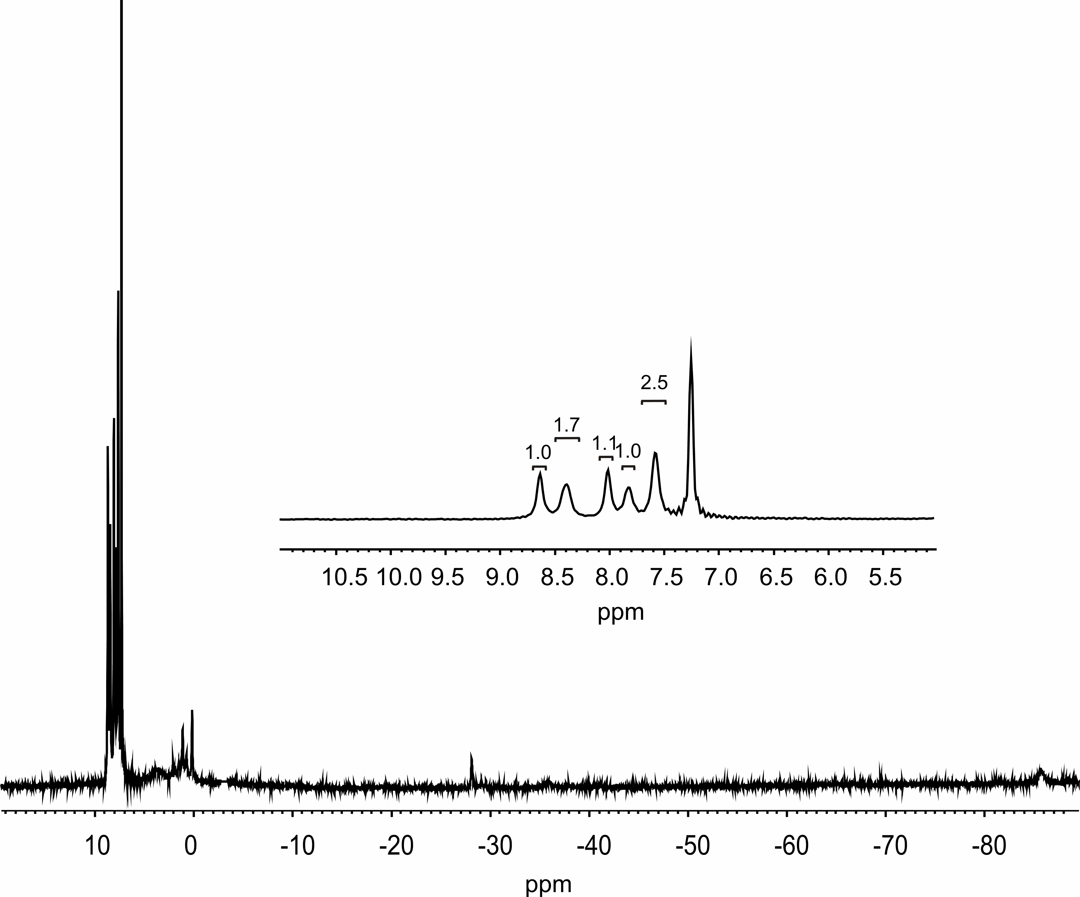

Figure S2. ¹H NMR spectrum of (Cl)Tb^{t}BuTP in CDCl₃

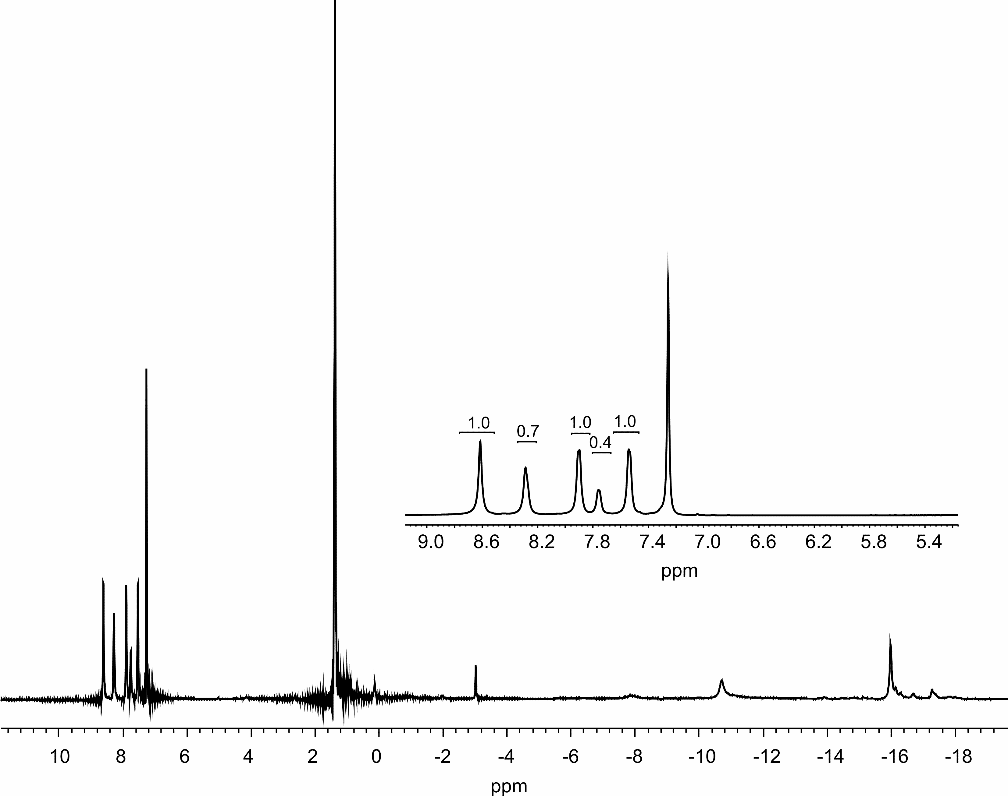
Figure S3. ¹H NMR spectrum of (Cl)TbPc DMF (insert spectrum in CDCl₃)

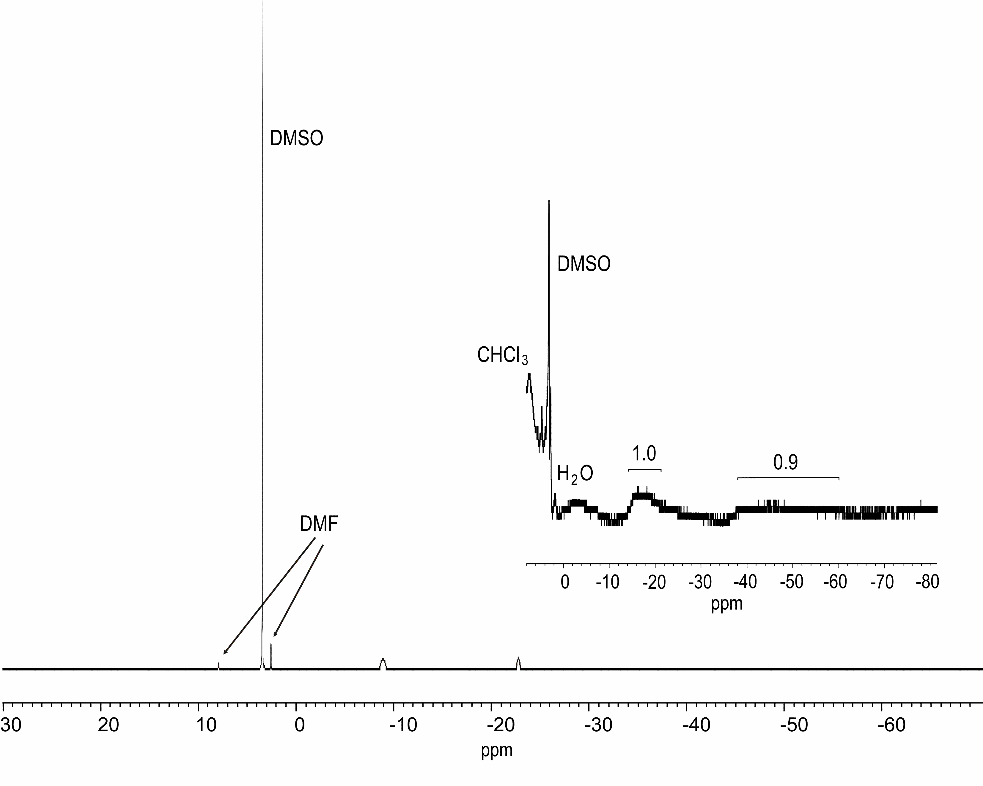

Figure S4. The IR spectra of (Cl)TbPc (top) and (Cl)TbT^{t}BuPP (bottom)

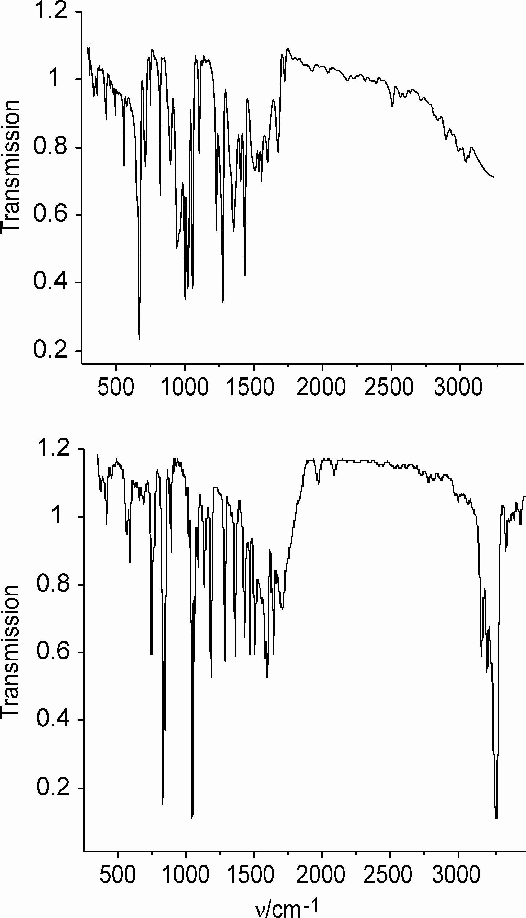
Figure S5. The MALDI TOF mass spectrum of (5,10,15,20-Tetra(4-tert-butylphenylporphinato))terbium(III) chloride (M = 1031.5392 g mol⁻¹). The matrix is CHCA (a), DHB (b), and without a matrix (c).
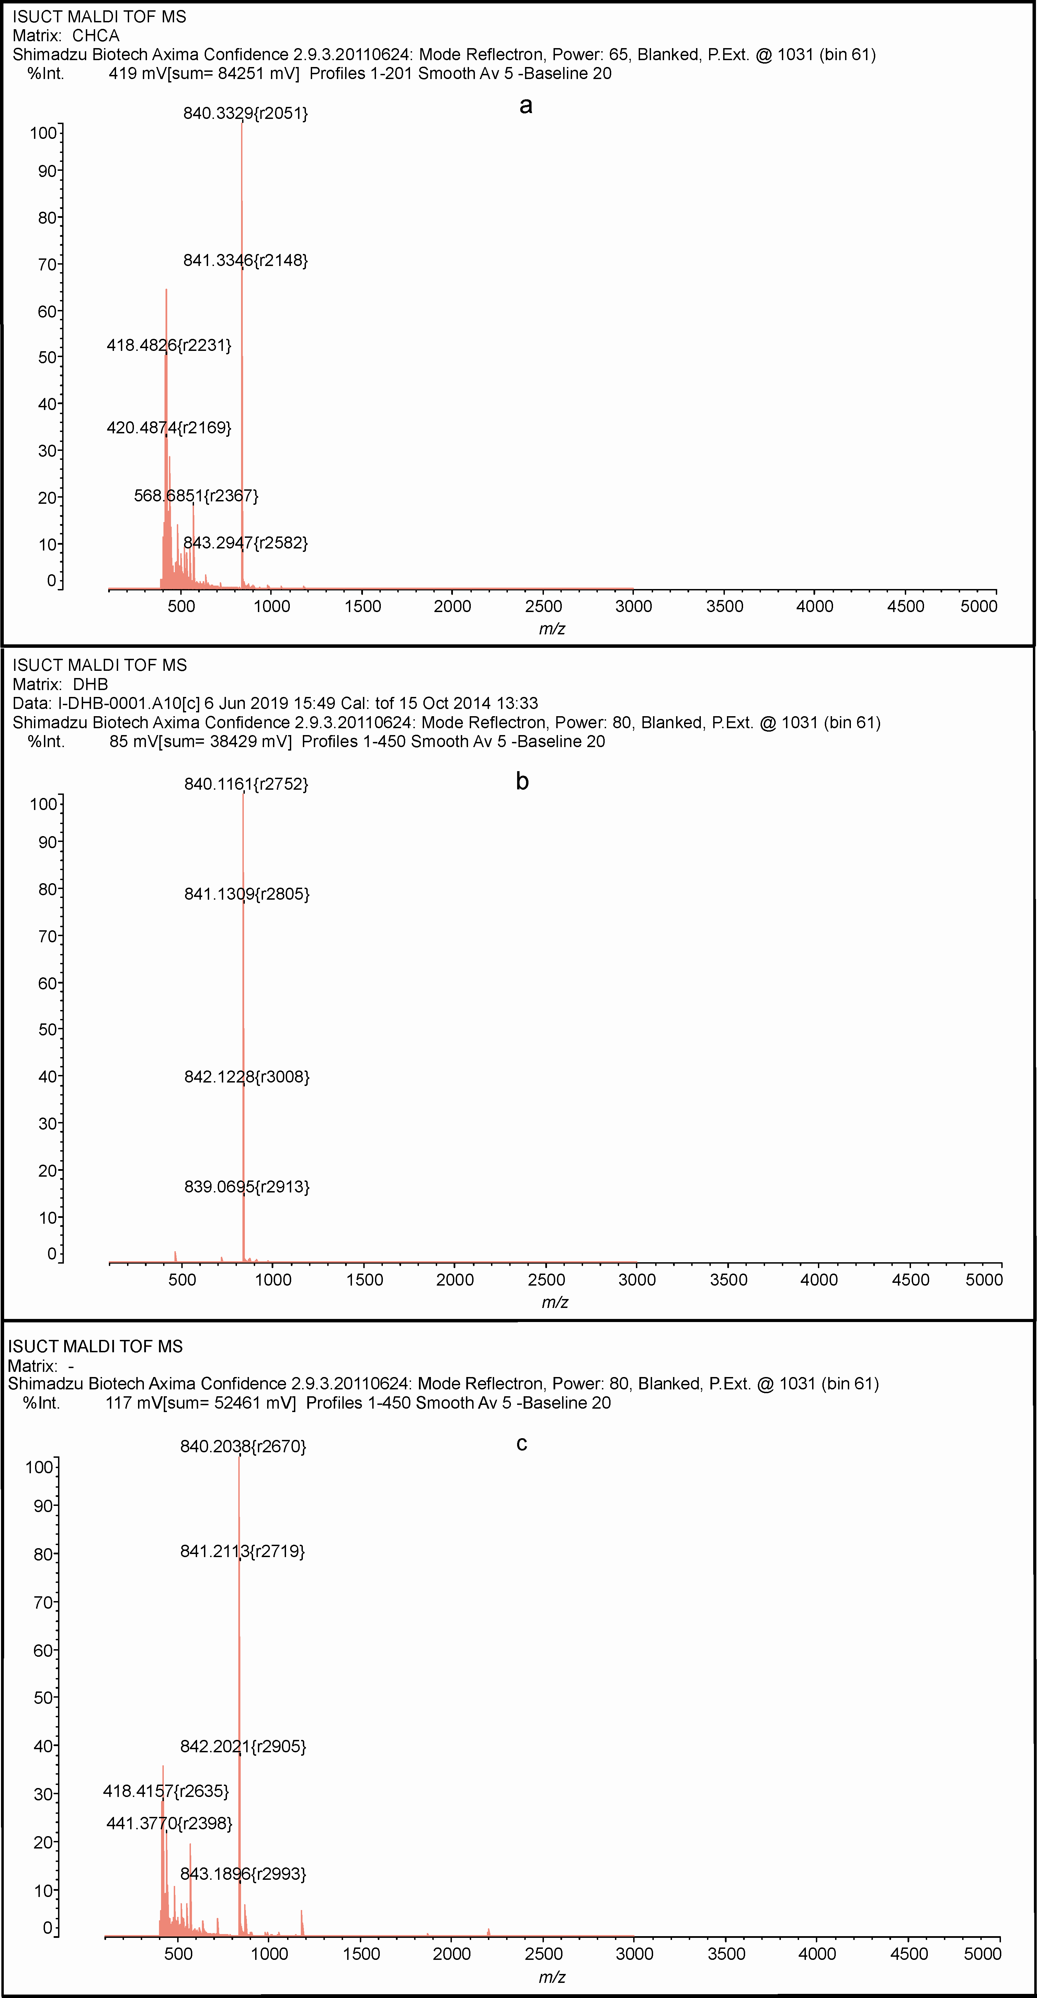

Figure S6. The MALDI TOF mass spectrum of (phthalocyaninato)terbium(III) chloride (M = 706.9104 g mol⁻¹). The matrix is DHB
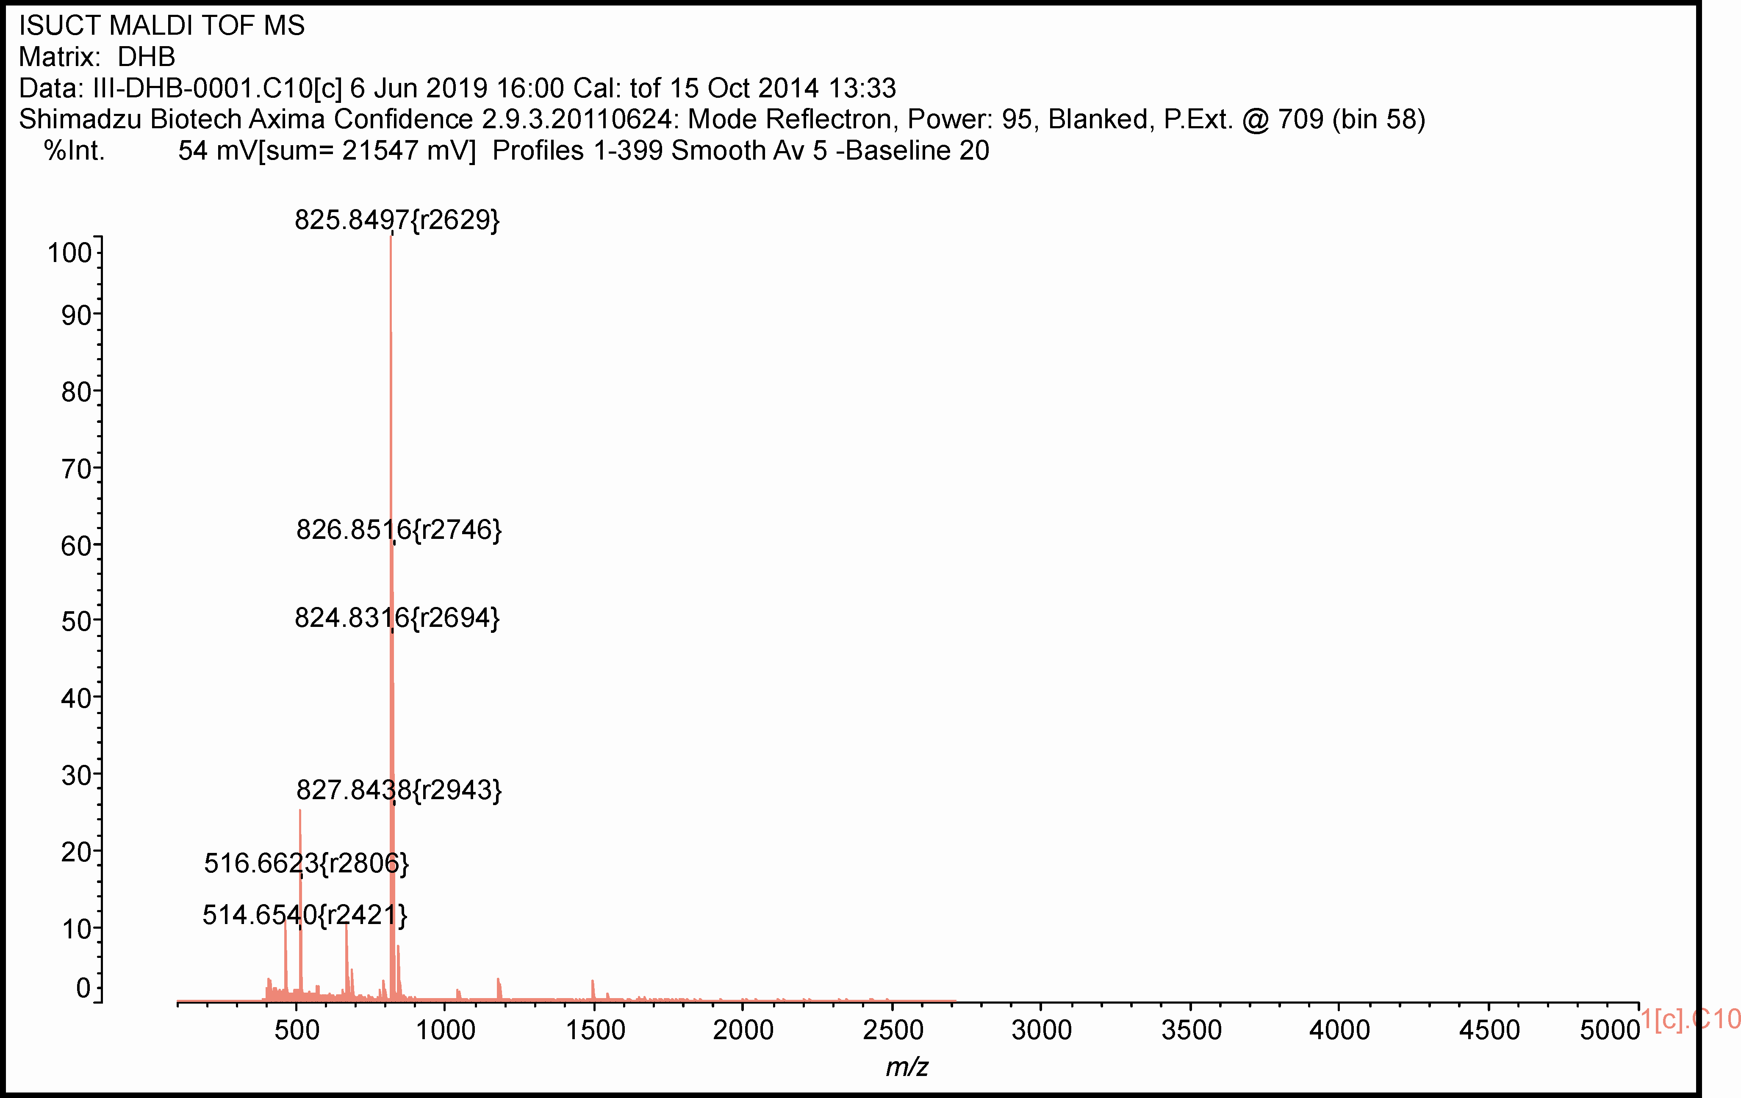
Table S1. The parameters of the UV-vis spectra of (Cl)TbT^{t}BuPP in chloroform
The complex | λ_{max}, nm (logε)
The complex | Q(0,0) | Q(0,1) | Q(0,2) | B(0,0) | B(0,1)^{[c]}
(Cl)ТbT^{t}BuPP | 593 (3.97) | 555 (4.34) | 517 (3.90) | 424 (5.68) | 400
(Cl)ТbT^{t}BuPP^{[a]} | 593 | 554 | 517 | 424 | 400
(Cl)ТbT^{t}BuPP^{[b]} | 593 | 554 | 517 | 424 | 400
^{[a]}After a DSC experiment. [b] After a microcaloric experiment (the ratio of the intensities of the absorption bands is B(0,0) > Q(0,1) > Q(0,0) > Q(0,2)). [c] A shoulder.
Table S2 Experimental specific/molar heat capacity of (5,10,15,20-tetraphenylporphinato)terbium(III) chloride (M = 807.1104 g·mol⁻¹)
T/К | С_{P}/  J K⁻¹g⁻¹ | С_{P}/  J K⁻¹mol⁻¹ | T/К | С_{P}/  J K⁻¹g⁻¹ | С_{P}/  J K⁻mol⁻¹ | T/К | С_{P}/  J K⁻¹g⁻¹ | С_{P}/  J K⁻¹mol⁻¹
270.07 | 1.04770 | 0.00130 | 291.07 | 1.22171 | 0.00151 | 312.07 | 1.46416 | 0.00181
271.07 | 1.05371 | 0.00131 | 292.07 | 1.23282 | 0.00153 | 313.07 | 1.47424 | 0.00183
272.07 | 1.05722 | 0.00131 | 293.07 | 1.24252 | 0.00154 | 314.07 | 1.48588 | 0.00184
273.07 | 1.06182 | 0.00132 | 294.07 | 1.25195 | 0.00155 | 315.07 | 1.49698 | 0.00185
274.07 | 1.06847 | 0.00132 | 295.07 | 1.26209 | 0.00156 | 316.07 | 1.50550 | 0.00187
275.07 | 1.07549 | 0.00133 | 296.07 | 1.27478 | 0.00158 | 317.07 | 1.51599 | 0.00188
276.07 | 1.08364 | 0.00134 | 297.07 | 1.28554 | 0.00159 | 318.07 | 1.52608 | 0.00189
277.07 | 1.09149 | 0.00135 | 298.07 | 1.29787 | 0.00161 | 319.07 | 1.53715 | 0.00190
278.07 | 1.10043 | 0.00136 | 299.07 | 1.31013 | 0.00162 | 320.07 | 1.54692 | 0.00192
279.07 | 1.10774 | 0.00137 | 300.07 | 1.32344 | 0.00164 | 321.07 | 1.55555 | 0.00193
280.07 | 1.11684 | 0.00138 | 301.07 | 1.33474 | 0.00165 | 322.07 | 1.56373 | 0.00194
281.07 | 1.12593 | 0.00140 | 302.07 | 1.34749 | 0.00167 | 323.07 | 1.57106 | 0.00195
282.07 | 1.13478 | 0.00141 | 303.07 | 1.35916 | 0.00168 | 324.07 | 1.58079 | 0.00196
283.07 | 1.14427 | 0.00142 | 304.07 | 1.37167 | 0.00170 | 325.07 | 1.58924 | 0.00197
284.07 | 1.15223 | 0.00143 | 305.07 | 1.38378 | 0.00171 | 326.07 | 1.59683 | 0.00198
285.07 | 1.16215 | 0.00144 | 306.07 | 1.39608 | 0.00173 | 327.07 | 1.60327 | 0.00199
286.07 | 1.17159 | 0.00145 | 307.07 | 1.40824 | 0.00174 | 328.07 | 1.61126 | 0.00200
287.07 | 1.18030 | 0.00146 | 308.07 | 1.42045 | 0.00176 | 329.07 | 1.61493 | 0.00200
288.07 | 1.19139 | 0.00148 | 309.07 | 1.43095 | 0.00177 | 330.07 | 1.62315 | 0.00201
289.07 | 1.20160 | 0.00149 | 310.07 | 1.44249 | 0.00179 | 331.07 | 1.62893 | 0.00202
290.07 | 1.21209 | 0.00150 | 311.07 | 1.45331 | 0.00180 | 332.07 | 1.63426 | 0.00202

Table S3 Experimental specific/molar heat capacity of (5,10,15,20-Tetra(4-tert-butylphenylporphinato))terbium(III) chloride (M = 1031.5392 g mol⁻¹)
T/К | С_{P}/  J K⁻¹g⁻¹ | С_{P}/  J K⁻¹mol⁻¹ | T/К | С_{P}/  J K⁻¹g⁻¹ | С_{P}/  J K⁻mol⁻¹ | T/К | С_{P}/  J K⁻¹g⁻¹ | С_{P}/  J K⁻¹mol⁻¹
270.07 | 1.17600 | 0.00114 | 291.07 | 1.34474 | 0.00130 | 312.07 | 1.56660 | 0.00152
271.07 | 1.18199 | 0.00115 | 292.07 | 1.35660 | 0.00132 | 313.07 | 1.57332 | 0.00153
272.07 | 1.18570 | 0.00115 | 293.07 | 1.36549 | 0.00132 | 314.07 | 1.58101 | 0.00153
273.07 | 1.19250 | 0.00116 | 294.07 | 1.37591 | 0.00133 | 315.07 | 1.59017 | 0.00154
274.07 | 1.19812 | 0.00116 | 295.07 | 1.38789 | 0.00135 | 316.07 | 1.59620 | 0.00155
275.07 | 1.20381 | 0.00117 | 296.07 | 1.39955 | 0.00136 | 317.07 | 1.60160 | 0.00155
276.07 | 1.21213 | 0.00118 | 297.07 | 1.40913 | 0.00137 | 318.07 | 1.60904 | 0.00156
277.07 | 1.21826 | 0.00118 | 298.07 | 1.42196 | 0.00138 | 319.07 | 1.61670 | 0.00157
278.07 | 1.22874 | 0.00119 | 299.07 | 1.43308 | 0.00139 | 320.07 | 1.62515 | 0.00158
279.07 | 1.23688 | 0.00120 | 300.07 | 1.44717 | 0.00140 | 321.07 | 1.62896 | 0.00158
280.07 | 1.24438 | 0.00121 | 301.07 | 1.45799 | 0.00141 | 322.07 | 1.63359 | 0.00158
281.07 | 1.25113 | 0.00121 | 302.07 | 1.47197 | 0.00143 | 323.07 | 1.63756 | 0.00159
282.07 | 1.25957 | 0.00122 | 303.07 | 1.48297 | 0.00144 | 324.07 | 1.64231 | 0.00159
283.07 | 1.26692 | 0.00123 | 304.07 | 1.49624 | 0.00145 | 325.07 | 1.64738 | 0.00160
284.07 | 1.27595 | 0.00124 | 305.07 | 1.50467 | 0.00146 | 326.07 | 1.65072 | 0.00160
285.07 | 1.28812 | 0.00125 | 306.07 | 1.51397 | 0.00147 | 327.07 | 1.65445 | 0.00160
286.07 | 1.29676 | 0.00126 | 307.07 | 1.52149 | 0.00147 | 328.07 | 1.65838 | 0.00161
287.07 | 1.30478 | 0.00126 | 308.07 | 1.53231 | 0.00149 | 329.07 | 1.65937 | 0.00161
288.07 | 1.31496 | 0.00127 | 309.07 | 1.53964 | 0.00149 | 330.07 | 1.66392 | 0.00161
289.07 | 1.32413 | 0.00128 | 310.07 | 1.54993 | 0.00150 | 331.07 | 1.66847 | 0.00162
290.07 | 1.33555 | 0.00129 | 311.07 | 1.55780 | 0.00151 | 332.07 | 1.67454 | 0.00162

Table S4 Experimental specific/molar heat capacity of (Phthalocyaninato)terbium(III) chloride (M = 706.9104 g mol⁻¹
T/К | С_{P}/  J K⁻¹g⁻¹ | С_{P}/  J K⁻¹mol⁻¹ | T/К | С_{P}/  J K⁻¹g⁻¹ | С_{P}/  J K⁻mol⁻¹ | T/К | С_{P}/  J K⁻¹g⁻¹ | С_{P}/  J K⁻¹mol⁻¹
270.07 | 0.88108 | 0.00125 | 291.07 | 0.99887 | 0.00141 | 312.07 | 1.16399 | 0.00165
271.07 | 0.88284 | 0.00125 | 292.07 | 1.00669 | 0.00142 | 313.07 | 1.17116 | 0.00166
272.07 | 0.88674 | 0.00125 | 293.07 | 1.01511 | 0.00144 | 314.07 | 1.17802 | 0.00167
273.07 | 0.89057 | 0.00126 | 294.07 | 1.02493 | 0.00145 | 315.07 | 1.18461 | 0.00168
274.07 | 0.89604 | 0.00127 | 295.07 | 1.03422 | 0.00146 | 316.07 | 1.19115 | 0.00169
275.07 | 0.90128 | 0.00127 | 296.07 | 1.04363 | 0.00148 | 317.07 | 1.19752 | 0.00169
276.07 | 0.90627 | 0.00128 | 297.07 | 1.05278 | 0.00149 | 318.07 | 1.20474 | 0.00170
277.07 | 0.91353 | 0.00129 | 298.07 | 1.06124 | 0.00150 | 319.07 | 1.21036 | 0.00171
278.07 | 0.91846 | 0.00130 | 299.07 | 1.06836 | 0.00151 | 320.07 | 1.21615 | 0.00172
279.07 | 0.92405 | 0.00131 | 300.07 | 1.07581 | 0.00152 | 321.07 | 1.22255 | 0.00173
280.07 | 0.92941 | 0.00131 | 301.07 | 1.08327 | 0.00153 | 322.07 | 1.22800 | 0.00174
281.07 | 0.93585 | 0.00132 | 302.07 | 1.09018 | 0.00154 | 323.07 | 1.23309 | 0.00174
282.07 | 0.94065 | 0.00133 | 303.07 | 1.09662 | 0.00155 | 324.07 | 1.23760 | 0.00175
283.07 | 0.94625 | 0.00134 | 304.07 | 1.10366 | 0.00156 | 325.07 | 1.24195 | 0.00176
284.07 | 0.95345 | 0.00135 | 305.07 | 1.11119 | 0.00157 | 326.07 | 1.24656 | 0.00176
285.07 | 0.95890 | 0.00136 | 306.07 | 1.11893 | 0.00158 | 327.07 | 1.25051 | 0.00177
286.07 | 0.96521 | 0.00137 | 307.07 | 1.12681 | 0.00159 | 328.07 | 1.25438 | 0.00177
287.07 | 0.97047 | 0.00137 | 308.07 | 1.13412 | 0.00160 | 329.07 | 1.25808 | 0.00178
288.07 | 0.97796 | 0.00138 | 309.07 | 1.14243 | 0.00162 | 330.07 | 1.26097 | 0.00178
289.07 | 0.98392 | 0.00139 | 310.07 | 1.15004 | 0.00163 | 331.07 | 1.26419 | 0.00179
290.07 | 0.98998 | 0.00140 | 311.07 | 1.15627 | 0.00164 | 332.07 | 1.26650 | 0.00179

Figure S7. The temperature dependences of (Cl)TbTPP MCE at the magnetic induction

Figure S8. The temperature dependences of (Cl)TbPc MCE at the magnetic induction

Figure S9. The temperature dependences of the enthalpy change due to the (Cl)TbT^{t}BuPP magnetization at the magnetic induction

Figure S10. The temperature dependences of the enthalpy change due to the (Cl)TbTPP magnetization at the magnetic induction

Figure S11. The temperature dependences of enthalpy change due to the (Cl)TbPc magnetization at the magnetic induction

Figure S12. The temperature dependences of the specific heat due to the (Cl)TbT^{t}BuPP magnetization at the magnetic induction

Figure S13. The temperature dependences of the specific heat due to the (Cl)TbTPP magnetization at the magnetic induction

Figure S14. The temperature dependences of the specific heat due to the (Cl)TbPc magnetization at the magnetic induction

Figure S15. The temperature dependences of the entropy change due to the (Cl)TbTPP magnetization at the magnetic induction

Figure S16. The temperature dependences of the entropy change due to the (Cl)TbT^{t}BuPP magnetization at the magnetic induction

Figure S17. The temperature dependences of the entropy change due to the (Cl)TbPc magnetization at the magnetic induction

