**Electronic Supplementary Information**

Oxidative lactonization of dimethyl ester of chlorin *e6*

Evgeniy S. Belyaev, Vladimir S. Tyurin@ and Ilya A. Zamilatskov

A.N. Frumkin Institute of Physical Chemistry and Electrochemistry, Russian Academy of Sciences, 119071 Moscow, Russia

@*Corresponding author E-mail: vst-1970@mail.ru*

**Contents**

|  |  |  |
| --- | --- | --- |
| 1. | NMR spectra | 2 |
| 2. | DFT calculations data | 6 |

**NMR spectra**

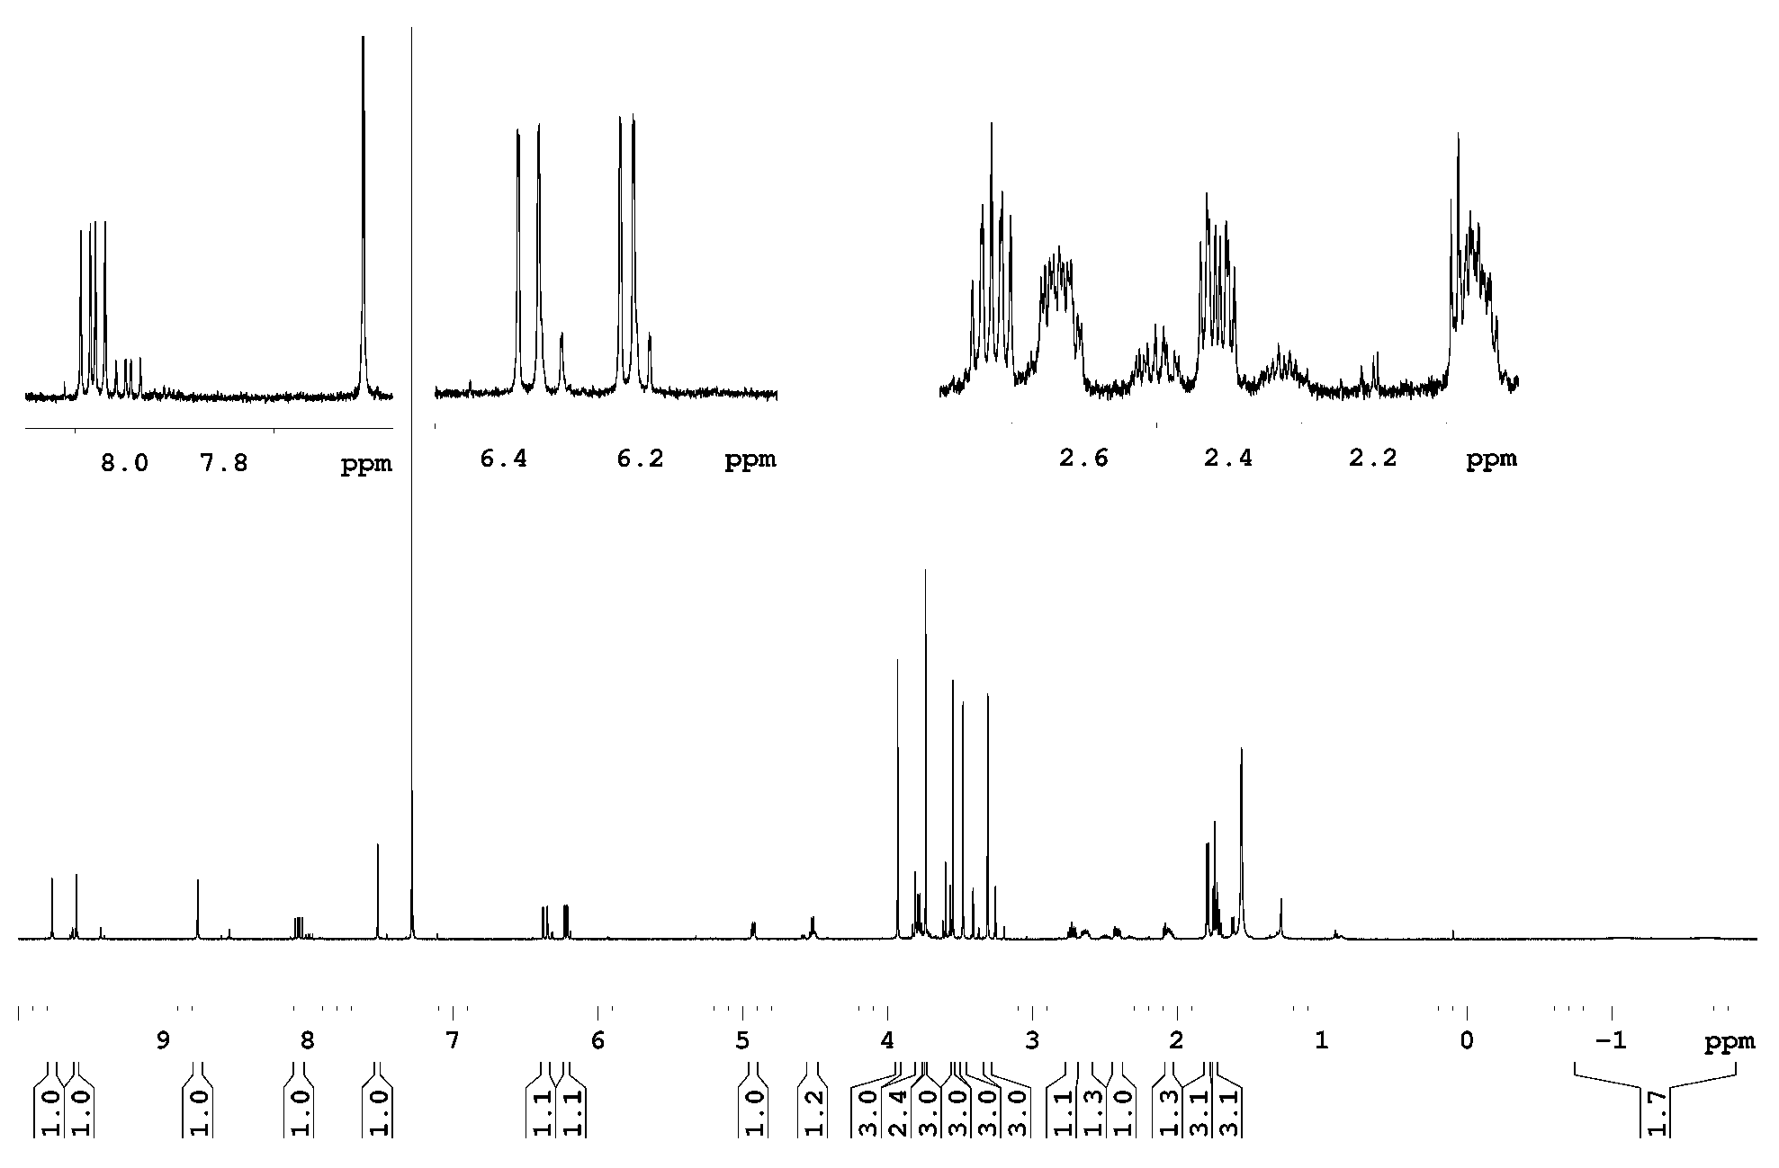

**Figure S1.** 1H NMR spectrum of the first diastereomer of the 131,133-Lactone derivative of the 152,173-dimethyl ester of the chlorin *e6* (**3a**) in CDCl3.

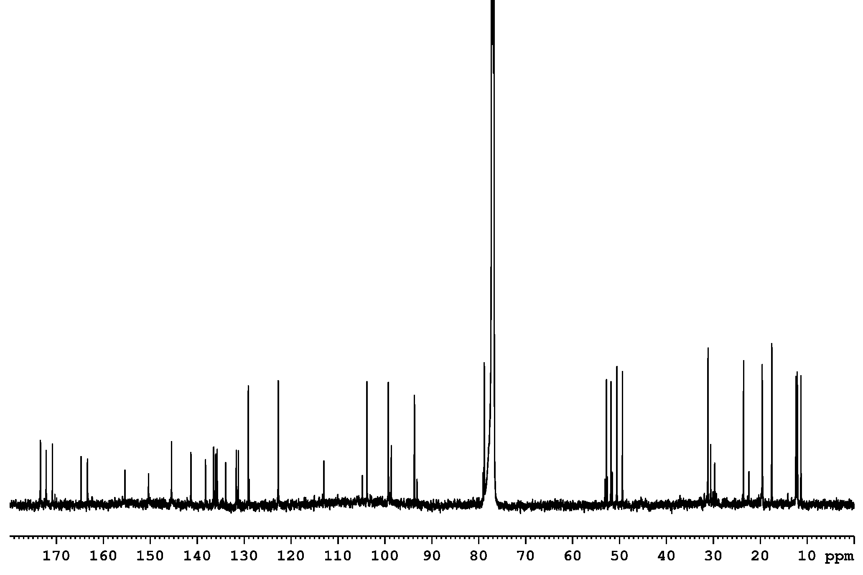

**Figure S2.** 13С NMR spectrum of the first diastereomer of the 131,133-Lactone derivative of the 152,173-dimethyl ester of the chlorin *e6* (**3a**) in CDCl3.

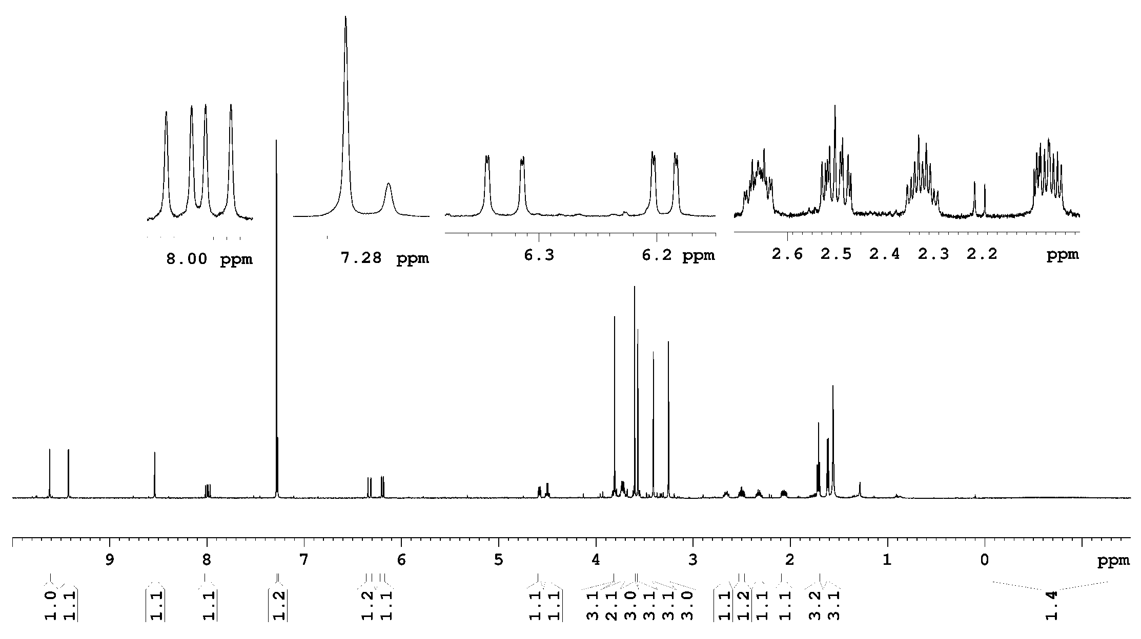

**Figure S3.** 1H NMR spectrum of the second diastereomer of the 131,133-Lactone derivative of the 152,173-dimethyl ester of the chlorin *e6* (**3b**) in CDCl3.

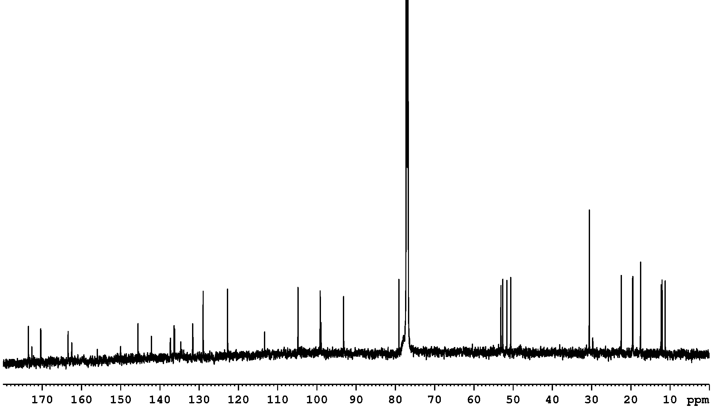

**Figure S4.** 13C NMR spectrum of the second diastereomer of the 131,133-Lactone derivative of the 152,173-dimethyl ester of the chlorin *e6* (**3b**) in CDCl3.

**DFT calculations data**

Computed geometry and energy data for the molecules



Scheme S1. Alternative pathways of the transformation of the .Pb(OAc)3 salt of the dimethyl chlorin e6 (**4**) into the lactone derivative (**3**).



Scheme S2. Alternative pathways of the transformation of the .Pb(OAc)3 salt of the enol tautomer of the dimethyl chlorin e6 (**4a**) into the lactone derivative (**3**).

**Table S1.** Cartesian coordinates and energy of the dimethyl ester of chlorin *e6* (**1**) in 1,4-dioxane

RB3LYP/6-31G(d,p) E = -2066.379787 a.u. G = -2065.756486 a.u.

Atom x y z

C 1.88029500 2.94005500 -0.50931400

C 3.75535600 0.45559000 -0.36824600

C 0.76016200 3.74229900 -0.25838100

C 1.47505200 1.55482700 -0.43608000

C 2.24388400 0.35118600 -0.42035500

C -0.34871100 2.86739100 -0.07182800

C 0.68382900 5.24016200 -0.24037600

N 0.12667800 1.57838800 -0.20796100

C 1.68513400 -0.92940000 -0.44994700

C -1.66184000 3.24912000 0.22360300

H -0.43042300 0.73474300 -0.12071600

N 0.35776500 -1.21191300 -0.62601600

C 2.49137600 -2.23179400 -0.33636500

C -2.81658800 2.47852200 0.33513300

C 0.24006200 -2.51270400 -0.95804400

C 1.59699300 -3.17647900 -1.16493000

C 2.56484800 -2.76314800 1.12076200

N -2.89558000 1.13670000 0.08058200

C -4.12816200 3.03342400 0.68812600

C -0.93823700 -3.24008500 -1.13478000

C 1.98444300 -3.22958900 -2.65368700

C 3.31652900 -1.90335000 2.13705100

C -4.20676600 0.82101500 0.23414800

C -5.00239300 1.98265600 0.63192300

C -4.40863800 4.46036400 1.06846100

C -2.26157800 -2.84081300 -0.94711900

C 3.26934700 -2.48929200 3.53532400

C -4.75706600 -0.45331300 -0.01712800

C -6.47732400 1.97041400 0.89961200

C -4.06915200 4.78510700 2.53607200

N -2.69151400 -1.59284800 -0.60133300

C -3.43191600 -3.68046700 -1.04940800

O 2.68095900 -3.49853500 3.86402100

O 3.98134600 -1.72956700 4.39600300

C -4.06013800 -1.56611200 -0.45125100

H -2.12073700 -0.76534800 -0.45239600

C -4.53994300 -2.90042400 -0.76133500

C -3.39816200 -5.12827100 -1.43273200

C 4.00027200 -2.18708100 5.76046900

C -5.93126000 -3.35184100 -0.76609500

C -7.00501600 -2.63570100 -1.12807500

H 4.16509000 -0.31591300 0.28737400

H -0.34845800 5.58933500 -0.29509200

H 1.23021600 5.67503800 -1.08021600

H 1.13599600 5.64724000 0.66997600

H -1.79180200 4.31255200 0.38755000

H 3.49192800 -2.15359700 -0.76564900

H 1.59802800 -4.19309400 -0.75624600

H 3.02823000 -3.75569400 1.09002200

H 1.54472300 -2.92018400 1.48739200

H -0.80729200 -4.27985800 -1.41612900

H 2.95264400 -3.72578000 -2.77783500

H 2.06875800 -2.22221400 -3.07066300

H 1.24040900 -3.78677100 -3.23174000

H 2.90198700 -0.89005500 2.19372600

H 4.37460100 -1.78644800 1.87306100

H -5.46668300 4.68235500 0.88983200

H -3.84986200 5.13892200 0.41146000

H -5.82207900 -0.57566400 0.13487900

H -6.85312000 2.97409400 1.11405500

H -6.72812500 1.33652300 1.75897600

H -7.04206500 1.58423400 0.04252000

H -3.01125200 4.60050100 2.74718700

H -4.65527200 4.16118600 3.21795300

H -4.28399900 5.83451400 2.76397900

H -2.77635800 -5.71156600 -0.74402200

H -2.98251500 -5.26558100 -2.43788300

H -4.39876400 -5.56478900 -1.43203500

H 4.44247400 -3.18396100 5.82602300

H 2.98766500 -2.22040300 6.16901600

H 4.60732500 -1.46425300 6.30442200

H -6.08613600 -4.38810900 -0.46909500

H -6.92826600 -1.61599300 -1.49048700

H -7.99892700 -3.07031700 -1.09599700

H 4.09281000 1.39462300 0.06571900

C 4.45439700 0.26740500 -1.70895000

O 3.96840400 -0.21804800 -2.70810100

O 5.74802200 0.63873000 -1.61375300

C 6.51634000 0.51069400 -2.82175100

H 6.09488800 1.14202000 -3.60720800

H 7.52340200 0.84050500 -2.56740400

H 6.52931000 -0.52638500 -3.16564400

C 3.16535400 3.47151100 -0.99239700

O 3.89109900 2.96182700 -1.82885000

O 3.47458100 4.67362300 -0.44006900

H 4.29022800 4.96580400 -0.88223600

**Table S2.** Cartesian coordinates and energy of the enol tautomer of the dimethyl ester of chlorin *e6* (**1a**) in 1,4-dioxane

RB3LYP/6-31G(d,p) E = -2066.341096 a.u. G = -2065.719506 a.u.

Atom x y z

C 1.61348300 3.00451200 -0.77681200

C 3.58857800 0.74314800 -0.37154400

C 0.50732300 3.79771100 -0.45655600

C 1.26971100 1.62673900 -0.55297100

C 2.13172300 0.48562800 -0.56830700

C -0.54386300 2.90661000 -0.08841700

C 0.35098500 5.28500900 -0.56795900

N -0.04263600 1.62305000 -0.18431700

C 1.65494900 -0.82445100 -0.66374400

C -1.84077900 3.25155400 0.30118000

H -0.57514400 0.78686500 0.02337300

N 0.33680800 -1.16143900 -0.81388500

C 2.53393300 -2.08018100 -0.67262300

C -2.93403800 2.41178900 0.50979700

C 0.26824200 -2.44852300 -1.20242100

C 1.64529800 -3.02617800 -1.51145100

C 2.72717300 -2.69292600 0.73787400

N -2.93834500 1.06627800 0.25374700

C -4.24822300 2.87272600 0.96578600

C -0.88891800 -3.21990400 -1.33085600

C 1.95817000 -2.97706100 -3.01748300

C 3.53301300 -1.85993200 1.73180300

C -4.20928500 0.66002700 0.50083200

C -5.04876800 1.76264600 0.97221900

C -4.59349400 4.27739600 1.37425300

C -2.20394800 -2.88050200 -1.00943700

C 3.69324800 -2.54918900 3.07145600

C -4.69858600 -0.64033800 0.25739600

C -6.49424100 1.64891500 1.35307600

C -4.15366100 4.62794100 2.80886500

N -2.64504800 -1.66368500 -0.57061800

C -3.34597700 -3.76225600 -1.03220500

O 3.21505200 -3.61989600 3.38507700

O 4.45538800 -1.80505500 3.90537800

C -3.99250100 -1.69979400 -0.28460600

H -2.08528700 -0.82468100 -0.45818600

C -4.44789400 -3.04132900 -0.60168900

C -3.29655600 -5.19200800 -1.47695900

C 4.66603000 -2.36085300 5.21569400

C -5.81318500 -3.55465400 -0.48592300

C -6.94741500 -2.87980400 -0.72011000

H -0.36732400 5.55124900 -1.35169000

H 1.30105300 5.76746000 -0.79322500

H -0.02519300 5.70762900 0.37046100

H -2.00976400 4.31436900 0.44015700

H 3.50346900 -1.90255600 -1.14124400

H 1.72168300 -4.06306300 -1.16577700

H 3.21915100 -3.66462200 0.61561400

H 1.74368300 -2.90755200 1.17067900

H -0.74270200 -4.24135400 -1.66650600

H 2.95566500 -3.38235300 -3.21533400

H 1.93400000 -1.94797700 -3.38907000

H 1.23183700 -3.56298300 -3.58962000

H 3.06439000 -0.88700400 1.91422900

H 4.53444800 -1.63850400 1.34731700

H -5.67550900 4.42649500 1.28621200

H -4.13878600 4.99095700 0.67522000

H -5.73707000 -0.83018000 0.49818300

H -6.91649000 2.62251100 1.61471400

H -6.63495500 0.98816200 2.21724400

H -7.09861300 1.23764500 0.53551400

H -3.07153500 4.51579700 2.92817000

H -4.63602200 3.96748800 3.53613700

H -4.41879300 5.66098700 3.05779100

H -2.59310700 -5.77635000 -0.87279700

H -2.97119600 -5.27459100 -2.52063500

H -4.27673400 -5.66694300 -1.40316500

H 5.17505300 -3.32524400 5.14803100

H 3.71387800 -2.49841800 5.73337000

H 5.28677400 -1.63902400 5.74561900

H -5.89366300 -4.60463400 -0.20786200

H -6.95121000 -1.84823900 -1.05606600

H -7.91348500 -3.36093100 -0.60576900

H 3.89845100 1.08616700 0.60976600

C 4.52341400 0.59419400 -1.33327000

O 4.24209800 0.33334900 -2.62933100

O 5.86397200 0.68672700 -1.18572200

C 6.38069600 0.89277000 0.12514900

H 6.04758600 0.10990300 0.81490900

H 7.46627900 0.86041900 0.02891600

H 6.07816300 1.86979400 0.51970800

C 2.78481000 3.45224600 -1.54995000

O 3.21015400 2.90837200 -2.55969700

O 3.33114100 4.60386600 -1.09978000

H 4.02525200 4.84388000 -1.73873700

H 3.53718500 0.96102100 -2.87803200

**Table S3.** Cartesian coordinates and energy of the Pb(OAc)3 salt of the dimethyl ester of chlorin *e6* (**4**) in 1,4-dioxane

RB3LYP/6-31G(d,p)-LanL2DZ E = -2754.742924 a.u.

Atom x y z

C -0.42731500 1.31072700 0.52484000

C -0.69406500 -1.63878200 1.59640900

C 0.17461100 2.56010700 0.32901100

C 0.61037900 0.30686800 0.60245100

C 0.52618600 -1.09405500 0.85249100

C 1.57821300 2.33625600 0.23721100

C -0.50593600 3.88589200 0.17710900

N 1.78366700 0.97697100 0.39652500

C 1.56705600 -2.00000700 0.60081400

C 2.54838000 3.31769700 0.01310600

H 2.68715300 0.51461800 0.40219000

N 2.86410800 -1.66697500 0.34674300

C 1.36227300 -3.52186700 0.53248100

C 3.92330700 3.20016900 -0.17833600

C 3.60958600 -2.79273300 0.36644300

C 2.79950100 -4.02272400 0.76268400

C 0.88317700 -3.96530100 -0.87664200

N 4.62683900 2.02781400 -0.16498200

C 4.79858400 4.34734200 -0.44571000

C 4.98094800 -2.90627800 0.13830600

C 3.07517300 -4.43711300 2.21970500

C -0.53410600 -3.56294700 -1.29497900

C 5.91225000 2.38119400 -0.42522300

C 6.05319200 3.82610500 -0.60610600

C 4.36476700 5.78240300 -0.56028300

C 5.93849500 -1.91941200 -0.10251200

C -0.82018800 -3.95775400 -2.73049700

C 6.98979600 1.47629200 -0.51197200

C 7.33620000 4.53969000 -0.91062100

C 3.80946000 6.14905500 -1.95077900

N 5.72847500 -0.57174300 -0.15494000

C 7.35302300 -2.13725000 -0.29158000

O 0.01521400 -4.20758700 -3.57471400

O -2.14988000 -3.98554000 -2.98402700

C 6.91184600 0.10368000 -0.35783000

H 4.83988900 -0.08220600 -0.09403100

C 7.95891500 -0.89796900 -0.42564000

C 8.00636900 -3.48573700 -0.28603000

C -2.50902600 -4.29017400 -4.34515100

C 9.39119900 -0.65816200 -0.60322700

C 10.09879900 0.36999500 -0.11336600

H -0.76903100 4.30159700 1.15664500

H -1.44106000 3.78813300 -0.37725400

H 0.12958000 4.60877000 -0.33820900

H 2.15566100 4.32717700 -0.02718800

H 0.68232000 -3.89378000 1.30085500

H 3.03981400 -4.86650200 0.10582500

H 0.95782000 -5.05876100 -0.91710000

H 1.58600100 -3.58704400 -1.62645200

H 5.37367500 -3.91726400 0.18239100

H 2.48398500 -5.31946200 2.48479600

H 2.80465300 -3.63459300 2.91281500

H 4.13307000 -4.67579000 2.36823900

H -0.67983100 -2.47697600 -1.22890200

H -1.29718100 -4.01700200 -0.65387000

H 5.21408400 6.43667100 -0.33275700

H 3.60744700 6.00629000 0.20146300

H 7.96750300 1.88535100 -0.73417000

H 7.19981500 5.62431300 -0.90917800

H 7.73136700 4.26147700 -1.89557200

H 8.11565800 4.30490500 -0.17579800

H 2.94185700 5.53230600 -2.20582800

H 4.56562300 5.98977100 -2.72587900

H 3.50226000 7.19979200 -1.98434800

H 7.57286600 -4.14510000 -1.04651100

H 7.88470600 -3.98558400 0.68246400

H 9.07821300 -3.41032200 -0.47987800

H -2.14639100 -5.28215500 -4.62413300

H -2.08513300 -3.55053300 -5.02792800

H -3.59752200 -4.25840500 -4.37786300

H 9.92448000 -1.41991800 -1.17049900

H 9.65283500 1.13875400 0.50922000

H 11.16411300 0.45212400 -0.30444200

H -1.50985600 -0.92564300 1.61929000

C -0.31868200 -1.94929400 3.03949800

O -0.15224900 -3.06172200 3.50273500

O -0.17619200 -0.81924200 3.75868700

C 0.21737000 -0.99643100 5.13076000

H 1.19061100 -1.48997800 5.19057500

H 0.27287300 0.00669000 5.55240200

H -0.51997000 -1.59798900 5.66757000

O -4.56231900 2.30999300 -1.45378300

C -5.81986300 2.16183700 -1.71215400

O -6.45959100 1.26197100 -1.11440300

C -6.45675300 3.06794900 -2.72953800

H -7.53743800 2.93303600 -2.73628300

H -6.20150100 4.10680400 -2.50852700

H -6.04906600 2.82942700 -3.71660800

C -5.01468100 -1.58318700 -1.23127600

O -5.25982500 -1.34134600 0.01121400

O -4.48110400 -0.68164900 -1.92911000

C -5.33390700 -2.93794000 -1.79773300

H -5.95196100 -3.51431000 -1.11061600

H -5.83782400 -2.81948200 -2.75951900

H -4.38716500 -3.45892200 -1.97411400

Pb -4.43965100 0.68056500 -0.01886100

O -2.34794800 0.05180900 -0.17189400

C -1.86983700 1.12397000 0.37526600

O -2.69840400 2.02605200 0.70837800

O -5.57006700 1.57229600 1.60415700

C -5.01179800 0.89735300 2.55668400

O -4.13496000 0.05014100 2.26467800

C -5.44045000 1.17100900 3.97204200

H -4.96493800 0.46943600 4.65586200

H -5.15952500 2.19498200 4.23544200

H -6.52819800 1.09773500 4.04560900

H -1.08266000 -2.55548900 1.15686900

**Table S4.** Cartesian coordinates and energy of the Pb(OAc)3 salt of the enol form of the dimethyl ester of chlorin *e6* (**4a**) in 1,4-dioxane

RB3LYP/6-31G(d,p)-LanL2DZ E = -2754.708955 a.u.

Atom x y z

C 0.49102300 1.16354100 0.04296300

C 0.80008100 -1.87571000 -0.35663800

C -0.08626500 2.40640600 0.33357300

C -0.56973400 0.19397000 -0.13301900

C -0.52800600 -1.22982000 -0.27685300

C -1.49813400 2.23365400 0.29915200

C 0.62130600 3.70277800 0.59213900

N -1.73321900 0.90047800 0.02507200

C -1.67972100 -2.03723600 -0.30569900

C -2.44183900 3.24596500 0.51030800

H -2.64443800 0.45741400 -0.05207200

N -2.96158100 -1.59189800 -0.45944500

C -1.65403900 -3.56139400 -0.12589100

C -3.83261800 3.22060500 0.45026000

C -3.76535700 -2.65437400 -0.67732400

C -2.98212000 -3.95691200 -0.79711400

C -1.67996000 -3.96983600 1.36924600

N -4.59300900 2.13382500 0.11977000

C -4.66899600 4.40106000 0.70179300

C -5.15133000 -2.66077000 -0.84229500

C -2.82322200 -4.38469800 -2.26719700

C -0.43600000 -3.61155400 2.18313800

C -5.87742600 2.57599000 0.13934700

C -5.95899100 3.98989100 0.50679700

C -4.17787500 5.75757100 1.12486400

C -6.07553100 -1.61714400 -0.78238200

C -0.47256600 -4.19808100 3.57956400

C -6.99986500 1.78299000 -0.17338800

C -7.22771000 4.77950100 0.62896300

C -3.89446600 5.86573500 2.63618000

N -5.80825200 -0.30133200 -0.53501500

C -7.50318300 -1.73375900 -0.96041100

O -1.26273800 -5.02673000 3.98526300

O 0.51991200 -3.68840900 4.34335300

C -6.96683300 0.44260200 -0.51826000

H -4.90603400 0.12428000 -0.33570000

C -8.05354400 -0.46827200 -0.82318400

C -8.21090800 -3.01612000 -1.27736100

C 0.59565400 -4.19973700 5.68485400

C -9.46989700 -0.12968000 -0.95473700

C -9.98048500 1.01376500 -1.43471400

H -0.01906300 4.55894500 0.37016200

H 1.52453100 3.78748400 -0.01497900

H 0.93799600 3.77580600 1.63849900

H -2.00615400 4.20802100 0.75398600

H -0.80158000 -4.02785800 -0.61606800

H -3.48647100 -4.76017900 -0.24758700

H -1.82354700 -5.05486200 1.41777000

H -2.56238000 -3.52785600 1.84810800

H -5.58501500 -3.63685700 -1.03653500

H -2.23878200 -5.30829400 -2.33667000

H -2.30354700 -3.61089100 -2.83955100

H -3.79787200 -4.56179200 -2.73361700

H -0.30010400 -2.52960800 2.26986600

H 0.47351900 -3.98252200 1.69442800

H -4.91927900 6.51518400 0.84654100

H -3.26809800 6.01653800 0.56844100

H -7.97487200 2.25110500 -0.12102800

H -7.02465000 5.83424100 0.83241900

H -7.86158400 4.40569500 1.44272600

H -7.82555800 4.73061900 -0.28918500

H -3.13801900 5.13932200 2.94952500

H -4.80121000 5.66838600 3.21663600

H -3.53398600 6.86685100 2.89619000

H -8.00947700 -3.78367400 -0.52129700

H -7.88930100 -3.42283600 -2.24363500

H -9.29226400 -2.87365000 -1.32855600

H 0.75767600 -5.28059500 5.67813800

H -0.32519300 -3.98412900 6.23237600

H 1.44103200 -3.69059400 6.14730900

H -10.16626500 -0.91078700 -0.65233800

H -9.35510300 1.81756900 -1.80915600

H -11.05425500 1.16269200 -1.48992800

H 1.53850100 -1.64611900 0.40322300

C 1.23092300 -2.63113000 -1.39103500

O 2.48286900 -3.11839900 -1.53695500

O 0.39270400 -3.03373000 -2.37510600

C 0.95928400 -3.35551300 -3.65145500

H 1.60813500 -4.23241100 -3.59278100

H 0.10776800 -3.56785900 -4.29896700

H 1.52538800 -2.51051700 -4.05655000

H 3.14622500 -2.55788000 -1.08362700

O 4.72494100 -0.05658200 1.72326700

C 5.98994500 -0.29383300 1.63748100

O 6.59467100 0.03179600 0.58348100

C 6.68468100 -0.95393300 2.79556900

H 7.75718800 -1.01056200 2.61591300

H 6.48045400 -0.39168700 3.71001400

H 6.27490000 -1.95948000 2.92796700

C 5.18085500 -1.12654300 -1.97956500

O 5.40285100 0.13073100 -2.13638900

O 4.64240600 -1.52248600 -0.90874200

C 5.56995100 -2.08656400 -3.06860800

H 5.85611800 -1.55671200 -3.97593800

H 6.41063800 -2.69229600 -2.71644300

H 4.73159400 -2.76009600 -3.26111400

Pb 4.55229800 0.83063800 -0.26104500

O 2.53417200 0.30361900 -0.94389200

C 1.94739500 1.03166300 -0.05848000

O 2.70230600 1.70436700 0.72227000

O 5.58496700 2.69906200 0.22575000

C 5.07182200 3.36199600 -0.75235600

O 4.29131200 2.76308300 -1.53993000

C 5.41346500 4.81690800 -0.90920300

H 4.99365900 5.21083000 -1.83348500

H 5.01203300 5.36808300 -0.05364300

H 6.49912700 4.93927100 -0.89990100

**Table S5.** Cartesian coordinates and energy of the PbCl(OAc)3 anionic complex of the dimethyl ester of chlorin *e6* (**5**) in 1,4-dioxane

RB3LYP/6-31G(d,p)-LanL2DZ E = -2769.853838 a.u., G = -2768.741445

Atom x y z

C 5.88764100 -0.46865200 2.03645000

O 6.40408400 0.29135700 1.15859100

O 4.63100100 -0.64199400 2.05523600

C 6.76500400 -1.13466900 3.06751900

H 7.00127500 -0.40080300 3.84503100

H 6.24981600 -1.97987400 3.52366800

H 7.70273100 -1.45573700 2.61046900

Pb 4.35644700 0.73896500 0.23726300

O 4.63776100 -1.08366600 -0.75545200

C 4.15074000 -1.26165000 -1.96245800

O 3.34356200 -0.51286600 -2.50782800

C 4.70734200 -2.49814700 -2.64284500

H 4.11433800 -2.73627400 -3.52619500

H 5.74195800 -2.28752300 -2.93415400

H 4.72007400 -3.34606700 -1.95357900

O 5.34868700 2.07696400 -1.04666500

C 6.30034500 1.73636100 -1.89804900

O 6.69200400 0.60040100 -2.13733400

C 6.89003500 2.96334300 -2.58629300

H 7.68106900 2.65920000 -3.27314100

H 6.10633900 3.49526700 -3.13397200

H 7.28957900 3.65392000 -1.83755500

Cl 4.15386000 2.59468900 1.99303900

C 0.26878900 1.23667100 -0.33792100

C 0.51349100 -1.77046000 -1.21938600

C -0.29924700 2.49588900 -0.19189300

C -0.79470900 0.25452200 -0.41790900

C -0.74411300 -1.14877400 -0.63085500

C -1.72161000 2.31136200 -0.13000900

C 0.40461400 3.81699600 -0.07877700

N -1.95956000 0.95804700 -0.26149700

C -1.83600500 -2.01691000 -0.46593900

C -2.66380400 3.32001000 0.04341400

H -2.87272700 0.51768500 -0.29585100

N -3.13681300 -1.64709500 -0.33168900

C -1.68167100 -3.54428900 -0.38703900

C -4.05715900 3.24235900 0.16831000

C -3.91301100 -2.75142400 -0.42691800

C -3.10227900 -4.00000100 -0.76492700

C -1.35775500 -4.01334100 1.05827000

N -4.79336300 2.09768200 0.10444300

C -4.90815800 4.41469300 0.39860900

C -5.29796500 -2.82184300 -0.32024000

C -3.24352400 -4.37887100 -2.25003000

C 0.00860200 -3.63290900 1.63200100

C -6.08666800 2.48925200 0.29181500

C -6.18772800 3.93433600 0.48197500

C -4.43586500 5.83369600 0.55401800

C -6.24131500 -1.80517000 -0.13091100

C 0.15670600 -4.07590300 3.07447300

C -7.19386000 1.62375200 0.28899600

C -7.46083500 4.69050000 0.72015300

C -3.96269100 6.17181100 1.98166600

N -5.98894800 -0.46666800 -0.02948000

C -7.66766700 -1.97393300 -0.05193400

O -0.74569000 -4.44812700 3.80018200

O 1.44157200 -3.99285200 3.47446900

C -7.15836800 0.24800300 0.10567700

H -5.08264300 -0.00592700 -0.02239100

C -8.23928700 -0.71268200 0.07238100

C -8.36847200 -3.29616500 -0.14240400

C 1.68937300 -4.33428700 4.84748200

C -9.67188000 -0.42895700 0.15250300

C -10.31183600 0.63945700 -0.34547600

H 0.46760900 4.29975800 -1.06165100

H 1.42964500 3.70275000 0.27662500

H -0.12604700 4.49679900 0.59367300

H -2.24121700 4.31717800 0.09810100

H -0.93412300 -3.93373000 -1.08289300

H -3.42591100 -4.84894900 -0.15185000

H -1.44751500 -5.10626700 1.07422400

H -2.13410500 -3.63771600 1.73308000

H -5.71983000 -3.81763600 -0.41747900

H -2.62966000 -5.25455000 -2.48529200

H -2.91902100 -3.55597800 -2.89563300

H -4.28366400 -4.61199100 -2.50000300

H 0.17173300 -2.54818800 1.61430800

H 0.83264400 -4.07109400 1.05907200

H -5.24577900 6.51860200 0.27620800

H -3.62178900 6.03701900 -0.15281200

H -8.16964500 2.06372400 0.45451200

H -7.29013400 5.77058700 0.71957700

H -7.91291300 4.43221000 1.68622400

H -8.21114100 4.47584000 -0.05054400

H -3.13653800 5.52274400 2.28841000

H -4.77479500 6.03414900 2.70302300

H -3.62088700 7.21058400 2.04587800

H -8.01340400 -3.99361100 0.62494800

H -8.20022100 -3.77456300 -1.11509100

H -9.44799300 -3.18530300 -0.01897300

H 1.40371000 -5.37110500 5.04437100

H 1.12551300 -3.67893200 5.51583300

H 2.76027700 -4.19743500 4.99539800

H -10.27002500 -1.19201400 0.64981300

H -9.79915000 1.41560800 -0.90414700

H -11.38524400 0.74996600 -0.22609500

H 1.34968700 -1.07880400 -1.22252000

C 0.31562900 -2.18218100 -2.67181300

O 0.56669200 -3.28424000 -3.12416200

O -0.15500600 -1.16590000 -3.41927300

C -0.30860100 -1.43710500 -4.82006500

H -0.98664800 -2.27970400 -4.98019100

H -0.72263400 -0.52609300 -5.25162500

H 0.65903700 -1.66535000 -5.27326600

O 2.17461600 0.08642500 0.56748300

C 1.72452000 1.02094200 -0.17938400

O 2.54469200 1.82307300 -0.71841200

H 0.85254600 -2.65340300 -0.68331200

**Table S6.** Cartesian coordinates and energy of the carboxyl radical intermediate of the dimethyl ester of chlorin *e6* (**6**) in 1,4-dioxane

UB3LYP/6-31G(d,p) E = -2065.721823 a.u., G = -2065.113231 a.u.

Atom x y z

C 1.86123700 2.92977500 -0.38410100

C 3.72138400 0.53947200 -0.46899600

C 0.75273500 3.72400100 -0.14867000

C 1.42796800 1.53334900 -0.34310200

C 2.21685100 0.37199100 -0.39316800

C -0.37179700 2.85712500 0.00506500

C 0.72870000 5.22158800 -0.10181900

N 0.07175800 1.55881600 -0.14254400

C 1.68310700 -0.93607300 -0.44491400

C -1.68547800 3.25612700 0.28707400

H -0.50628500 0.73115900 -0.06817500

N 0.36495000 -1.23151700 -0.58222400

C 2.52914200 -2.20993900 -0.39802500

C -2.83264900 2.47957100 0.37925000

C 0.25934400 -2.53734800 -0.92533300

C 1.61572500 -3.17262200 -1.18597700

C 2.71017300 -2.75073400 1.04723400

N -2.89429500 1.12910400 0.13134100

C -4.16095600 3.02415000 0.71341900

C -0.91711900 -3.27371500 -1.07013400

C 1.94415100 -3.21630300 -2.69112300

C 3.50685600 -1.88168900 2.02069300

C -4.19689800 0.80478700 0.27210100

C -5.01813400 1.96618100 0.65404300

C -4.45498500 4.45102700 1.07932600

C -2.23563400 -2.86904200 -0.86832500

C 3.55431300 -2.48571800 3.41221600

C -4.73776800 -0.48191400 0.03411600

C -6.49422200 1.92944900 0.90279900

C -4.11966800 4.79036100 2.54493600

N -2.66334000 -1.61670100 -0.53914100

C -3.41019600 -3.71576100 -0.95481900

O 2.95901200 -3.48091200 3.77173800

O 4.35222300 -1.75994800 4.22093500

C -4.03224500 -1.58982700 -0.38403300

H -2.08873900 -0.79043800 -0.40521700

C -4.51402300 -2.93567700 -0.67718100

C -3.37082600 -5.16729600 -1.31815100

C 4.45976100 -2.22935900 5.57795100

C -5.90614000 -3.38346900 -0.67288900

C -6.97386400 -2.67005700 -1.05705400

H 4.22736900 -0.25643100 0.08182800

H 0.29986800 5.64825000 -1.01601800

H 1.74566400 5.60217000 0.00866000

H 0.13721000 5.58951900 0.74308700

H -1.80725800 4.32232200 0.44157200

H 3.49802900 -2.08645900 -0.88516500

H 1.64938400 -4.18930700 -0.78002600

H 3.19499900 -3.73018200 0.97258700

H 1.72035300 -2.93783000 1.47723400

H -0.78955700 -4.31381900 -1.34957300

H 2.91358900 -3.69862900 -2.84996900

H 1.99841400 -2.20642900 -3.10683500

H 1.18736900 -3.78376400 -3.24120600

H 3.07499000 -0.87850800 2.11755300

H 4.54215600 -1.73651500 1.69138800

H -5.51461900 4.65944200 0.89675200

H -3.90092100 5.12631200 0.41581500

H -5.80162300 -0.61072900 0.18489300

H -6.88447300 2.92287400 1.13544400

H -6.74436900 1.27199100 1.74418100

H -7.04170500 1.55518600 0.02946700

H -3.06050500 4.61955200 2.76027000

H -4.70184000 4.16833800 3.23166100

H -4.34513300 5.83962500 2.76000500

H -2.75369900 -5.73879500 -0.61586000

H -2.94554000 -5.31468900 -2.31757600

H -4.37062600 -5.60460600 -1.32082200

H 4.87515400 -3.23939700 5.60276600

H 3.47992900 -2.23526500 6.06085700

H 5.12778200 -1.52932500 6.07803800

H -6.06415600 -4.41225600 -0.35418000

H -6.89108300 -1.65971500 -1.44357000

H -7.96932300 -3.10036900 -1.02287600

H 4.05673400 1.46469700 -0.00149800

C 4.25775100 0.47851400 -1.89583700

O 3.68110300 -0.02144800 -2.84058100

O 5.49977100 0.98169600 -1.94834600

C 6.08058100 1.07493900 -3.26109200

H 5.51054200 1.78521000 -3.86352300

H 7.09620900 1.43767600 -3.10703800

H 6.08903200 0.09974200 -3.75314700

C 3.21512900 3.45382900 -0.79054800

O 3.46209700 3.26624000 -2.01192000

O 3.92696100 4.02103500 0.06149700

**Table S7.** Cartesian coordinates and energy of the carboxyl radical intermediate of the enol form of the dimethyl ester of chlorin *e6* (**6a**) in 1,4-dioxane

UB3LYP/6-31G(d,p) E = -2065.690960 a.u.

Atom x y z

C 1.88769600 2.74419300 -0.90340000

C 3.54135300 0.26777900 -1.16292700

C 0.81761800 3.58040600 -0.60424700

C 1.42810300 1.38171600 -0.71451500

C 2.13814600 0.16084100 -0.85349200

C -0.30251000 2.75953600 -0.26999000

C 0.81810500 5.07900700 -0.64590700

N 0.10066400 1.45266700 -0.34143100

C 1.54029200 -1.13995300 -0.60246400

C -1.59268300 3.22882300 0.03189900

H -0.50680400 0.64730300 -0.25985800

N 0.23566500 -1.39445600 -0.63520500

C 2.35776700 -2.36318700 -0.17918300

C -2.78315500 2.53188400 0.19427700

C 0.05438600 -2.75904600 -0.52508300

C 1.38328500 -3.49971100 -0.54974100

C 2.63322700 -2.37125500 1.34819100

N -2.92787800 1.17553600 0.03742000

C -4.06917700 3.17546200 0.49066600

C -1.14324200 -3.43067900 -0.46014600

C 1.66576500 -4.12325800 -1.92901900

C 3.58393000 -1.29208300 1.86664700

C -4.25051000 0.94112600 0.20349300

C -4.99361900 2.16879600 0.49845600

C -4.27767600 4.63853400 0.76290600

C -2.46570400 -2.93763100 -0.38672900

C 3.89759100 -1.47261500 3.33905700

C -4.85554900 -0.33104200 0.08693500

C -6.46940600 2.24544700 0.74640100

C -3.92709800 5.05100600 2.20575400

N -2.83880000 -1.63287100 -0.30918800

C -3.65964800 -3.73537200 -0.34207400

O 3.45038100 -2.34482200 4.05650100

O 4.75484100 -0.52361100 3.76749600

C -4.20888200 -1.52368100 -0.18010400

H -2.23519800 -0.81609300 -0.28480900

C -4.74198700 -2.86839000 -0.24352900

C -3.68474800 -5.23118700 -0.43277100

C 5.11567200 -0.59057300 5.15919700

C -6.15062000 -3.25255400 -0.19908600

C -7.17948400 -2.56569200 -0.71661700

H -0.09231700 5.47018400 -1.11094900

H 1.67109400 5.42414600 -1.23083600

H 0.88578800 5.50981900 0.36072200

H -1.65848000 4.30810900 0.11602400

H 3.30173700 -2.44671000 -0.71479300

H 1.39151400 -4.29307000 0.20523000

H 3.05156100 -3.35217100 1.59846900

H 1.68128000 -2.30536400 1.88736600

H -1.06879200 -4.51332100 -0.43839300

H 2.63636700 -4.62978400 -1.92668900

H 1.68322400 -3.35694600 -2.70879700

H 0.89878100 -4.85979800 -2.18733600

H 3.17727000 -0.28391700 1.73541500

H 4.53265700 -1.29437000 1.31727500

H -5.32233100 4.89876600 0.56047200

H -3.68258000 5.23682300 0.06192600

H -5.92522000 -0.38801700 0.24691400

H -6.79831800 3.27881100 0.87943100

H -6.75745400 1.69119600 1.64797500

H -7.04260100 1.82225100 -0.08709700

H -2.88038400 4.83168300 2.43784400

H -4.54651600 4.50905900 2.92706100

H -4.09022800 6.12341600 2.35337400

H -3.09713600 -5.69372800 0.36841000

H -3.26928800 -5.58214100 -1.38443000

H -4.70367500 -5.61612400 -0.36177200

H 5.60461900 -1.54126600 5.38479900

H 4.23028600 -0.48793400 5.79086000

H 5.80053500 0.24012300 5.32490800

H -6.36068700 -4.20815700 0.27841700

H -7.04289500 -1.63711900 -1.26108600

H -8.19495100 -2.93864100 -0.63223500

H 4.02757800 1.17184800 -0.79782200

C 4.25726300 -0.47768900 -2.05711700

O 3.72343900 -1.47092800 -2.78893900

O 5.54390000 -0.29551800 -2.36587900

C 6.30935600 0.70630000 -1.65685700

H 6.42706400 0.40671000 -0.61162300

H 7.27730600 0.72536000 -2.15518400

H 5.82090300 1.68351100 -1.70292700

C 3.23908600 3.29067100 -1.37487500

O 3.19814800 3.97195600 -2.41750100

O 4.24153700 3.03277700 -0.64821600

H 4.41309900 -1.81498000 -3.37914000

**Table S8.** Cartesian coordinates and energy of the carboxyl cation intermediate of the dimethyl ester of chlorin *e6* (**10**) in 1,4-dioxane

RB3LYP/6-31G(d,p) E = -2065.511562a.u., G = -2064.900829

Atom x y z

C 1.86170500 2.88843100 -0.51933900

C 3.70589400 0.49073200 -0.67162000

C 0.76113600 3.69051400 -0.25809700

C 1.43724600 1.48154700 -0.38132100

C 2.21745300 0.34975400 -0.44446000

C -0.33580800 2.82058700 -0.01036400

C 0.73318600 5.18840100 -0.28327000

N 0.07923200 1.52444500 -0.10474600

C 1.67631300 -1.00574600 -0.39304200

C -1.66314800 3.25045000 0.29549800

H -0.51244800 0.71470400 0.02108500

N 0.39087100 -1.29295000 -0.54254300

C 2.54149600 -2.24214100 -0.19288500

C -2.80082100 2.49855200 0.37631000

C 0.28401400 -2.66528600 -0.70893300

C 1.64152100 -3.31608900 -0.84231400

C 2.74719600 -2.57236800 1.31475500

N -2.86161900 1.12207900 0.11740300

C -4.14074600 3.04110100 0.67713200

C -0.88427000 -3.38816300 -0.79011700

C 2.00334400 -3.58985600 -2.31883900

C 3.58716000 -1.58832100 2.12986200

C -4.14981300 0.82189400 0.21484700

C -4.99265400 1.98691900 0.57627700

C -4.43764900 4.46327000 1.05345900

C -2.21405000 -2.93374400 -0.68194700

C 3.66902900 -2.00638700 3.58935400

C -4.69894200 -0.48855600 -0.02428000

C -6.47371100 1.93975400 0.77418500

C -4.14864000 4.77294300 2.53629800

N -2.61795300 -1.65825100 -0.49657800

C -3.39371400 -3.78163800 -0.74118000

O 3.03043700 -2.90798800 4.09224900

O 4.53958900 -1.23225300 4.25777500

C -4.00071400 -1.60058000 -0.38412800

H -2.02454200 -0.84059200 -0.40632200

C -4.49507300 -2.96880700 -0.59768500

C -3.34957500 -5.26042200 -0.96162800

C 4.69293200 -1.52376300 5.66270900

C -5.89248600 -3.38226300 -0.63820800

C -6.90770900 -2.66346100 -1.14136200

H 4.25446400 -0.25742600 -0.09505600

H 0.26071600 5.56591700 -1.19652800

H 1.75301400 5.57446800 -0.24331400

H 0.18734100 5.59862200 0.57179600

H -1.76321500 4.31821300 0.45078400

H 3.50489000 -2.16485500 -0.69875900

H 1.66590600 -4.25887900 -0.28773300

H 3.21580700 -3.56020600 1.36479200

H 1.76548600 -2.67988400 1.78852700

H -0.77334500 -4.45572800 -0.94017700

H 2.98552300 -4.06699500 -2.37200000

H 2.04354300 -2.66012600 -2.89196900

H 1.27228500 -4.26077500 -2.77853000

H 3.17035600 -0.57378800 2.10985400

H 4.61106200 -1.50750000 1.74802900

H -5.48851600 4.67841400 0.83726900

H -3.85802600 5.14331700 0.41814500

H -5.76787100 -0.60287500 0.10178700

H -6.87016900 2.92288900 1.03371700

H -6.74819200 1.24912500 1.58037200

H -6.99020100 1.60251800 -0.13214700

H -3.09896900 4.59176200 2.78688200

H -4.76141600 4.14776200 3.19213500

H -4.37331300 5.82033100 2.75587200

H -2.76329400 -5.76116100 -0.18350800

H -2.89183800 -5.50366900 -1.92684400

H -4.35111400 -5.69171800 -0.95620700

H 5.05301900 -2.54508800 5.80237700

H 3.74067200 -1.40418500 6.18368200

H 5.42412400 -0.80587500 6.03074600

H -6.09891700 -4.38281200 -0.26584400

H -6.76428000 -1.68926700 -1.59679700

H -7.91666300 -3.06128900 -1.14707300

H 4.09091800 1.45122900 -0.33488200

C 4.06049000 0.26552500 -2.14046800

O 3.35921400 -0.35392100 -2.91793100

O 5.25355900 0.78095200 -2.42363200

C 5.68004000 0.68397700 -3.80036300

H 5.00699300 1.26406200 -4.43393600

H 6.68315200 1.10576200 -3.82163800

H 5.68903900 -0.35790400 -4.12591700

C 3.17898800 3.38745600 -1.04209600

O 3.27008400 3.21476700 -2.28110100

O 3.98544000 3.89981200 -0.24659400

**Table S9.** Cartesian coordinates and energy of the carboxyl cation intermediate of the enol form of the dimethyl ester of chlorin *e6* (**10a**) in 1,4-dioxane

RB3LYP/6-31G(d,p) E = -2065.498443 a.u.

Atom x y z

C 2.18027600 2.15016300 -0.98435900

C 2.93078900 -0.62736100 -1.99057600

C 1.28292900 3.17588800 -0.65232200

C 1.44702000 0.92037400 -0.89529600

C 1.87519100 -0.42852300 -1.11841700

C 0.01433000 2.57140900 -0.40876500

C 1.56403300 4.64363700 -0.56890200

N 0.16376400 1.21312200 -0.50874400

C 1.26463300 -1.52064600 -0.31114400

C -1.21798100 3.22901900 -0.21774300

H -0.62201300 0.57506400 -0.54376700

N -0.01796000 -1.72441400 -0.27866200

C 2.08178000 -2.37502200 0.64935600

C -2.49098300 2.68469900 -0.15931400

C -0.25919500 -2.84694800 0.53394100

C 1.03782700 -3.45716900 1.03224700

C 2.57855300 -1.54454500 1.86746200

N -2.76244700 1.33067300 -0.23245500

C -3.72524400 3.47062000 -0.07386500

C -1.49728200 -3.34834800 0.78931100

C 1.32381000 -4.83386500 0.40261800

C 3.86938600 -0.75326700 1.62761100

C -4.10459200 1.24862000 -0.20466400

C -4.74670200 2.56041500 -0.11619700

C -3.80720700 4.96348700 0.06877900

C -2.76112200 -2.78277600 0.42724100

C 4.22829500 0.08957400 2.83561800

C -4.83282700 0.01898500 -0.20426600

C -6.22482600 2.79795300 -0.06091800

C -3.63811800 5.44491700 1.52354400

N -2.95971700 -1.50175300 0.05688400

C -4.03590300 -3.44727300 0.46181300

O 3.43966200 0.46771700 3.67985000

O 5.53764300 0.39337300 2.84385200

C -4.31287000 -1.24687000 -0.10394300

H -2.26869400 -0.76000300 0.01947600

C -4.99792500 -2.51674300 0.09075000

C -4.22697800 -4.89462600 0.79613200

C 5.97180400 1.26707000 3.90459600

C -6.42618700 -2.76170300 -0.05718300

C -7.23933400 -2.14911700 -0.93130700

H 1.25443800 5.14836800 -1.49175500

H 2.63428800 4.81344400 -0.46486700

H 1.02909100 5.10759900 0.26500400

H -1.14872200 4.31051500 -0.16258200

H 2.95059100 -2.81850300 0.15822000

H 0.98722700 -3.57488000 2.11981300

H 2.75252600 -2.25178900 2.68615700

H 1.78959200 -0.87061900 2.21608400

H -1.55001400 -4.28024500 1.34300600

H 2.27285800 -5.23034300 0.77506200

H 1.37947100 -4.76252000 -0.68723000

H 0.53731200 -5.54997600 0.65682600

H 3.81155700 -0.05856400 0.77666400

H 4.70636800 -1.42436200 1.40753600

H -4.77263300 5.30958900 -0.31430600

H -3.04902800 5.44121800 -0.56299400

H -5.91408600 0.09461200 -0.20742800

H -6.45484200 3.86503600 -0.08418200

H -6.66556500 2.38831000 0.85582400

H -6.74219800 2.33168000 -0.90709800

H -2.67364300 5.13400300 1.93705300

H -4.42286800 5.03266900 2.16470000

H -3.69393700 6.53621900 1.57481600

H -3.93216800 -5.11008500 1.82953300

H -3.62562600 -5.53631800 0.14357000

H -5.26960900 -5.19348700 0.67945500

H 5.77531000 0.81393500 4.87877600

H 5.45380900 2.22659500 3.84439000

H 7.04177000 1.40158000 3.75294200

H -6.83938200 -3.53998700 0.58011100

H -6.88083300 -1.41465800 -1.64505400

H -8.29345600 -2.40027000 -0.97689100

H 3.36946900 0.25796600 -2.42028800

C 3.53950300 -1.82745600 -2.40282700

O 2.94743900 -2.99615600 -2.25007500

O 4.68768400 -1.88930400 -3.01216100

C 5.53638800 -0.69928800 -3.17724400

H 5.47757400 -0.05686900 -2.29514700

H 6.53508400 -1.10244000 -3.32632600

H 5.20191800 -0.17024700 -4.07085000

C 3.67462700 2.35259600 -1.26463800

O 3.95973100 3.43629700 -1.81014100

O 4.45740200 1.41732000 -0.92834100

H 3.52170500 -3.70689100 -2.59006900

**Table S10.** Cartesian coordinates and energy of the Pb(OAc)3 radical intermediate in 1,4-dioxane

UB3LYP/6-31G(d,p)-LanL2DZ E = -688.988825 a.u. G = -688.890625 a.u.

Atom x y z

C -2.30642800 1.24511100 0.27205900

O -1.24441400 1.32183600 0.97955800

O -2.32399900 0.58397700 -0.80845800

C -3.55546500 1.94362100 0.75675700

H -3.30841600 2.96368400 1.05912900

H -4.32128100 1.94656400 -0.01770600

H -3.92851000 1.41604000 1.63988900

Pb -0.00021700 0.00071900 -0.37384800

O -0.52791600 -1.73830000 0.97533200

C 0.07416800 -2.61933200 0.27103600

O 0.66055500 -2.30405200 -0.80648200

C 0.09170400 -4.05016500 0.75649800

H 0.47784800 -4.71502200 -0.01499000

H 0.72906500 -4.10826300 1.64406800

H -0.91704100 -4.34690300 1.05216400

O 1.66912400 1.72105200 -0.80707000

C 2.23344900 1.37228800 0.27209100

O 1.76815900 0.41383400 0.97871200

C 3.46376800 2.10288300 0.75755500

H 3.19426500 2.68850000 1.64178300

H 4.22308300 1.37769600 1.05844300

H 3.84952600 2.76556000 -0.01595700

**Table S11.** Cartesian coordinates and energy of the Pb(OAc)3 anion intermediate in 1,4-dioxane

RB3LYP/6-31G(d,p)-LanL2DZ E = -689.152611 a.u. G = -689.049138 a.u.

Atom x y z

C 2.63989500 -0.60705200 0.43586000

O 1.46359500 -0.99058000 0.80528100

O 2.86044600 0.15684600 -0.52195000

C 3.79304000 -1.15183700 1.27477500

H 3.71894400 -2.24050700 1.35520700

H 4.75355700 -0.87225700 0.83842000

H 3.72440500 -0.74774600 2.29034400

Pb 0.00464900 -0.00354800 -0.61773500

O -1.30359900 -2.53350400 -0.51805800

O 0.14234300 1.75890900 0.79748200

C -1.86065900 -1.95396900 0.43296600

O -1.59411600 -0.74693000 0.80246500

C -0.79399000 2.56812300 0.43110300

O -1.57446800 2.35050700 -0.51449000

C -0.90042100 3.85252000 1.24872800

H -1.69574100 4.49283100 0.86299700

H -1.10395700 3.60316100 2.29520100

H 0.05322700 4.38956700 1.22532800

C -2.92126400 -2.67060500 1.26461200

H -3.79153600 -2.02416300 1.40845400

H -3.22076100 -3.60537200 0.78718500

H -2.51255300 -2.88960500 2.25702900

**Table S12.** Cartesian coordinates and energy of the PbCl(OAc)3 anion radical intermediate in 1,4-dioxane

UB3LYP/6-31G(d,p)-LanL2DZ E = -704.106293 a.u. G = -704.005129 a.u.

Atom x y z

C -2.59234800 -0.37256600 0.85121900

O -2.58085800 0.13164100 -0.29410500

O -1.52869900 -0.78646200 1.44049100

C -3.89650500 -0.51406400 1.62168900

H -4.74092300 -0.19154000 1.01194100

H -4.03085400 -1.55485100 1.92915000

H -3.84523500 0.09198900 2.53155300

Pb 0.00262300 -0.22350300 -0.18176100

O 1.51186500 -0.81058900 1.46741500

C 2.55695900 -0.33449400 0.89786700

O 2.51405500 0.23288600 -0.22045600

C 3.87836500 -0.49852000 1.63106800

H 4.68525800 -0.00276200 1.09085100

H 3.79238500 -0.08735400 2.64075400

H 4.10182500 -1.56508900 1.73021300

O -0.00916000 1.87027300 -1.55850900

C -0.02255900 2.51624400 -0.47914600

O -0.04575400 1.94392200 0.66341500

C 0.02104000 4.03526000 -0.50148000

H -0.68741300 4.43898900 0.22558500

H 1.02367300 4.36170800 -0.20651600

H -0.19908200 4.41451500 -1.49979800

Cl 0.06611700 -2.42487700 -1.80368600