Supplementary Materials for
A New Three-Component Pathway to the Production
of Chlorin Ketazines. Optimized Functionalization Method
of 13¹-Keto Group of Pheophorbides
Evgeny S. Belyaev,@ and Anastasia S. Toms
Frumkin Institute of Physical Chemistry and Electrochemistry of the Russian Academy of Sciences, 119071 Moscow, Russia
@Corresponding author E-mail: cronse@yandex.ru

¹H NMR spectrum of compound 7
¹³C NMR spectrum of compound 7
¹H NMR spectrum of compound 3
¹³C NMR spectrum of compound 3
¹H NMR spectrum of compound 9a
¹³C NMR spectrum of compound 9a
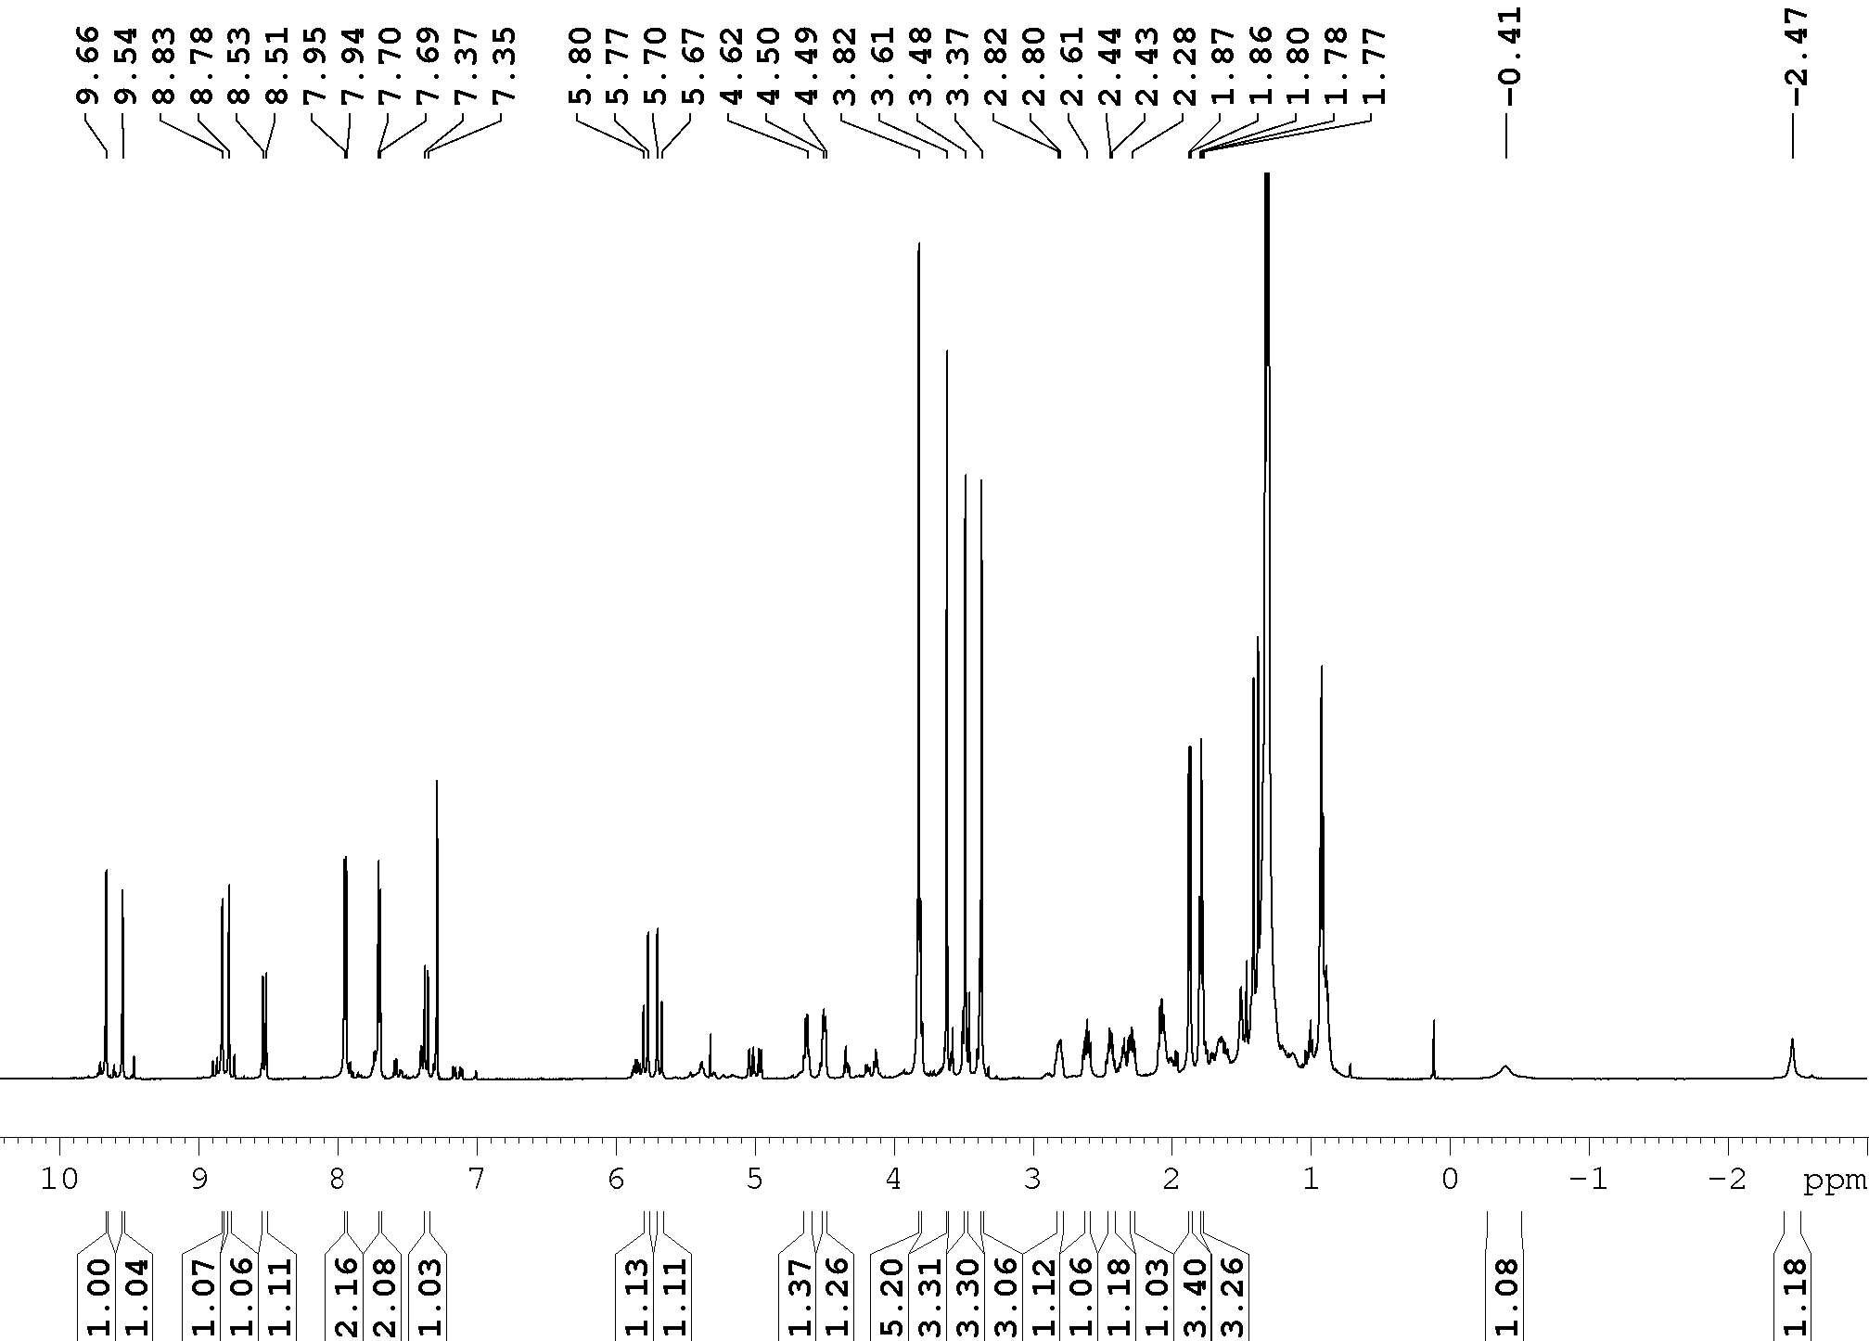
¹H NMR spectrum of compound 9b
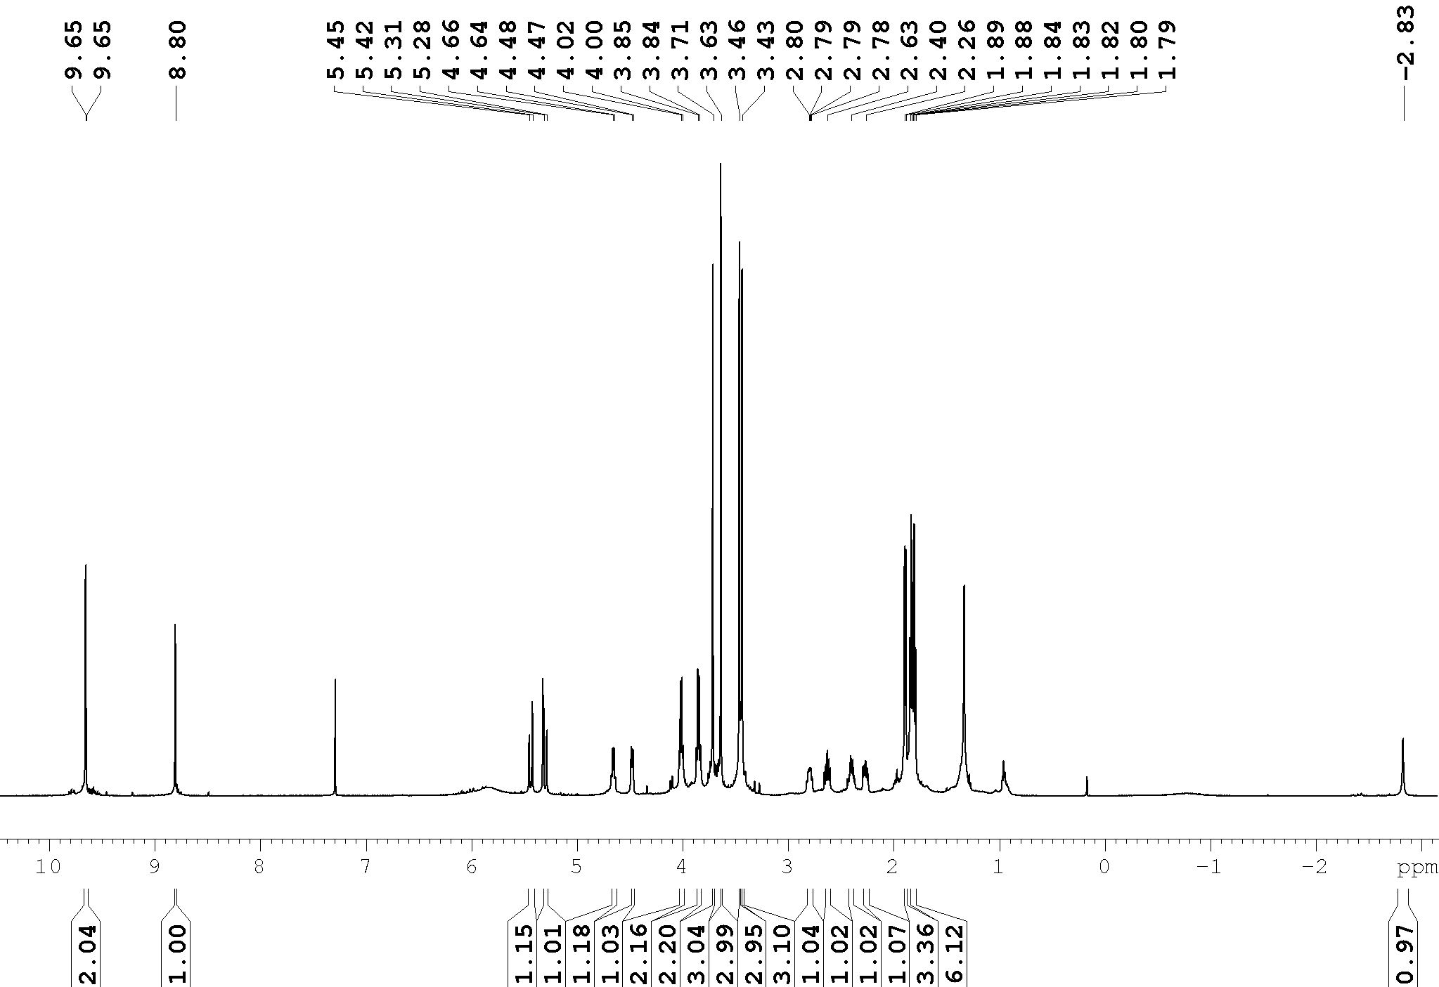
¹H NMR spectrum of compound 2
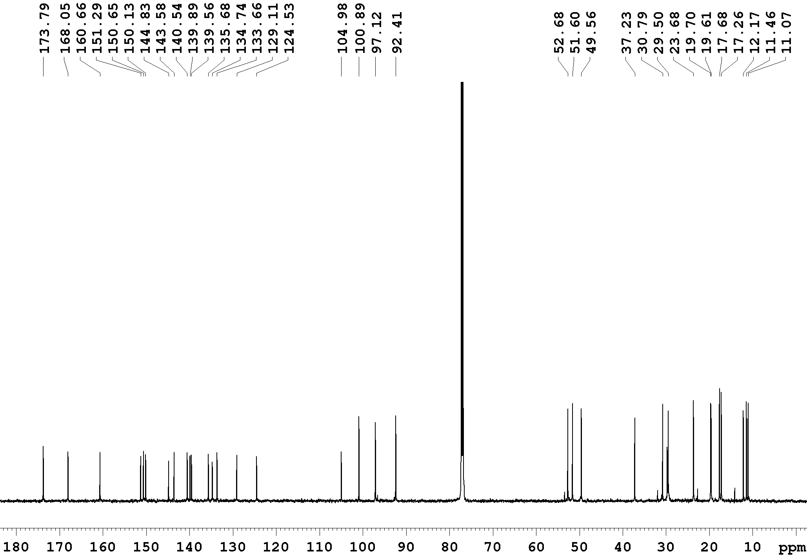
¹³C NMR spectrum of compound 2
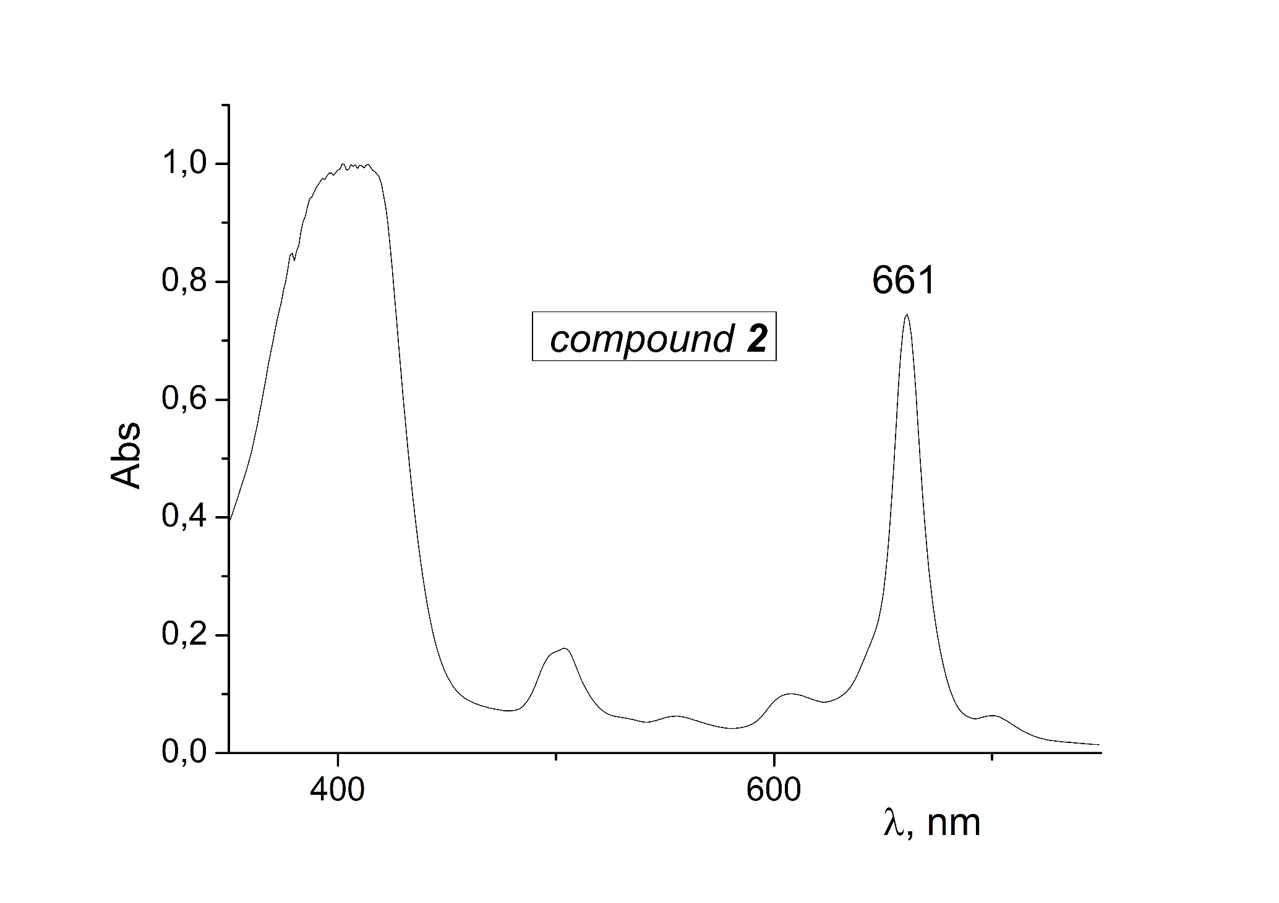
UV-vis spectrum of compound 2
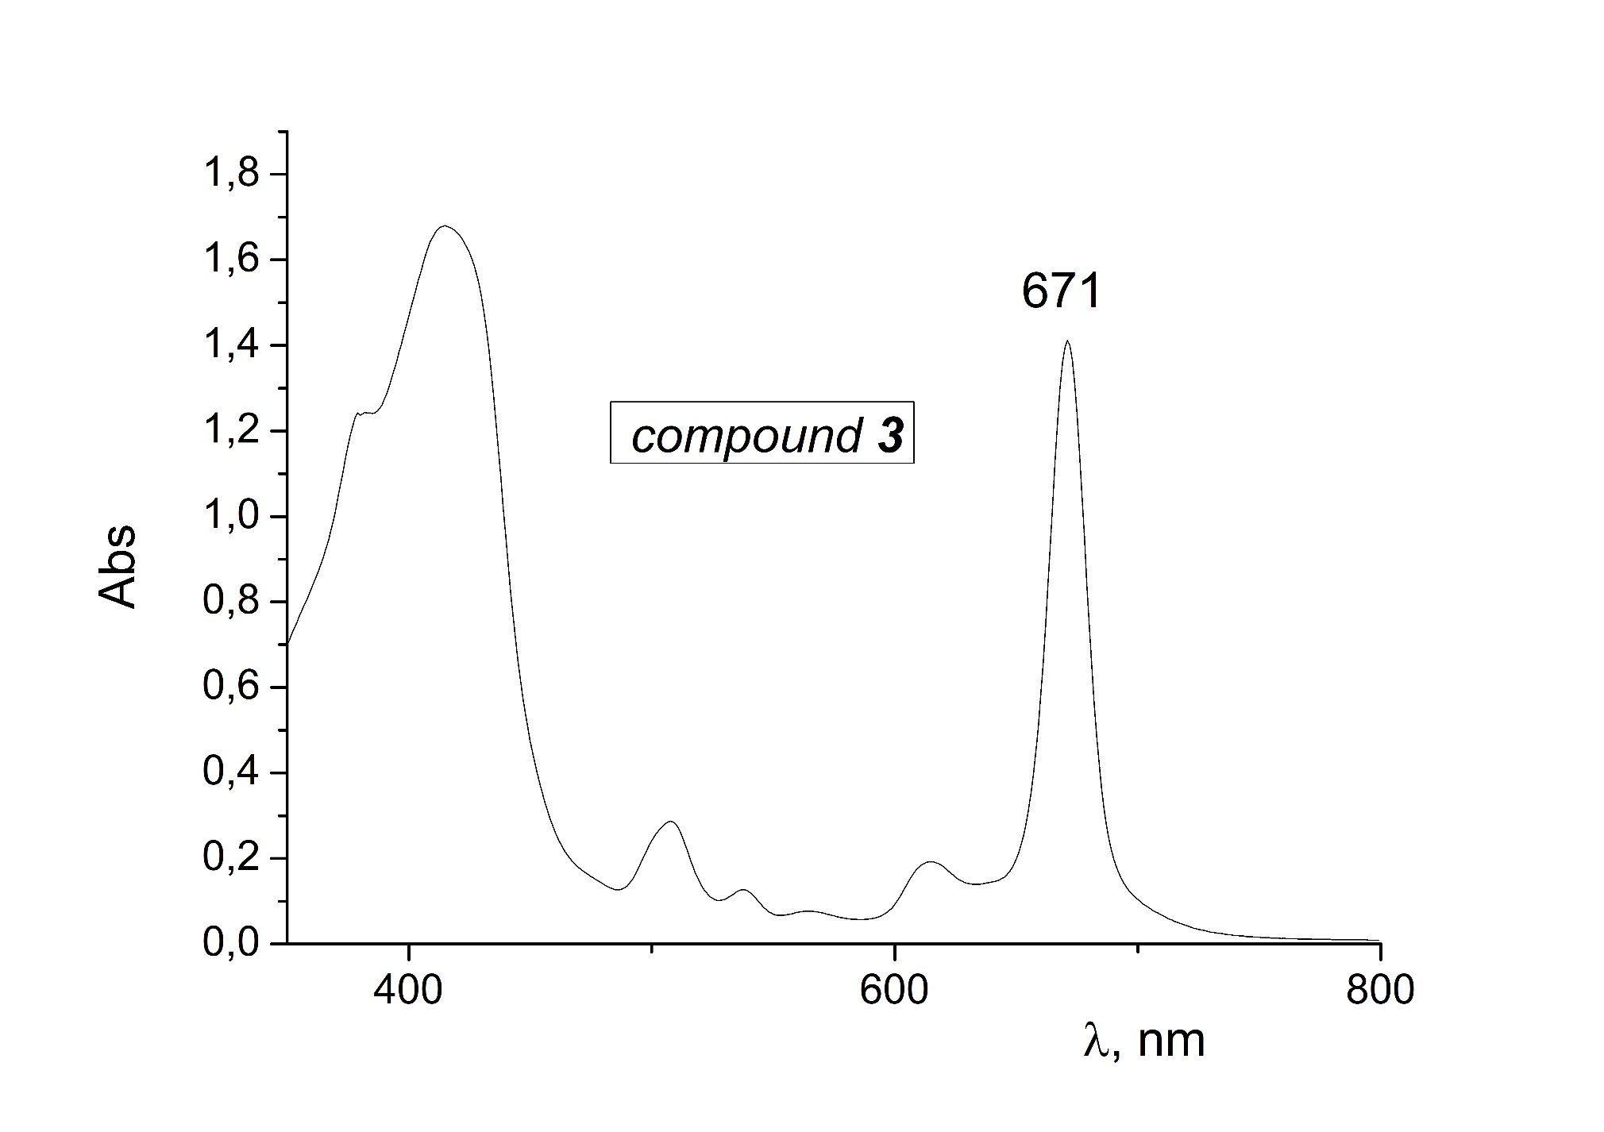
UV-vis spectrum of compound 3
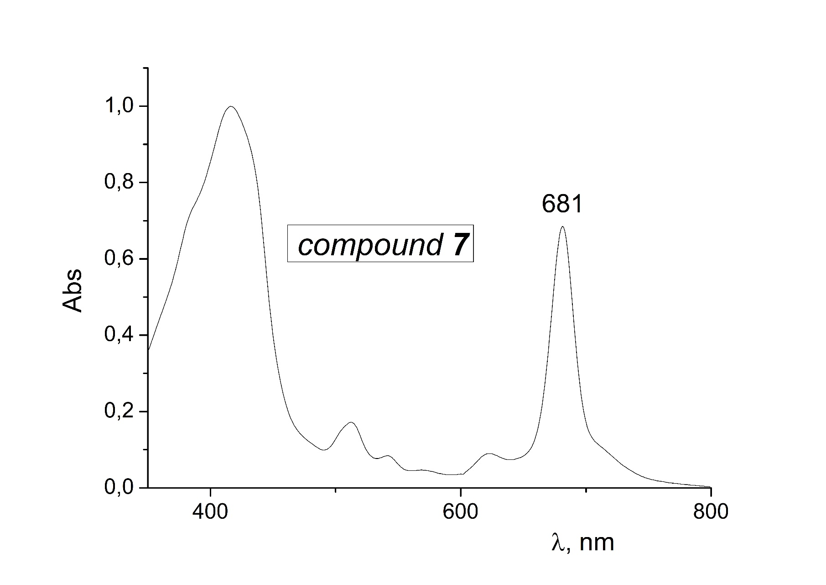
UV-vis spectrum of compound 7
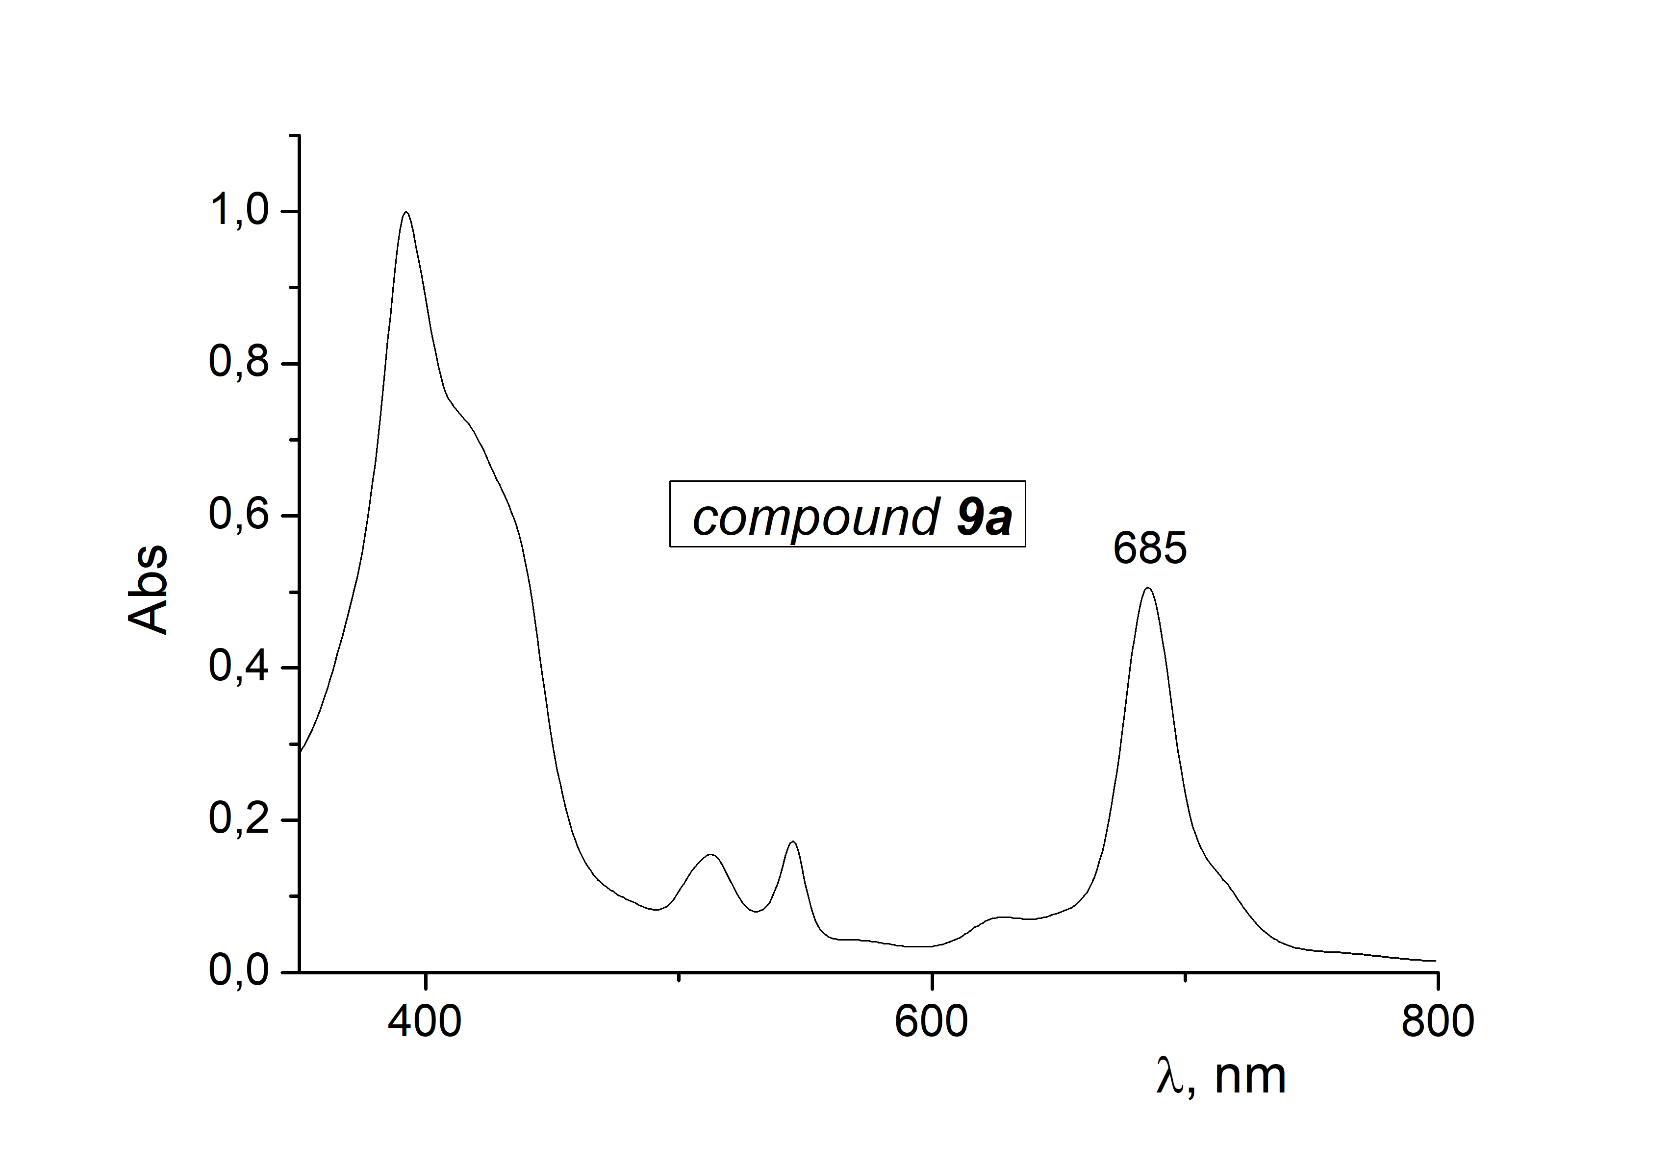
UV-vis spectrum of compound 9a
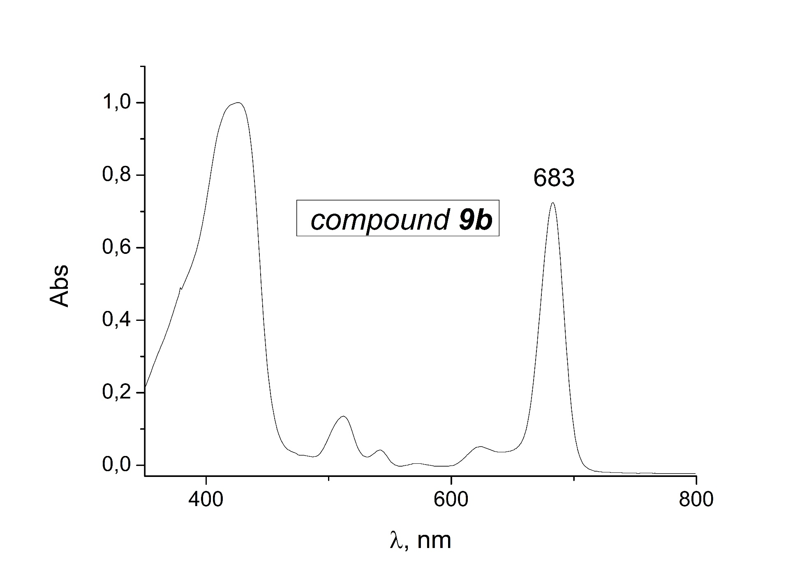
UV-vis spectrum of compound 9b
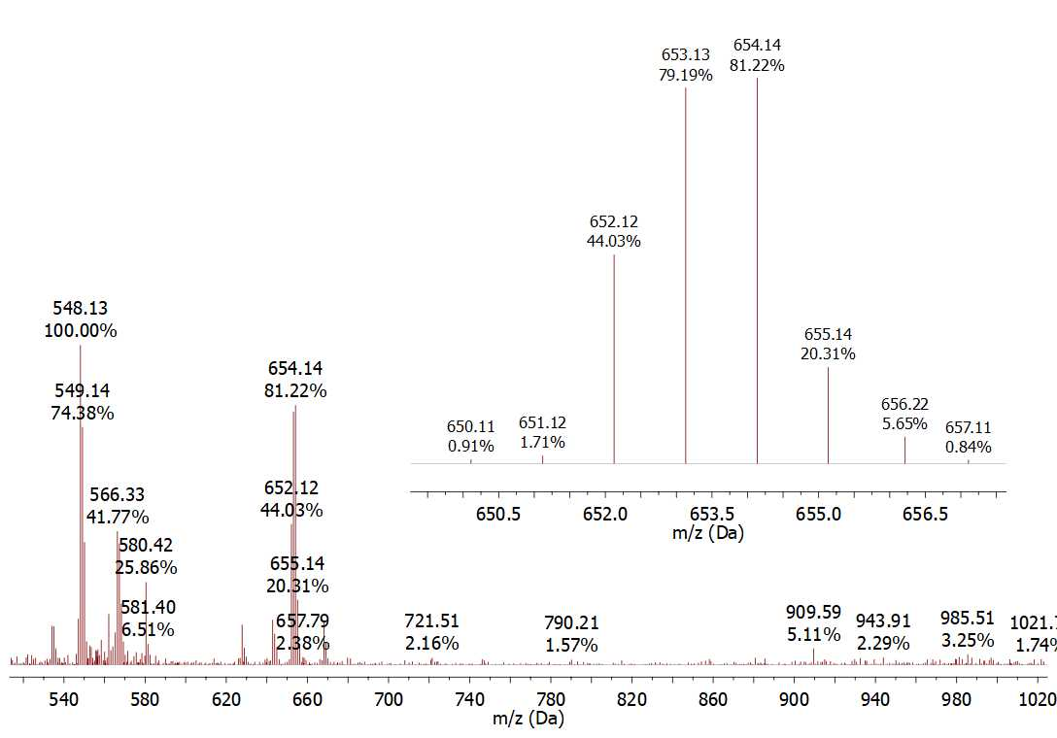
Mass spectrum fragment of compound 3
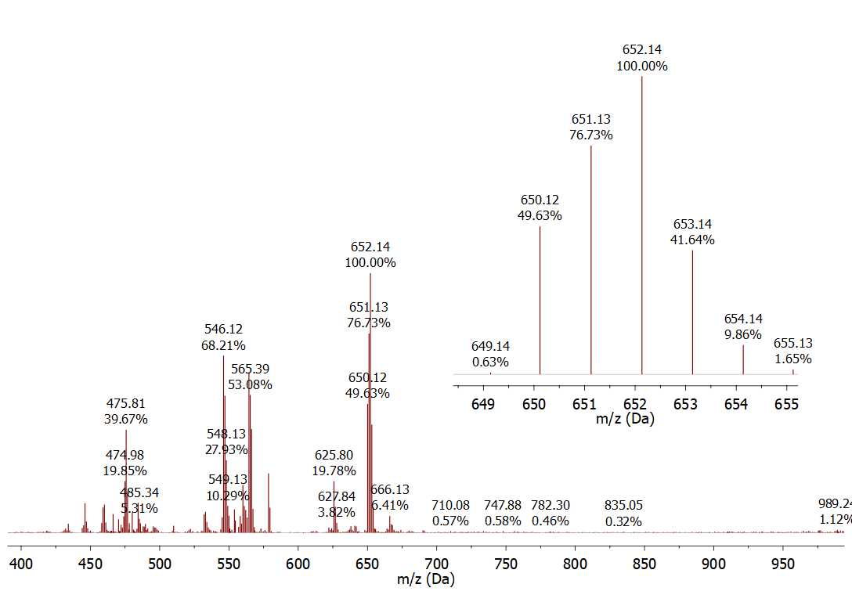
Mass spectrum fragment of compound 7
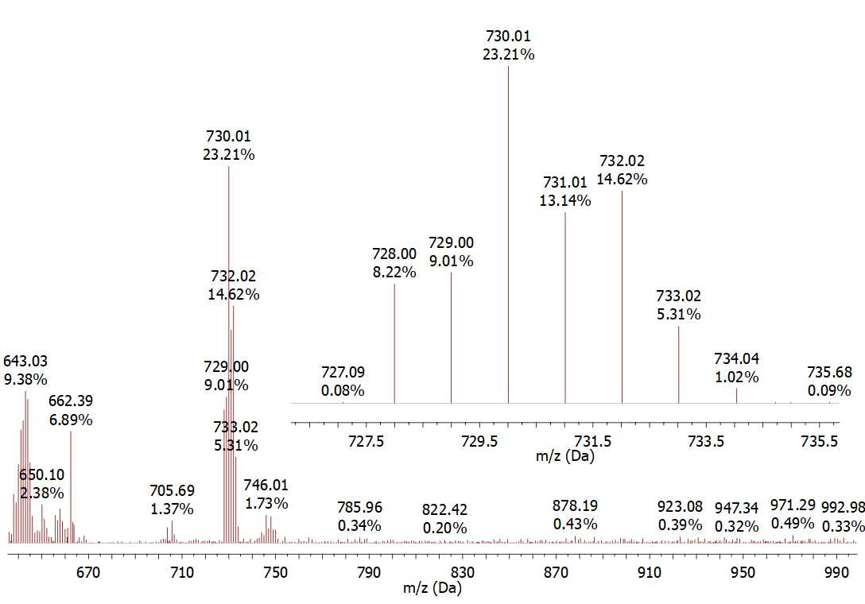
Mass spectrum fragment of compound 9a
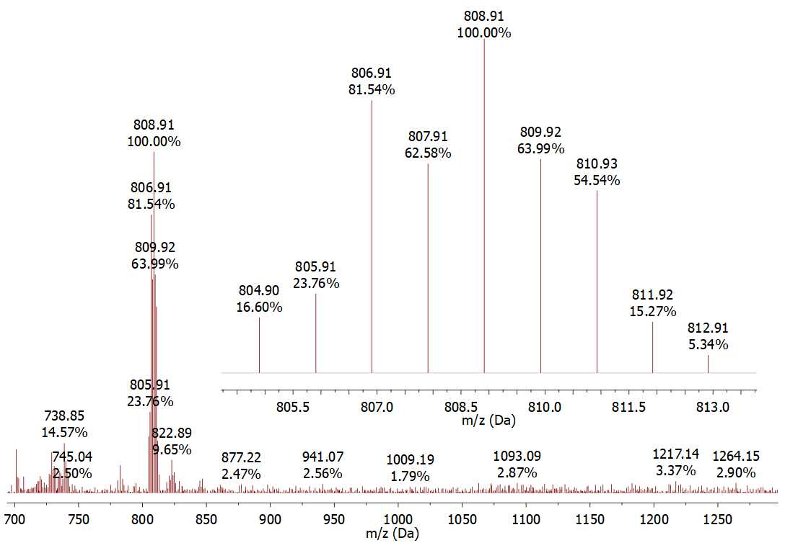
Mass spectrum fragment of compound 9b

