**Supporting Information**

Effect of the Synthesis Method on the Structure of Tetrafluorosubstituted Tin Phthalocyanines (DOI: 10.6060/mhc245862b)

Darya D. Klyamer, Aleksandr S. Sukhikh, Dmitry V. Bonegardt and Tamara V. Basova@

Nikolaev Institute of Inorganic Chemistry SB RAS., Novosibirsk, 630090, Russia

@*Corresponding author E-mail: basova@niic.nsc.ru*

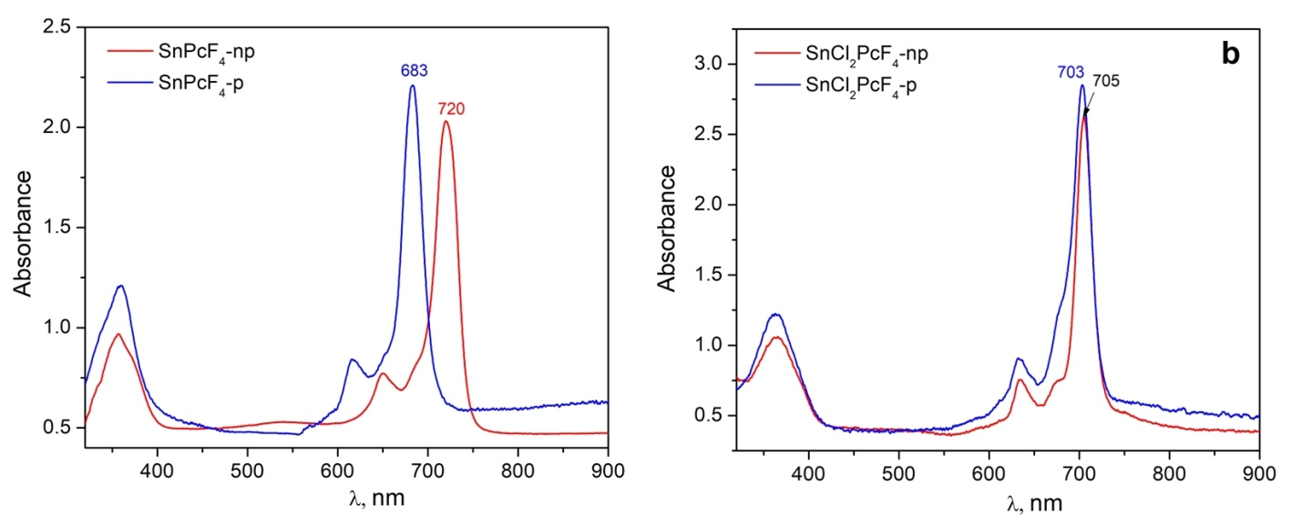

**Figure S1.** Optical absorption spectra ofthe solutions (in tetrahydrofuran) of Sn(II) (a) and Sn(IV) (b) phthalocyanine derivatives.



**Figure S2.** Mass-spectra of SnPcF4-p (a) and SnPcF4-np (b).



**Figure S3.** TG curves of SnPcF4-p (a) and SnPcF4-np (b).

**Figure S4.** XRD patterns of SnCl2PcF4-p (a) and SnCl2PcF4-p (b) powders before and after sublimation of the crude products (Method 2) in comparison with the XRD patterns calculated from the SnPcF4-p and SnPcF4-np single crystal data.