SUPPLEMENTARY MATERIALS
Influence of Substitution Patterns in A Set of BODIPY Derivatives on Aggregation Properties in Binary Solvent Mixtures.
Elena V. Antina¹, Daniil D. Gryaznov², Evgeniy E. Molchanov^{2,3}, Valeria A. Kalinkina^{1,2}, Alexander A. Kalyagin¹, Tatiana V. Kokurina², Lubov A. Antina¹, Ksenia V. Ksenofontova^{2,3}, Yuriy S. Marfin³ and Sergey D. Usoltsev^{2,3 @}
¹ G.A. Krestov Institute of Solution Chemistry of the Russian Academy of Sciences, Ivanovo, 153045, Russia
² Ivanovo State University of Chemistry and Technology, Ivanovo, 153000, Russia.
³ Pacific National University, Khabarovsk, 680035, Russia
@ Corresponding author E-mail: sergeyusoltsev@yahoo.com

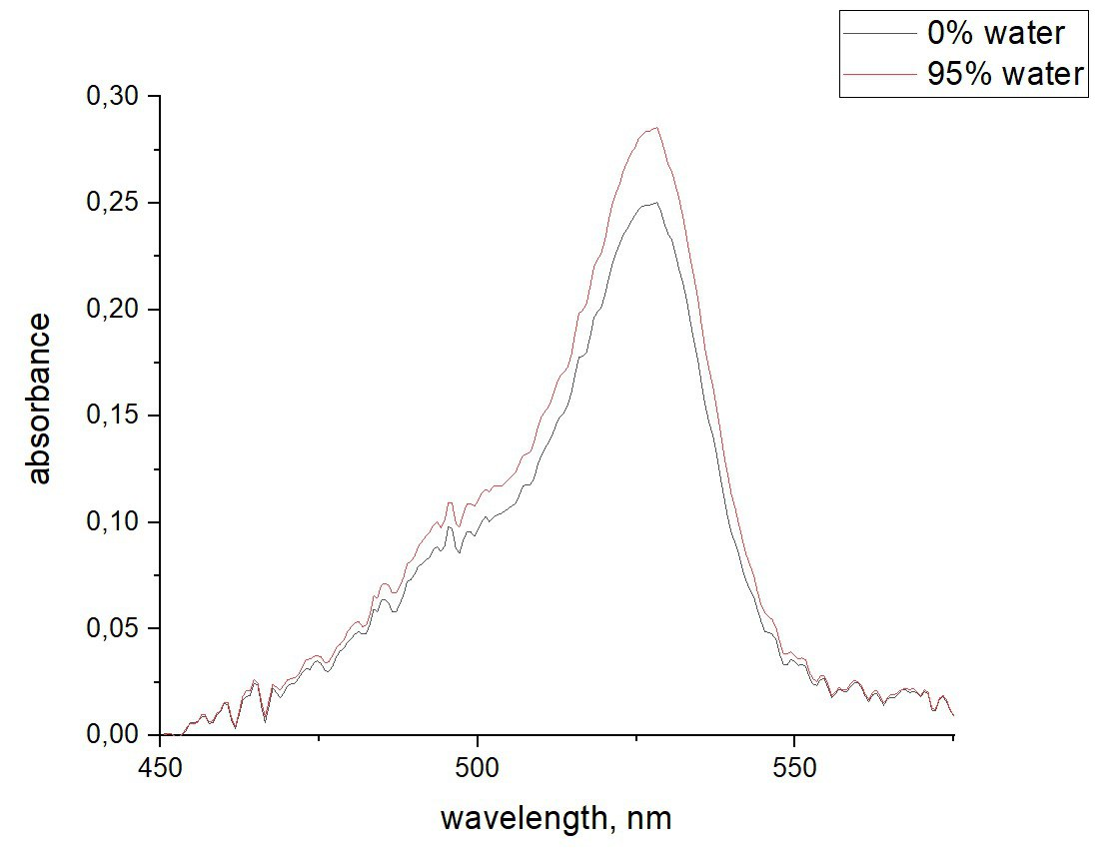 | 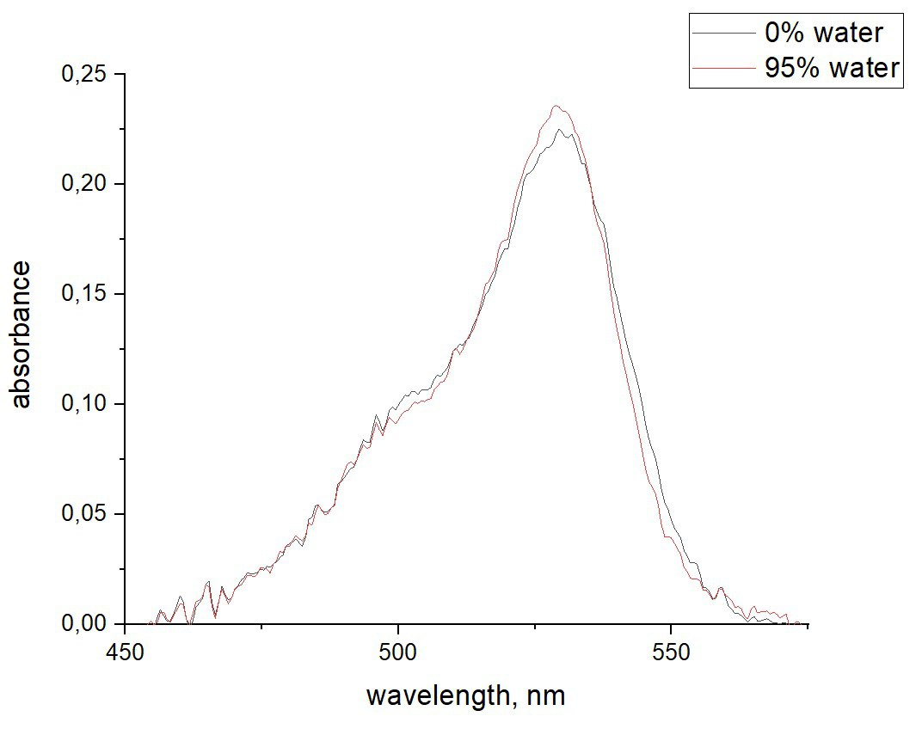 | 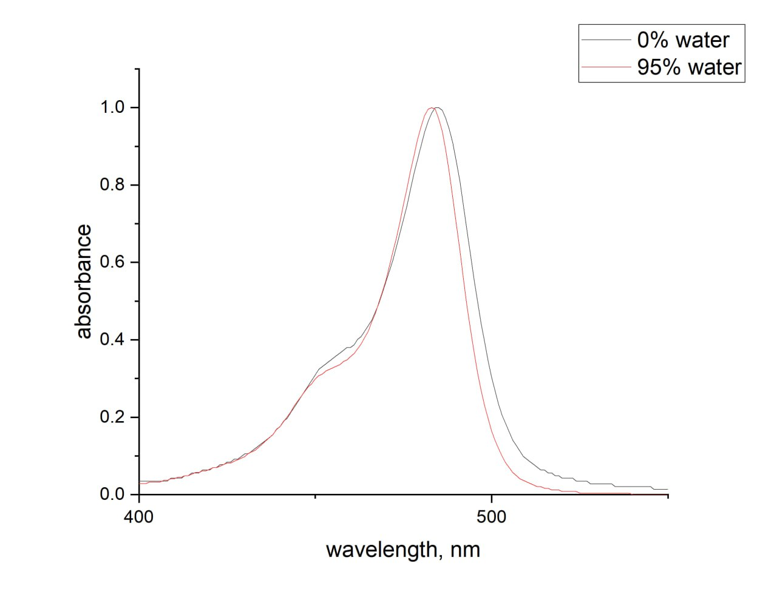
(a) | (b) | (c)
Figure S1. Example electronic absorption spectra, demonstrating lack of significant changes during aggregation experiment. (a) meso-ortho-pyridine-BODIPY in water – acetonitrile mixture, (b) meso-para-pyridine-BODIPY in water – acetonitrile mixture, (c) meso-vanilin-BODIPY in water – THF mixture
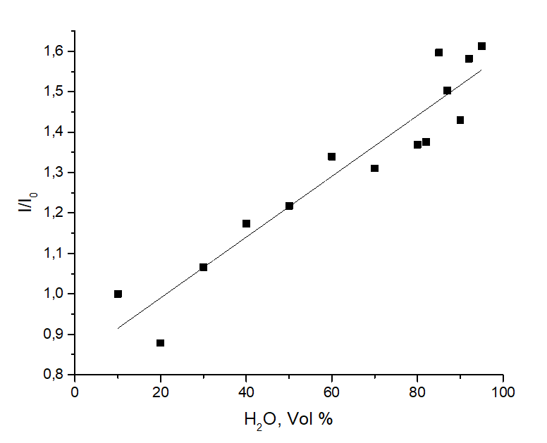 | 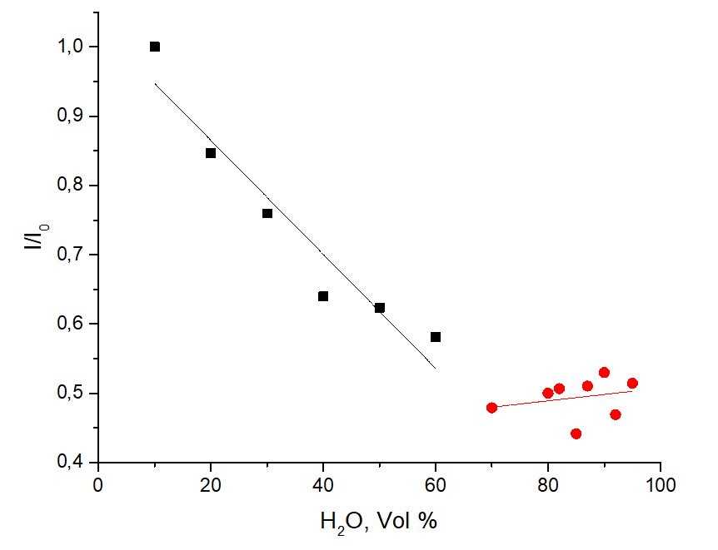
(a) | (b)
Figure S2. Dependencies of fluorescence intensity on water content for (a) meso-ortho-pyridine-BODIPY in Water – DMSO mixtures and (b) meso-para-pyridine-BODIPY in water-DMSO mixtures. Dependencies are normalized to the first point. Black points are intensities before inflection, red points – beyond “critical” water content. λ_{ex} = 530 nm, λ_{em} = 545 nm for both compounds.

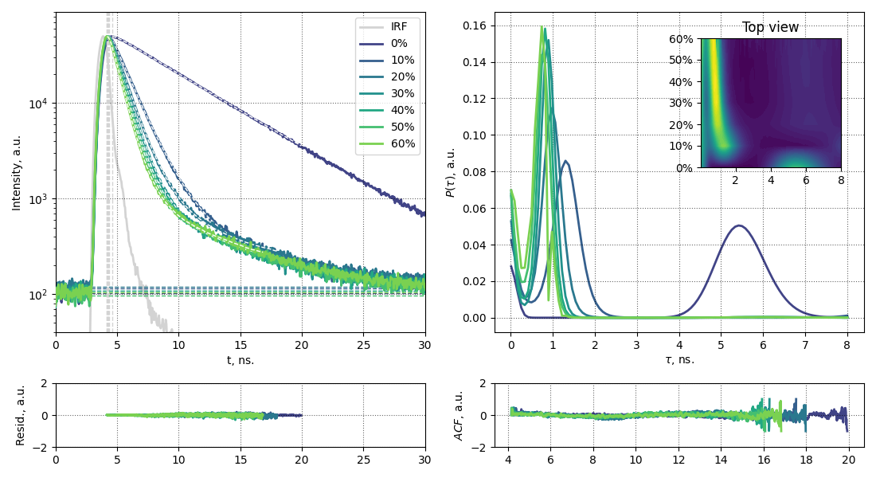 | 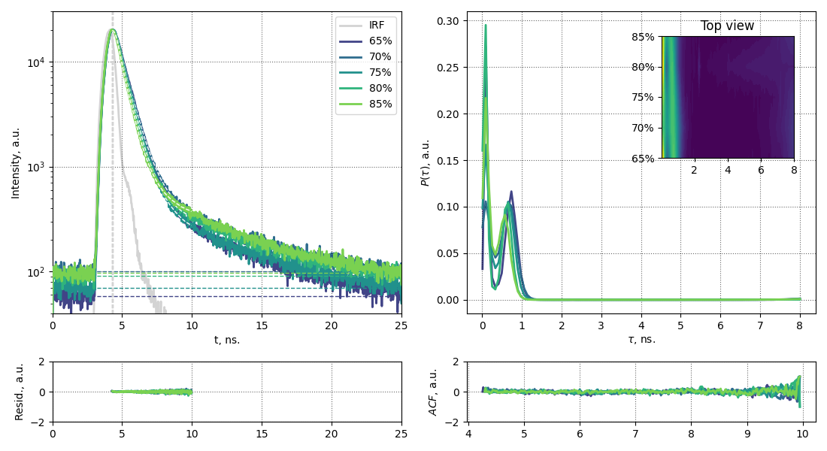
(a) | (b)
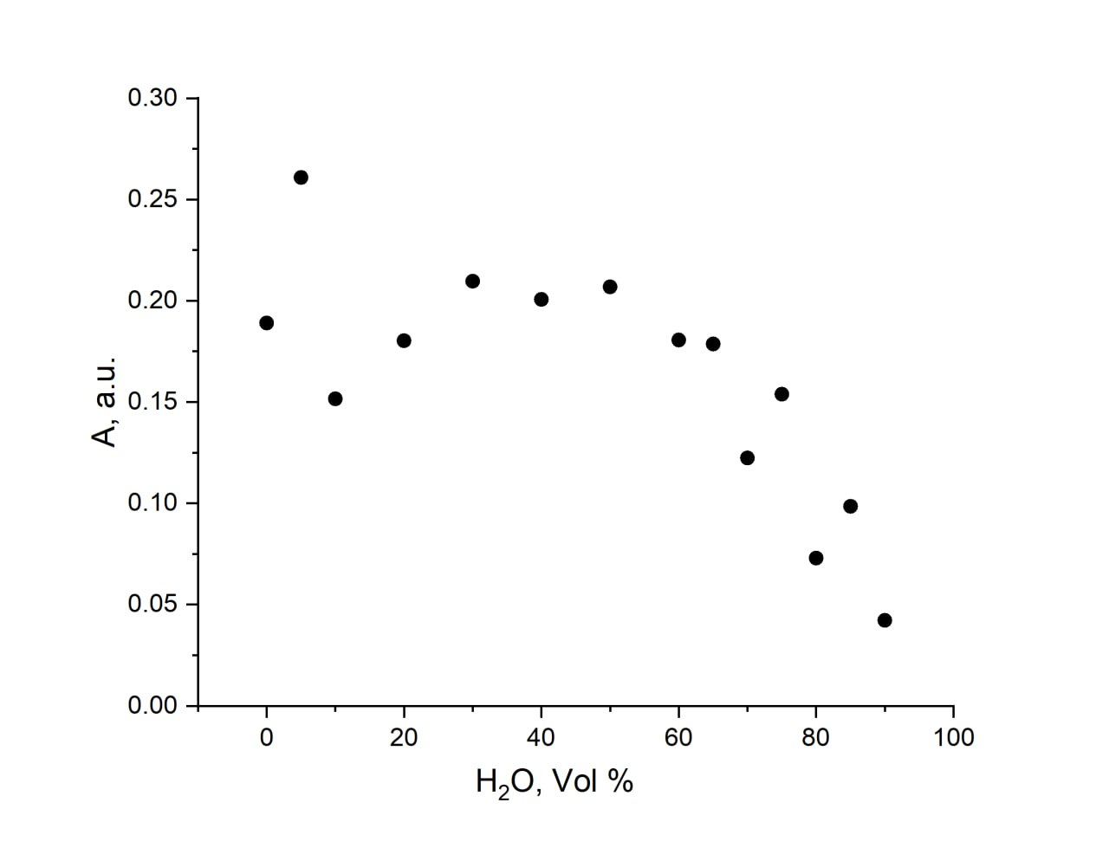
Figure S3. Fluorescence lifetime distributions obtained from maximum entropy fitting of 100 lifetimes in Water – ACN mixtures for vanilin-BODIPY in (a) range of 0 – 8 ns up to 60 Vol.% water content and (b) range of 0 – 8 ns with water content in the range of 65 – 85 Vol.%

Figure S4. Changes in EAS maximum intensity for meso-vanilin-BODIPY in water – ACN mixture upon change in volumetric water content.

