Supporting information for

Oxygen Activation Process vs the Metal-Organic Frameworks Structure (DOI: 10.6060/mhc245905k)
Vyacheslav A. Kulev, Igor V. Novikov, Nadezhda M. Berezina, Mikhail I. Bazanov, and Tatyana A. Ageeva

Figure 1. IR spectra of cobalt tetracarboxyphthalocyanine (red line) and MOF based on them (black line)

Figure 2. IR spectra of cobalt octacarboxyphthalocyanine (red line) and MOF based on them (black line)

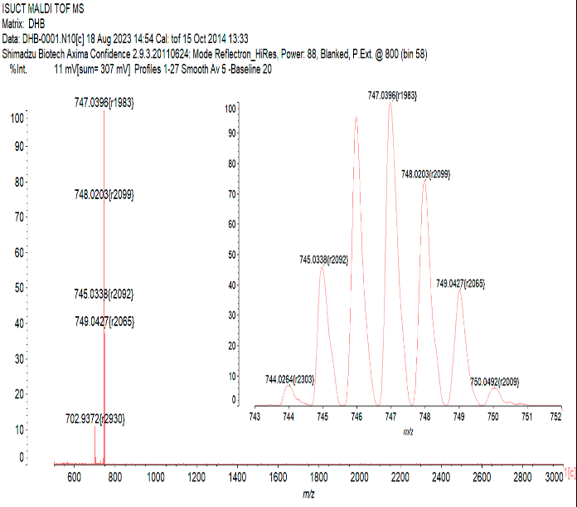  a | 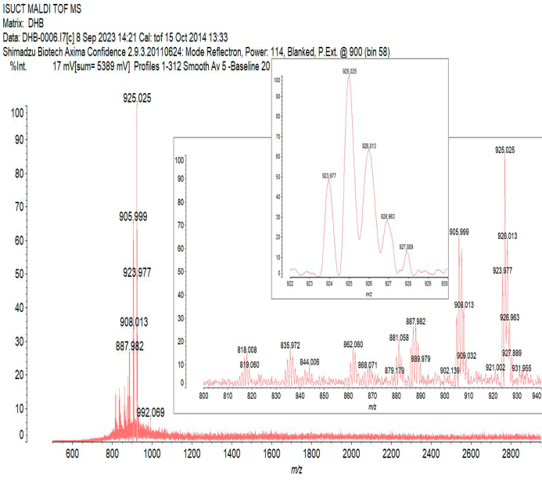  b
Figure 3. MALDI ToF mass spectra of the cobalt tetracarboxyphthalocyanine (a) and cobalt octacarboxyphthalocyanine (b)

The mass spectra show molecular peaks corresponding to tetra- and octaphthalocyanes ([M⁺] = 747 Da for CoPc(COOH)₄ and [M⁺] = 925 Da for CoPc(COOH)₈), but there are also peaks associated with the elimination of water (for CoPc(COOH)₈ to formation of anhydrides) and CO₂. These processes occur at the sample ionization by a laser impact.

