SUPPORTING INFORMATION
Novel Imidazolium Derivatives of Thiacalix[4]arenes Containing Fluorescein Fragments: Synthesis, Aggregation Properties and Photocatalytic Activity
DOI: 10.6060/mhc256787s
Elza D. Sultanova,@ Alina A. Artemenko, Ekaterina A. Bondareva,
Ilshat M. Bogdanov, Aliya E. Akhatova, Diana A. Mironova, Vladimir A. Burilov, Svetlana E. Solovieva, and Igor S. Antipin

Kazan Federal University, 420008 Kazan, Russian Federation.
@Corresponding author E-mail: elsultanova123@gmail.com

a)

b)
c)
C-O
Ph
CH
C-Br
d)
Figure S1. NMR ¹H (a), ¹³C (b), FT IR (c) and HRESI MS (d) spectra of (2b).

a)

b)
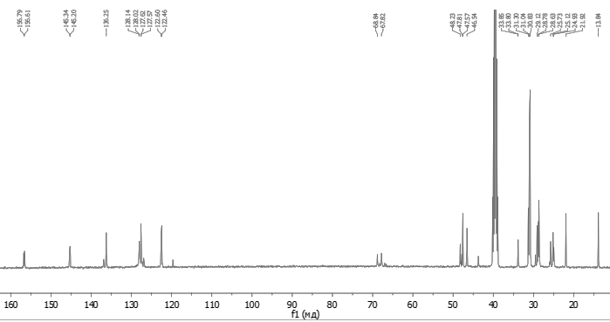
c)

d)
Figure S2. NMR ¹H (a), ¹³C (b), FT IR (c) and HRESI MS (d) spectra of (4b).

a)
b)
c)

d)
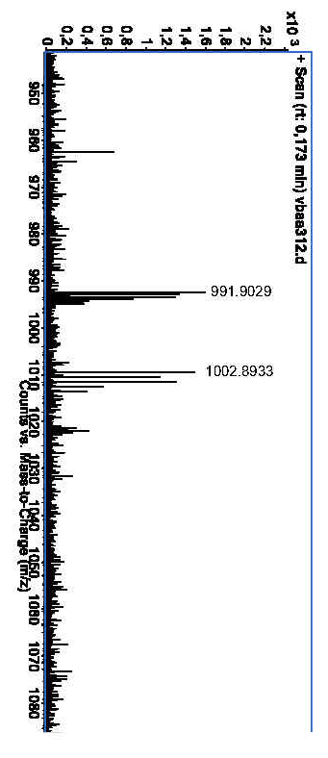
Figure S3. NMR ¹H (a), ¹³C (b), FT IR (c) and HRESI MS (d) spectra of 6a.

a)
b)
c)

d)
Figure S4. NMR ¹H (a), ¹³C (b), FT IR (c) and HRESI MS (d) spectra of 6b.

Table 1S. Data from Boltzmann Equation.
Model | Boltzmann
Equation | y = A2 + (A1-A2)/(1 + exp((x-x0)/dx))
Reduced Chi-Sqr | 8.56E-05 | 7.38E-05
Adj. R-Square | 0.99898 | 0.99727
 |  | Value | Standard Error
D | A1 | 1.6491 | 0.00905
D | A2 | 1.11111 | 0.01524
D | x0 | -0.84214 | 0.03025
B | A1 | 1.73661 | 0.01048
B | A2 | 0.83296 | 0.00636
B | x0 | -1.31381 | 0.0124

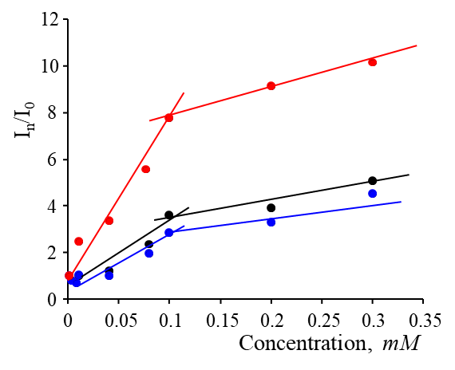
Figure S5. Dependence of the emission intensity of 5 (black), Flu-TCA-C4 (blue) and Flu-TCA-C8 (red) on the concentration.

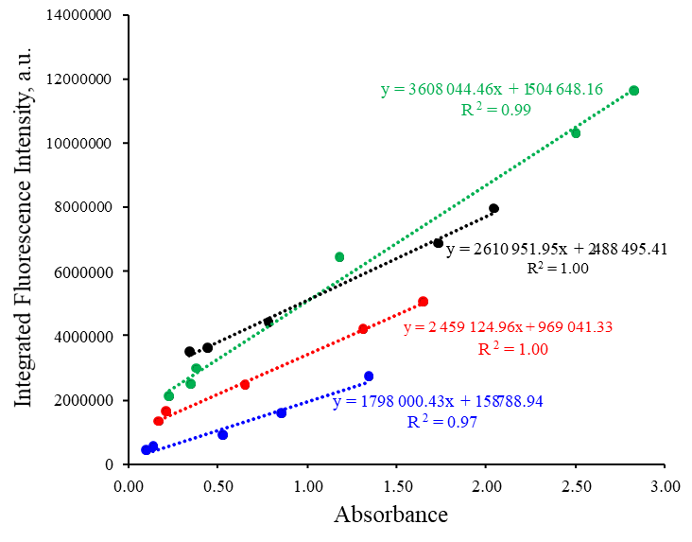
Figure S6. Integrated fluorescence intensity vs max. absorbance at different concentrations for fluorescein (0.1M NaOH) and fluorescein (green), 5 (black), Flu-TCA-C4 (blue), Flu-TCA-C8 (red) (water with 50% DMF); C = 0.001-0.1 mM

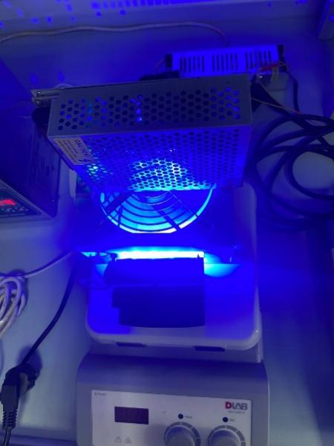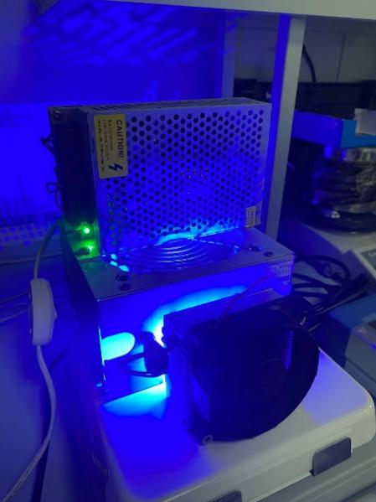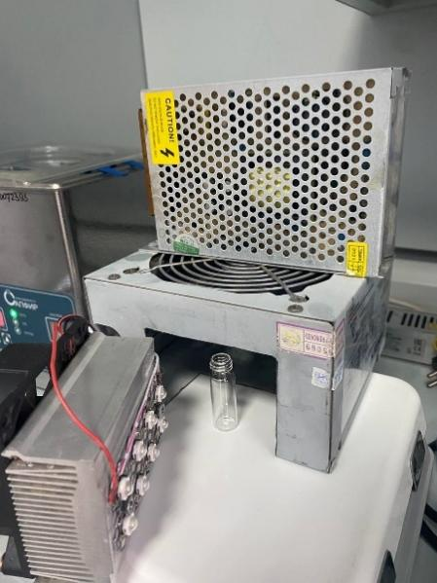
Figure S8. Photo of the photoreactor.

Figure S9. Graph of the dependence of the peak area of N-phenyl-1,2,3,4-tetrahydroisoquinoline on the GC-MS spectra on its concentration.

Figure S10. NMR ¹H-spectrum of the reaction mixture with a catalyst (6a), CDCl₃, 25 ºC.

