SUPPORTING INFORMATION FOR

Unexpected reactivity of 2,3-diaminoporphyrins with β-diketones (DOI: 10.6060/mhc256900b)

Ekaterina S. Shremzer,ª Kirill P. Birin,^{a@} and Aslan Yu. Tsivadze^{a,b}
ªFrumkin Institute of Physical Chemistry and Electrochemistry Russian Academy of Sciences, Leninsky prosp., 31-4, Moscow, 119071, Russia
^{b}Kurnakov Institute of General and Inorganic Chemistry Russian Academy of Sciences, Leninsky prosp., 31, 119991 Moscow, Russia
@Corresponding author E-mail: kirill.birin@gmail.com

Table of contents
1. NMR spectra of the synthesized compounds 2
1.1. NMR spectra of mixture of Ni-3 and Ni-4 2
1.2. NMR spectra of Ni-5 7
1.3. NMR spectra of Ni-6 12
1.4. NMR spectra of Ni-7 18
2. UV-Vis spectrum of mixture of Ni-3 and Ni-4 23
3. Mass spectra of the synthesized compounds 23
References 25

- NMR spectra of the synthesized compounds
  - NMR spectra of mixture of Ni-3 and Ni-4
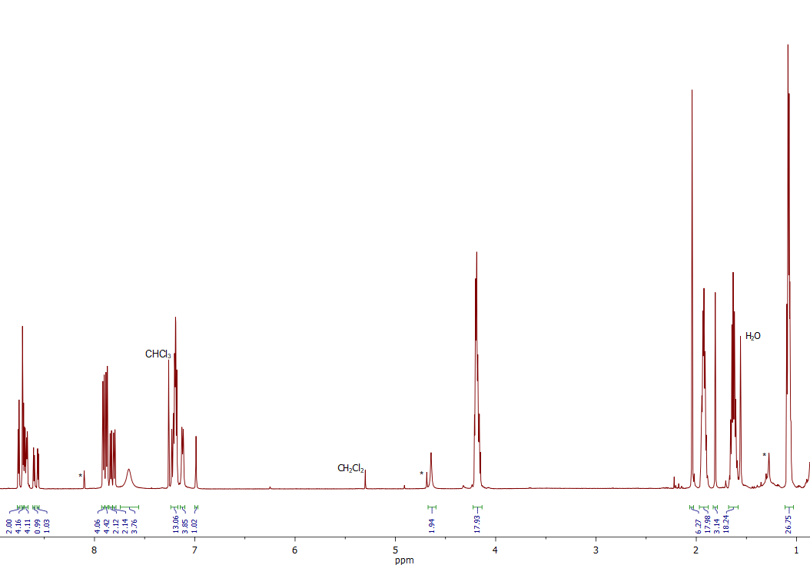
Figure S 1. ¹H NMR spectrum of mixture of Ni-3 and Ni-4 (CDCl₃). The absence of distinct signals for the diastereotopic protons of the diazepine CH₂ group suggests that the coalescence temperature associated with the inversion of the 1,4-diazepine ring is near ambient temperature [1].
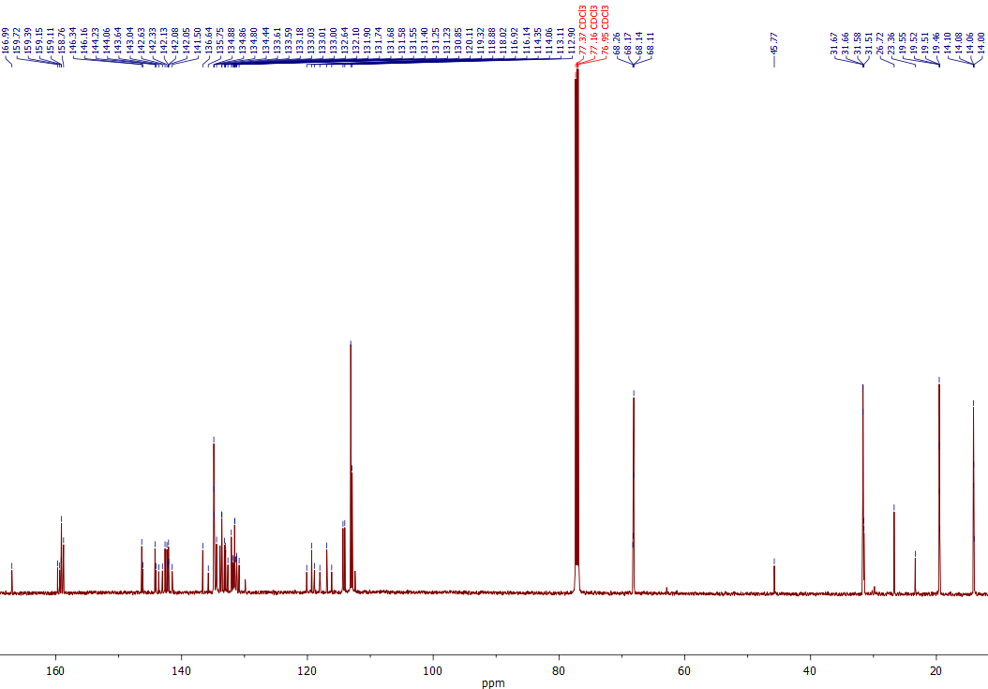
Figure S 2. ¹³C NMR spectrum of mixture of Ni-3 and Ni-4 (CDCl₃).
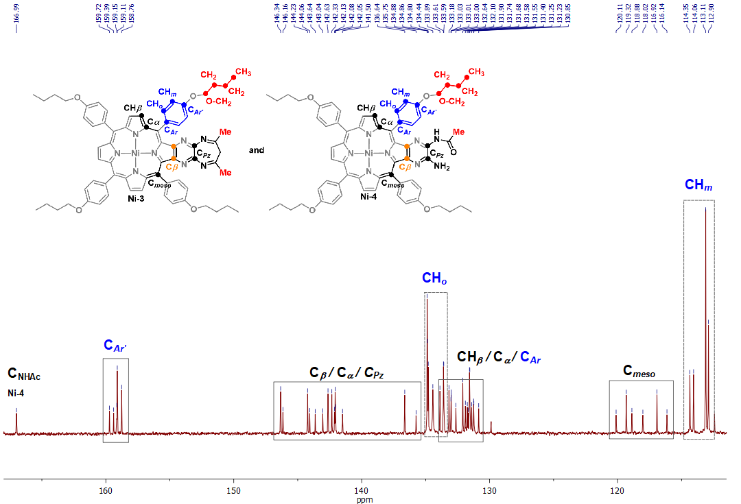
Figure S 3. Expansion of the ¹³C NMR spectrum of mixture of Ni-3 and Ni-4 (aromatic carbon region, CDCl₃) with partial signal assignments.
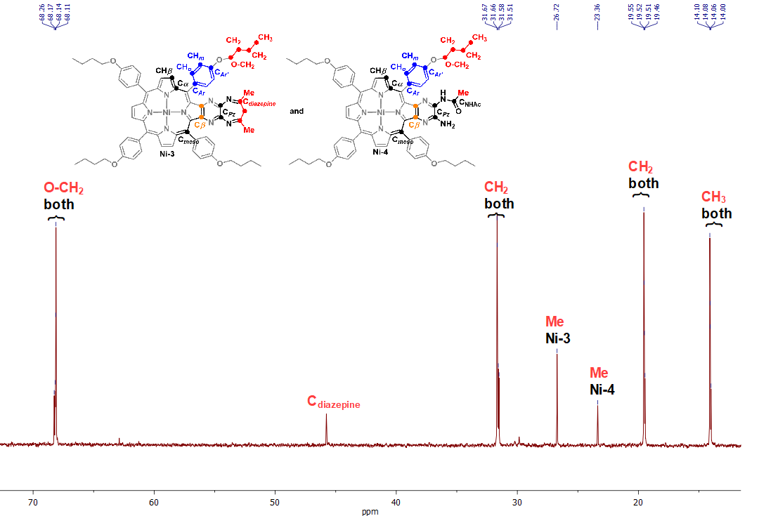
Figure S 4. Expansion of the ¹³C NMR spectrum of mixture of Ni-3 and Ni-4 (aliphatic carbon region, CDCl₃) with partial signal assignments.
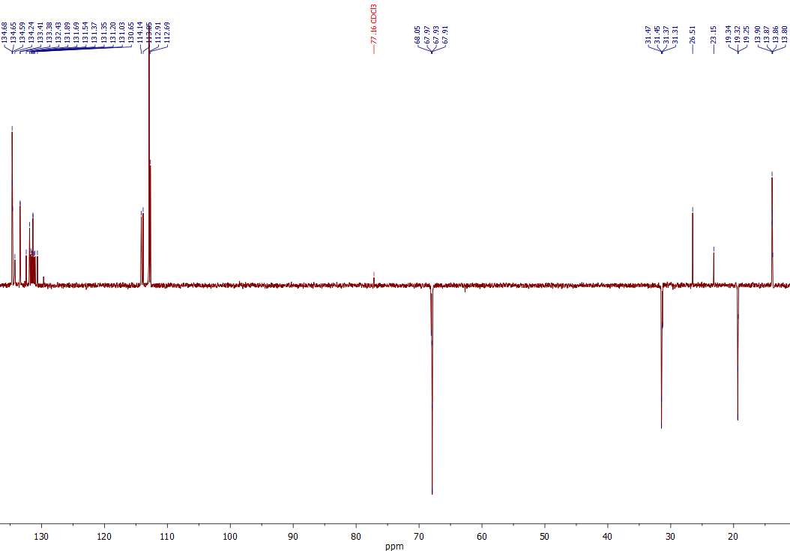
Figure S 5. ¹³C DEPT-135 spectrum of mixture of Ni-3 and Ni-4 (CDCl₃).
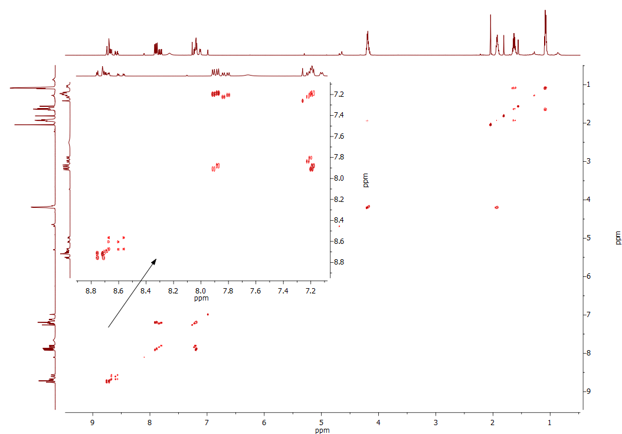
Figure S 6. ¹H-¹H COSY spectrum of mixture of Ni-3 and Ni-4 (CDCl₃).
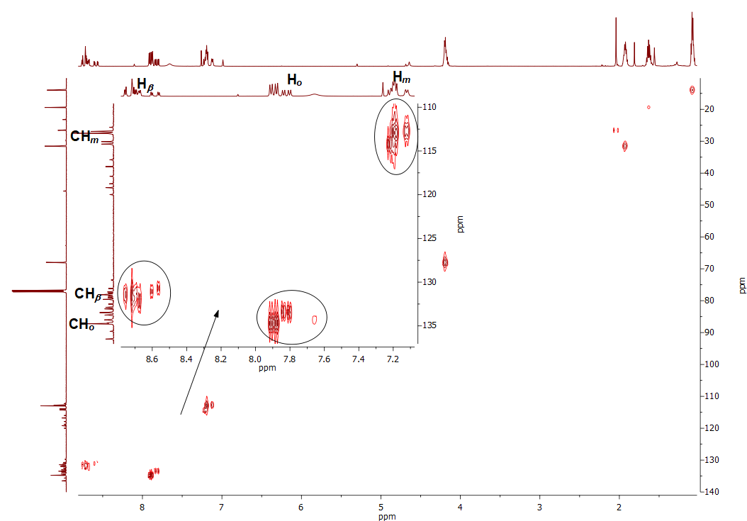
Figure S 7. ¹H-¹³C HSQC spectrum of mixture of Ni-3 and Ni-4 (CDCl₃).
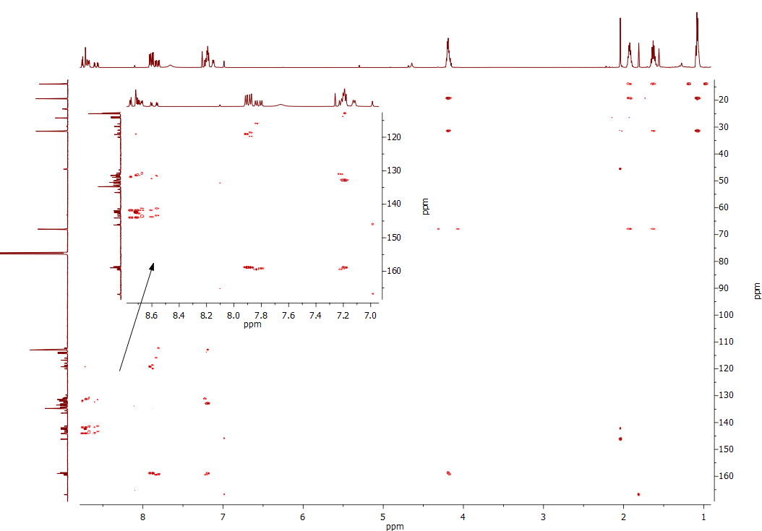
Figure S 8. ¹H-¹³C HMBC spectrum of mixture of Ni-3 and Ni-4 (CDCl₃).
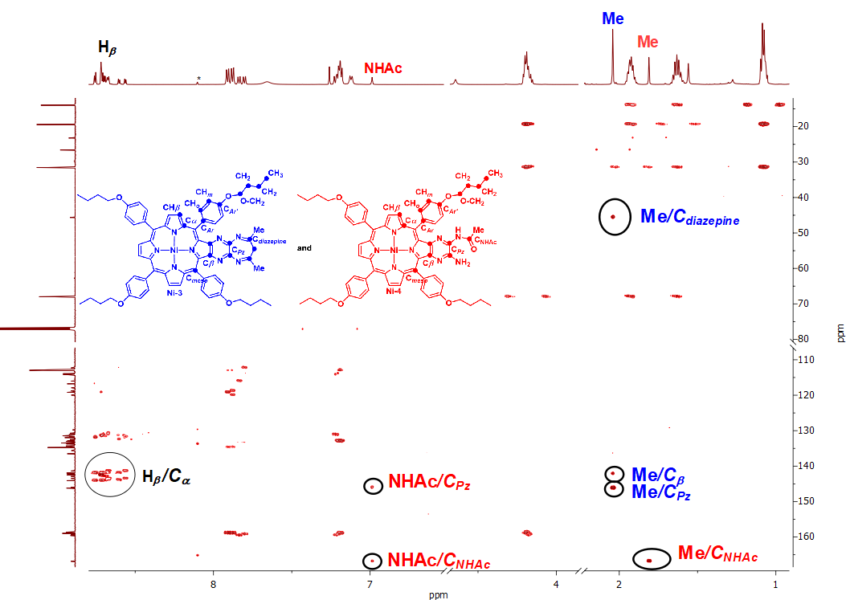
Figure S 9. ¹H-¹³C HMBC spectrum of mixture of Ni-3 and Ni-4 with key correlations indicated (CDCl₃).
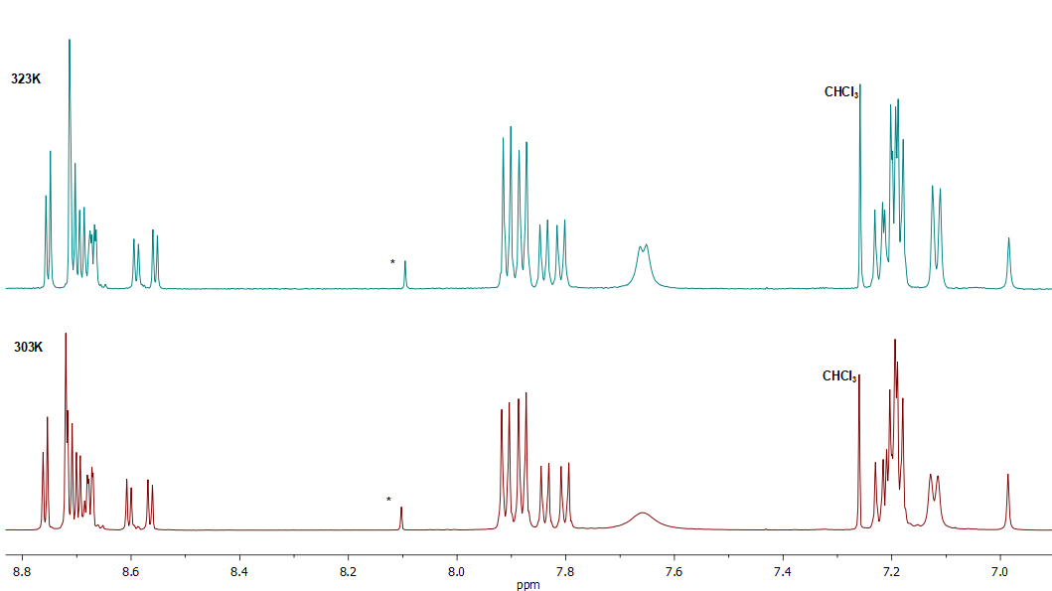
Figure S 10. ¹H NMR spectra of mixture of Ni-3 and Ni-4 (CDCl₃) at various temperature.

  - NMR spectra of Ni-5
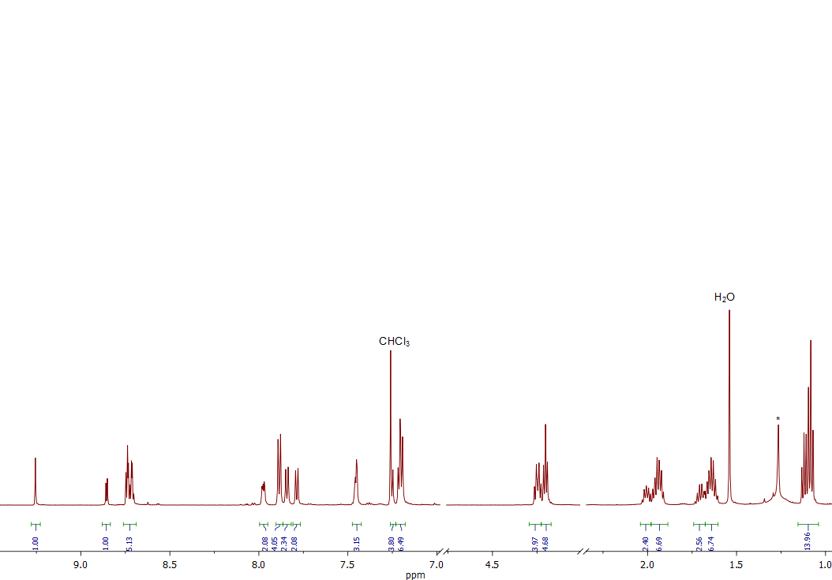
Figure S 11. ¹H NMR spectrum of Ni-5 (CDCl₃).
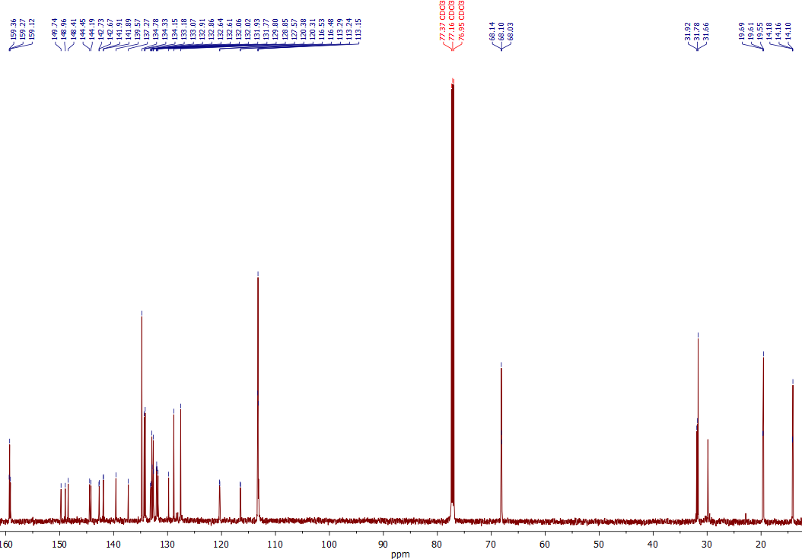
Figure S 12. ¹³C NMR spectrum of Ni-5 (CDCl₃).
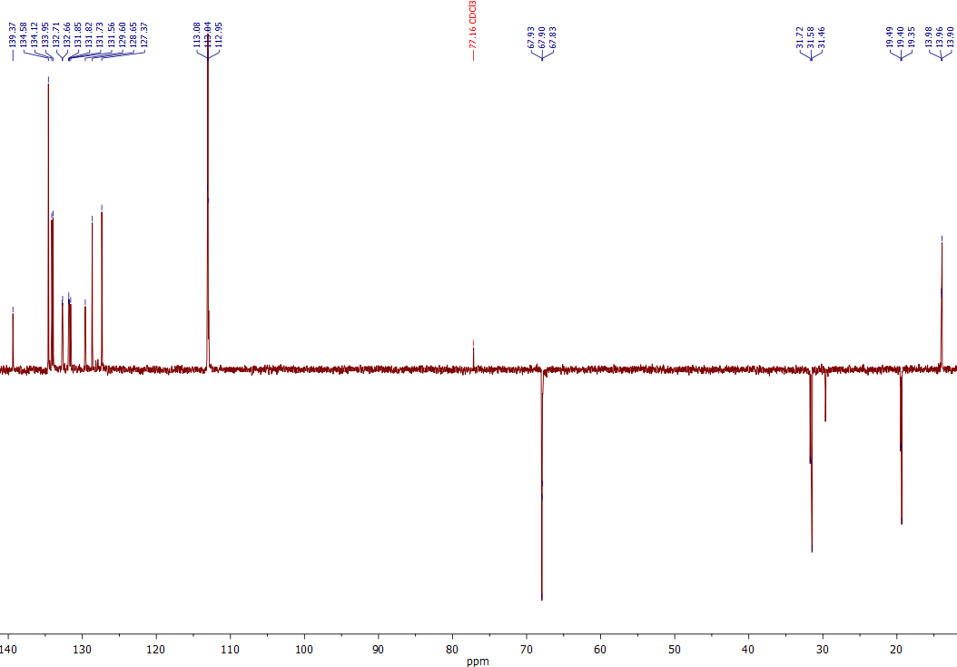
Figure S 13. ¹³C DEPT-135 spectrum of Ni-5 (CDCl₃).
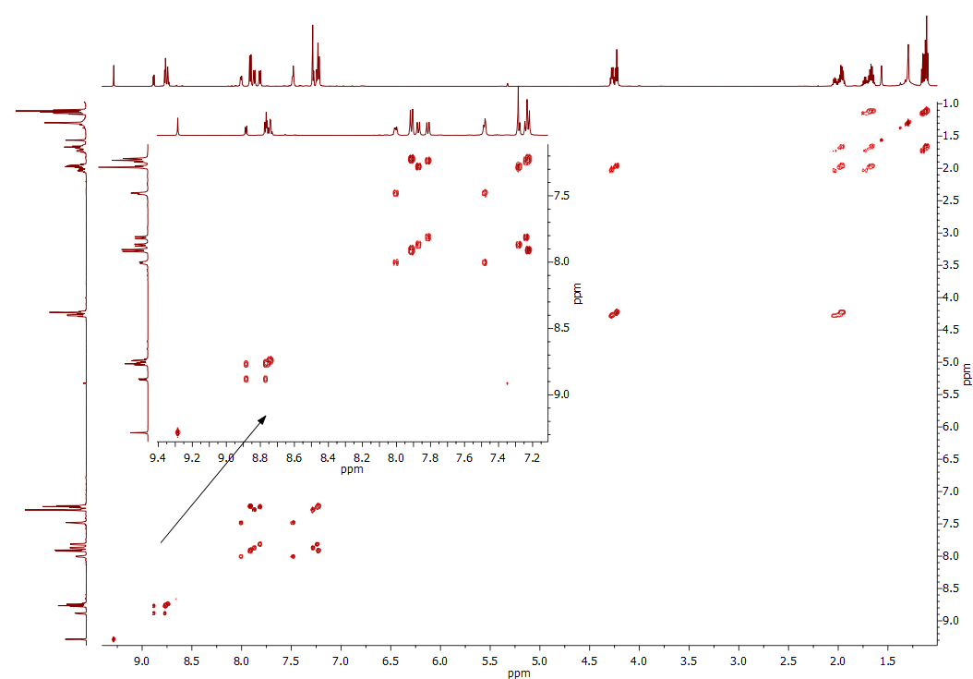
Figure S 14. ¹H-¹H COSY spectrum of Ni-5 (CDCl₃).
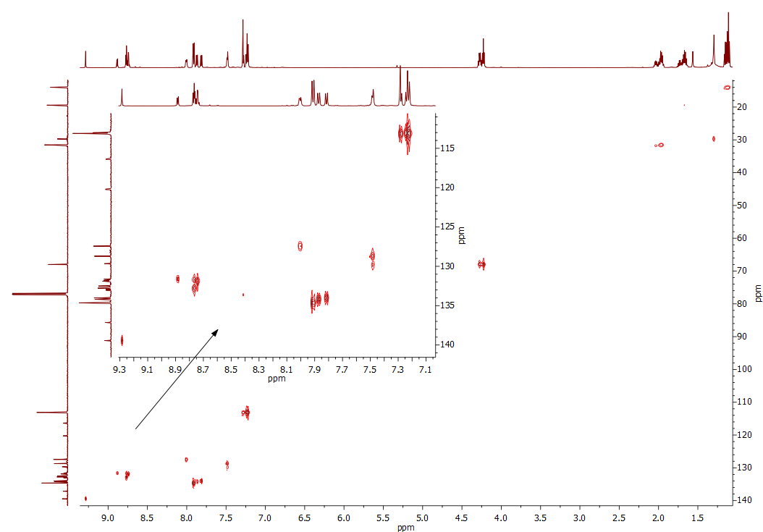
Figure S 15. ¹H-¹³C HSQC spectrum of Ni-5 (CDCl₃).
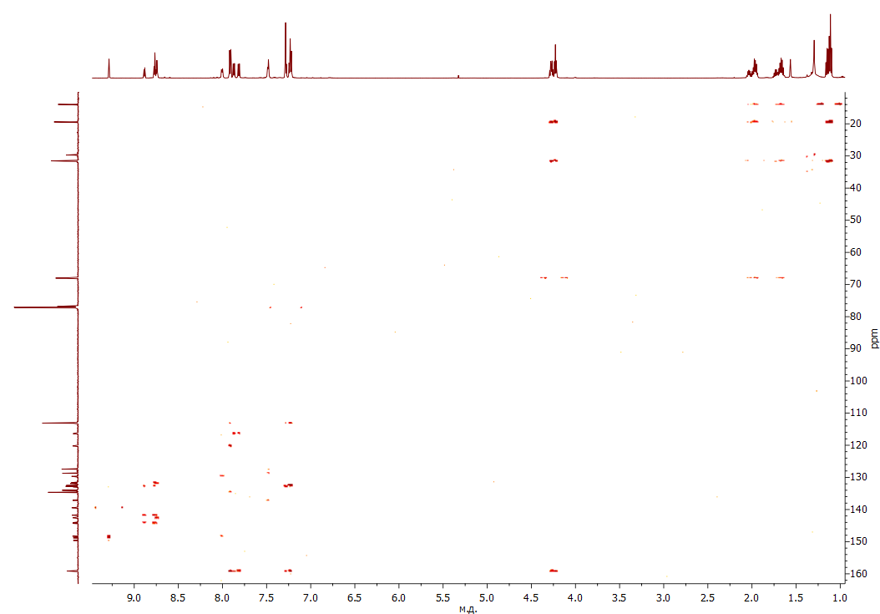
Figure S 16. ¹H-¹³C HMBC spectrum of Ni-5 (CDCl₃).
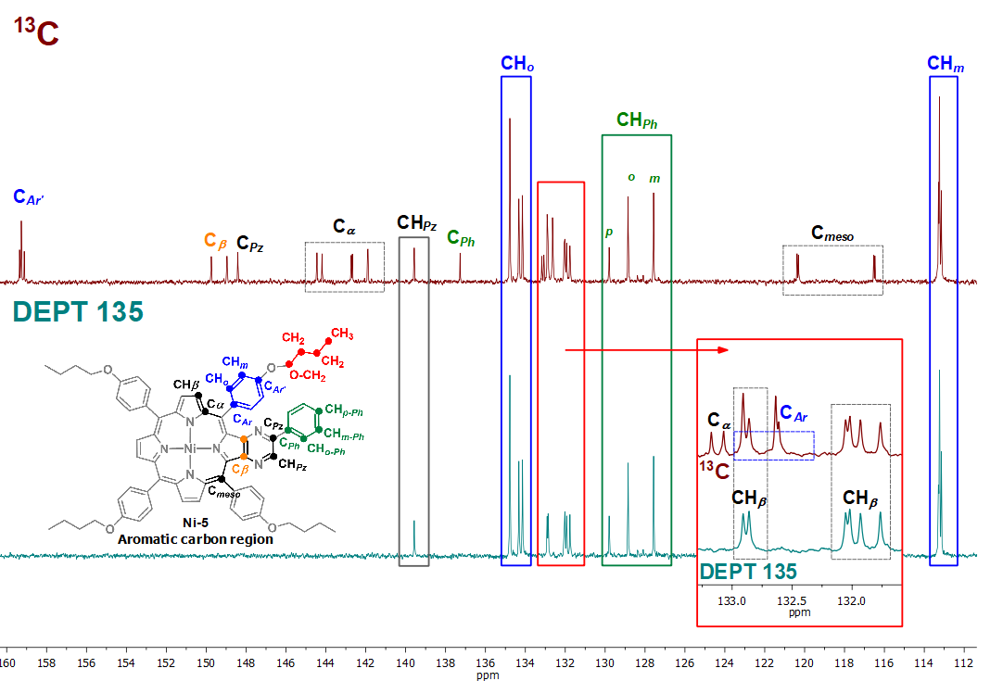
Figure S 17. Stacked ¹³C NMR and ¹³C DEPT-135 spectra of Ni-5 (aromatic carbon region, CDCl₃) with signal assignments.
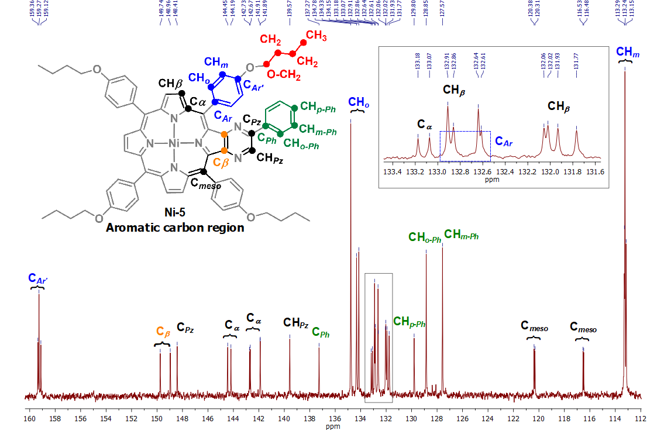
Figure S 18. Expansion of the ¹³C NMR spectrum of Ni-5 (aromatic carbon region, CDCl₃) with signal assignments.
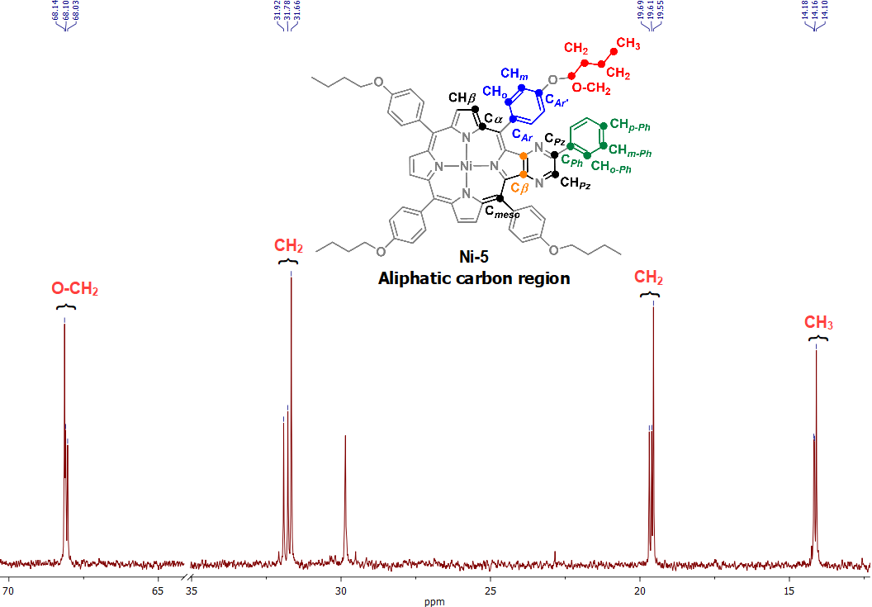
Figure S 19. Expansion of the ¹³C NMR spectrum of Ni-5 (aliphatic carbon region, CDCl₃) with signal assignments.
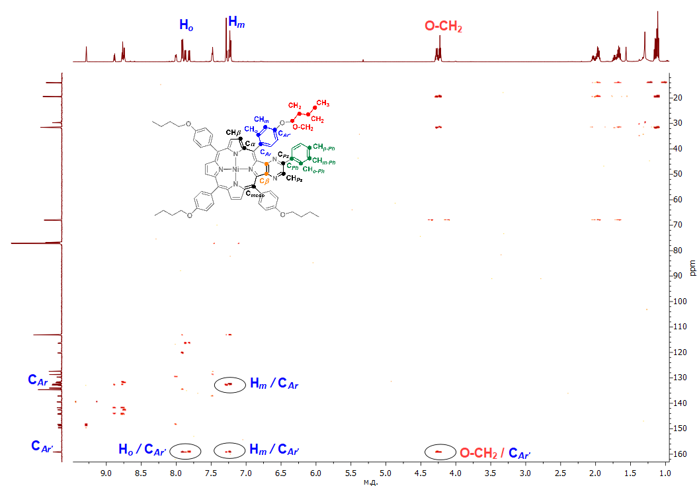
Figure S 20. ¹H-¹³C HMBC spectrum of Ni-5 with key correlations indicated (CDCl₃).
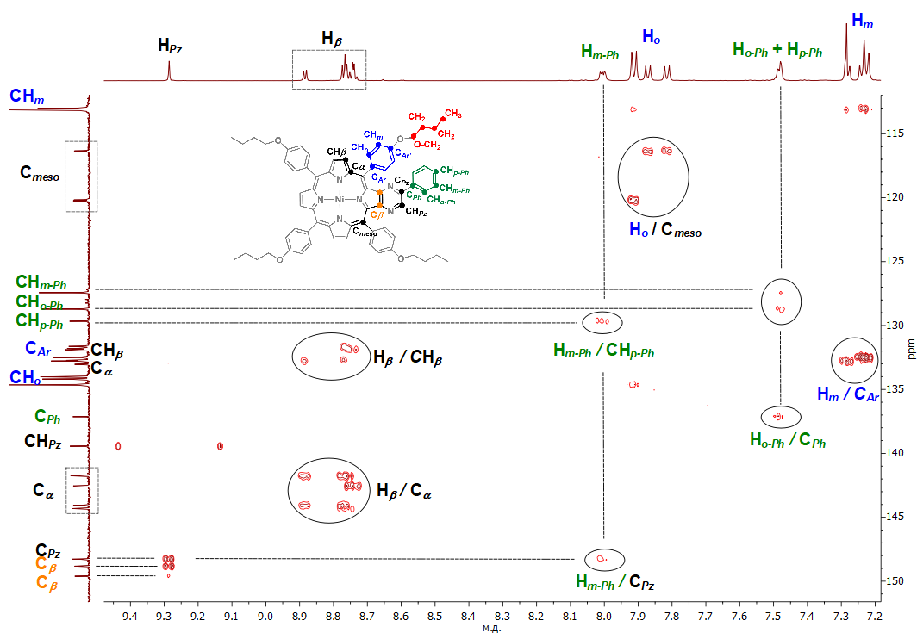
Figure S 21. Expansion of the ¹H-¹³C HMBC spectrum of Ni-5 with key correlations indicated (CDCl₃).

  - NMR spectra of Ni-6
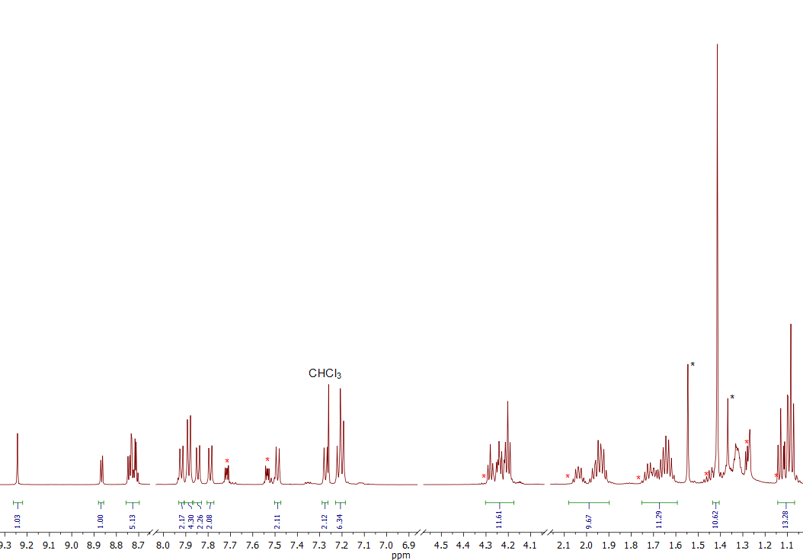
Figure S 22. ¹H NMR spectrum of Ni-6 (CDCl₃).
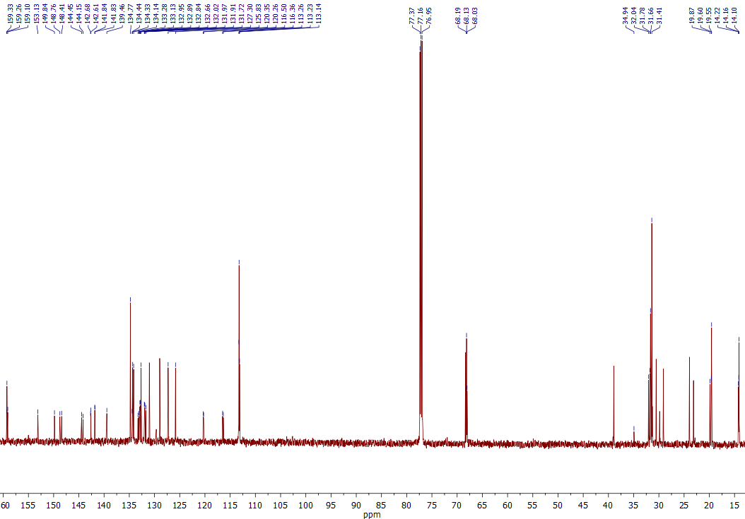
Figure S 23. ¹³C NMR spectrum of Ni-6 (CDCl₃).
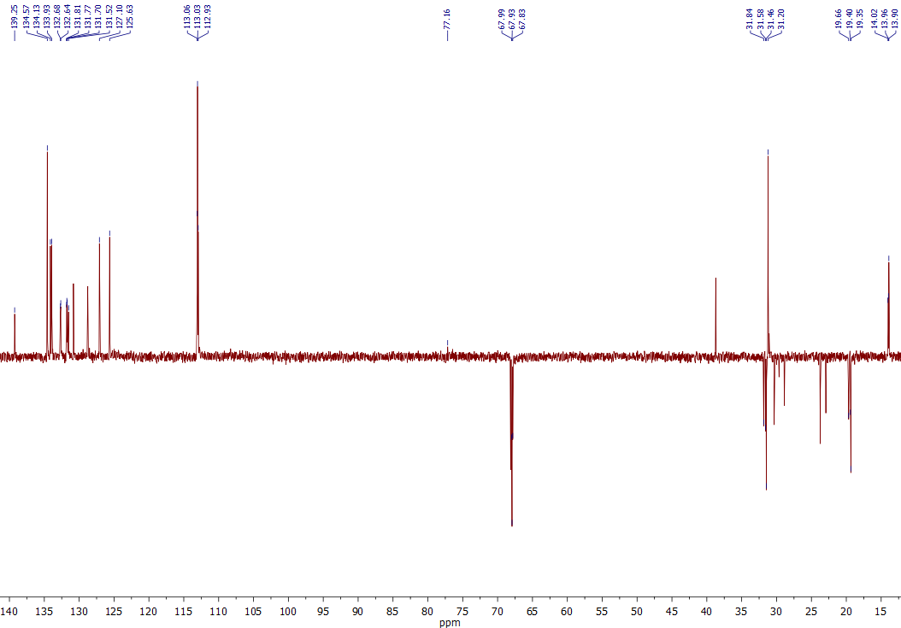
Figure S 24. ¹³C DEPT-135 spectrum of Ni-6 (CDCl₃).
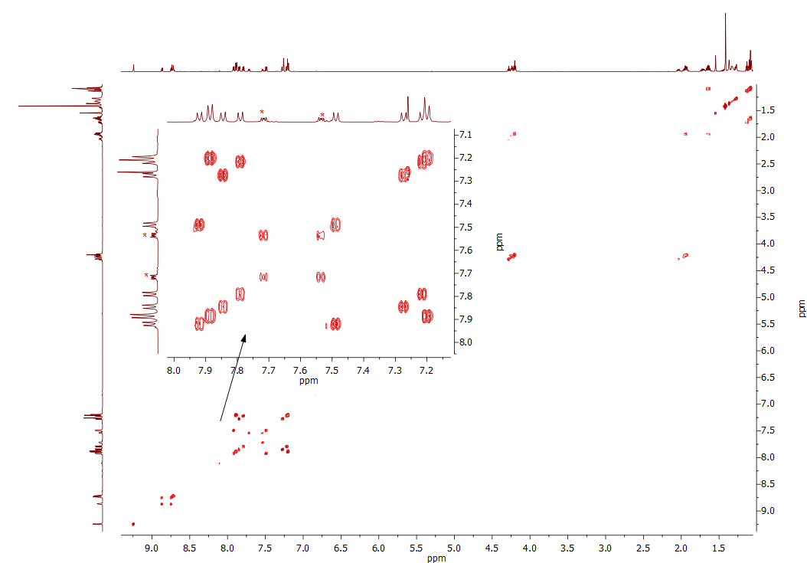
Figure S 25. ¹H-¹H COSY spectrum of Ni-6 (CDCl₃).
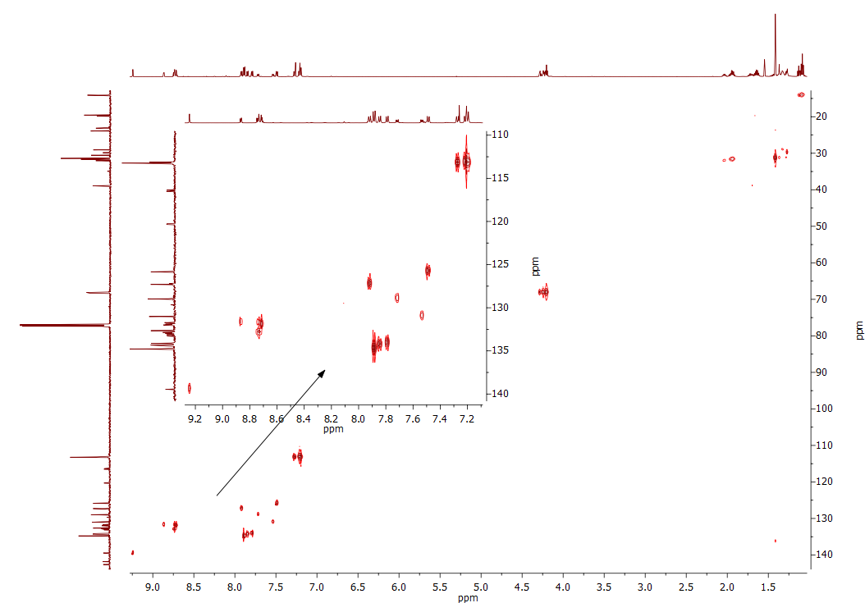
Figure S 26. ¹H-¹³C HSQC spectrum of Ni-6 (CDCl₃).
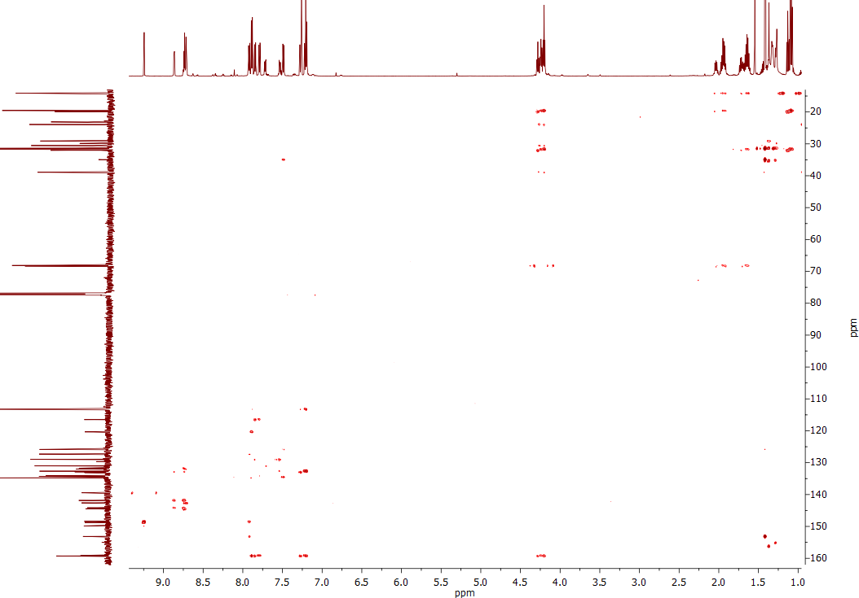
Figure S 27. ¹H-¹³C HMBC spectrum of Ni-6 (CDCl₃).
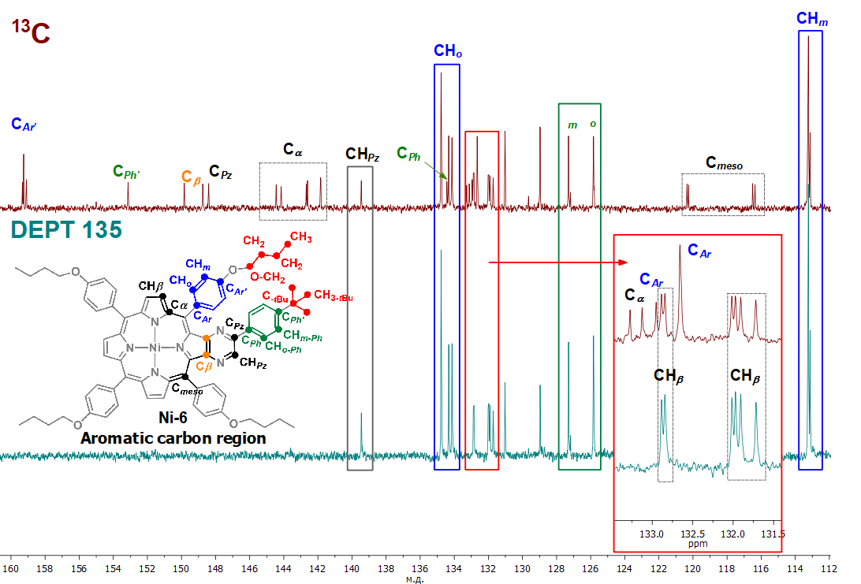
Figure S 28. Stacked ¹³C NMR and ¹³C DEPT-135 spectra of Ni-6 (aromatic carbon region, CDCl₃) with signal assignments. Signals of the phthalate plasticizer derivative are not assigned.
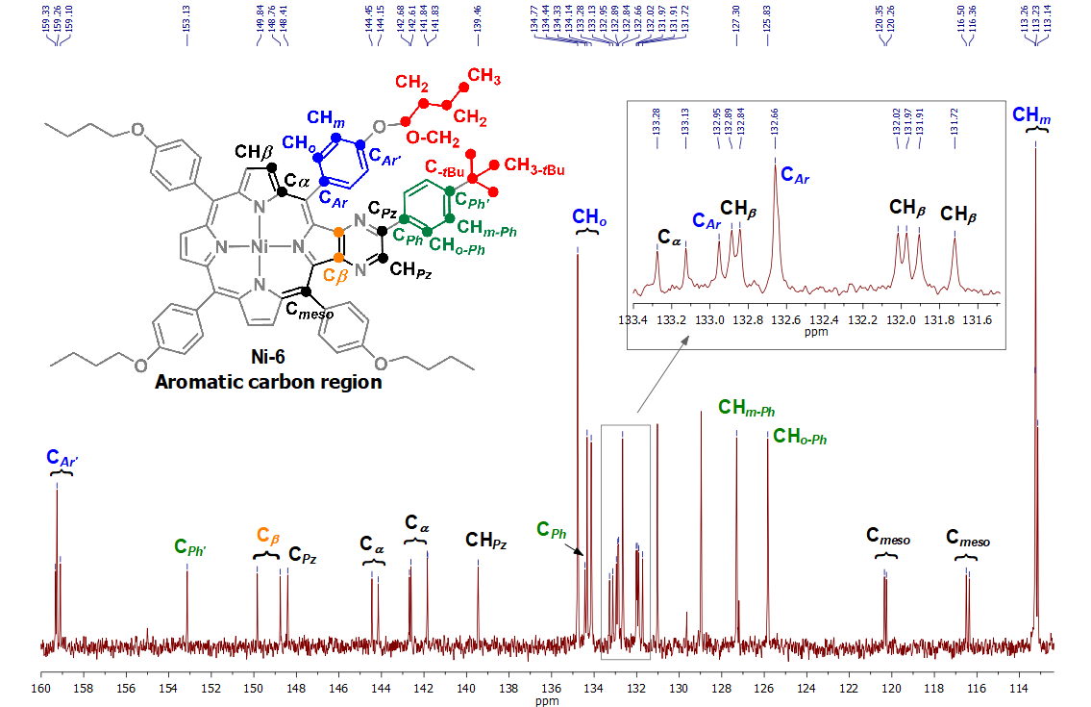
Figure S 29. Expansion of the ¹³C NMR spectrum of Ni-6 (aromatic carbon region, CDCl₃) with signal assignments. Signals of the phthalate plasticizer derivative are not assigned.
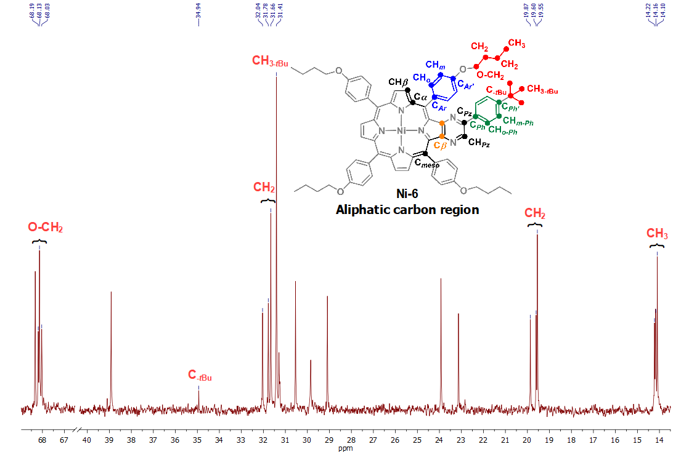
Figure S 30. Expansion of the ¹³C NMR spectrum of Ni-6 (aliphatic carbon region, CDCl₃) with signal assignments. Signals of the phthalate plasticizer derivative are not assigned.
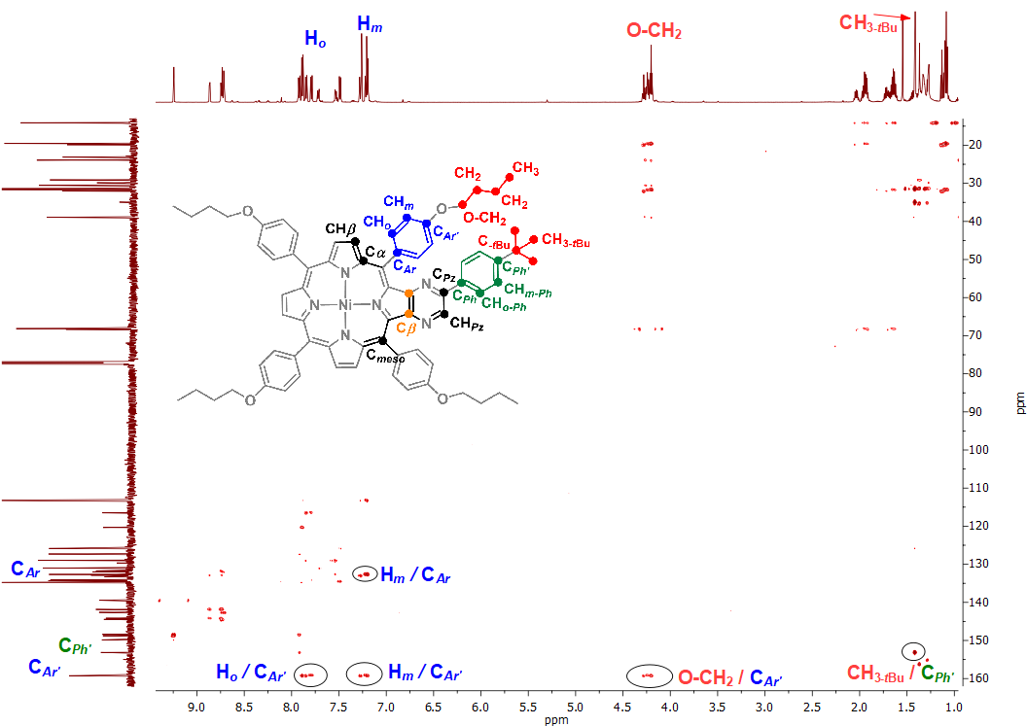
Figure S 31. ¹H-¹³C HMBC spectrum of Ni-6 with key correlations indicated (CDCl₃). Signals of the phthalate plasticizer derivative are not assigned.
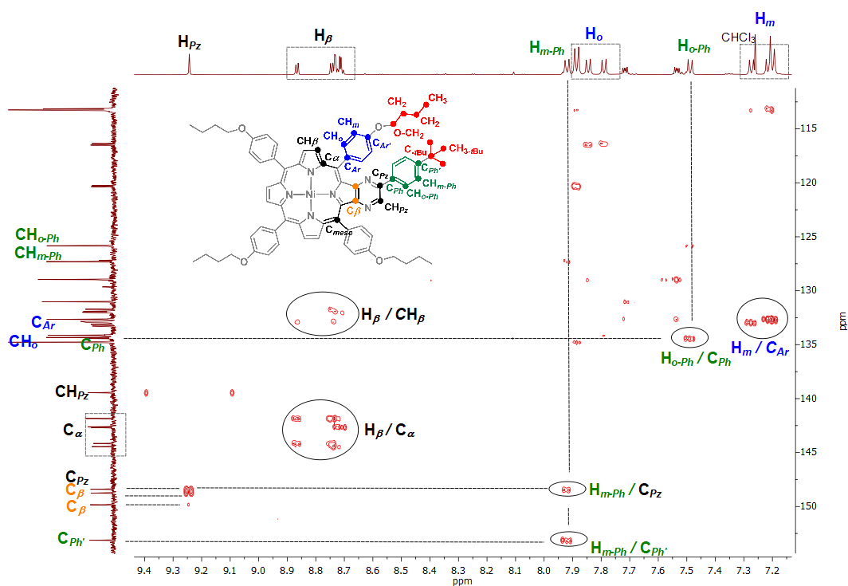
Figure S 32. Expansion of the ¹H-¹³C HMBC spectrum of Ni-6 with key correlations indicated (CDCl₃). Signals of the phthalate plasticizer derivative are not assigned.

  - NMR spectra of Ni-7
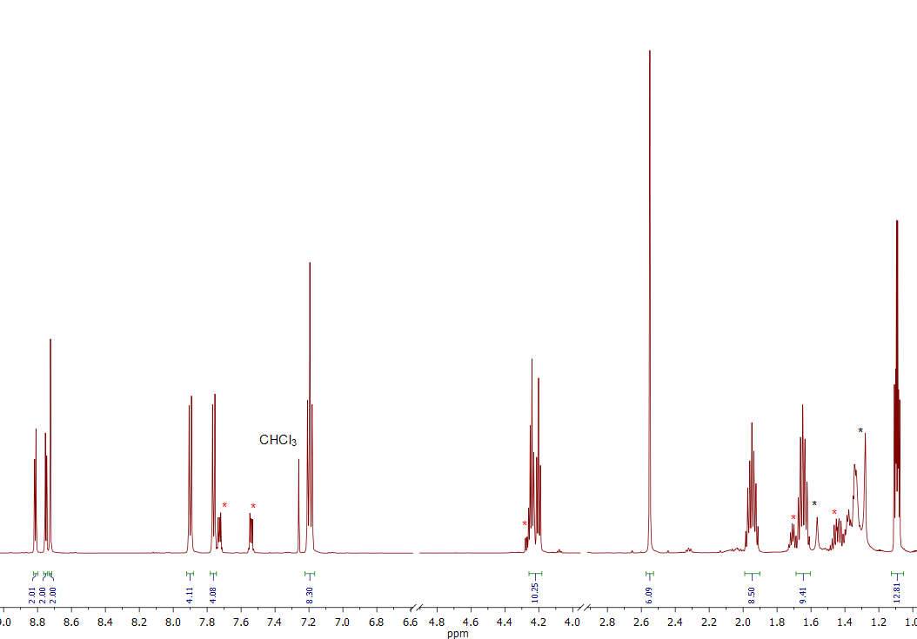
Figure S 33. ¹H NMR spectrum of Ni-7 (CDCl₃). Minor proton signals of the phthalate plasticizer derivative are designated by red *.
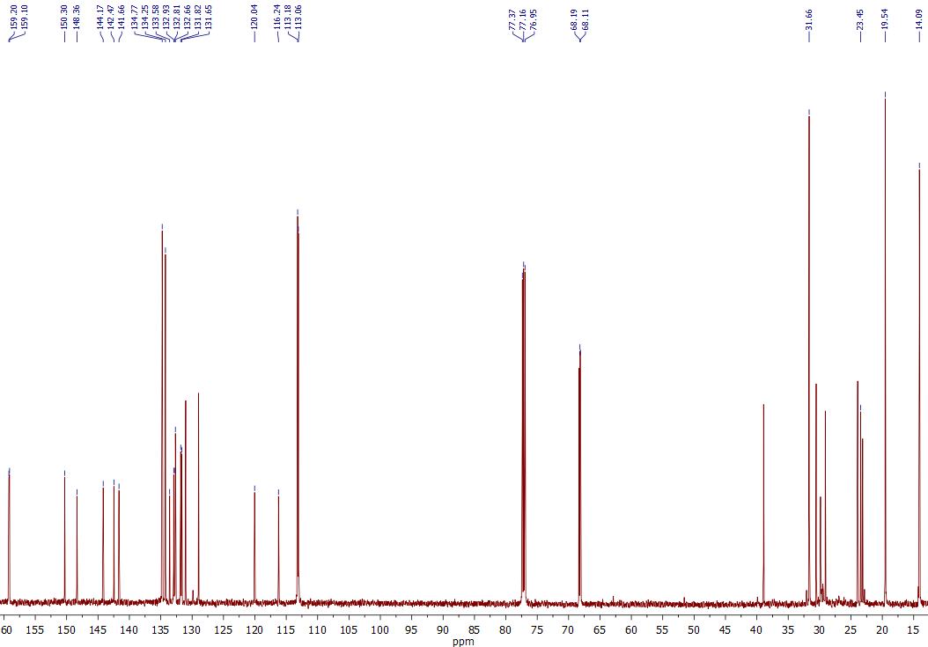
Figure S 34. ¹³C NMR spectrum of Ni-7 (CDCl₃).
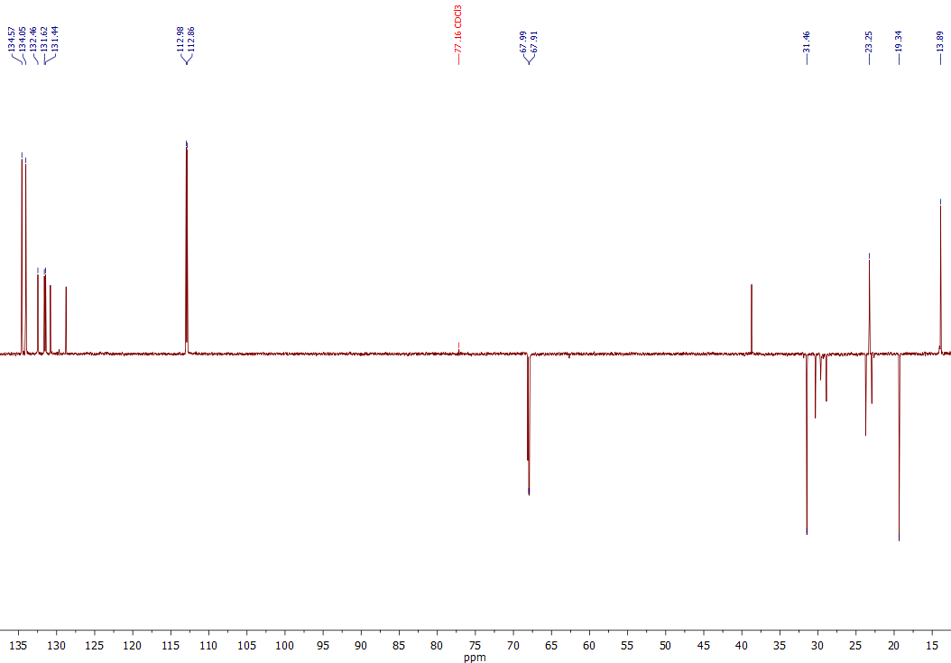
Figure S 35. ¹³C DEPT-135 spectrum of Ni-7 (CDCl₃).
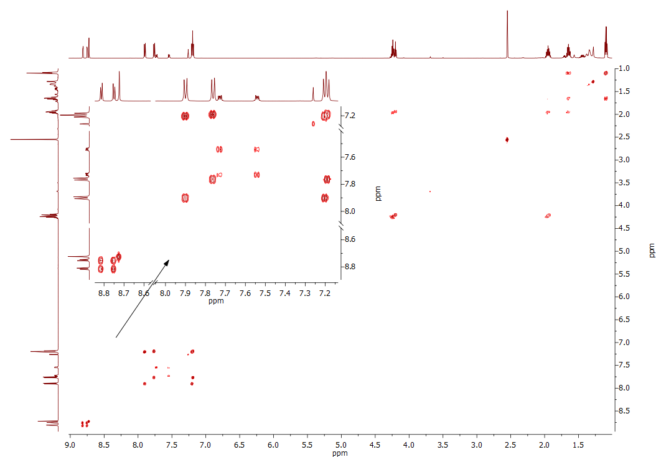
Figure S 36. ¹H-¹H COSY spectrum of Ni-7 (CDCl₃).
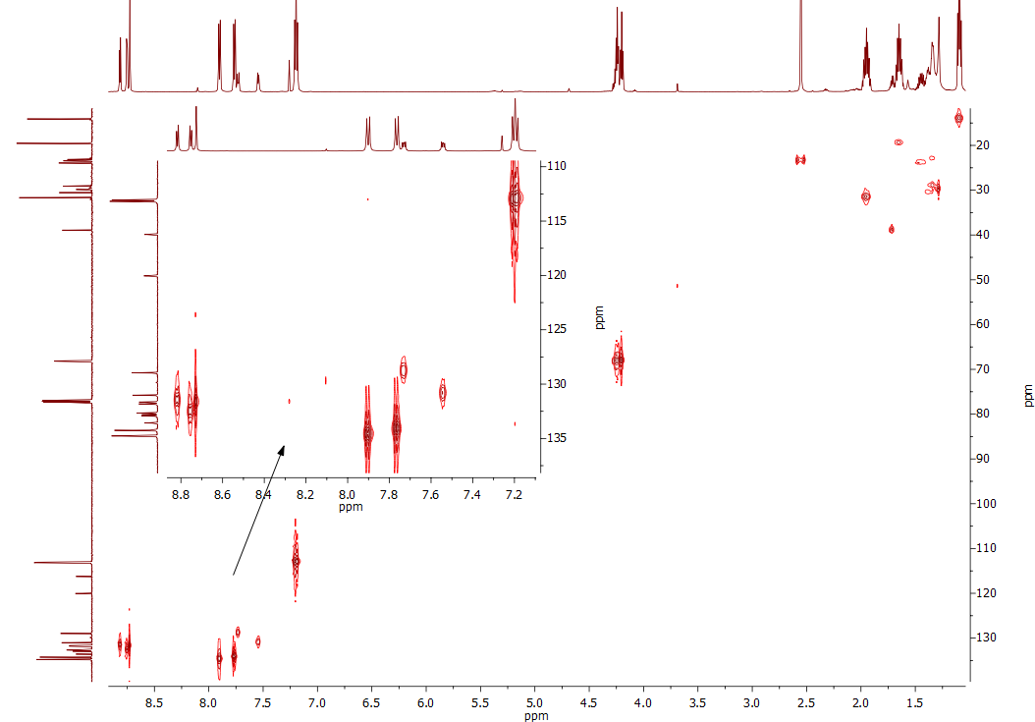
Figure S 37. ¹H-¹³C HSQC spectrum of Ni-7 (CDCl₃).
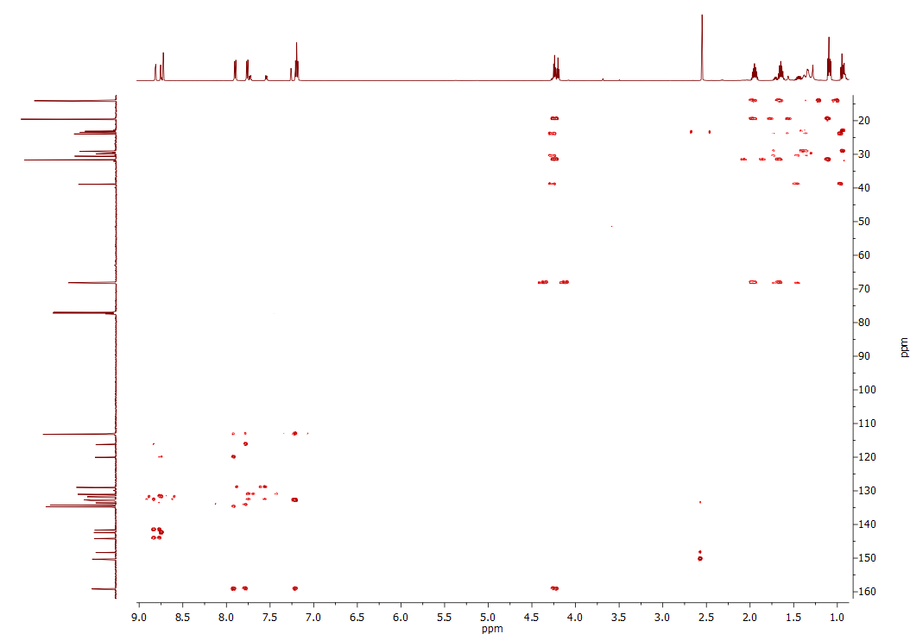
Figure S 38. ¹H-¹³C HMBC spectrum of Ni-7 (CDCl₃).
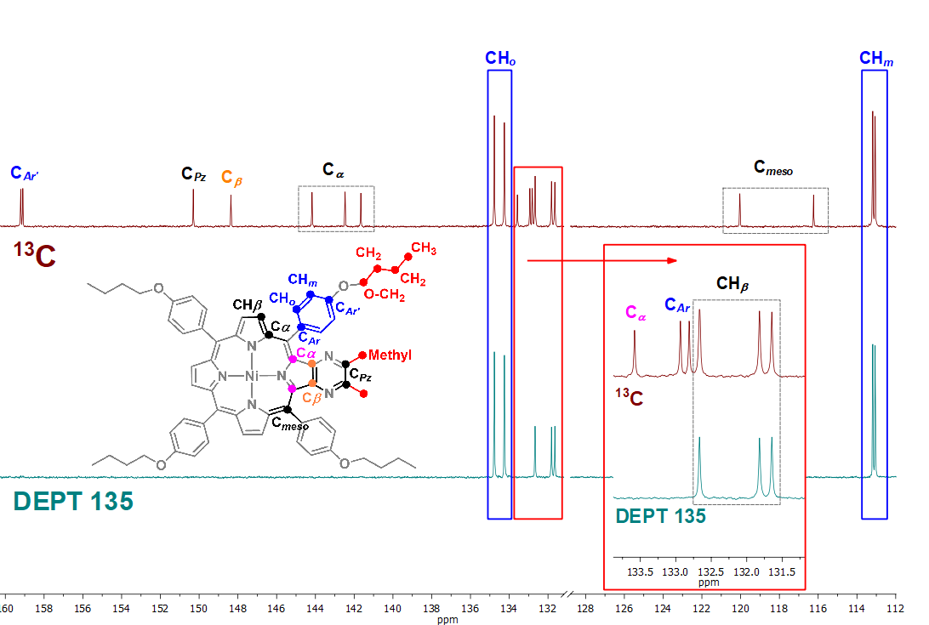
Figure S 39. Stacked ¹³C NMR and ¹³C DEPT-135 spectra of Ni-7 with signal assignments (aromatic carbon region, CDCl₃). Signals of the phthalate plasticizer derivative are not assigned.
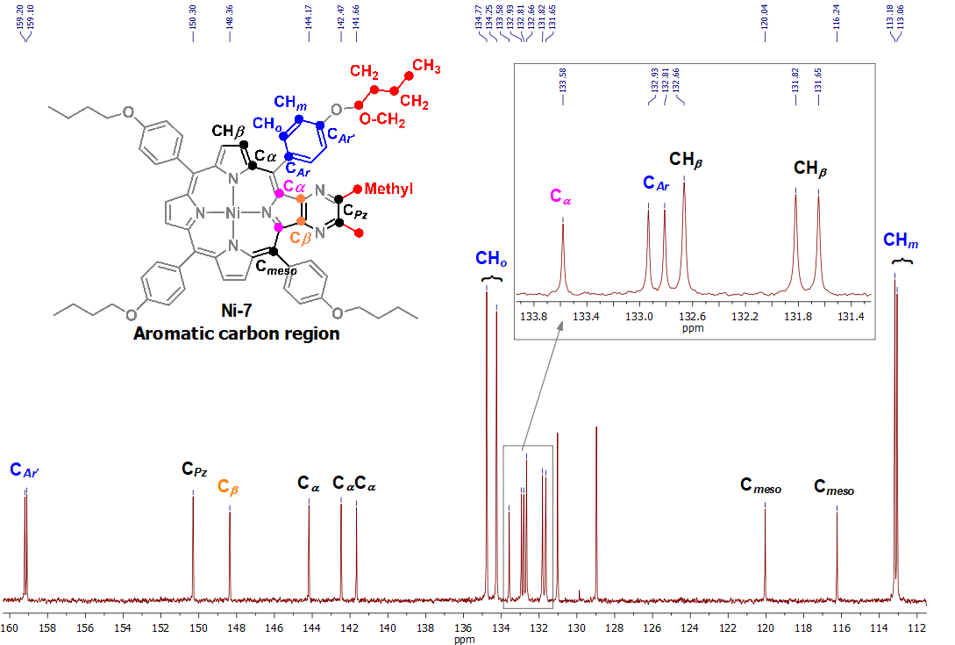
Figure S 40. Expansion of the ¹³C NMR spectrum of Ni-7 (aromatic carbon region, CDCl₃) with signal assignments. Signals of the phthalate plasticizer derivative are not assigned.
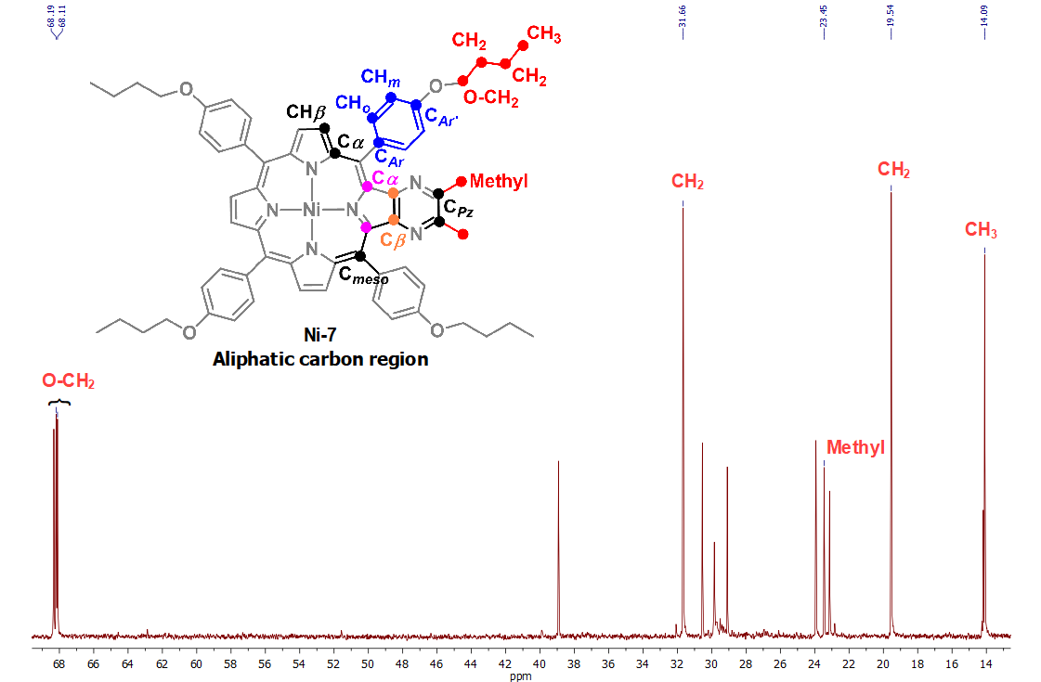
Figure S 41. Expansion of the ¹³C NMR spectrum of Ni-7 (aliphatic carbon region, CDCl₃) with signal assignments. Signals of the phthalate plasticizer derivative are not assigned.
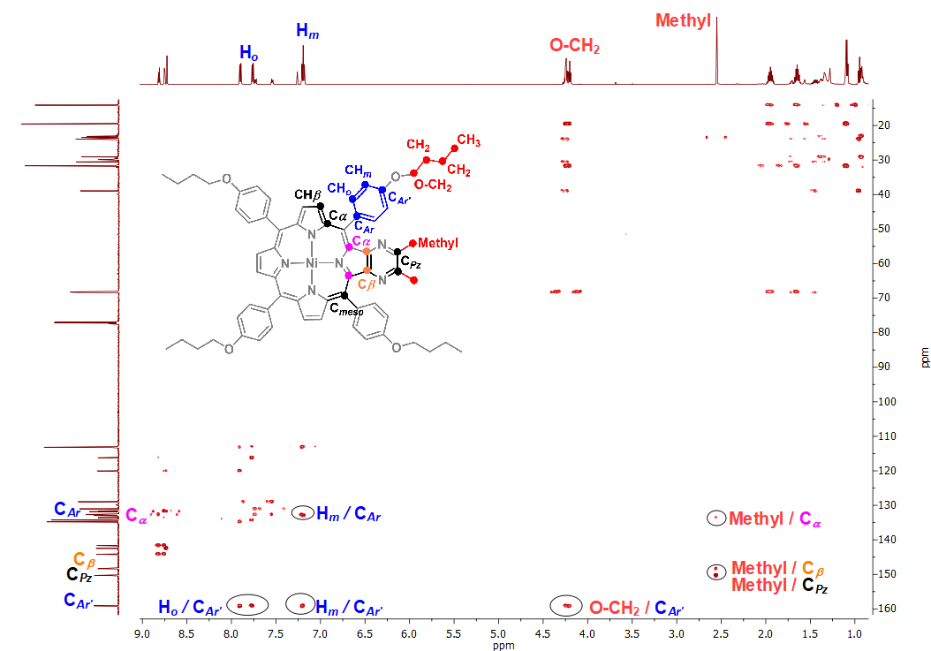
Figure S 42. ¹H-¹³C HMBC spectrum of Ni-7 with key correlations indicated (CDCl₃). Signals of the phthalate plasticizer derivative are not assigned.
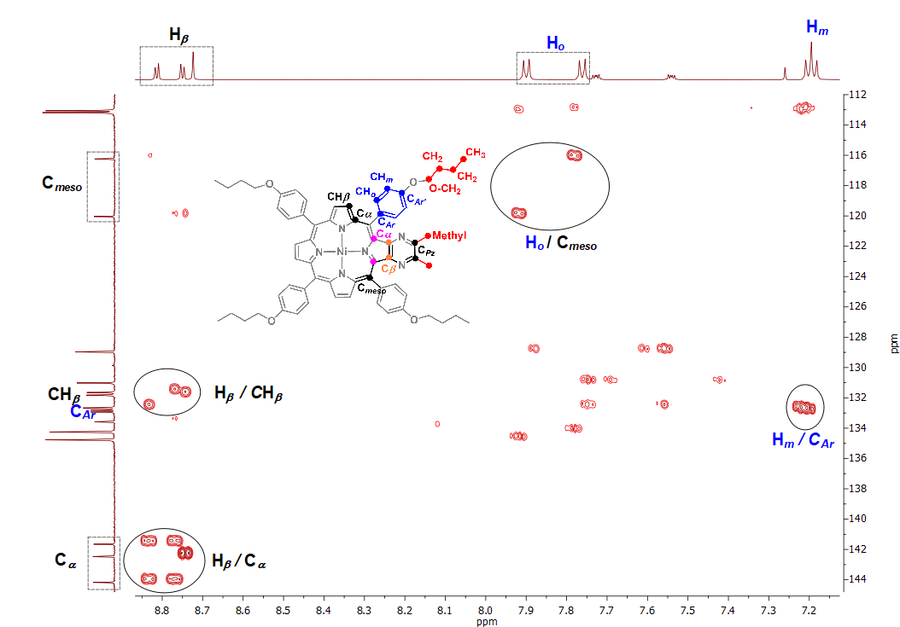
Figure S 43. Expansion of the ¹H-¹³C HMBC spectrum of Ni-7 with key correlations indicated (CDCl₃). Signals of the phthalate plasticizer derivative are not assigned.

UV-Vis spectrum of mixture of Ni-3 and Ni-4

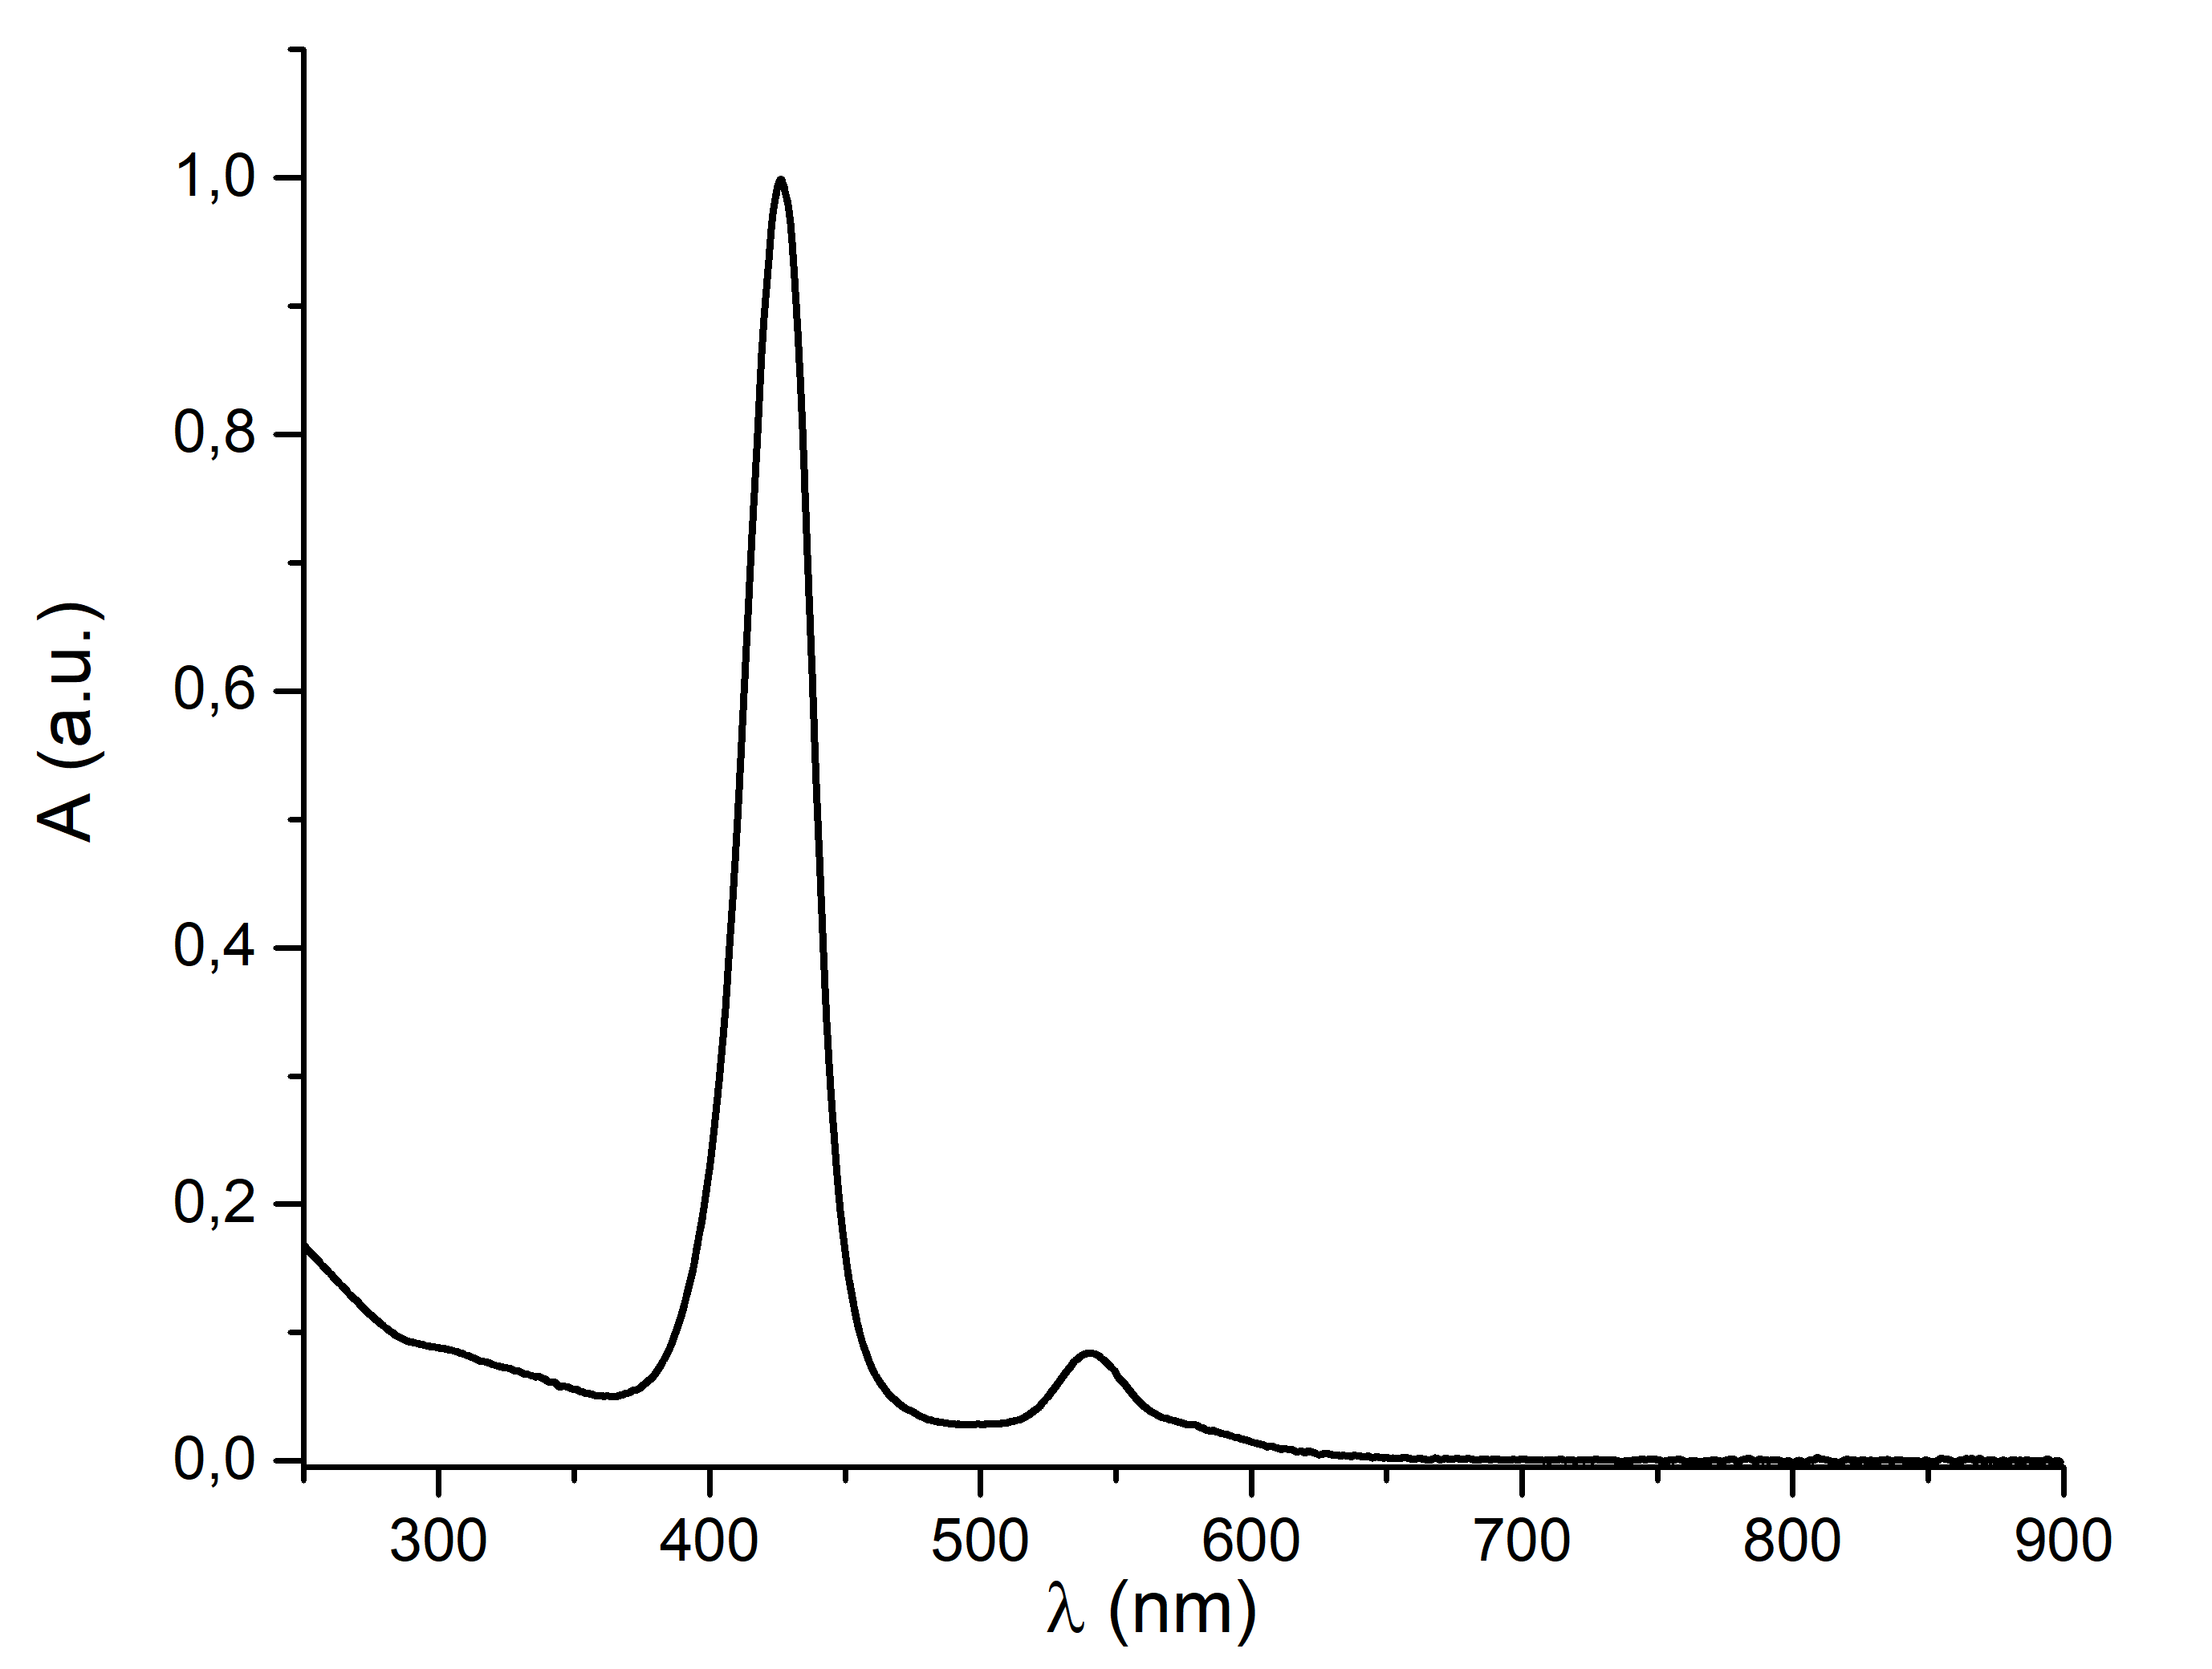
Figure S 44. UV-Vis spectrum of mixture of Ni-3 and Ni-4 (CHCl₃)

- Mass spectra of the synthesized compounds

Figure S 45. MALDI TOF mass spectrum of mixture of Ni-3 and Ni-4.

Figure S 46. HRMS ESI spectrum of Ni-5.

Figure S 47. HRMS ESI spectrum of Ni-6.

Figure S 48. MALDI TOF mass spectrum of Ni-7.

References
[1] Tarakanov PA, Simakov AO, Tarakanova EN, Chernyak A V., Klykov V, Stuzhin PA, et al. A Sterically Driven Approach to the Efficient Synthesis of Low-Symmetry 1,4-Diazepinoporphyrazines. Macroheterocycles 2018;11:312–5. https://doi.org/10.6060/mhc180484t.

