Supporting information for
Theoretical Study of Z,E-Isomerism of the meso-Aza Bridge in Pyrazine-Fused 5,5’-Diphenylazadipyrromethenes
Daniil N. Finogenov, Alexey V. Eroshin and Pavel A. Stuzhin

Ivanovo State University of Chemistry and Technology, Research Institute of Chemistry of Macroheterocyclic Compounds, 153000 Ivanovo, Russia

Contents
Equation 1. Calculation of each isomer percentage, ΔG_{i} =Relative Gibbs free energy, R = 8,3145 J/(mol*K - universal gas constant, T = 298,15K – temperature 1
Table S1. Percentage distribution of conformers depending on the substituents in the pyrazine ring of aza-DIPY and their energies and difference in energy 1
Figure S1. Molecular structures of Z,Z (left) and Z,E (right) of Et₄ azaDIPY 2
Figure S2. Molecular structures of Z,Z (left) and Z,E (right) of Ph₄ azaDIPY 2
Figure S3. Molecular structure of Z,Z (left) and Z,E (right) of PhO₄ azaDIPY 3
Figure S4. Molecular structure of Z,Z (left) and Z,E (right) of t-BuO₄ azaDIPY 4
Figure S5. Molecular structure of Z,Z (left) and Z,E (right) of iPr₂PhO₄ azaDIPY 4
Cortesian coordinates for H₄ azaDIPY (Z,Z) calculated by B3LYP/pcseg-2 4
Cortesian coordinates for H₄ azaDIPY (Z,E) calculated by B3LYP/pcseg-2 5
Cortesian coordinates for Et₄ azaDIPY (Z,E) calculated by B3LYP/pcseg-2 7
Cortesian coordinates for Et₄ azaDIPY (Z,Z) calculated by B3LYP/pcseg-2 9
Cortesian coordinates for Ph₄ azaDIPY (Z,Z) calculated by B3LYP/pcseg-2 11
Cortesian coordinates for Ph₄ azaDIPY (Z,E) calculated by B3LYP/pcseg-2 14
Cortesian coordinates for PhO₄ azaDIPY (Z,Z) calculated by B3LYP/pcseg-2 17
Cortesian coordinates for t-BuO₄ azaDIPY (Z,Z) calculated by B3LYP/pcseg-2 20
Cortesian coordinates for iPr₂PhO₄ azaDIPY (Z,Z) calculated by B3LYP/pcseg-2 23

$χ_{i}=\frac{e^{\frac{−ΔGi}{RT}}}{{Σe}^{\frac{−ΔGi}{RT}}}$

Equation 1. Calculation of each isomer percentage, ΔG_{i} =Relative Gibbs free energy, R = 8,3145 J/(mol*K - universal gas constant, T = 298,15K – temperature

Table S1. Percentage distribution of conformers depending on the substituents in the pyrazine ring of aza-DIPY and their energies and difference in energy calculated by B3LYP/pcseg-2
-R | Z,Z conformer percentage (%) | G, a.u. | Z,E conformer percentage (%) | G, a.u. | ΔG, kcal/mol
-H | 36,82 | -1306,236 | 63,18 | -1306,2360 | 0,320
-Et | ~100 | -1617,3010 | ~0 | -1617,2993 | 1,484
-Ph | 9 | -2225,53 | 91 | -2225,53 | -1,10815
-O-Ph | ~100 | -2530,7573 | ~0 | -2530,74 | 10,849209
-O-tBu | 100 | -2235.509 | n.f. | - | -
-O-2,6-iPr₂Ph | 100 | -3474.55928 | n.f. | - | -

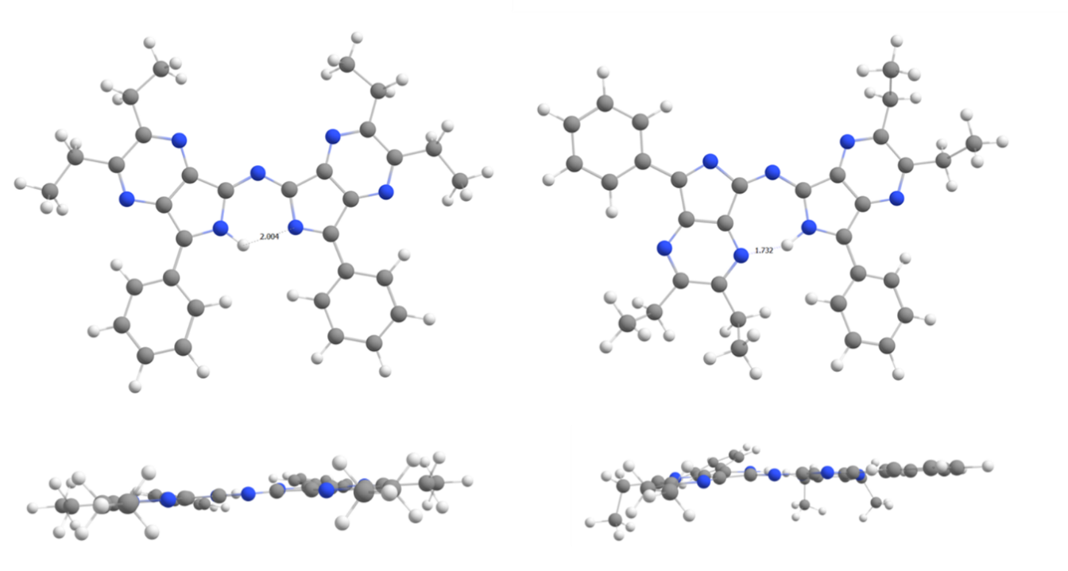

Figure S1. Molecular structures of Z,Z (left) and Z,E (right) of Et₄ azaDIPY
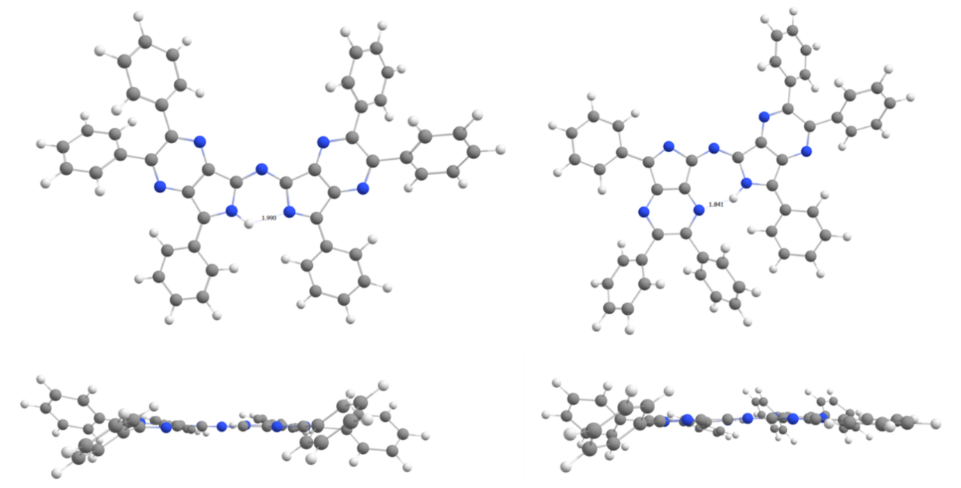

Figure S2. Molecular structures of Z,Z (left) and Z,E (right) of Ph₄ azaDIPY

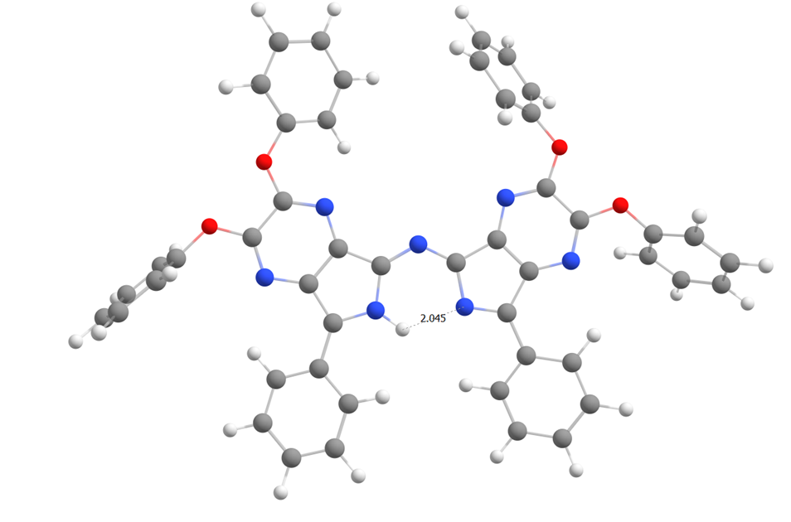

Figure S3. Molecular structure of Z,Z (left) and Z,E (right) of PhO₄ azaDIPY
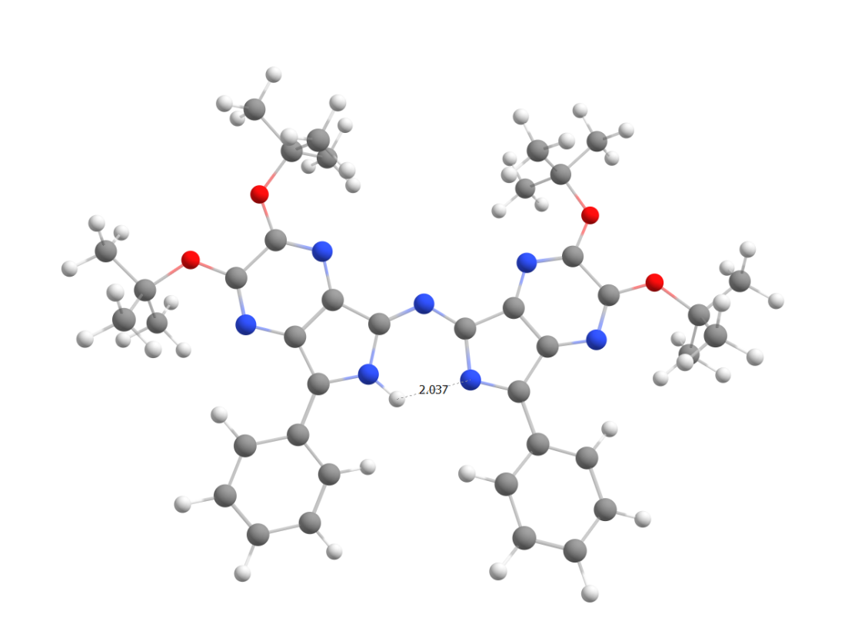

Figure S4. Molecular structure of Z,Z (left) and Z,E (right) of t-BuO₄ azaDIPY
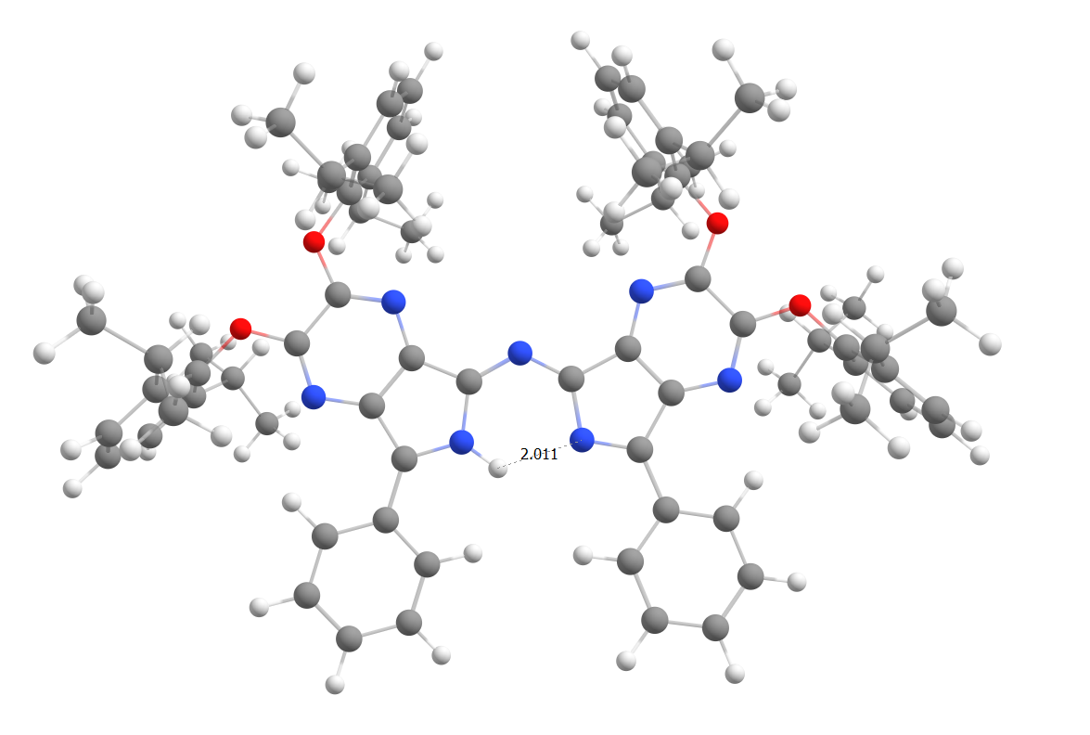

Figure S5. Molecular structure of Z,Z (left) and Z,E (right) of iPr₂PhO₄ azaDIPY

Cortesian coordinates for H₄ azaDIPY (Z,Z) calculated by B3LYP/pcseg-2
symmetry c1
C -2.434895000 -2.142354000 -0.030592000
C -3.405949000 -1.097016000 -0.022712000
C -2.713095000 0.148785000 0.025873000
N -1.396281000 -0.170690000 0.033934000
C -1.149209000 -1.534916000 0.002499000
C -3.201695000 1.513663000 0.086084000
C 3.431692000 -1.083852000 0.029490000
C 2.488376000 -2.129245000 0.034776000
C 1.179273000 -1.491835000 -0.000798000
N 1.365129000 -0.106264000 -0.033549000
C 2.656470000 0.166164000 -0.024079000
N 0.041157000 -2.122491000 0.002595000
C 3.172197000 1.530251000 -0.084944000
N -2.774069000 -3.440312000 -0.064886000
C -4.071589000 -3.664863000 -0.088354000
C -5.042078000 -2.629390000 -0.076917000
N -4.727722000 -1.350956000 -0.043425000
N 4.743805000 -1.304552000 0.055843000
C 5.087193000 -2.591972000 0.090453000
C 4.143522000 -3.627540000 0.096704000
N 2.829254000 -3.412571000 0.068944000
C -4.557488000 1.794680000 -0.155624000
C -5.024900000 3.099009000 -0.105818000
C -4.161071000 4.150183000 0.184956000
C -2.817360000 3.884707000 0.433250000
C -2.341622000 2.584221000 0.387307000
C 4.529572000 1.805372000 0.143592000
C 5.000192000 3.110542000 0.092329000
C 4.134760000 4.160308000 -0.192878000
C 2.786587000 3.898402000 -0.430704000
C 2.309895000 2.600030000 -0.376993000
H -0.600930000 0.461639000 0.032930000
H -5.231611000 0.981342000 -0.376522000
H -6.071427000 3.295912000 -0.296293000
H -4.530769000 5.165848000 0.223967000
H -2.139939000 4.693250000 0.672994000
H -1.298553000 2.404082000 0.611151000
H 5.205797000 0.991616000 0.355565000
H 6.048333000 3.307172000 0.274048000
H 4.506119000 5.175538000 -0.236332000
H 2.111046000 4.710347000 -0.665135000
H 1.268814000 2.394055000 -0.576818000
H 4.472695000 -4.659571000 0.125129000
H 6.145966000 -2.819566000 0.113833000
H -4.395781000 -4.699158000 -0.117103000
H -6.095939000 -2.882448000 -0.095574000

Cortesian coordinates for H₄ azaDIPY (Z,E) calculated by B3LYP/pcseg-2
symmetry c1
C -2.183309000 -2.106136000 -0.260727000
C -3.409479000 -1.398546000 -0.111104000
C -3.096901000 -0.024076000 0.119526000
N -1.745894000 0.054463000 0.099788000
C -1.117645000 -1.166252000 -0.127347000
C -3.955776000 1.125234000 0.342532000
C 2.727897000 1.081195000 0.103643000
C 1.337961000 0.813129000 0.119762000
C 1.198679000 -0.625708000 -0.118063000
N 2.478017000 -1.154597000 -0.262865000
C 3.383118000 -0.213023000 -0.145147000
N 0.173472000 -1.425610000 -0.215250000
C 4.813353000 -0.489950000 -0.265725000
N -2.136543000 -3.427384000 -0.486116000
C -3.315633000 -4.011249000 -0.557560000
C -4.540275000 -3.311240000 -0.411556000
N -4.603481000 -2.014191000 -0.188922000
N 3.218056000 2.299882000 0.286199000
C 2.306096000 3.256820000 0.486486000
C 0.936716000 3.000329000 0.503062000
N 0.438024000 1.772588000 0.319041000
C -5.354469000 0.984349000 0.319715000
C -6.175748000 2.081039000 0.532630000
C -5.631316000 3.338636000 0.771933000
C -4.248072000 3.492153000 0.796931000
C -3.419273000 2.402219000 0.586314000
C 5.777227000 0.519387000 -0.126528000
C 7.128151000 0.221092000 -0.251745000
C 7.539239000 -1.079909000 -0.516822000
C 6.588413000 -2.089922000 -0.656266000
C 5.240328000 -1.801385000 -0.532171000
H -1.185325000 0.906833000 0.227415000
H -5.781585000 0.010741000 0.134542000
H -7.249615000 1.951778000 0.511567000
H -6.276500000 4.190703000 0.937871000
H -3.814442000 4.465635000 0.982955000
H -2.348495000 2.550055000 0.615347000
H 5.463367000 1.531539000 0.077613000
H 7.861395000 1.009136000 -0.142042000
H 8.592375000 -1.308354000 -0.614437000
H 6.903123000 -3.104386000 -0.862468000
H 4.495072000 -2.576185000 -0.638798000
H 0.229364000 3.802985000 0.667733000
H 2.673172000 4.263897000 0.639055000
H -3.329808000 -5.080312000 -0.737775000
H -5.478118000 -3.849987000 -0.483075000

Cortesian coordinates for Et₄ azaDIPY (Z,E) calculated by B3LYP/pcseg-2
symmetry c1
C -2.419416121 -0.818451333 -1.062811831
C -3.239387389 -0.593627227 0.080843324
C -2.437274703 0.038982356 1.063931772
N -1.200153138 0.156786267 0.542476548
C -1.116892989 -0.334497638 -0.746906835
C -2.820193766 0.545288002 2.356439556
C 3.155497703 0.641850167 -0.334389993
C 1.793173004 0.454868699 -0.007273779
C 1.139227763 0.049613701 -1.253708113
N 2.084350314 0.039352713 -2.248871796
C 3.252586406 0.387931142 -1.766626916
N -0.071657533 -0.328335509 -1.537230382
C 4.434969551 0.497622712 -2.585633246
N -2.898838182 -1.405744871 -2.157979808
C -4.168803671 -1.754960802 -2.131101477
C -4.996890675 -1.511798323 -0.996194240
N -4.531176517 -0.941029652 0.095319366
N 4.051138718 0.974888774 0.577107739
C 3.618054982 1.091418695 1.830767227
C 2.263802699 0.904291279 2.167233100
N 1.354747736 0.607563992 1.236025391
C -4.656353559 -2.477510535 -3.352139357
C -6.461578254 -1.839686933 -0.972748576
C 1.733190190 0.990689712 3.568541689
C 4.695726415 1.421911509 2.823282732
C 2.010356028 -0.299944812 4.342067522
C 5.676733437 0.254880427 2.951310092
C -2.044965088 1.505727562 3.015435582
C -2.424569358 1.978386372 4.255487516
C -3.582660303 1.510167904 4.856709734
C -4.370426741 0.576062083 4.200828444
C -3.999102524 0.096406192 2.961188755
C 5.660123606 0.881245589 -2.034064015
C 6.777330820 0.983524516 -2.839770032
C 6.689887172 0.708085113 -4.195740894
C 5.476000260 0.326418087 -4.749635920
C 4.354197169 0.220538479 -3.954319996
C -4.480988006 -3.987901046 -3.173213749
C -7.272197718 -0.678303533 -1.553285189
H -0.351719428 0.472182140 1.044168773
H -4.047510974 -2.150524710 -4.195538745
H -5.700968940 -2.244343839 -3.556743585
H -6.756331387 -1.991011663 0.066752189
H -6.665465951 -2.752546852 -1.531618234
H 0.653584157 1.138878977 3.519972794
H 2.173009166 1.841219166 4.092247375
H 4.276435519 1.665485580 3.797961941
H 5.239776364 2.293120553 2.450995629
H 1.570345696 -0.240082484 5.334630286
H 3.078366410 -0.471747167 4.446481641
H 1.573232566 -1.149311988 3.821565077
H 6.480618739 0.511953035 3.636832791
H 6.103284585 0.023485159 1.978828043
H 5.173692226 -0.635208301 3.324379749
H -1.164826525 1.906409049 2.533980143
H -1.819875053 2.721790307 4.754776021
H -3.875073672 1.881310447 5.827660618
H -5.280218253 0.221738629 4.662523638
H -4.607200550 -0.624505988 2.438716793
H 5.718814489 1.095882841 -0.978405687
H 7.723776857 1.280855266 -2.411297534
H 7.567026374 0.791266812 -4.821136984
H 5.410645741 0.112543195 -5.806596265
H 3.398701019 -0.073877084 -4.358715845
H -4.819124099 -4.513027984 -4.063259290
H -5.050200502 -4.349984232 -2.319085660
H -3.431578724 -4.218998075 -3.009325828
H -7.097617256 0.222847134 -0.970461796
H -8.334133838 -0.910871113 -1.526483235
H -6.985827215 -0.479727050 -2.583942598

Cortesian coordinates for Et₄ azaDIPY (Z,Z) calculated by B3LYP/pcseg-2
symmetry c1
C -2.434450000 -1.236958000 0.010909000
C -3.382049000 -0.194117000 -0.002135000
C -2.681727000 1.033707000 -0.042345000
N -1.377194000 0.707931000 -0.037938000
C -1.150741000 -0.649368000 -0.006926000
C -3.154950000 2.400305000 -0.113604000
C 3.392522000 -0.213452000 0.006473000
C 2.469374000 -1.251152000 -0.003930000
C 1.159377000 -0.625653000 0.018393000
N 1.336915000 0.753963000 0.051920000
C 2.613967000 1.025928000 0.052759000
N 0.031389000 -1.252037000 0.004044000
C 3.118627000 2.389446000 0.118915000
N -2.795986000 -2.525803000 0.035483000
C -4.080052000 -2.759974000 0.044854000
C -5.056735000 -1.692410000 0.028826000
N -4.701867000 -0.437962000 0.005397000
N 4.700014000 -0.429851000 -0.011966000
C 5.078035000 -1.694235000 -0.040115000
C 4.126918000 -2.754894000 -0.050244000
N 2.826483000 -2.524972000 -0.033098000
C -4.536948000 -4.191186000 0.074979000
C -6.525236000 -2.013294000 0.034067000
C 4.585322000 -4.185782000 -0.083578000
C 6.552562000 -1.986186000 -0.056473000
C 3.461442000 -5.206650000 -0.078261000
C 7.438123000 -0.753397000 -0.106589000
C -2.292459000 3.448729000 -0.454922000
C -2.752307000 4.751353000 -0.515050000
C -4.082441000 5.037186000 -0.241402000
C -4.948232000 4.004794000 0.090366000
C -4.495425000 2.699140000 0.154286000
C 4.473858000 2.671000000 -0.073687000
C 4.932119000 3.976999000 -0.014030000
C 4.053608000 5.017803000 0.244599000
C 2.705262000 4.747002000 0.444888000
C 2.241876000 3.447329000 0.381754000
C -3.410864000 -5.208999000 0.072072000
C -7.433690000 -0.797197000 0.054341000
H -0.578516000 1.337209000 -0.020899000
H -5.202461000 -4.366831000 -0.777388000
H -5.171362000 -4.338532000 0.956313000
H -6.747072000 -2.654624000 0.893493000
H -6.755187000 -2.630245000 -0.841469000
H 5.253970000 -4.361499000 0.766336000
H 5.216659000 -4.331625000 -0.967354000
H 6.778222000 -2.637009000 -0.907625000
H 6.805476000 -2.582913000 0.826842000
H 3.875496000 -6.214407000 -0.105165000
H 2.804861000 -5.084225000 -0.937601000
H 2.841941000 -5.116160000 0.812117000
H 7.273853000 -0.104159000 0.752016000
H 7.251683000 -0.162379000 -1.002446000
H 8.486955000 -1.049258000 -0.111309000
H -1.256409000 3.255044000 -0.706131000
H -2.070644000 5.545958000 -0.787768000
H -4.442021000 6.056179000 -0.292277000
H -5.987648000 4.217457000 0.302384000
H -5.178544000 1.900841000 0.407806000
H 5.167138000 1.864447000 -0.265931000
H 5.983365000 4.180990000 -0.168072000
H 4.416487000 6.035916000 0.295704000
H 2.016295000 5.553675000 0.657664000
H 1.194784000 3.238810000 0.554447000
H -3.821947000 -6.218070000 0.095520000
H -2.757755000 -5.085647000 0.933904000
H -2.788592000 -5.114227000 -0.815939000
H -8.477026000 -1.111879000 0.048323000
H -7.267518000 -0.156595000 -0.810328000
H -7.270331000 -0.190563000 0.944173000

Cortesian coordinates for Ph₄ azaDIPY (Z,Z) calculated by B3LYP/pcseg-2
symmetry c1
C -2.432667000 0.121325000 0.247960000
C -3.212896000 0.970752000 1.062231000
C -2.334441000 1.789928000 1.810785000
N -1.096352000 1.418532000 1.444568000
C -1.073791000 0.413360000 0.503659000
C -2.597022000 2.834050000 2.778818000
C 3.481465000 0.354044000 0.251995000
C 2.421061000 -0.340521000 -0.330678000
C 1.212679000 0.203080000 0.263731000
N 1.585319000 1.164451000 1.197864000
C 2.885531000 1.273321000 1.222295000
N 0.004752000 -0.137416000 -0.037844000
C 3.573955000 2.185102000 2.123226000
N -2.987448000 -0.740341000 -0.603542000
C -4.299067000 -0.774449000 -0.631688000
C -5.099406000 0.038017000 0.257282000
N -4.546900000 0.910594000 1.064445000
N 4.732661000 0.160929000 -0.113940000
C 4.941508000 -0.766831000 -1.041302000
C 3.869668000 -1.564332000 -1.533903000
N 2.607993000 -1.308955000 -1.203526000
C -4.885936000 -1.680614000 -1.641436000
C -6.572377000 -0.065207000 0.345710000
C 4.072564000 -2.745760000 -2.397610000
C 6.332275000 -0.867709000 -1.530247000
C -5.961151000 -1.299320000 -2.442124000
C -6.453828000 -2.159623000 -3.409308000
C -5.886544000 -3.413663000 -3.583539000
C -4.808910000 -3.795989000 -2.797762000
C -4.304486000 -2.931057000 -1.841321000
C -7.333355000 1.100239000 0.405159000
C -8.712467000 1.034906000 0.519766000
C -9.346713000 -0.196428000 0.596481000
C -8.593583000 -1.361069000 0.560544000
C -7.215971000 -1.297674000 0.430879000
C 3.173164000 -3.009037000 -3.429016000
C 3.334426000 -4.127082000 -4.231326000
C 4.381038000 -5.007659000 -3.999306000
C 5.262771000 -4.767959000 -2.955289000
C 5.112099000 -3.643789000 -2.161780000
C 6.617554000 -0.974005000 -2.890232000
C 7.929304000 -1.019056000 -3.331033000
C 8.974325000 -0.965224000 -2.419965000
C 8.699089000 -0.851060000 -1.065162000
C 7.387269000 -0.792736000 -0.623647000
C -1.589650000 3.717142000 3.185179000
C -1.846538000 4.697032000 4.126254000
C -3.113562000 4.820569000 4.679216000
C -4.122035000 3.956901000 4.276182000
C -3.873504000 2.973867000 3.335037000
C 4.932374000 2.472713000 1.966070000
C 5.561552000 3.357780000 2.826577000
C 4.854587000 3.958822000 3.856643000
C 3.505665000 3.670797000 4.026636000
C 2.871277000 2.794229000 3.168342000
H -0.211352000 1.777126000 1.796252000
H -6.409692000 -0.322162000 -2.322397000
H -7.283283000 -1.846632000 -4.029249000
H -6.278781000 -4.087244000 -4.334130000
H -4.354601000 -4.768492000 -2.933654000
H -3.451020000 -3.220309000 -1.242785000
H -6.836923000 2.060517000 0.355117000
H -9.292640000 1.947758000 0.551444000
H -10.423583000 -0.248843000 0.688387000
H -9.079985000 -2.324608000 0.633739000
H -6.640197000 -2.213430000 0.405181000
H 2.345982000 -2.331955000 -3.595342000
H 2.635820000 -4.313966000 -5.036134000
H 4.503416000 -5.882569000 -4.624197000
H 6.069832000 -5.460080000 -2.755209000
H 5.804157000 -3.473534000 -1.347794000
H 5.810928000 -1.015369000 -3.610335000
H 8.134699000 -1.095120000 -4.390414000
H 9.998856000 -1.007651000 -2.765342000
H 9.508931000 -0.804951000 -0.348988000
H 7.174193000 -0.694741000 0.432763000
H -0.598887000 3.666633000 2.749229000
H -1.056035000 5.374028000 4.421562000
H -3.313709000 5.588341000 5.414537000
H -5.113351000 4.046934000 4.700054000
H -4.666997000 2.308119000 3.026076000
H 5.493060000 2.004974000 1.169050000
H 6.612029000 3.577805000 2.690750000
H 5.351623000 4.645529000 4.529072000
H 2.951187000 4.126878000 4.836029000
H 1.826054000 2.557325000 3.314075000

Cortesian coordinates for Ph₄ azaDIPY (Z,E) calculated by B3LYP/pcseg-2
symmetry c1
C -2.382513000 0.532156000 -0.060969000
C -2.746166000 -0.824153000 0.031306000
C -1.557659000 -1.590545000 0.104408000
N -0.544573000 -0.712273000 0.035074000
C -0.966520000 0.603016000 -0.061967000
C -1.375222000 -3.017821000 0.272234000
C 3.318766000 1.693437000 -0.039449000
C 2.155749000 0.913967000 -0.086756000
C 1.039147000 1.852950000 -0.084182000
N 1.567303000 3.132644000 -0.053546000
C 2.864742000 3.086845000 -0.015085000
N -0.245104000 1.703893000 -0.099969000
C 3.681899000 4.292267000 0.042794000
N -3.293196000 1.503387000 -0.082504000
C -4.551447000 1.129863000 -0.043337000
C -4.926492000 -0.266240000 -0.044628000
N -4.022522000 -1.213267000 0.025478000
N 4.518478000 1.156953000 -0.042957000
C 4.588884000 -0.172682000 -0.110481000
C 3.419206000 -0.966104000 -0.127973000
N 2.209754000 -0.404205000 -0.121760000
C -5.536548000 2.229283000 0.033916000
C -6.325553000 -0.734980000 -0.148441000
C 3.443070000 -2.443233000 -0.152555000
C 5.954843000 -0.734181000 -0.168814000
C -6.646373000 2.166573000 0.874313000
C -7.521780000 3.236216000 0.961004000
C -7.304896000 4.379230000 0.205890000
C -6.195244000 4.454865000 -0.623378000
C -5.311053000 3.392088000 -0.700963000
C -6.754996000 -1.775081000 0.672695000
C -8.048647000 -2.260887000 0.574418000
C -8.923454000 -1.726715000 -0.360121000
C -8.496211000 -0.705051000 -1.196375000
C -7.207711000 -0.207777000 -1.089051000
C 2.724613000 -3.124987000 -1.131441000
C 2.747284000 -4.509817000 -1.181469000
C 3.474478000 -5.226477000 -0.243237000
C 4.171202000 -4.553788000 0.751734000
C 4.160764000 -3.169449000 0.794773000
C 6.302725000 -1.735601000 -1.073025000
C 7.601019000 -2.214865000 -1.124569000
C 8.568182000 -1.706311000 -0.270096000
C 8.232725000 -0.701932000 0.625979000
C 6.937921000 -0.211813000 0.669269000
C -2.422197000 -3.899609000 -0.022360000
C -2.252650000 -5.262173000 0.141419000
C -1.047395000 -5.771770000 0.605783000
C -0.008132000 -4.904931000 0.909921000
C -0.167543000 -3.540889000 0.744725000
C 3.051930000 5.538396000 0.123959000
C 3.799764000 6.698515000 0.180714000
C 5.188131000 6.638439000 0.155987000
C 5.820810000 5.407951000 0.073111000
C 5.077095000 4.239496000 0.017308000
H 0.455957000 -0.950576000 0.006542000
H -6.825946000 1.286316000 1.476580000
H -8.374546000 3.176311000 1.623939000
H -7.993520000 5.211446000 0.269654000
H -6.012529000 5.347217000 -1.207236000
H -4.433333000 3.458064000 -1.329798000
H -6.068590000 -2.198869000 1.394018000
H -8.373445000 -3.060101000 1.227508000
H -9.933034000 -2.107816000 -0.439550000
H -9.168468000 -0.292038000 -1.936617000
H -6.885875000 0.589004000 -1.746550000
H 2.157501000 -2.567436000 -1.866113000
H 2.188233000 -5.028063000 -1.948747000
H 3.493315000 -6.307728000 -0.282409000
H 4.730296000 -5.108378000 1.493546000
H 4.715509000 -2.650274000 1.565451000
H 5.562178000 -2.136874000 -1.751840000
H 7.857852000 -2.986508000 -1.837874000
H 9.580365000 -2.086932000 -0.307107000
H 8.982566000 -0.295082000 1.291505000
H 6.682163000 0.579779000 1.361506000
H -3.367506000 -3.511123000 -0.373909000
H -3.069259000 -5.931334000 -0.094852000
H -0.921843000 -6.838553000 0.735880000
H 0.933445000 -5.286031000 1.280556000
H 0.655164000 -2.888284000 1.008365000
H 1.971236000 5.579194000 0.142126000
H 3.299941000 7.656059000 0.244609000
H 5.772291000 7.548335000 0.200341000
H 6.901287000 5.354059000 0.050339000
H 5.581256000 3.285822000 -0.050094000

Cortesian coordinates for PhO₄ azaDIPY (Z,Z) calculated by B3LYP/pcseg-2
C -2.329493000 0.099446000 -0.662804000
C -3.271506000 -0.938371000 -0.850325000
C -2.645290000 -2.169796000 -0.530773000
N -1.370837000 -1.852375000 -0.177563000
C -1.110875000 -0.491362000 -0.240470000
C -3.156891000 -3.528484000 -0.517760000
C 3.264726000 -0.884805000 1.095534000
C 2.390358000 0.132966000 0.726742000
C 1.130155000 -0.512396000 0.389935000
N 1.289712000 -1.893326000 0.543740000
C 2.523603000 -2.139942000 0.949434000
N 0.043730000 0.108984000 0.030107000
C 3.015471000 -3.496148000 1.177162000
N 4.529169000 -0.630385000 1.478302000
C 4.882813000 0.625404000 1.479294000
C 3.979177000 1.671238000 1.084997000
N 2.751441000 1.423719000 0.716559000
N -2.640416000 1.397587000 -0.872211000
C -3.853746000 1.635945000 -1.258288000
C -4.826707000 0.569784000 -1.455554000
N -4.541562000 -0.675202000 -1.254816000
C -2.436396000 -4.572579000 0.087792000
C -2.927079000 -5.868709000 0.086713000
C -4.149466000 -6.156806000 -0.513172000
C -4.877156000 -5.131255000 -1.108783000
C -4.393203000 -3.831886000 -1.113483000
C 2.274234000 -4.599678000 0.724328000
C 2.721545000 -5.891372000 0.943800000
C 3.917951000 -6.112581000 1.623336000
C 4.664947000 -5.029202000 2.071646000
C 4.225342000 -3.731035000 1.848128000
O -4.329247000 2.871819000 -1.491412000
O -6.049031000 0.969185000 -1.872194000
O 4.490066000 2.920609000 1.099757000
O 6.118837000 1.018491000 1.867134000
C 3.724087000 4.036224000 0.763154000
C 7.117320000 0.075069000 2.102054000
C -3.598392000 4.051620000 -1.376969000
C -4.354726000 5.153132000 -0.990394000
C -3.757795000 6.403893000 -0.917570000
C -2.410707000 6.554089000 -1.231341000
C -1.669492000 5.444818000 -1.620550000
C -2.252800000 4.183740000 -1.700078000
C 2.547534000 4.354143000 1.427804000
C 1.892858000 5.536304000 1.104936000
C 2.409406000 6.390383000 0.135238000
C 3.591331000 6.058751000 -0.517015000
C 4.253836000 4.876788000 -0.204903000
C 7.650131000 -0.672466000 1.060400000
C 8.714437000 -1.526985000 1.318625000
C 9.241915000 -1.628422000 2.602860000
C 8.699755000 -0.869333000 3.633357000
C 7.631322000 -0.012991000 3.386202000
H -0.615386000 -2.478034000 0.082926000
H -1.495902000 -4.372763000 0.583760000
H -2.357407000 -6.655521000 0.562886000
H -4.531438000 -7.168737000 -0.512058000
H -5.829789000 -5.343988000 -1.575343000
H -4.965751000 -3.041828000 -1.574724000
H 1.353617000 -4.425594000 0.187226000
H 2.141885000 -6.730159000 0.581583000
H 4.265969000 -7.122481000 1.795471000
H 5.596833000 -5.193266000 2.596133000
H 4.814878000 -2.894381000 2.190106000
H -4.347150000 7.259402000 -0.616054000
H -1.943597000 7.527838000 -1.173456000
H -0.620523000 5.550523000 -1.862138000
H 0.971960000 5.787288000 1.613491000
H 1.894586000 7.310139000 -0.107179000
H 4.002365000 6.717944000 -1.269826000
H 9.135230000 -2.111610000 0.511575000
H 10.073443000 -2.292282000 2.796472000
H 9.107421000 -0.939240000 4.632858000
C -7.078160000 0.038109000 -2.018331000
C -7.541995000 -0.217170000 -3.299007000
C -7.681669000 -0.530186000 -0.905512000
C -8.634065000 -1.062179000 -3.469212000
C -8.769903000 -1.374619000 -1.086695000
C -9.248186000 -1.643447000 -2.366002000
H -9.246978000 -1.820519000 -0.224345000
H -9.003601000 -1.262289000 -4.465915000
H -10.098024000 -2.298743000 -2.500185000
H -7.304498000 -0.312061000 0.083300000
H -7.055138000 0.250487000 -4.143241000
H -1.666406000 3.327937000 -1.986126000
H -5.401367000 5.013963000 -0.758904000
H 2.145310000 3.687324000 2.174671000
H 5.176962000 4.601819000 -0.695531000
H 7.200128000 0.590711000 4.172361000
H 7.237824000 -0.583219000 0.065571000

Cortesian coordinates for t-BuO₄ azaDIPY (Z,Z) calculated by B3LYP/pcseg-2
symmetry c1
C -2.432371000 -0.339527000 -0.023944000
C -3.387405000 0.698739000 0.036520000
C -2.692572000 1.929512000 0.143766000
N -1.368819000 1.612203000 0.133696000
C -1.142888000 0.248559000 0.038530000
C -3.163610000 3.295109000 0.290875000
C 3.429380000 0.660786000 -0.015015000
C 2.493574000 -0.360868000 0.049247000
C 1.184227000 0.272942000 -0.001608000
N 1.369186000 1.656045000 -0.087784000
C 2.667204000 1.908351000 -0.112955000
N 0.043028000 -0.355868000 0.021128000
C 3.182532000 3.268140000 -0.260600000
N -2.786277000 -1.639851000 -0.136412000
C -4.061401000 -1.884455000 -0.175993000
C -5.063957000 -0.811225000 -0.075902000
N -4.724733000 0.437999000 0.020938000
N 4.757528000 0.415076000 -0.005923000
C 5.109433000 -0.841852000 0.085459000
C 4.121086000 -1.904963000 0.184960000
N 2.836913000 -1.654331000 0.155004000
O -4.570318000 -3.107874000 -0.310571000
O -6.327658000 -1.242686000 -0.093633000
O 4.621505000 -3.135622000 0.308962000
O 6.381203000 -1.256994000 0.097538000
C -2.305400000 4.313895000 0.740807000
C -2.756685000 5.618158000 0.870994000
C -4.074454000 5.941004000 0.561718000
C -4.937209000 4.941582000 0.121852000
C -4.492450000 3.635092000 -0.012339000
C 4.528777000 3.573599000 -0.012673000
C 4.995209000 4.874439000 -0.149161000
C 4.133816000 5.892114000 -0.543329000
C 2.795935000 5.600347000 -0.801162000
C 2.324784000 4.305531000 -0.661263000
H -0.571196000 2.239180000 0.119048000
H -1.284414000 4.084953000 1.015284000
H -2.079213000 6.384124000 1.224336000
H -4.425327000 6.958760000 0.666463000
H -5.963820000 5.182033000 -0.121168000
H -5.165521000 2.864349000 -0.353987000
H 5.201202000 2.784912000 0.286018000
H 6.035663000 5.093363000 0.051525000
H 4.500786000 6.903894000 -0.654193000
H 2.122497000 6.385652000 -1.118446000
H 1.291731000 4.074513000 -0.874820000
C -3.756689000 -4.326973000 -0.480345000
C -2.914405000 -4.234881000 -1.752971000
C -4.826958000 -5.406788000 -0.627561000
C -2.907355000 -4.578206000 0.764925000
H -4.356313000 -6.380081000 -0.766231000
H -5.461405000 -5.201403000 -1.489263000
H -5.456425000 -5.447888000 0.261023000
H -3.545512000 -3.988713000 -2.607777000
H -2.452427000 -5.204507000 -1.943920000
H -2.129846000 -3.489425000 -1.663155000
H -2.440224000 -5.560908000 0.684825000
H -3.533594000 -4.574981000 1.657895000
H -2.126501000 -3.831317000 0.875141000
C -7.510928000 -0.381312000 0.049935000
C -7.614129000 0.582907000 -1.131795000
H -6.805927000 1.307784000 -1.128158000
H -8.562907000 1.118345000 -1.078011000
H -7.588345000 0.033106000 -2.073061000
C -7.487882000 0.342206000 1.396657000
H -6.686734000 1.073670000 1.446642000
H -7.362983000 -0.374334000 2.209113000
H -8.438683000 0.856292000 1.543670000
C -8.654178000 -1.393478000 0.007887000
H -8.640879000 -1.946214000 -0.930965000
H -9.611359000 -0.879299000 0.095458000
H -8.566154000 -2.106520000 0.827073000
C 3.801867000 -4.347705000 0.482410000
C 4.865580000 -5.435899000 0.617485000
C 2.939468000 -4.591226000 -0.755764000
C 2.971005000 -4.255035000 1.762804000
H 5.486909000 -5.478968000 -0.276742000
H 4.389613000 -6.406390000 0.757963000
H 5.509215000 -5.236732000 1.473816000
H 2.162531000 -3.838907000 -0.856804000
H 2.466913000 -5.571298000 -0.674444000
H 3.557818000 -4.589050000 -1.654236000
H 2.503783000 -5.221996000 1.954760000
H 2.191023000 -3.503653000 1.682262000
H 3.611367000 -4.015957000 2.612753000
C 7.550944000 -0.384097000 -0.065802000
C 7.502773000 0.334985000 -1.414632000
C 8.706530000 -1.383053000 -0.037617000
C 7.662545000 0.585313000 1.111360000
H 8.712956000 -1.933402000 0.902729000
H 9.656604000 -0.858516000 -0.140298000
H 8.603157000 1.133099000 1.040144000
H 7.660000000 0.037644000 2.054236000
H 6.845038000 1.299669000 1.120458000
H 7.372155000 -0.385579000 -2.222647000
H 8.446835000 0.856749000 -1.577320000
H 6.694894000 1.059615000 -1.456356000
H 8.614590000 -2.099394000 -0.853488000

Cortesian coordinates for iPr₂PhO₄ azaDIPY (Z,Z) calculated by B3LYP/pcseg-2
symmetry c1
C -2.447178000 0.504510000 0.192849000
C -3.394264000 1.553876000 0.259106000
C -2.696673000 2.788066000 0.229048000
N -1.381119000 2.461977000 0.136480000
C -1.157328000 1.093011000 0.106029000
C -3.172000000 4.158049000 0.301810000
C 3.397520000 1.530520000 -0.256130000
C 2.470919000 0.494472000 -0.189499000
C 1.160889000 1.124693000 -0.097258000
N 1.340146000 2.512212000 -0.126898000
C 2.631505000 2.777830000 -0.222228000
N 0.025516000 0.492880000 0.003832000
C 3.147329000 4.142307000 -0.300057000
N 4.719195000 1.298066000 -0.355288000
C 5.078668000 0.044157000 -0.384285000
C 4.117056000 -1.023367000 -0.314611000
N 2.833398000 -0.797142000 -0.218954000
N -2.818571000 -0.795724000 0.221315000
C -4.092560000 -1.018749000 0.312701000
C -5.070083000 0.057085000 0.381627000
N -4.725503000 1.303839000 0.355841000
C -2.281522000 5.229385000 0.490307000
C -2.742250000 6.535103000 0.547117000
C -4.101693000 6.807033000 0.422692000
C -4.995612000 5.755645000 0.246189000
C -4.542973000 4.446374000 0.185918000
C 2.266556000 5.221895000 -0.477361000
C 2.741117000 6.520659000 -0.543634000
C 4.107202000 6.774609000 -0.434087000
C 4.991366000 5.715497000 -0.264969000
C 4.521709000 4.410277000 -0.200848000
O -4.605804000 -2.261372000 0.348436000
O -6.360206000 -0.328360000 0.478976000
O 4.621710000 -2.271766000 -0.351881000
O 6.376399000 -0.320644000 -0.486505000
C 3.764129000 -3.386566000 -0.322528000
C 7.371854000 0.670404000 -0.514066000
C -3.753728000 -3.382083000 0.321356000
C -3.420809000 -3.934545000 -0.917682000
C -2.668868000 -5.109167000 -0.906924000
C -2.275070000 -5.699686000 0.284087000
C -2.629204000 -5.123403000 1.494247000
C -3.379262000 -3.948389000 1.542265000
C 3.430097000 -3.937239000 0.917258000
C 2.673216000 -5.108664000 0.908859000
C 2.275318000 -5.698848000 -0.281010000
C 2.630136000 -5.124992000 -1.492158000
C 3.384949000 -3.953121000 -1.542093000
C 7.982436000 1.021924000 0.693817000
C 9.021689000 1.951007000 0.636496000
C 9.433179000 2.494729000 -0.571331000
C 8.814295000 2.109257000 -1.751463000
C 7.769688000 1.184802000 -1.751795000
C 3.766189000 -3.336520000 -2.878931000
C 4.636740000 -4.288223000 -3.714871000
C 2.523676000 -2.885498000 -3.663589000
C 3.857366000 -3.303598000 2.231696000
C 2.643129000 -2.821553000 3.041832000
C 4.738574000 -4.251841000 3.060431000
C 7.110010000 0.763999000 -3.056140000
C 6.397393000 1.943443000 -3.737603000
C 8.115174000 0.098471000 -4.009582000
C 7.556786000 0.416887000 2.023125000
C 8.697474000 -0.389306000 2.665331000
C 7.020000000 1.483130000 2.991240000
C -3.843206000 -3.300610000 -2.233566000
C -2.625531000 -2.824030000 -3.041775000
C -4.726249000 -4.246604000 -3.062952000
C -3.759221000 -3.329048000 2.878210000
C -2.515546000 -2.878968000 3.661626000
C -4.631108000 -4.278021000 3.715888000
H -0.579529000 3.081198000 0.061480000
H -1.222967000 5.045418000 0.615758000
H -2.038996000 7.343267000 0.697599000
H -4.459472000 7.826713000 0.468959000
H -6.054851000 5.954982000 0.153483000
H -5.243835000 3.636806000 0.051975000
H 1.209952000 5.022967000 -0.576795000
H 2.048534000 7.339496000 -0.687136000
H 4.476925000 7.790068000 -0.486471000
H 6.053639000 5.903337000 -0.183978000
H 5.215557000 3.593276000 -0.077041000
H -2.386612000 -5.566278000 -1.845936000
H -1.691352000 -6.610475000 0.268788000
H -2.318664000 -5.592232000 2.418529000
H 2.390627000 -5.563826000 1.848766000
H 1.688169000 -6.607439000 -0.264033000
H 2.316640000 -5.593491000 -2.415657000
H 9.518186000 2.247795000 1.550900000
H 10.242169000 3.212995000 -0.593993000
H 9.149215000 2.530497000 -2.690094000
H 4.367186000 -2.450856000 -2.677679000
H 4.944116000 -3.804139000 -4.643672000
H 4.093605000 -5.197139000 -3.979321000
H 5.535264000 -4.581630000 -3.171183000
H 2.818729000 -2.384365000 -4.587550000
H 1.916625000 -2.195909000 -3.077331000
H 1.895545000 -3.736138000 -3.934243000
H 4.464008000 -2.429607000 1.998270000
H 2.013280000 -3.659282000 3.346620000
H 2.971239000 -2.306462000 3.946844000
H 2.028437000 -2.136676000 2.458544000
H 5.075020000 -3.755840000 3.972731000
H 5.619466000 -4.565223000 2.499211000
H 4.192441000 -5.149607000 3.354709000
H 6.355074000 0.016623000 -2.816883000
H 7.107711000 2.716971000 -4.034943000
H 5.664814000 2.398729000 -3.071913000
H 5.879561000 1.605185000 -4.636955000
H 7.608557000 -0.245136000 -4.913193000
H 8.595233000 -0.761529000 -3.541626000
H 8.898293000 0.794779000 -4.314211000
H 6.747037000 -0.282632000 1.821922000
H 9.546900000 0.249171000 2.914093000
H 9.052845000 -1.173190000 1.995818000
H 8.354886000 -0.860863000 3.588097000
H 6.669440000 1.015698000 3.913200000
H 6.188205000 2.033708000 2.551839000
H 7.794603000 2.203621000 3.259532000
H -4.447074000 -2.424007000 -2.002613000
H -2.949904000 -2.309260000 -3.948290000
H -1.997986000 -3.664394000 -3.343894000
H -2.009638000 -2.140399000 -2.458324000
H -5.609192000 -4.556625000 -2.503079000
H -4.182588000 -5.146388000 -3.355509000
H -5.059303000 -3.750280000 -3.976291000
H -4.358915000 -2.442639000 2.676143000
H -2.809332000 -2.376197000 4.585086000
H -1.907554000 -2.191256000 3.074182000
H -1.888779000 -3.730331000 3.933010000
H -4.089300000 -5.187196000 3.981977000
H -5.530160000 -4.571127000 3.172903000
H -4.937551000 -3.791797000 4.643849000
C -7.370640000 0.649267000 0.500406000
C -7.983192000 0.985685000 -0.710603000
C -7.776537000 1.164994000 1.734740000
C -9.033505000 1.902684000 -0.660199000
C -8.832443000 2.076523000 1.727197000
C -9.453524000 2.448163000 0.543824000
C -7.114696000 0.759711000 3.042906000
H -9.174515000 2.498545000 2.662859000
H -9.532098000 2.188039000 -1.577068000
H -10.271088000 3.156783000 0.561094000
C -7.548526000 0.378698000 -2.036133000
C -7.010709000 1.444988000 -3.003741000
C -8.682830000 -0.433021000 -2.682594000
H -6.737417000 -0.317617000 -1.829242000
H -6.182436000 1.998728000 -2.561688000
H -7.786550000 2.162617000 -3.276059000
H -6.654975000 0.977306000 -3.923570000
H -8.332832000 -0.907017000 -3.601281000
H -9.532389000 0.201908000 -2.939709000
H -9.040504000 -1.215418000 -2.012581000
C -6.417775000 1.951563000 3.718986000
H -6.350217000 0.019977000 2.810171000
C -8.114179000 0.087834000 3.997841000
H -8.906175000 0.776539000 4.296670000
H -7.605617000 -0.244535000 4.904527000
H -8.582978000 -0.780465000 3.533817000
H -5.898985000 1.624982000 4.622069000
H -7.138002000 2.718585000 4.009117000
H -5.688449000 2.410788000 3.052480000

