Supporting information
for
Morpholine Substituted Chlorin p₆ Derivatives with Antimicrobial Activity (DOI: 10.6060/mhc267029s)
Margarita A. Shagabaeva, Nikita V. Suvorov, Alexey N. Noev, Viktoria V. Shchelkova, Alexander A. Popov, Sergey I. Tikhonov, Viktor A. Pogorilyy, Nadezhda V. Konovalova, Yuri L. Vasil’ev, Mikhail A. Grin

CONTENTS
NMR spectra and mass spectrometry data 2
Compound 3 2
Compound 7 3
Compound 9 5
Compound 11 7
UV/VIS data for compounds 7, 9, 11 8

NMR spectra and mass spectrometry data
Compound 3
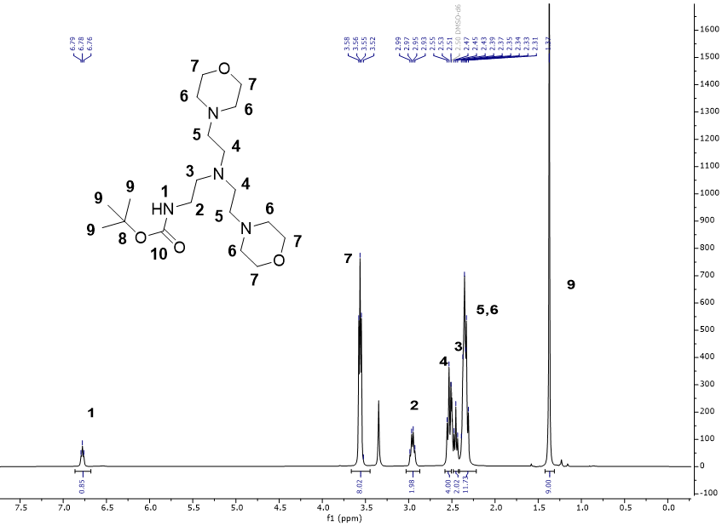
Fig. S1. ¹Н NMR of compound 3 in DMSO-d₆.
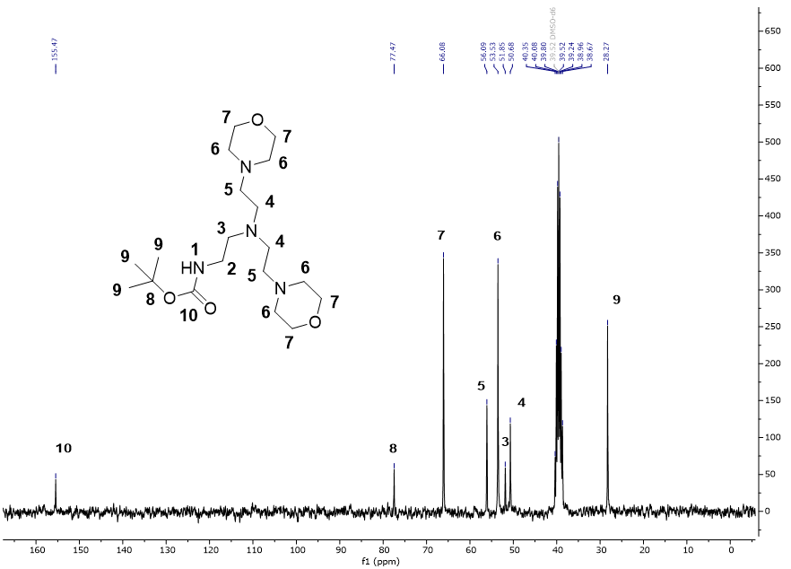
Fig. S2. ¹³C NMR of compound 3 in DMSO-d₆.
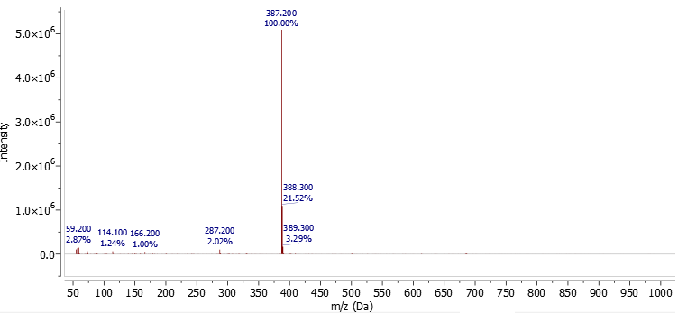
Fig. S3. MS-ESI⁺ of compound 3.
Compound 7
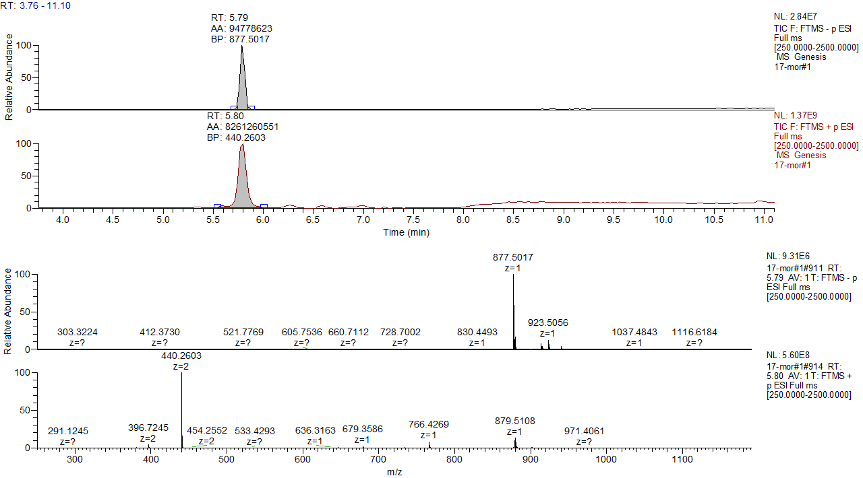
Fig. S4. Chromatogram and HRMS (ESI) of compound 7.

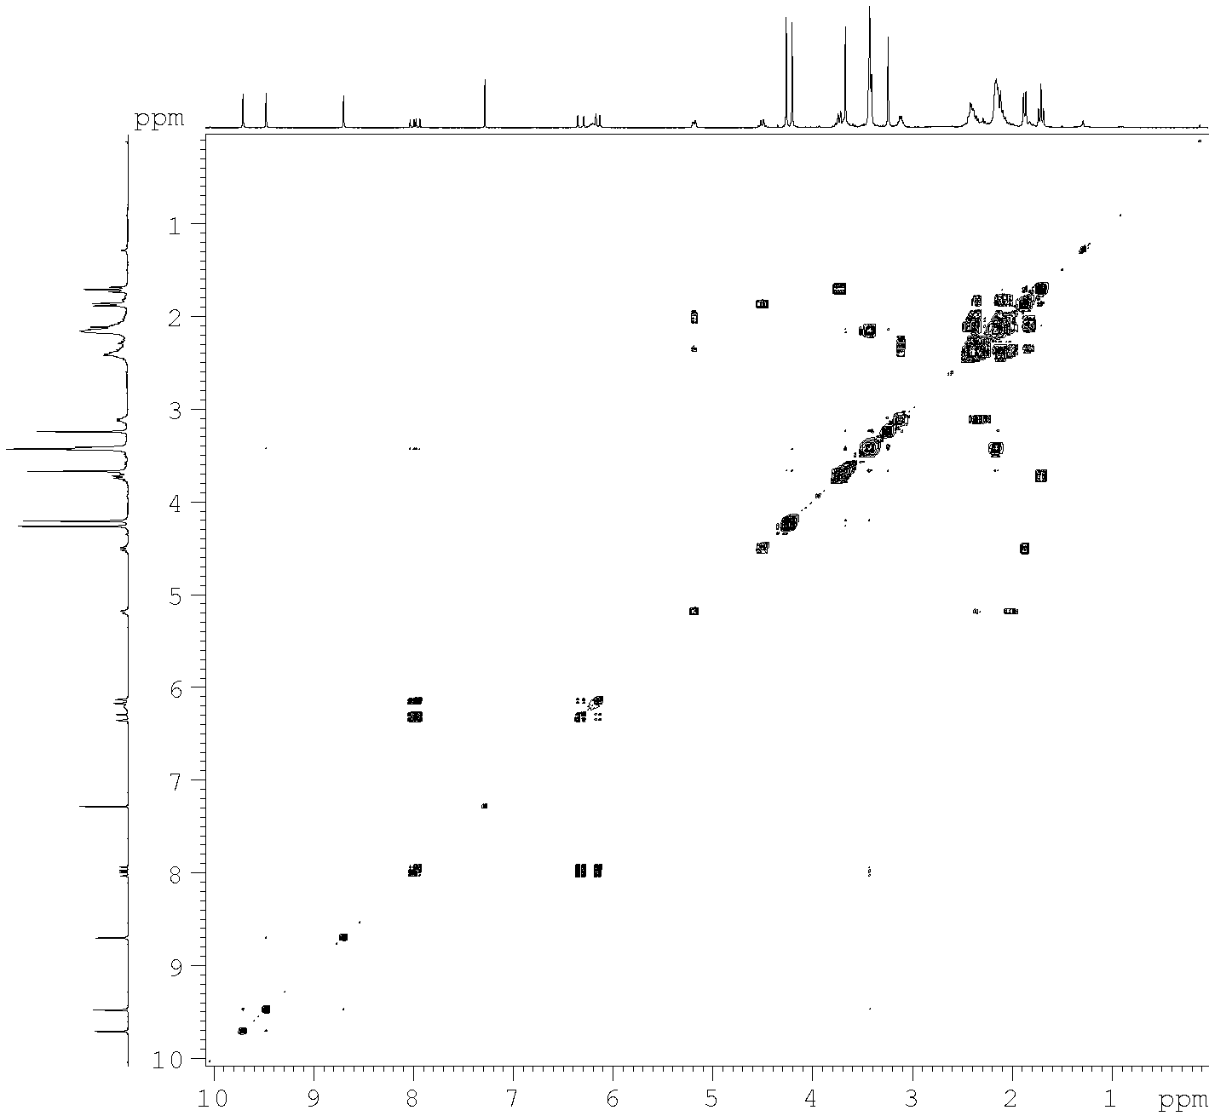 | ¹H | δ (ppm), mult.
 | Chl
 | H-2¹ | 3.65, s
 | H-3¹ | 7.96, dd
 | H-3² | 6.30+6.12, dd
 | H-5 | 9.45, s
 | H-7¹ | 3.22, s
 | H-8¹ | 3.72, m
 | H-8² | 1.68, t
 | H-10 | 9.69, s
 | H-12¹ | 3.40, m
 | H-13¹ | 4.24, s
 | H-15¹ | 4.18, s
 | H-17 | 5.17, m
 | H-17¹ | 2.39+2.14, m
 | H-17² | 2.39+2.14, m
 | H-18 | 4.48, q
 | H-18¹ | 1.85, d
 | H-20 | 8.68, s
 | Mor
 | H-1 | 6.18, bs
 | H-2 | 3.09, m
 | H-3 | 2.39, m
 | H-4 | 2.39, m
 | H-4' | 2.39, m
 | H-5 | 2.13, m
 | H-5' | 2.13, m
 | H-5¹ | 2.13, m
 | H-5² | 3.40, m
 | H-5⁴ | 3.40, m
 | H-5⁵ | 2.13, m
 | H-5'¹ | 2.13, m
 | H-5'² | 3.40, m
 | H-5'⁴ | 3.40, m
 | H-5'⁵ | 2.13, m
Fig. S5. {¹H,¹H}COSY NMR of compound 7 in CDCl₃ and signals assignment.

Compound 9
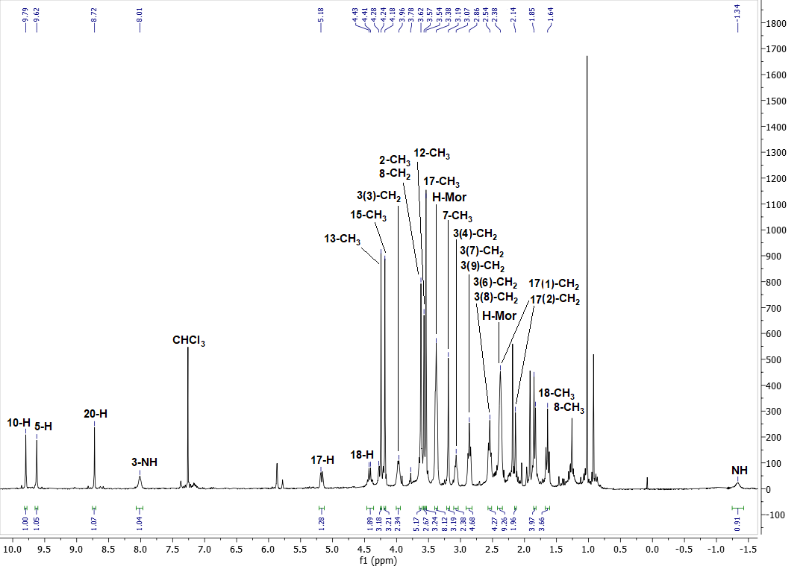
Fig. S6. ¹Н NMR of compound 9 in CDCl₃.

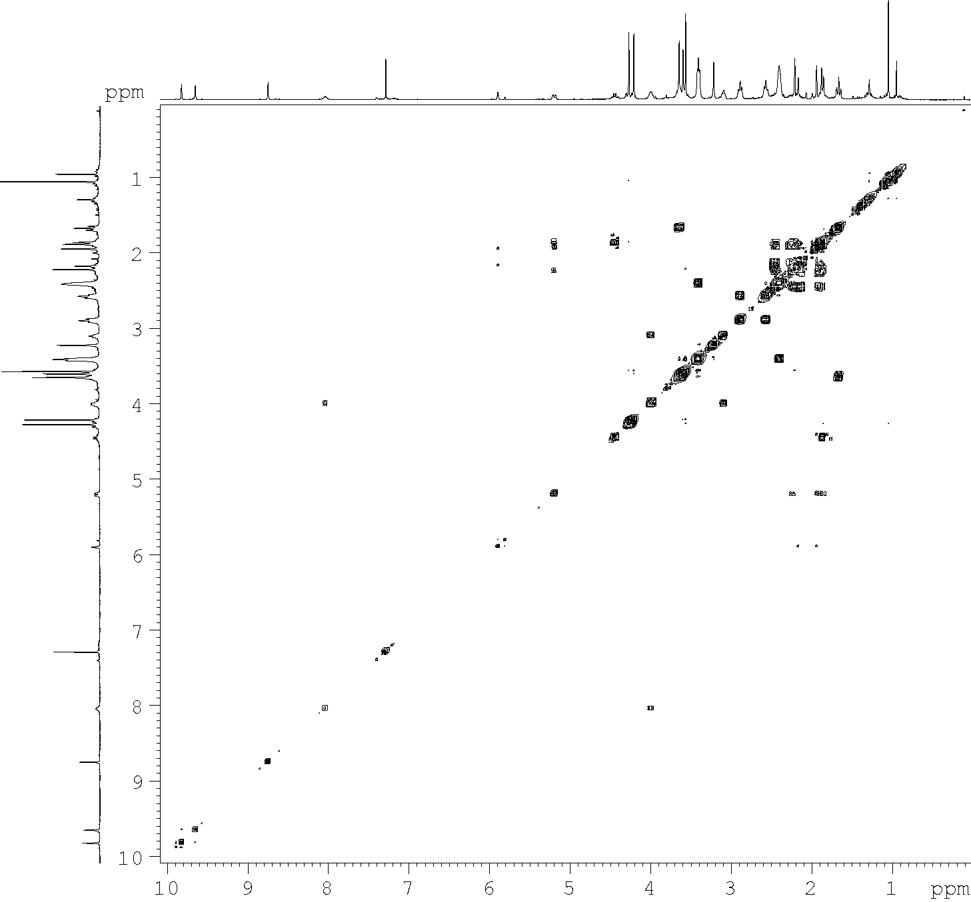 | ¹H | δ (ppm), mult.
 | Chl
 | H-2¹ | 3.62, s
 | H-5 | 9.62, s
 | H-7¹ | 3.19, s
 | H-8¹ | 3.62, m
 | H-8² | 1.64, t
 | H-10 | 9.79, s
 | H-12¹ | 3.57, s
 | H-13¹ | 4.24, s
 | H-15¹ | 4.18, s
 | H-17 | 5.18, m
 | H-17¹ | 2.41+2.14, m
 | H-17² | 2.41+2.14, m
 | H-17⁵ | 3.54, s
 | H-18 | 4.42, q
 | H-18¹ | 1.85, m
 | H-20 | 8.72, s
 | Mor
 | H-1 | 8.01, bs
 | H-2 | 3.96, m
 | H-3 | 3.07, m
 | H-4 | 2.54, m
 | H-4' | 2.54, m
 | H-5 | 2.86, m
 | H-5' | 2.86, m
 | H-5¹ | 2.41, m
 | H-5² | 3.38, m
 | H-5⁴ | 3.38, m
 | H-5⁵ | 2.41, m
 | H-5'¹ | 2.41, m
 | H-5'² | 3.38, m
 | H-5'⁴ | 3.38, m
 | H-5'⁵ | 2.41, m
Fig. S7. {¹H,¹H}COSY NMR of compound 9 in CDCl₃ and signals assignment.
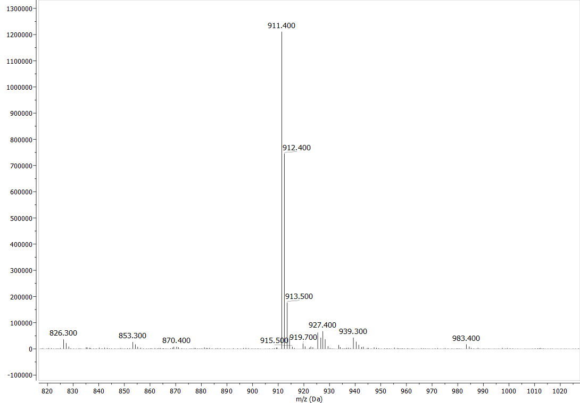
Fig. S8. MS-ESI⁺ of compound 9.
Compound 11
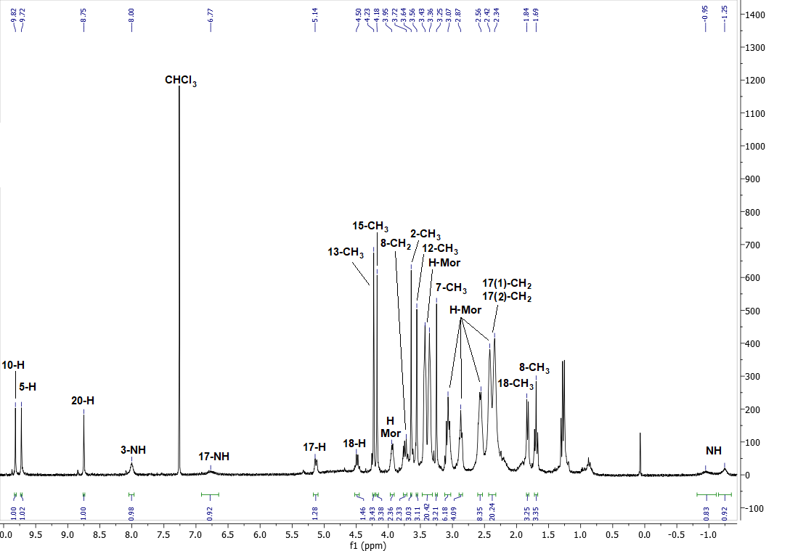
Fig. S9. ¹Н NMR of compound 11 in CDCl₃.
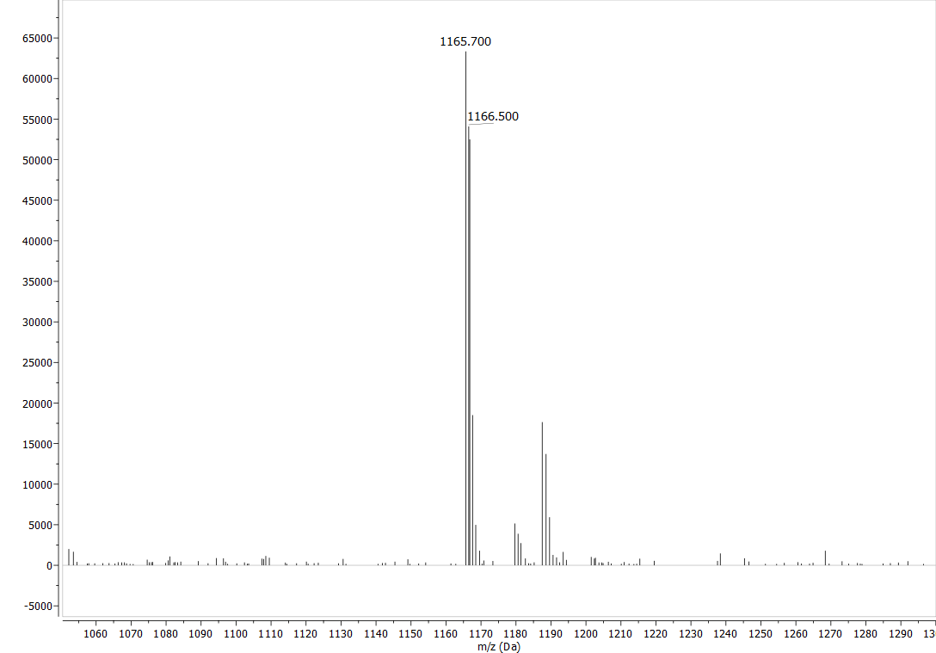
Fig. S10. MS-ESI⁺ of compound 11.
UV/VIS data for compounds 7, 9, 11
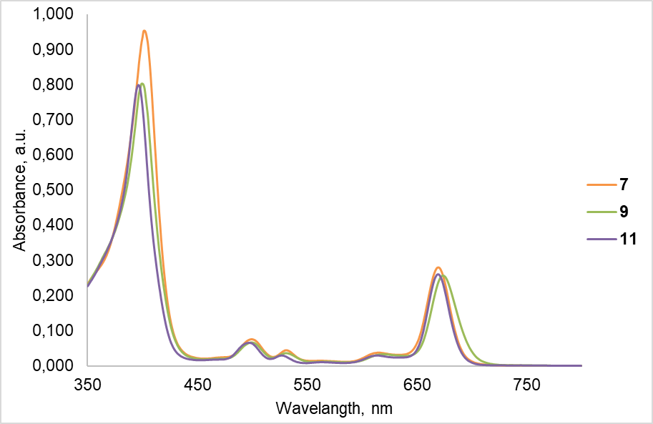
Fig. S11. Absorbance spectra of compounds 7, 9, 11.

Table S1. Results of absorbance measurements.
Compound | Absorbance wavelength, λ, nm
Compound | Soret | I | II | III | IV
7 | 402 | 500 | 532 | 615 | 670
9 | 400 | 500 | 531 | 623 | 675
11 | 396 | 497 | 527 | 614 | 669

