SUPPLEMENTARY INFORMATION
for
A Novel Unsymmetrically Substituted Dibromo-BODIPY
Photosensitizer: Synthesis, Photophysical/Photochemical
Characteristics and Antimicrobial Activity
DOI: 10.6060/mhc267110a
Lubov A. Antina,ª Daria A. Fedorova,^{a,b} Аrtem S. Sherudillo,^{a@}
Оlga V. Miloshevskaya,^{a,b} Alexey N. Sivukhin,^{a,c} Mikhail B. Berezin,ª
and Elena V. Antinaª
ªG.A. Krestov Institute of Solution Chemistry of the Russian Academy of Sciences, 153045 Ivanovo, Russia
^{b}Ivanovo State University of Chemistry and Technology, 153000 Ivanovo, Russia
^{c}Ivanovo State University, 153025 Ivanovo, Russia
@Corresponding author E-mail: artsherudillo@gmail.com
Content
Figure S1. ¹H NMR spectrum (CDCl₃, δ, ppm) of 3,5,4',5'-tetramethyl-2,2'-dipyrrolylmethene hydrobromide: 13.30 (bs, 1x1H, NH); 13.09 (bs, 1x1H, NH); 6.97 (s, 1H, C-H); 6.85 (s, 1H, C-H); 6.14 (s, 1H, ms-H ); 2.67 (s, 3H, -CH₃); 2.65 (s, 3H, -CH₃); 2.31 (s, 3H, -CH₃); 2.05 (s, 3H, -CH₃). 1
Figure S2. ¹³C NMR spectrum (CDCl₃, δ, ppm) of 3,5,4ʹ,5ʹ-tetramethyl-2,2ʹ-dipyrromethene hydrobromide: 156.49; 155.96; 146.92; 134.23; 127.90; 127.24; 127.08; 123.57; 118.26; 15.13; 13.50; 12.71; 11.24. 1
Figure S3. ¹H NMR spectrum (CDCl₃, δ, ppm) of BODIPY 1: 6.97 (s, 1H, C-H); 6.71 (s, 1H, C-H); 6.05 (s, 1H, ms-H); 2.56 (s, 3H, -CH₃); 2.53 (s, 3H, -CH₃); 2.24 (s, 3H, -CH₃); 2.06 (s, 3H, -CH₃). 2
Figure S4. ¹³C NMR spectrum (CDCl₃, δ, ppm) of BODIPY 1: 157.69; 156.56; 142.08; 134.47; 133.24; 128.56; 128.34; 122.88; 119.57; 15.27; 13.26; 11.81; 11.69. 2
Figure S5. MALDI TOF of BODIPY (1): Found: [M]⁺ = 248.24. Calculated: C₁₃H₁₅BF₂N₂, [M]⁺=248.08 3
Figure S6. ¹H NMR spectrum (CDCl₃, δ, ppm) of BODIPY 2: 7.12 (s, 1H, ms-H); 2.57 (s, 3H, -CH₃); 2.56 (s, 3H, -CH₃); 2.26 (s, 3H, -CH₃); 2.05 (s, 3H, -CH₃). 3
Figure S7. ¹³C NMR spectrum (CDCl₃, δ, ppm) of BODIPY 2: 156.59; 155.59; 139.97; 132.79; 132.08; 128.38; 121.39; 120.88; 110.19; 14.15; 13.90; 11.71; 10.87. 4
Figure S8. MALDI TOF of BODIPY (2): Found: [M+H]⁺ = 406.52. Calculated: BF₂C₁₃H₁₃Br₂N₂; [M]⁺ = 405.87 4
Table S1. Spectral characteristics of BODIPYs (β-Br)₂-BODIPY and (β'-Br)₂-BODIPY in organic solvents (Т = 25ºC)¹ 4
Figure S9. Fluorescence decay curves of BODIPY 1 (a) and BODIPY 2 (b) in organic solvents. 5
Figure S10. Singlet oxygen emission spectra recorded upon excitation of BODIPY 1 (a) and BODIPY 2 (b) solutions at an excitation wavelength of 500 nm in organic solvents. 5
SolvatoChrom: Analysis Report for BODIPY 1 6
SolvatoChrom: Analysis Report for BODIPY 2 12
References 18

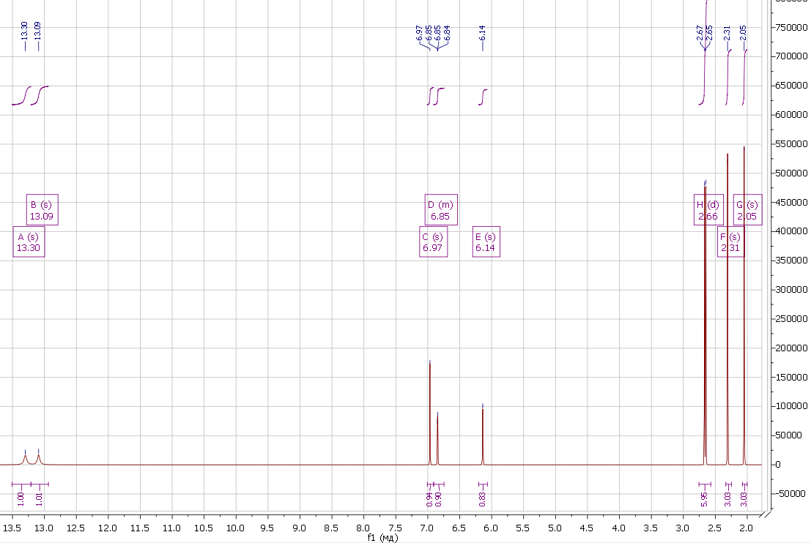

Figure S1. ¹H NMR spectrum (CDCl₃, δ, ppm) of 3,5,4',5'-tetramethyl-2,2'-dipyrrolylmethene hydrobromide: 13.30 (bs, 1x1H, NH); 13.09 (bs, 1x1H, NH); 6.97 (s, 1H, C-H); 6.85 (s, 1H, C-H); 6.14 (s, 1H, ms-H ); 2.67 (s, 3H, -CH₃); 2.65 (s, 3H, -CH₃); 2.31 (s, 3H, -CH₃); 2.05 (s, 3H, -CH₃).

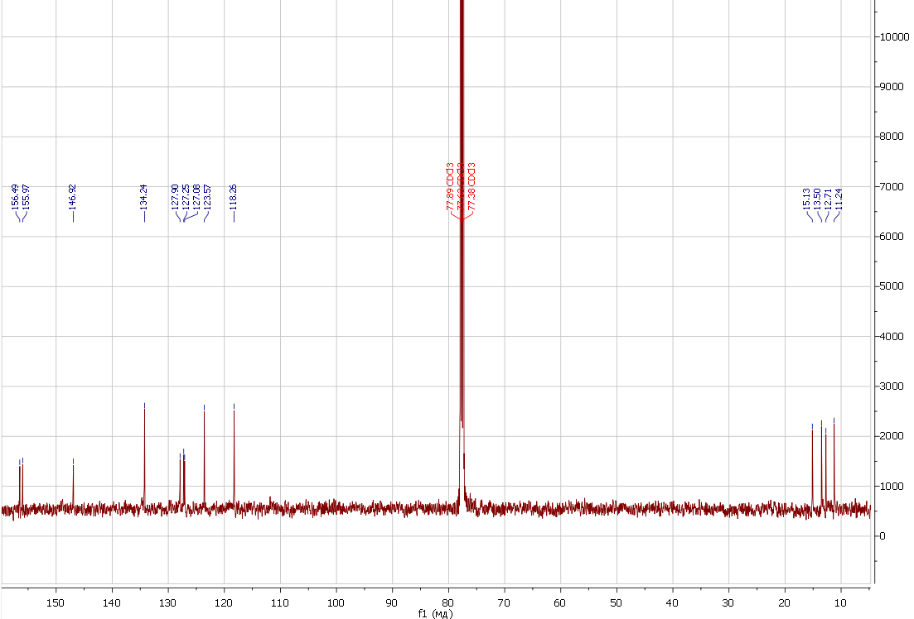
Figure S2. ¹³C NMR spectrum (CDCl₃, δ, ppm) of 3,5,4ʹ,5ʹ-tetramethyl-2,2ʹ-dipyrromethene hydrobromide: 156.49; 155.96; 146.92; 134.23; 127.90; 127.24; 127.08; 123.57; 118.26; 15.13; 13.50; 12.71; 11.24.
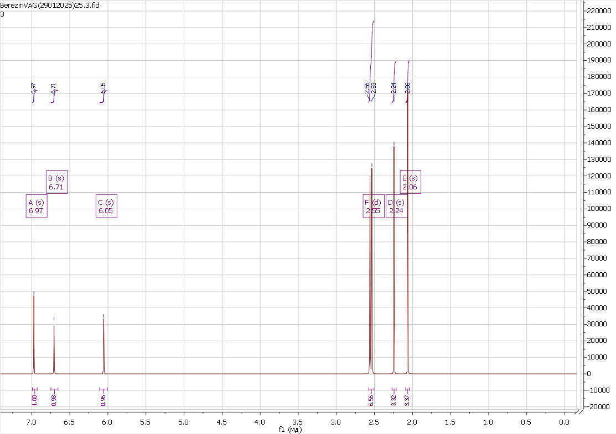

Figure S3. ¹H NMR spectrum (CDCl₃, δ, ppm) of BODIPY 1: 6.97 (s, 1H, C-H); 6.71 (s, 1H, C-H); 6.05 (s, 1H, ms-H); 2.56 (s, 3H, -CH₃); 2.53 (s, 3H, -CH₃); 2.24 (s, 3H, -CH₃); 2.06 (s, 3H, -CH₃).
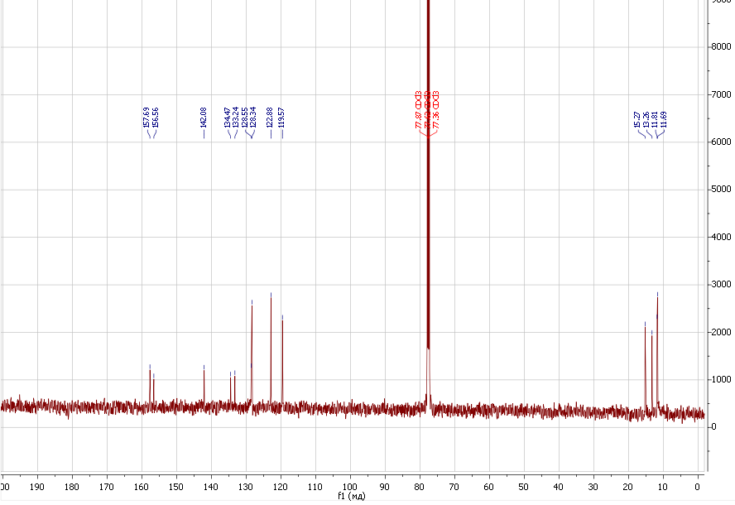

Figure S4. ¹³C NMR spectrum (CDCl₃, δ, ppm) of BODIPY 1: 157.69; 156.56; 142.08; 134.47; 133.24; 128.56; 128.34; 122.88; 119.57; 15.27; 13.26; 11.81; 11.69.

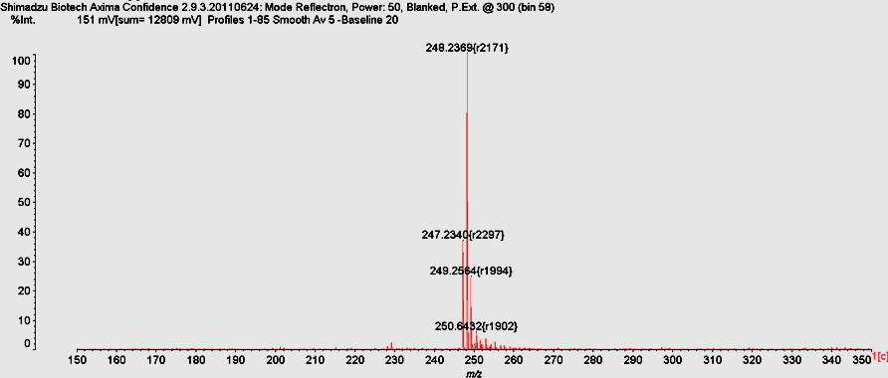

Figure S5. MALDI TOF of BODIPY (1): Found: [M]⁺ = 248.24. Calculated: C₁₃H₁₅BF₂N₂, [M]⁺=248.08

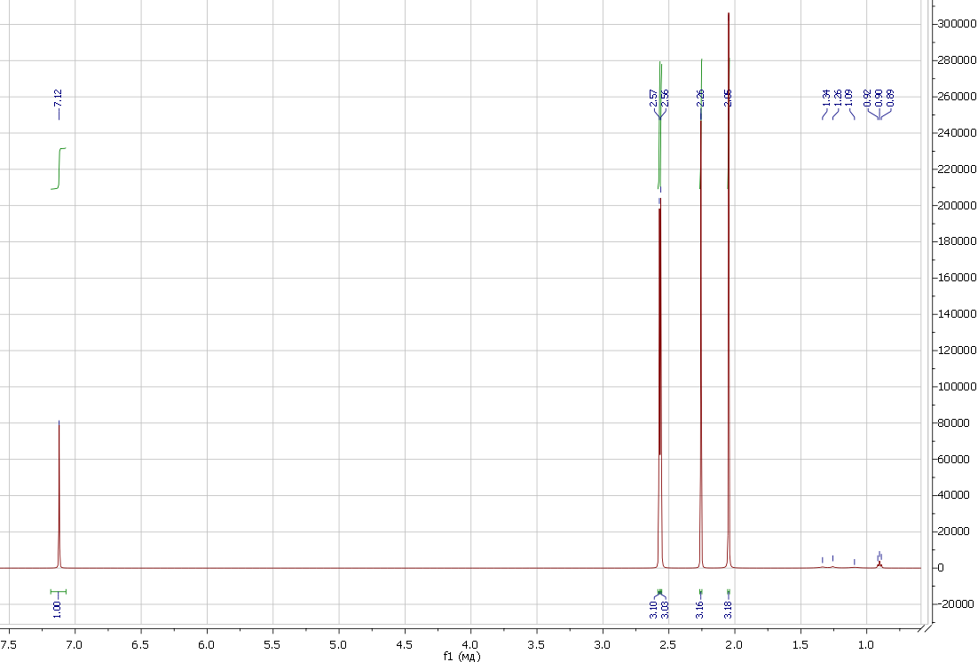

Figure S6. ¹H NMR spectrum (CDCl₃, δ, ppm) of BODIPY 2: 7.12 (s, 1H, ms-H); 2.57 (s, 3H, -CH₃); 2.56 (s, 3H, -CH₃); 2.26 (s, 3H, -CH₃); 2.05 (s, 3H, -CH₃).

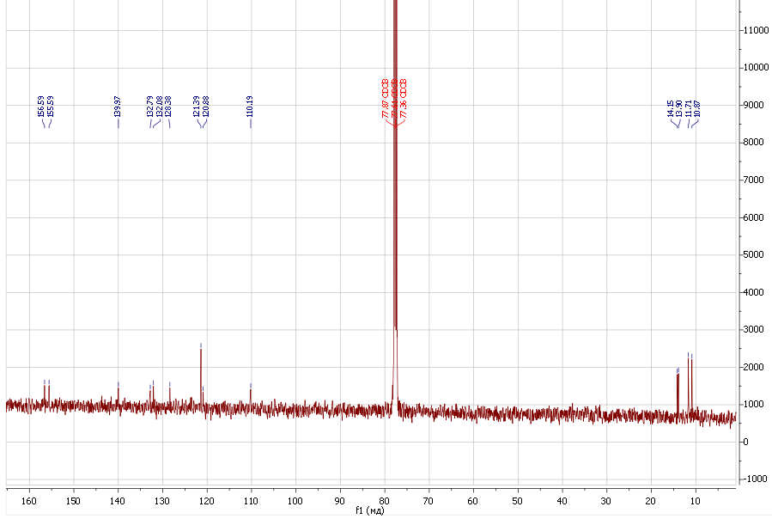

Figure S7. ¹³C NMR spectrum (CDCl₃, δ, ppm) of BODIPY 2: 156.59; 155.59; 139.97; 132.79; 132.08; 128.38; 121.39; 120.88; 110.19; 14.15; 13.90; 11.71; 10.87.
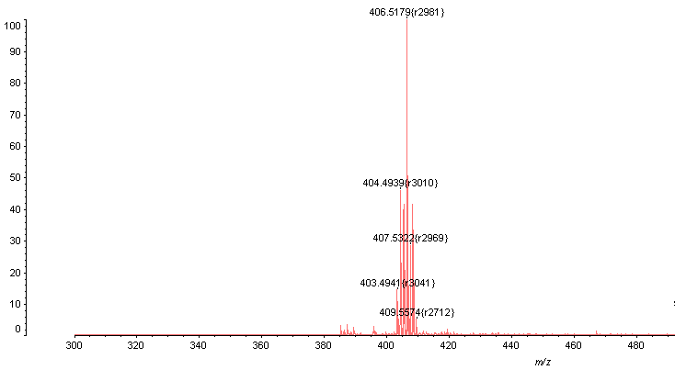

Figure S8. MALDI TOF of BODIPY (2): Found: [M+H]⁺ = 406.52. Calculated: BF₂C₁₃H₁₃Br₂N₂; [M]⁺ = 405.87

Table S1. Spectral characteristics of BODIPYs (β-Br)₂-BODIPY and (β'-Br)₂-BODIPY in organic solvents (Т = 25ºC)¹
Solvent | $λ_{abs}^{max}$, nm | lgε | $λ_{fluo}^{max}$, nm | ${Δν}_{ss}$, cm⁻¹ | $$Ф_{fluo}$$ | $τ_{fluo}$, ns | $k_{rad}$·10⁻⁸, s⁻¹ | $k_{nrad}$·10⁻⁸, s⁻¹ | $Ф_{∆}$(¹O₂)
(β-Br)₂-BODIPY
Cyclohexane | 538 | 4.83 | 547 | 306 | 0.45 | 2.67 | 1.69 | 2.06 | -
Benzene | 533 | 4.60 | 546 | 447 | 0.56 | 2.36 | 2.37 | 1.86 | 0.32
Chloroform | 539 | 4.65 | 549 | 338 | 0.41 | 2.54 | 1.61 | 2.32 | 0.45
THF | 529 | 4.87 | 547 | 622 | 0.44 | 2.15 | 2.05 | 2.6 | 0.56
Ethanol | 528 | - | 545 | 591 | 0.32 | 2.16 | 1.48 | 3.15 | 0.66
DMF | 528 | 4.60 | 546 | 624 | 0.32 | 3.19 | 1.0 | 2.13 | 0.49
Acetonitrile | 525 | 4.86 | 544 | 665 | 0.32 | 1.83 | 1.75 | 3.72 | 0.67
(β'-Br)₂-BODIPY
Cyclohexane | 533 | 5.15 | 544 | 379 | 0.23 | 1.61 | 1.43 | 4.78 | -
Benzene | 538 | 5.15 | 552 | 471 | 0.19 | 1.41 | 1.35 | 5.74 | 0.41
Chloroform | 536 | 5.05 | 550 | 475 | 0.18 | 1.54 | 1.17 | 5.32 | 0.54
THF | 534 | 4.93 | 546 | 412 | 0.20 | 1.17 | 1.71 | 6.84 | 0.79
Ethanol | 532 | 4.85 | 546 | 482 | 0.16 | 1.16 | 1.38 | 7.24 | 0.72
DMF | 535 | 4.73 | 548 | 443 | 0.11 | 1.20 | 0.92 | 7.42 | 0.42
Acetonitrile | 531 | 4.86 | 545 | 484 | 0.13 | 0.96 | 1.35 | 9.06 | 0.75
Note: absorption maxima ($λ_{abs}^{max}$, nm), molar absorption coefficients (lgε), emission maxima ($λ_{fluo}^{max}$, nm), Stokes shift (${Δν}_{ss}$, cm⁻¹), fluorescence quantum yield ($Ф_{fluo}$), fluorescence lifetime ($τ_{fluo}$, ns), the radiative and non-radiative rate constants ( $k_{rad}$ and $k_{nrad}$), singlet oxygen quantum yield ($Ф_{∆}$(¹O₂)).

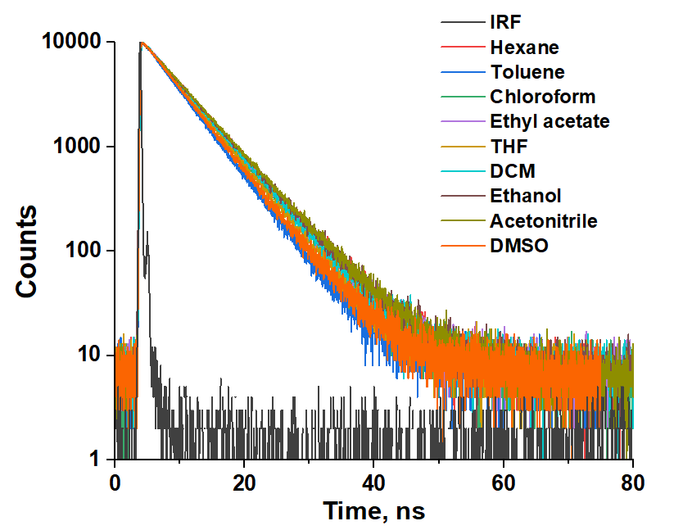 | 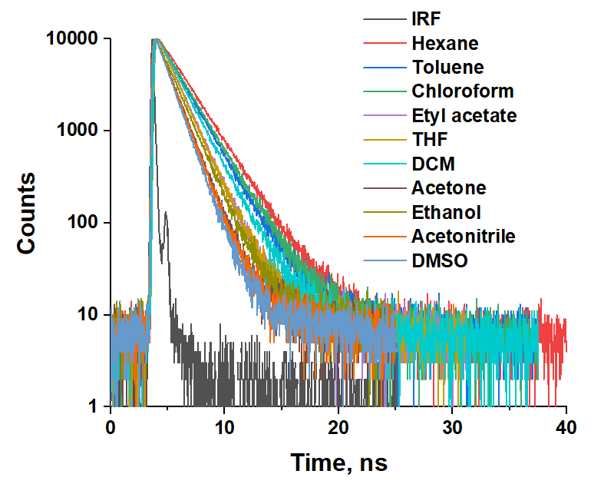
a | b

Figure S9. Fluorescence decay curves of BODIPY 1 (a) and BODIPY 2 (b) in organic solvents.
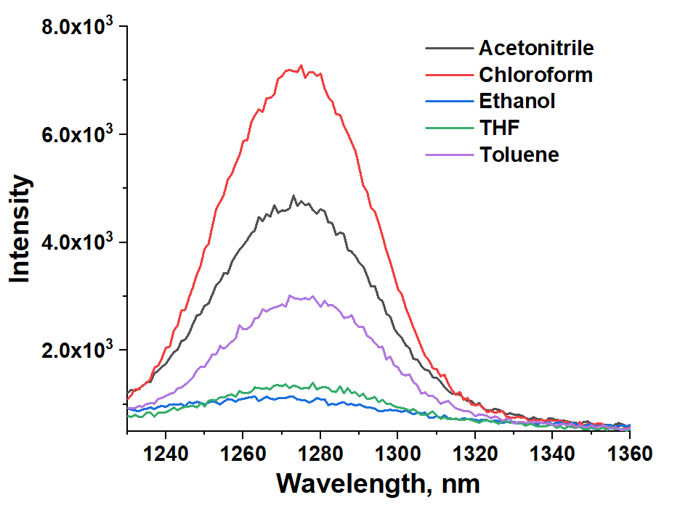 | 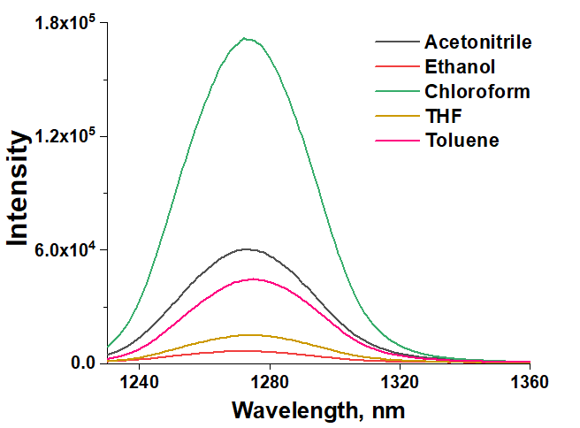
a | b

Figure S10. Singlet oxygen emission spectra recorded upon excitation of BODIPY 1 (a) and BODIPY 2 (b) solutions at an excitation wavelength of 500 nm in organic solvents.



SolvatoChrom: Analysis Report for BODIPY 1

User Input: Photophysical Parameters for Selected Solvents

Solvent | λabs, nm | λem, nm | νss, cm⁻¹ | ФFL | τ, ns
hexane | 522 | 526 | 146 | 0.66 | 6.17
toluene | 525 | 531 | 215 | 0.72 | 5.25
chloroform | 524 | 530 | 216 | 0.74 | 5.89
tetrahydrofuran | 520 | 527 | 255 | 0.69 | 5.71
ethyl acetate | 518 | 529 | 401 | 0.77 | 6.02
dichloromethane | 522 | 529 | 253 | 0.73 | 6.0
acetone | 518 | 526 | 294 | 0.76 | 6.22
ethanol | 519 | 526 | 256 | 0.7 | 6.24
acetonitrile | 517 | 525 | 295 | 0.68 | 6.29
dimethyl sulfoxide | 520 | 530 | 363 | 0.69 | 5.46

Single Linear Regression (SLR)

Photophysical parameter | Solvation parameter | Equation | R²
λabs, nm | ET(30) | λabs, nm = -0.2491ET(30) + 530.5883 | 0.319
λabs, nm | SP | λabs, nm = 20.4134SP + 506.0657 | 0.341
λabs, nm | SdP | λabs, nm = -5.1913SdP + 523.9097 | 0.370
λabs, nm | SA | λabs, nm = -4.2023SA + 520.7534 | 0.037
λabs, nm | SB | λabs, nm = -7.3710SB + 523.1771 | 0.454
λabs, nm | ρ | λabs, nm = 4.6686ρ + 516.0228 | 0.214
λabs, nm | μ | λabs, nm = -1.4551μ + 523.1395 | 0.487
λabs, nm | SPP | λabs, nm = -10.4549SPP + 528.9894 | 0.277
λabs, nm | nD | λabs, nm = 38.0902nD + 466.9299 | 0.579
λabs, nm | δd | λabs, nm = 2.5104δd + 500.0657 | 0.378
λabs, nm | δp | λabs, nm = -0.6367δp + 522.8493 | 0.482
λabs, nm | δh | λabs, nm = -0.4775δh + 522.1759 | 0.205

Photophysical parameter | Solvation parameter | Equation | R²
λabs, nm | α | λabs, nm = -2.0133α + 520.7939 | 0.039
λabs, nm | β | λabs, nm = -6.3565β + 522.8201 | 0.432
λabs, nm | π* | λabs, nm = -2.6319π* + 522.0871 | 0.071
λabs, nm | ε | λabs, nm = -0.0987ε + 522.1123 | 0.345
λabs, nm | Δf | λabs, nm = -19.1877Δf + 524.2206 | 0.614
λem, nm | ET(30) | λem, nm = -0.1057ET(30) + 532.1799 | 0.090
λem, nm | SP | λem, nm = 23.6046SP + 511.2092 | 0.720
λem, nm | SdP | λem, nm = -0.9346SdP + 528.5138 | 0.019
λem, nm | SA | λem, nm = -4.4119SA + 528.1660 | 0.064
λem, nm | SB | λem, nm = -1.7135SB + 528.5223 | 0.039
λem, nm | ρ | λem, nm = 5.1603ρ + 522.9513 | 0.412
λem, nm | μ | λem, nm = -0.3103μ + 528.4629 | 0.035
λem, nm | SPP | λem, nm = 0.0734SPP + 527.8404 | 0.000
λem, nm | nD | λem, nm = 35.5405nD + 477.9159 | 0.795
λem, nm | δd | λem, nm = 2.7536δd + 505.4855 | 0.716
λem, nm | δp | λem, nm = -0.2282δp + 528.7421 | 0.098
λem, nm | δh | λem, nm = -0.1742δh + 528.5116 | 0.043
λem, nm | α | λem, nm = -2.8346α + 528.3139 | 0.123
λem, nm | β | λem, nm = -1.6598β + 528.5058 | 0.046
λem, nm | π* | λem, nm = 2.2669π* + 526.5330 | 0.083
λem, nm | ε | λem, nm = -0.0341ε + 528.4565 | 0.065
λem, nm | Δf | λem, nm = -7.4295Δf + 529.3406 | 0.145
νss, cm⁻¹ | ET(30) | νss, cm⁻¹ = 5.3798ET(30) + 51.5168 | 0.195
νss, cm⁻¹ | SP | νss, cm⁻¹ = 93.3623SP + 203.3835 | 0.009
νss, cm⁻¹ | SdP | νss, cm⁻¹ = 157.8648SdP + 165.7144 | 0.450
νss, cm⁻¹ | SA | νss, cm⁻¹ = -4.9061SA + 269.6958 | 0.000
νss, cm⁻¹ | SB | νss, cm⁻¹ = 209.5576SB + 193.2887 | 0.483
νss, cm⁻¹ | ρ | νss, cm⁻¹ = 12.7000ρ + 257.2207 | 0.002
νss, cm⁻¹ | μ | νss, cm⁻¹ = 42.5738μ + 192.1712 | 0.549
νss, cm⁻¹ | SPP | νss, cm⁻¹ = 387.5764SPP + -45.3121 | 0.501
νss, cm⁻¹ | nD | νss, cm⁻¹ = -130.3074nD + 452.6643 | 0.009
νss, cm⁻¹ | δd | νss, cm⁻¹ = 6.0404δd + 220.2314 | 0.003
νss, cm⁻¹ | δp | νss, cm⁻¹ = 15.3102δp + 212.9052 | 0.367
νss, cm⁻¹ | δh | νss, cm⁻¹ = 11.2670δh + 229.8529 | 0.150
νss, cm⁻¹ | α | νss, cm⁻¹ = -27.9688α + 273.4834 | 0.010
νss, cm⁻¹ | β | νss, cm⁻¹ = 174.2988β + 205.7810 | 0.427
νss, cm⁻¹ | π* | νss, cm⁻¹ = 178.2748π* + 161.9003 | 0.430
νss, cm⁻¹ | ε | νss, cm⁻¹ = 2.4197ε + 229.8665 | 0.273
νss, cm⁻¹ | Δf | νss, cm⁻¹ = 440.4798Δf + 183.9895 | 0.426
ФFL | ET(30) | ФFL = 0.0000ET(30) + 0.7122 | 0.000
ФFL | SP | ФFL = 0.0529SP + 0.6766 | 0.013
ФFL | SdP | ФFL = 0.0250SdP + 0.6976 | 0.048
ФFL | SA | ФFL = -0.0517SA + 0.7171 | 0.031
ФFL | SB | ФFL = 0.0111SB + 0.7100 | 0.006
ФFL | ρ | ФFL = 0.0488ρ + 0.6672 | 0.130
ФFL | μ | ФFL = -0.0003μ + 0.7145 | 0.000
ФFL | SPP | ФFL = 0.0558SPP + 0.6687 | 0.044

Photophysical parameter | Solvation parameter | Equation | R²
ФFL | nD | ФFL = 0.0173nD + 0.6897 | 0.001
ФFL | δd | ФFL = 0.0084δd + 0.6457 | 0.023
ФFL | δp | ФFL = -0.0019δp + 0.7210 | 0.024
ФFL | δh | ФFL = 0.0005δh + 0.7121 | 0.001
ФFL | α | ФFL = -0.0120α + 0.7158 | 0.008
ФFL | β | ФFL = -0.0083β + 0.7170 | 0.004
ФFL | π* | ФFL = 0.0393π* + 0.6903 | 0.088
ФFL | ε | ФFL = -0.0006ε + 0.7243 | 0.078
ФFL | Δf | ФFL = 0.0577Δf + 0.7028 | 0.031
τ, ns | ET(30) | τ, ns = 0.0195ET(30) + 5.1369 | 0.113
τ, ns | SP | τ, ns = -3.7389SP + 8.5688 | 0.663
τ, ns | SdP | τ, ns = 0.1923SdP + 5.7987 | 0.029
τ, ns | SA | τ, ns = 0.8169SA + 5.8757 | 0.081
τ, ns | SB | τ, ns = 0.0251SB + 5.9159 | 0.000
τ, ns | ρ | τ, ns = -0.3598ρ + 6.2700 | 0.074
τ, ns | μ | τ, ns = 0.0227μ + 5.8839 | 0.007
τ, ns | SPP | τ, ns = 0.0397SPP + 5.8927 | 0.000
τ, ns | nD | τ, ns = -6.1073nD + 14.5142 | 0.862
τ, ns | δd | τ, ns = -0.4141δd + 9.2956 | 0.595
τ, ns | δp | τ, ns = 0.0222δp + 5.8431 | 0.034
τ, ns | δh | τ, ns = 0.0296δh + 5.8213 | 0.045
τ, ns | α | τ, ns = 0.5858α + 5.8395 | 0.193
τ, ns | β | τ, ns = 0.0144β + 5.9197 | 0.000
τ, ns | π* | τ, ns = -0.3277π* + 6.1226 | 0.064
τ, ns | ε | τ, ns = 0.0021ε + 5.8905 | 0.009
τ, ns | Δf | τ, ns = 1.3155Δf + 5.6699 | 0.167

Multiple Linear Regression (MLR) – Catalán Model 1

Photophysical parameter | Model | Equation | R²
λabs, nm | Catalan (SA, SB, SdP, SP) | λabs, nm = (507.6249 ± 2.3440) + (5.8502 ±  2.1959)SA + (-4.1076 ±  1.2996)SB + (-4.9230 ±  0.9816)SdP + (24.3920  ± 3.3318)SP | 0.960
λem, nm | Catalan (SA, SB, SdP, SP) | λem, nm = (511.0936 ± 4.1082) + (-0.2285 ±  3.8487)SA + (0.9858 ±  2.2778)SB + (-2.4107 ±  1.7204)SdP + (25.5205  ± 5.8394)SP | 0.808
νss, cm⁻¹ | Catalan (SA, SB, SdP, SP) | νss, cm⁻¹ = (142.6789 ± 176.2145) + (-225.3516  ± 165.0861)SA + (185.7907 ± 97.7038)SB  + (95.7168 ±  73.7934)SdP + (14.0911  ± 250.4737)SP | 0.705

Photophysical parameter | Model | Equation | R²
ФFL | Catalan (SA, SB, SdP, SP) | ФFL = (0.6912 ± 0.1494)  + (-0.0751 ± 0.1400)SA  + (0.0044 ± 0.0829)SB + (0.0305 ± 0.0626)SdP + (0.0081 ± 0.2124)SP | 0.107
τ, ns | Catalan (SA, SB, SdP, SP) | τ, ns = (8.7507 ± 0.5229)  + (0.3898 ± 0.4899)SA + (-0.6757 ± 0.2900)SB + (0.6364 ± 0.2190)SdP + (-4.2736 ± 0.7433)SP | 0.886

Multiple Linear Regression (MLR) – Catalán Model 2

Photophysical parameter | Model | Equation | R²
λabs, nm | Catalan (SA, SB, SPP) | λabs, nm = (525.3583 ± 5.3761) + (2.3155 ±  7.1258)SA + (-6.7633 ±  4.4887)SB + (-3.1299 ±  7.5919)SPP | 0.479
λem, nm | Catalan (SA, SB, SPP) | λem, nm = (526.2410 ± 5.6321) + (-3.4426 ±  7.4651)SA + (-2.1251 ±  4.7024)SB + (3.2494 ±  7.9534)SPP | 0.099
νss, cm⁻¹ | Catalan (SA, SB, SPP) | νss, cm⁻¹ = (30.6756 ± 112.3921) + (-210.0015 ±  148.9705)SA + (172.4502 ± 93.8402)SB  + (232.4551 ± 158.7147)SPP | 0.701
ФFL | Catalan (SA, SB, SPP) | ФFL = (0.6622 ± 0.0951)  + (-0.0710 ± 0.1261)SA + (0.0023 ± 0.0794)SB + (0.0680 ± 0.1343)SPP | 0.097
τ, ns | Catalan (SA, SB, SPP) | τ, ns = (5.8813 ± 0.9318)  + (0.9724 ± 1.2351)SA + (-0.2060 ± 0.7780)SB + (0.0738 ± 1.3159)SPP | 0.094

Multiple Linear Regression (MLR) – Kamlet-Taft

Photophysical parameter | Model | Equation | R²
λabs, nm | Kamlet-Taft (π*, α, β) | λabs, nm = (522.3907 ± 2.0176) + (0.9858 ±  3.5546)π* + (0.9048 ±  3.4489)α + (-7.1706 ±  3.7823)β | 0.443
λem, nm | Kamlet-Taft (π*, α, β) | λem, nm = (526.9442 ± 1.8142) + (3.7127 ±  3.1962)π* + (-1.7148 ±  3.1011)α + (-2.8290 ±  3.4009)β | 0.290

Photophysical parameter | Model | Equation | R²
νss, cm⁻¹ | Kamlet-Taft (π*, α, β) | νss, cm⁻¹ = (165.5257 ± 43.0796) + (96.9993 ±  75.8964)π* + (-95.1930 ±  73.6395)α + (162.4161 ±  80.7578)β | 0.666
ФFL | Kamlet-Taft (π*, α, β) | ФFL = (0.6922 ± 0.0335)  + (0.0583 ± 0.0591)π* + (0.0028 ± 0.0573)α +  (-0.0376 ± 0.0629)β | 0.147
τ, ns | Kamlet-Taft (π*, α, β) | τ, ns = (6.0400 ± 0.3055)  + (-0.2983 ± 0.5381)π* + (0.6168 ± 0.5221)α +  (-0.0691 ± 0.5726)β | 0.261

SolvatoChrom: Analysis Report for BODIPY 2

User Input: Photophysical Parameters for Selected Solvents

Solvent | λabs, nm | λem, nm | νss, cm⁻¹ | ФFL | τ, ns
hexane | 535 | 540 | 173 | 0.32 | 2.23
toluene | 540 | 547 | 237 | 0.31 | 1.49
chloroform | 537 | 544 | 240 | 0.29 | 2.09
tetrahydrofuran | 533 | 541 | 277 | 0.26 | 1.58
ethyl acetate | 534 | 540 | 208 | 0.26 | 1.59
dichloromethane | 535 | 543 | 275 | 0.25 | 1.82
acetone | 529 | 539 | 351 | 0.19 | 1.33
ethanol | 532 | 541 | 313 | 0.22 | 1.99
acetonitrile | 529 | 539 | 351 | 0.15 | 1.3
dimethyl sulfoxide | 536 | 544 | 274 | 0.18 | 1.24
Single Linear Regression (SLR)

Photophysical parameter | Solvation parameter | Equation | R²
λabs, nm | ET(30) | λabs, nm = -0.2947ET(30) + 545.9348 | 0.271
λabs, nm | SP | λabs, nm = 30.6249SP + 512.3452 | 0.467
λabs, nm | SdP | λabs, nm = -5.9765SdP + 537.9254 | 0.298
λabs, nm | SA | λabs, nm = -5.1647SA + 534.3114 | 0.034
λabs, nm | SB | λabs, nm = -5.9409SB + 536.1577 | 0.180
λabs, nm | ρ | λabs, nm = 5.6014ρ + 528.6283 | 0.187
λabs, nm | μ | λabs, nm = -1.4100μ + 536.5577 | 0.278
λabs, nm | SPP | λabs, nm = -10.4549SPP + 542.4894 | 0.169
λabs, nm | nD | λabs, nm = 55.6972nD + 455.6674 | 0.753
λabs, nm | δd | λabs, nm = 3.6232δd + 504.5072 | 0.479
λabs, nm | δp | λabs, nm = -0.6920δp + 536.5536 | 0.347
λabs, nm | δh | λabs, nm = -0.4749δh + 535.6668 | 0.123

Photophysical parameter | Solvation parameter | Equation | R²
λabs, nm | α | λabs, nm = -3.7390α + 534.5459 | 0.083
λabs, nm | β | λabs, nm = -5.2475β + 535.9153 | 0.179
λabs, nm | π* | λabs, nm = -1.8099π* + 535.0914 | 0.020
λabs, nm | ε | λabs, nm = -0.0984ε + 535.6072 | 0.209
λabs, nm | Δf | λabs, nm = -23.0179Δf + 538.4633 | 0.538
λem, nm | ET(30) | λem, nm = -0.0945ET(30) + 545.6274 | 0.048
λem, nm | SP | λem, nm = 29.0009SP + 521.2935 | 0.721
λem, nm | SdP | λem, nm = -1.7347SdP + 542.9393 | 0.043
λem, nm | SA | λem, nm = -0.9913SA + 541.8598 | 0.002
λem, nm | SB | λem, nm = -3.2414SB + 542.9773 | 0.092
λem, nm | ρ | λem, nm = 5.1461ρ + 536.8649 | 0.272
λem, nm | μ | λem, nm = -0.5956μ + 542.8805 | 0.085
λem, nm | SPP | λem, nm = -1.7486SPP + 543.2199 | 0.008
λem, nm | nD | λem, nm = 46.6722nD + 476.1603 | 0.910
λem, nm | δd | λem, nm = 3.4627δd + 513.6134 | 0.752
λem, nm | δp | λem, nm = -0.2740δp + 542.8109 | 0.093
λem, nm | δh | λem, nm = -0.1551δh + 542.3443 | 0.023
λem, nm | α | λem, nm = -1.3550α + 541.9978 | 0.019
λem, nm | β | λem, nm = -2.3048β + 542.6413 | 0.059
λem, nm | π* | λem, nm = 2.0603π* + 540.5576 | 0.046
λem, nm | ε | λem, nm = -0.0319ε + 542.3207 | 0.038
λem, nm | Δf | λem, nm = -11.0974Δf + 543.9518 | 0.215
νss, cm⁻¹ | ET(30) | νss, cm⁻¹ = 7.1522ET(30) + -19.7630 | 0.559
νss, cm⁻¹ | SP | νss, cm⁻¹ = -88.8632SP + 332.7352 | 0.014
νss, cm⁻¹ | SdP | νss, cm⁻¹ = 151.1550SdP + 170.6214 | 0.667
νss, cm⁻¹ | SA | νss, cm⁻¹ = 147.8976SA + 260.9818 | 0.097
νss, cm⁻¹ | SB | νss, cm⁻¹ = 97.4200SB + 234.5170 | 0.169
νss, cm⁻¹ | ρ | νss, cm⁻¹ = -21.7590ρ + 290.7669 | 0.010
νss, cm⁻¹ | μ | νss, cm⁻¹ = 29.2772μ + 216.7911 | 0.420
νss, cm⁻¹ | SPP | νss, cm⁻¹ = 307.5446SPP + 20.1738 | 0.511
νss, cm⁻¹ | nD | νss, cm⁻¹ = -367.7881nD + 787.1572 | 0.115
νss, cm⁻¹ | δd | νss, cm⁻¹ = -9.4876δd + 347.1289 | 0.011
νss, cm⁻¹ | δp | νss, cm⁻¹ = 15.0177δp + 214.4848 | 0.571
νss, cm⁻¹ | δh | νss, cm⁻¹ = 11.3749δh + 229.9740 | 0.247
νss, cm⁻¹ | α | νss, cm⁻¹ = 85.7184α + 257.3851 | 0.152
νss, cm⁻¹ | β | νss, cm⁻¹ = 105.3925β + 231.4317 | 0.253
νss, cm⁻¹ | π* | νss, cm⁻¹ = 133.9392π* + 189.1347 | 0.393
νss, cm⁻¹ | ε | νss, cm⁻¹ = 2.3759ε + 231.0818 | 0.425
νss, cm⁻¹ | Δf | νss, cm⁻¹ = 430.8797Δf + 186.3510 | 0.659
ФFL | ET(30) | ФFL = -0.0074ET(30) + 0.5423 | 0.619
ФFL | SP | ФFL = 0.0740SP + 0.1907 | 0.010
ФFL | SdP | ФFL = -0.1642SdP + 0.3509 | 0.817
ФFL | SA | ФFL = -0.1140SA + 0.2499 | 0.060
ФFL | SB | ФFL = -0.1316SB + 0.2908 | 0.320
ФFL | ρ | ФFL = 0.0260ρ + 0.2181 | 0.015
ФFL | μ | ФFL = -0.0410μ + 0.3175 | 0.856
ФFL | SPP | ФFL = -0.3513SPP + 0.5283 | 0.691

Photophysical parameter | Solvation parameter | Equation | R²
ФFL | nD | ФFL = 0.3828nD + -0.2953 | 0.129
ФFL | δd | ФFL = 0.0126δd + 0.1402 | 0.021
ФFL | δp | ФFL = -0.0190δp + 0.3132 | 0.952
ФFL | δh | ФFL = -0.0112δh + 0.2822 | 0.248
ФFL | α | ФFL = -0.0501α + 0.2503 | 0.054
ФFL | β | ФFL = -0.1382β + 0.2934 | 0.451
ФFL | π* | ФFL = -0.1470π* + 0.3317 | 0.491
ФFL | ε | ФFL = -0.0032ε + 0.2960 | 0.824
ФFL | Δf | ФFL = -0.4675Δf + 0.3336 | 0.805
τ, ns | ET(30) | τ, ns = -0.0151ET(30) + 2.2791 | 0.069
τ, ns | SP | τ, ns = -1.0519SP + 2.4098 | 0.053
τ, ns | SdP | τ, ns = -0.6836SdP + 2.1150 | 0.376
τ, ns | SA | τ, ns = 0.8093SA + 1.6172 | 0.080
τ, ns | SB | τ, ns = -0.6532SB + 1.9032 | 0.209
τ, ns | ρ | τ, ns = 0.2294ρ + 1.4461 | 0.030
τ, ns | μ | τ, ns = -0.2025μ + 2.0334 | 0.554
τ, ns | SPP | τ, ns = -1.5965SPP + 2.9623 | 0.379
τ, ns | nD | τ, ns = -0.7177nD + 2.6753 | 0.012
τ, ns | δd | τ, ns = -0.0777δd + 2.2988 | 0.021
τ, ns | δp | τ, ns = -0.0834δp + 1.9737 | 0.485
τ, ns | δh | τ, ns = -0.0073δh + 1.6915 | 0.003
τ, ns | α | τ, ns = 0.4586α + 1.5990 | 0.120
τ, ns | β | τ, ns = -0.6011β + 1.8854 | 0.227
τ, ns | π* | τ, ns = -0.9067π* + 2.2128 | 0.496
τ, ns | ε | τ, ns = -0.0133ε + 1.8835 | 0.368
τ, ns | Δf | τ, ns = -1.5384Δf + 1.9643 | 0.232

Multiple Linear Regression (MLR) – Catalán Model 1

Photophysical parameter | Model | Equation | R²
λabs, nm | Catalan (SA, SB, SdP, SP) | λabs, nm = (511.9424 ± 3.3876) + (5.1531 ±  3.1737)SA + (0.4500 ±  1.8783)SB + (-8.2872 ±  1.4186)SdP + (38.2216  ± 4.8152)SP | 0.950
λem, nm | Catalan (SA, SB, SdP, SP) | λem, nm = (520.5414 ± 3.2274) + (6.5219 ±  3.0235)SA + (-1.0595 ±  1.7894)SB + (-3.2869 ±  1.3515)SdP + (33.1056  ± 4.5874)SP | 0.921
νss, cm⁻¹ | Catalan (SA, SB, SdP, SP) | νss, cm⁻¹ = (322.0318 ± 123.9248) + (41.9669 ±  116.0986)SA +  (-53.9276 ± 68.7112)SB  + (180.3820 ± 51.8960)SdP + (-217.1557 ± 176.1483)SP | 0.764

Photophysical parameter | Model | Equation | R²
ФFL | Catalan (SA, SB, SdP, SP) | ФFL = (0.2104 ± 0.0843)  + (0.0329 ± 0.0790)SA + (0.0007 ± 0.0467)SB +  (-0.1765 ± 0.0353)SdP + (0.2068 ± 0.1198)SP | 0.887
τ, ns | Catalan (SA, SB, SdP, SP) | τ, ns = (2.3617 ± 0.8661)  + (1.6536 ± 0.8114)SA + (-0.5775 ± 0.4802)SB + (-0.5790 ± 0.3627)SdP + (-0.2905 ± 1.2311)SP | 0.682

Multiple Linear Regression (MLR) – Catalán Model 2

Photophysical parameter | Model | Equation | R²
λabs, nm | Catalan (SA, SB, SPP) | λabs, nm = (540.3020 ± 8.4724) + (-0.4765 ±  11.2297)SA + (-3.7160 ±  7.0739)SB + (-6.0636 ±  11.9643)SPP | 0.213
λem, nm | Catalan (SA, SB, SPP) | λem, nm = (540.6304 ± 6.8336) + (2.3065 ±  9.0576)SA + (-4.9484 ±  5.7056)SB + (3.4824 ±  9.6501)SPP | 0.119
νss, cm⁻¹ | Catalan (SA, SB, SPP) | νss, cm⁻¹ = (8.0009 ± 108.6236) + (96.5558 ±  143.9755)SA + (-39.6663  ± 90.6937)SB + (333.1079 ± 153.3929)SPP | 0.548
ФFL | Catalan (SA, SB, SPP) | ФFL = (0.5205 ± 0.0876)  + (-0.0203 ± 0.1161)SA + (-0.0096 ± 0.0731)SB +  (-0.3360 ± 0.1237)SPP | 0.695
τ, ns | Catalan (SA, SB, SPP) | τ, ns = (2.8354 ± 0.5832)  + (1.5910 ± 0.7730)SA + (-0.5254 ± 0.4870)SB + (-1.3233 ± 0.8236)SPP | 0.640

Multiple Linear Regression (MLR) – Kamlet-Taft

Photophysical parameter | Model | Equation | R²
λabs, nm | Kamlet-Taft (π*, α, β) | λabs, nm = (535.6314 ± 3.1018) + (0.7109 ±  5.4646)π* + (-1.7229 ±  5.3021)α + (-4.9549 ±  5.8146)β | 0.199
λem, nm | Kamlet-Taft (π*, α, β) | λem, nm = (540.7664 ± 2.3486) + (4.3925 ±  4.1378)π* + (0.4900 ±  4.0147)α + (-4.6210 ±  4.4028)β | 0.210

Photophysical parameter | Model | Equation | R²
νss, cm⁻¹ | Kamlet-Taft (π*, α, β) | νss, cm⁻¹ = (177.2066 ± 39.6126) + (125.4157 ±  69.7883)π* + (78.2142 ±  67.7130)α + (15.4753 ±  74.2584)β | 0.543
ФFL | Kamlet-Taft (π*, α, β) | ФFL = (0.3388 ± 0.0348)  + (-0.1061 ± 0.0613)π* + (-0.0162 ± 0.0594)α +  (-0.0806 ± 0.0652)β | 0.635
τ, ns | Kamlet-Taft (π*, α, β) | τ, ns = (2.1489 ± 0.1820)  + (-0.6365 ± 0.3207)π* + (0.6878 ± 0.3111)α +  (-0.5466 ± 0.3412)β | 0.734

References
1 S.A. Dogadaeva, A.A. Kalyagin, A.A. Ksenofontov, L.A. Antina, M.B. Berezin, E.V. Antina, A.S. Semeikin, MHC, 2024, 17, 322; https://doi.org/10.6060/mhc245846d.

